**ANDROID APPLICATION FLOW (CUSTOMER)**

**HEADER**:

* Toggle menu in the left, nearby stores, search bar, Wishlist & Cart.

**Toggle Menu:**

* Home
* List of categories (optional)
* My account
* My address
* My orders
* Track my order
* Notifications
* Help / call us.
* Login / Logout.

**TOTAL PAGES: 12 pages**

PAGE-1: Login / register page.

PAGE-2: Home page.

PAGE-3: Sub-category page.

PAGE-4: Grid view of sub-items

PAGE-5: List of products page.

PAGE-6: Single product page.

PAGE-7: Billing flow:

PAGE-8: Track my order page.

PAGE-9: My orders page.

PAGE-10: My Wishlist page.

PAGE-11: My account page.

PAGE-12: Nearby stores.

**BASIC FLOW:**

Home page

Sub-Category page

Sub-items page (if sub-item was not there, then it must be redirected directly to list of products).

List of products page

Single product page

My cart page (check for login/registration).

My address page

Payment page

Thanks for shopping page

**PAGES EXPLANATION**:

**PAGE-1: Login / register page**: email/mobile number, password, otp verification, forgot password.

**PAGE-2: Home page**: 14 partitions*(from api)*

1. Banner- full width banner (see img-1)
2. Categories- fixed four sections (see img-2)
3. Top offers- fixed four sections (see img-2)
4. Banner- semi width banner(see img-3)
5. Trending- fixed four sections (see img-2)
6. Best Deals - fixed four sections (see img-2)
7. Banner- half width banner (see img-3)
8. Season sales - fixed four sections (see img-2)
9. Discounts for you- fixed four sections (see img-2)
10. Banner- half width banner (see img-3)
11. Recently viewed - fixed four sections (see img-2)
12. Best sellers- fixed four sections (see img-2)
13. Banner- half width banner (see img-3)
14. Load more- on click expansion (see img-2)

* Best products in category-1 - fixed four sections (see img-2)
* Best products in category-2 - fixed four sections (see img-2)
* ……..

**PAGE-3: Category page**:

* Total of 14 partitions.

1. Banner- semi width banner (see img-3)
2. Sub categories: One sub categories display (same as categories in the homepage). On clicking sub categories should be redirected to expandable page.
3. Top brands: brand tiles
4. Banner- half width banner (see img-3)
5. Shop by: fixed four sections (see img-2)
6. Shop by: fixed four sections (see img-2)
7. Banner- semi width banner (see img-3)
8. Another sub-item display (same as categories in the homepage).
9. Shop by: fixed four sections (see img-2)
10. Shop by: fixed four sections (see img-2)
11. Banner- half width banner (see img-3)
12. Most viewed: fixed four sections (see img-2)
13. Recommended: fixed four sections (see img-2)
14. Banner- semi width banner (see img-3)

**PAGE-4:** Gird view of list of subitems (see img-4).

**PAGE-5: List of products page**:

* List of products of that sub-item with header(items). If header is not there, then it should be hidden. *(from api)*

**PAGE-6: Single product page**: *(from api)*

* Header must be white colour with back button in the left &cart button in the right.
* Product image (scrolling, single photo view, gallery view)/details/description(fragments), add to Wishlist button on image, add to cart / buy now button in the bottom.
* “Enter pin code for estimated delivery time” functionality also must be there in this page& delivery options (like speed delivery or normal delivery, where you will take pin code (comes from api)).(see img-5).

**PAGE-7: Billing flow:**

* My cart page: list of products details added to cart & grand total, proceed button
* Address page: saved address*(from api)* or add new address (current location).
* Payment page: payment mode-cash/swipe on delivery*(from api)*
* Order success page: success message and track my order link.
* For billing flow pages, back button should be redirected to **single product page.**

**PAGE-8: Track my order page**:

* Order details*(from api)*, delivery address details, track progress bar*(from api)*

**PAGE-9: My orders page**: past orders history*(from api)*

**PAGE-10: My Wishlist page**:

* list of products added to Wishlist, add to cart / buy now button *(from api)*

**PAGE-11: My account page**:

* email/phone number/name/address edit.*(from api).*

**PAGE-12: Nearby stores***(from api).***:**

* This option will be present in the header section.
* On selecting this option, a page with all the list of stores with expandable categories should open.
* On selecting specific category, sub-category with expandable sub-item page should be opened (same flow as PAGE-3🡪PAGE-4🡪PAGE-5🡪PAGE-6🡪PAGE-7🡪PAGE-8🡪PAGE-9🡪).

**MODULE-1:**

**PAGE-1: Login / register page**:

* Email/mobile number, password, otp verification, forgot password, Social Logins.

**PAGE-2: Home page**:

* 14 partitions *(from api)*

1. Banner- full width banner (see img-1)
2. Categories- fixed four sections (see img-2)
3. Top offers- fixed four sections (see img-2)
4. Banner- semi width banner (see img-3)
5. Trending- fixed four sections (see img-2)
6. Best Deals - fixed four sections (see img-2)
7. Banner- half width banner (see img-3)
8. Season sales - fixed four sections (see img-2)
9. Discounts for you- fixed four sections (see img-2)
10. Banner- half width banner (see img-3)
11. Recently viewed - fixed four sections (see img-2)
12. Best sellers- fixed four sections (see img-2)
13. Banner- half width banner (see img-3)
14. Load more- on click expansion (see img-2)

* Best products in category-1 - fixed four sections (see img-2)
* Best products in category-2 - fixed four sections (see img-2)
* ……..

**PAGE-3: Category page**:

* 14 partitions *(from api)*

1. Banner- semi width banner (see img-3)
2. Sub categories: One sub categories display (same as categories in the homepage). On clicking sub categories, should be redirected to grid view page (see img-4).
3. Top brands: brand tiles
4. Banner- half width banner (see img-3)
5. Shop by: fixed four sections (see img-2)
6. Shop by: fixed four sections (see img-2)
7. Banner- semi width banner (see img-3)
8. Another sub-item display (same as categories in the homepage).
9. Shop by: fixed four sections (see img-2)
10. Shop by: fixed four sections (see img-2)
11. Banner- half width banner (see img-3)
12. Most viewed: fixed four sections (see img-2)
13. Recommended: fixed four sections (see img-2)
14. Banner- semi width banner (see img-3)

**PAGE-4:** Gird view of list of subitems (see img-4).

**PAGE-5: List of products page**:

* list of products of that sub-item with header(items). If header is not there, then it should be hidden.*(from api)*With Wishlist and add to cart.

**PAGE-6: Single product page**: *(from api)*

* Product image (scrolling, single photo view, gallery view)/details/description(fragments), add to Wishlist button on image, add to cart / buy now button in the bottom.
* “Enter pin code for estimated delivery time” functionality also must be there in this page& delivery options (like speed delivery or normal delivery, where you will take pin code (comes from api)). (see img-5).

**MODULE-2:**

**PAGE-7: Billing flow:**

* My cart page: list of products details added to cart & grand total, proceed button.
* Address page: saved address *(from api)* or add new address (current location)& type of delivery confirmation(by using pincode).
* Payment page: payment mode-cash/swipe on delivery *(from api)*
* Order success page: success message and track my order link. On selecting track my order link, it should be redirected to track my order page.

**Add to cart functionality**:

* When product is added to cart, quantity must be updated in the cart which is present in the header.
* A strip should come in the bottom of the screen with items quantity, total price and checkout button.
* On selecting checkout button, it should be redirected to My cart page.
* This strip should be hidden in single product page.

**PAGE-8: Track my order page**: order details *(from api)*, delivery address details, track progress bar *(from api).*

**PAGE-9: My orders page**: past orders history *(from api).*

**PAGE-10: My Wishlist page**: list of products added to Wishlist, add to cart / buy now button *(from api).*

**PAGE-11: My account page**: email/phone number/name/address edit. *(from api).*

**PAGE-11: Nearby stores***(from api).***:**

1. This option will be present in the header section.
2. On selecting this option, a page with all the list of stores with expandable categories should open.
3. On selecting specific category, sub-category with expandable sub-item page should be opened (same flow as 3🡪4🡪5🡪6🡪7🡪8🡪9🡪).

**IMAGE REFERENCES:**

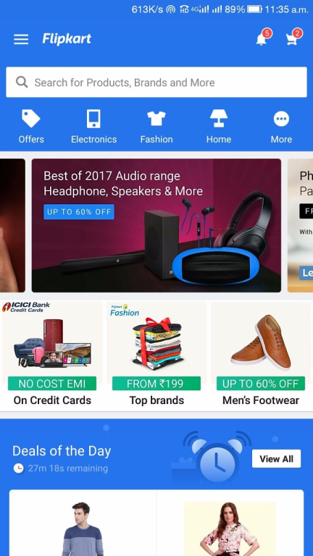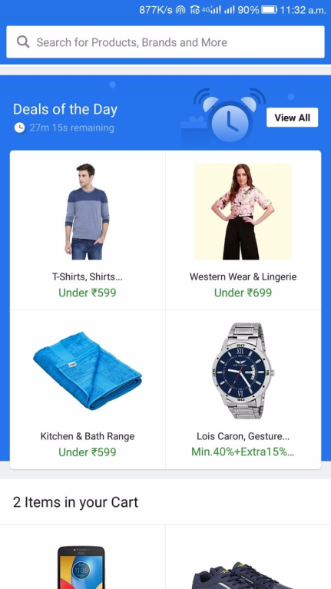



IMG-2

IMG-1

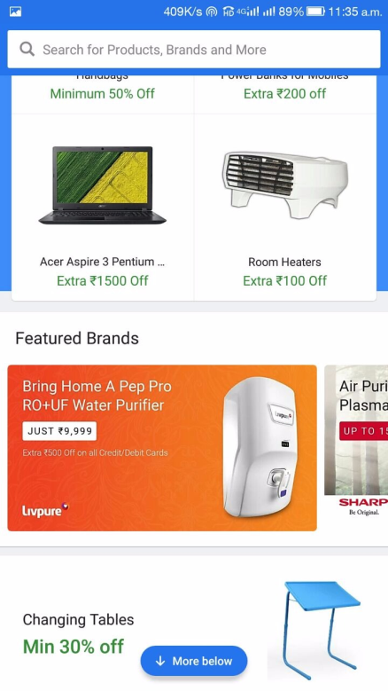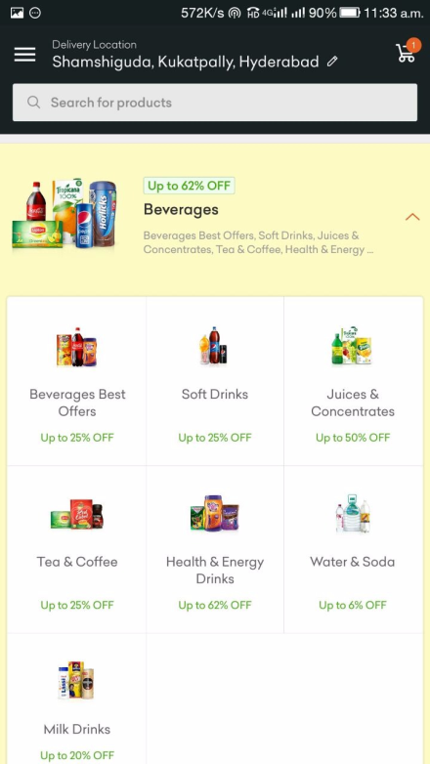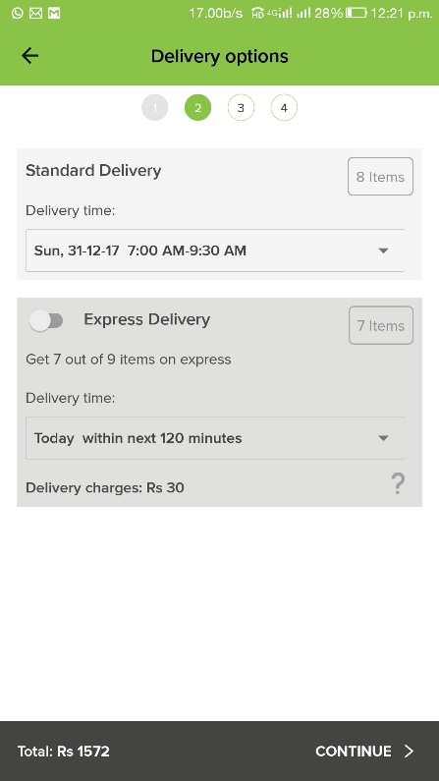



IMG-3

IMG-4

IMG-5