**www.whatsLyf.com Motivation Site Requirement:**

* The main aim of the website is, admin can post motivation thought and share to entire world who visits the web no need to login or sign up.

Like:

* User visited to website can like the post (Here number of likes has to be displayed i.e. count)

Comments:

* User can also make some comment on the particular post which has been uploaded. (With in this section: User should be able to comment i.e. text enter should be displayed with emoji)

Share:

* Any user visiting to website should be able to share any particular post which he would like to, on any social media sites (From Our site).
* Website screen should consist of following functionality:
* In header with logo, all the post which admin has made should should be visible in header as quick jump, short form of post with heading and scrollable should be visible. Once user tap on the story should navigate to another view with that particular story details.
* In middle of screen all post has to visible with acquiring 70% of screen. (Same as LinkedIn (Features should same reflect as LinkedIn (For Text, For Images, For Videos) Right partition of the screen for google ads if any)).

1. **Home:**

* Home screen should display all the list of post which have been made by the admin with scrollable view.
* On top menu bar we should have logo search bar and the menu (home, about us, feedback, contact us)
* These post has to be sorted based on the time or date which admin has posted (Latest First)
* There should be a login feature for admin (Once he has logged in then only he/she would be able to post stories)
* Once user select any one story which has been posted should navigate to another screen new window with brief description of that particular post (Same as quick jump on top), Within this section all the functionality which are available in home screen should I.e. (Like, comments, share) should also be available, and back to home option.
* All the font & colour within website should match to the logo of logo colour which have be updated by client.
* If post is text, two to three lines should be visible if there are more lines of text available there should be read more option.
* If it’s an image should be visible full length, If there are multiple image uploaded should also be visible same as Facebook.
* Videos should be of full length, same as LinkedIn should open within our Url itself i.e. it should not navigate to any other url.
* Admin should be able to post, Images(Multiple), Videos (Multiple), Text (Multiple Lines)
* There should be option available to the user where he can follow admin on different social network (Facebook, Twitter, Google+ and More)
* On the right section of the home page we should have newsletter option and follow us on social media buttons must be places. like the image below Facebook page or group shortcut.
* 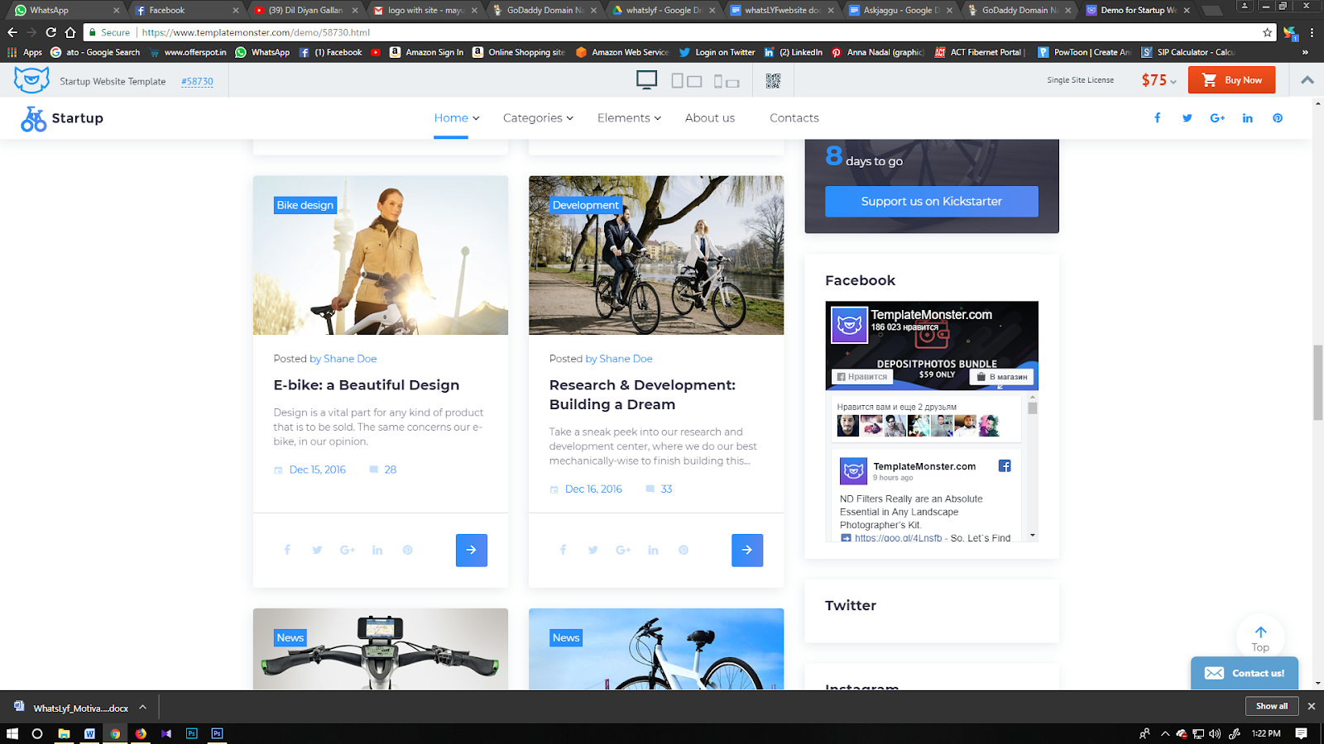
* And in inner page also we have 2 section left or content and right section for ads.
* if I post a YouTube link after video is finished suggestion must not come or it should not redirect to YouTube

1. **Reference Purpose:**

* Please find the logo of Site.





* Please go through these following links for reference.

1. [**http://whatslyf.com/demo (Please**](http://whatslyf.com/demo%20(Please) **go through this link its important).**
2. [**https://www.templatemonster.com/demo/58730.html**](https://www.templatemonster.com/demo/58730.html)
3. **for plug In Please refer this below links.**
4. <https://developers.facebook.com/docs/plugins/comments/>
5. <https://www.sitepoint.com/10-social-sharing-jquery-plugins-missed/>
6. <https://wordpress.org/plugins/add-to-any/>
7. <https://www.templatemonster.com/demo/58730.html>

**Domain Name Apart from this(**http://whatslyf.com**) Which client requires(**jagdishbhakodia.com**):**

**But website will be hosted in on the www.whatslyf.com**

**after finishing the site i will register with google ads or affiliate links which need to be implemented on the sidebar.**

* **In privacy policy please do right the same as Facebook privacy policy (but do not copy the privacy policy same as they have ...change the content and rewrite in our own style ..but do not copy word to word from Facebook.**