**Shared memory sort**

Single Node :

10GB readings

8threads

Configuration changes in the file /resources

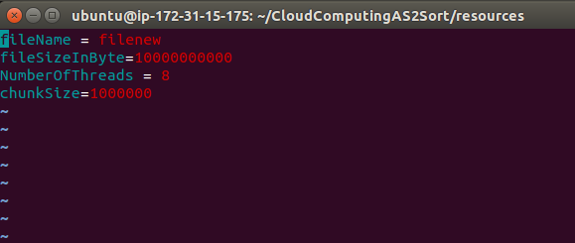

Starting the merge

The file is sorted...

Please find the sorted file at location ./dest/

Total time taken in ms :4827593

4threads

Starting the merge

The file is sorted...

Please find the sorted file at location ./dest/

Total time taken in ms :6500016

2 thread

Starting the merge

The file is sorted...

Please find the sorted file at location ./dest/

Total time taken in ms :5615374

1 threads

Starting the merge

The file is sorted...

Please find the sorted file at location ./dest/

Total time taken in ms :6382355