AWS screenshot hadoop with 16 nodes

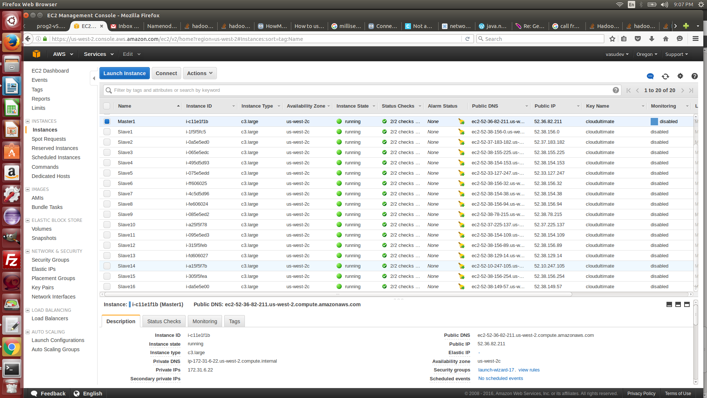

Check running 17 nodes on Hadoop UI at DNS : 50070

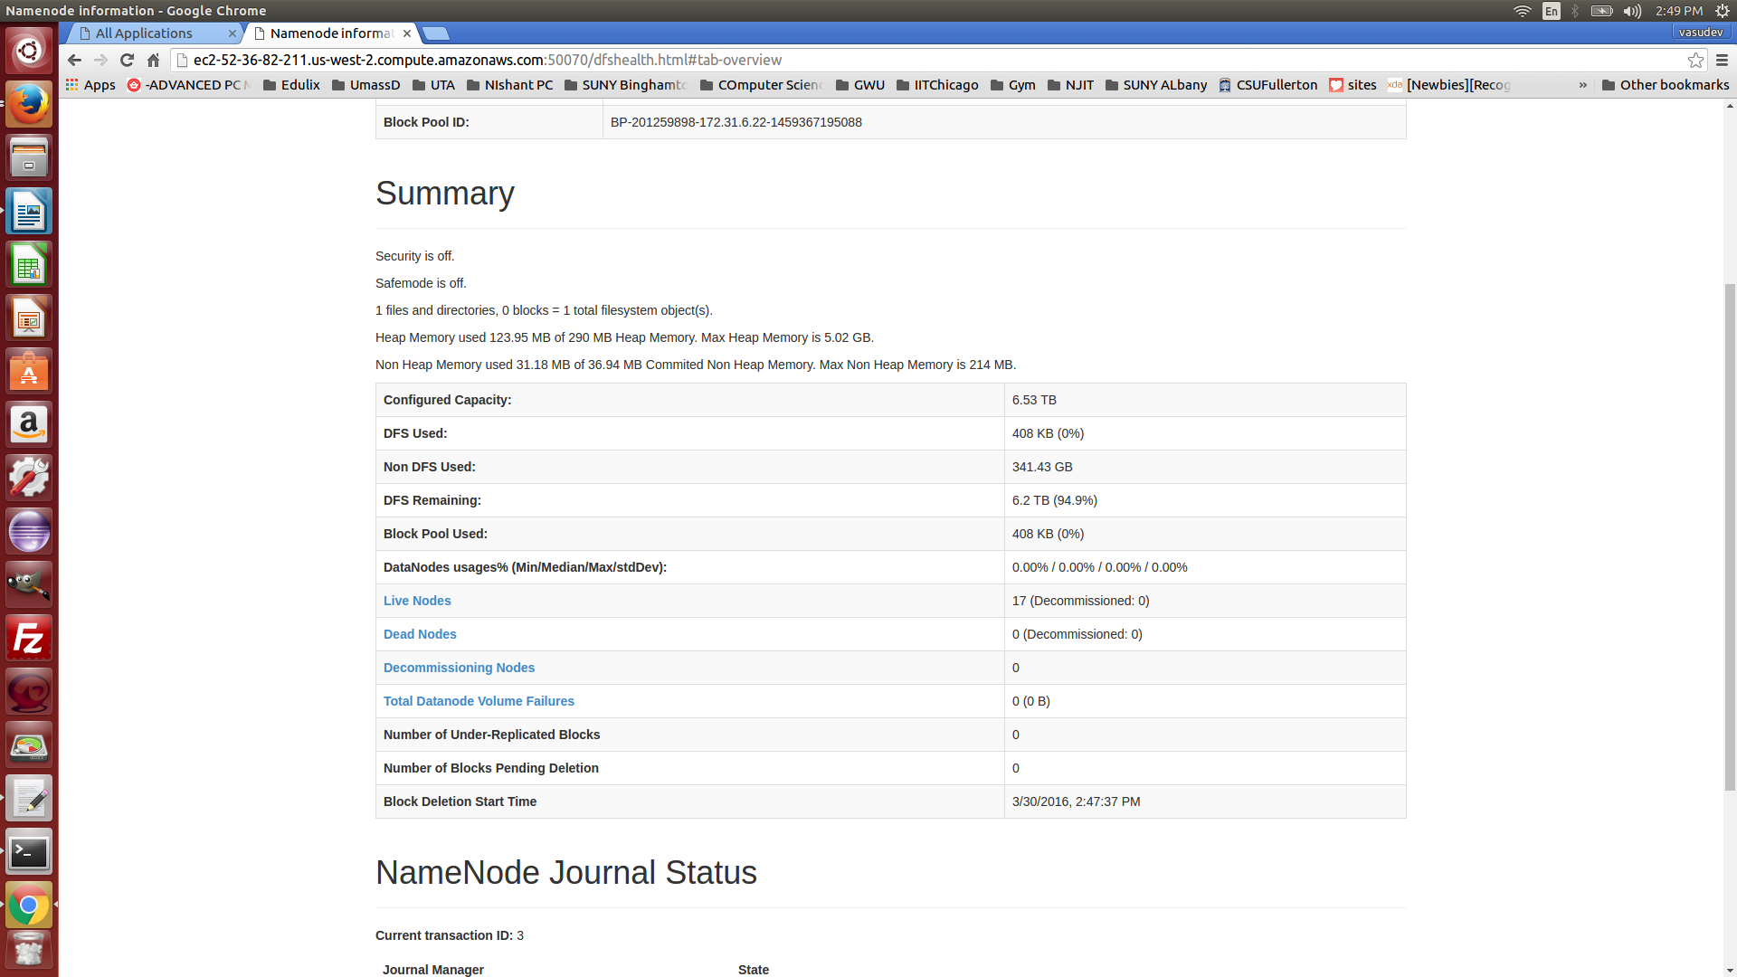

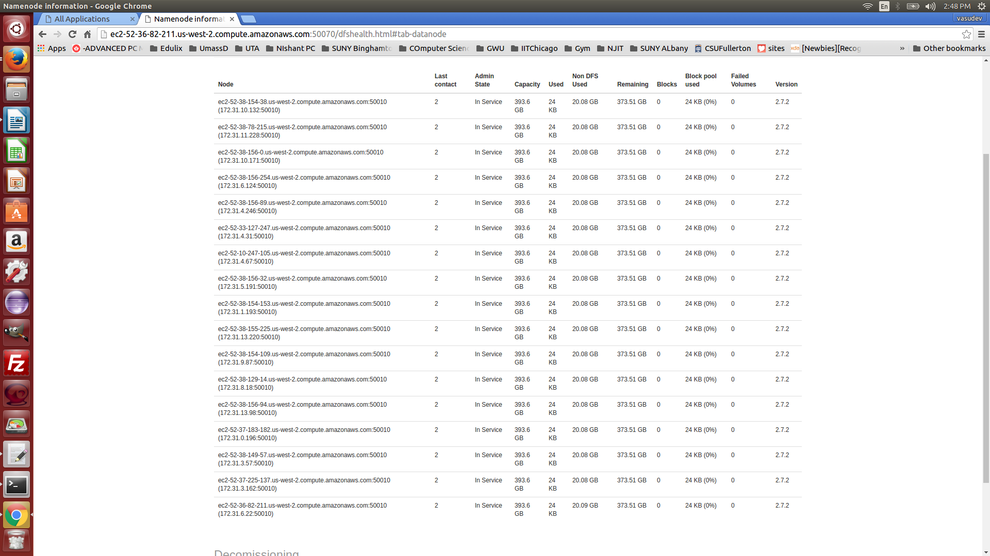

Check the status of the run at DNS: 9006 ( webaddress specified in confi file)

**Running state**

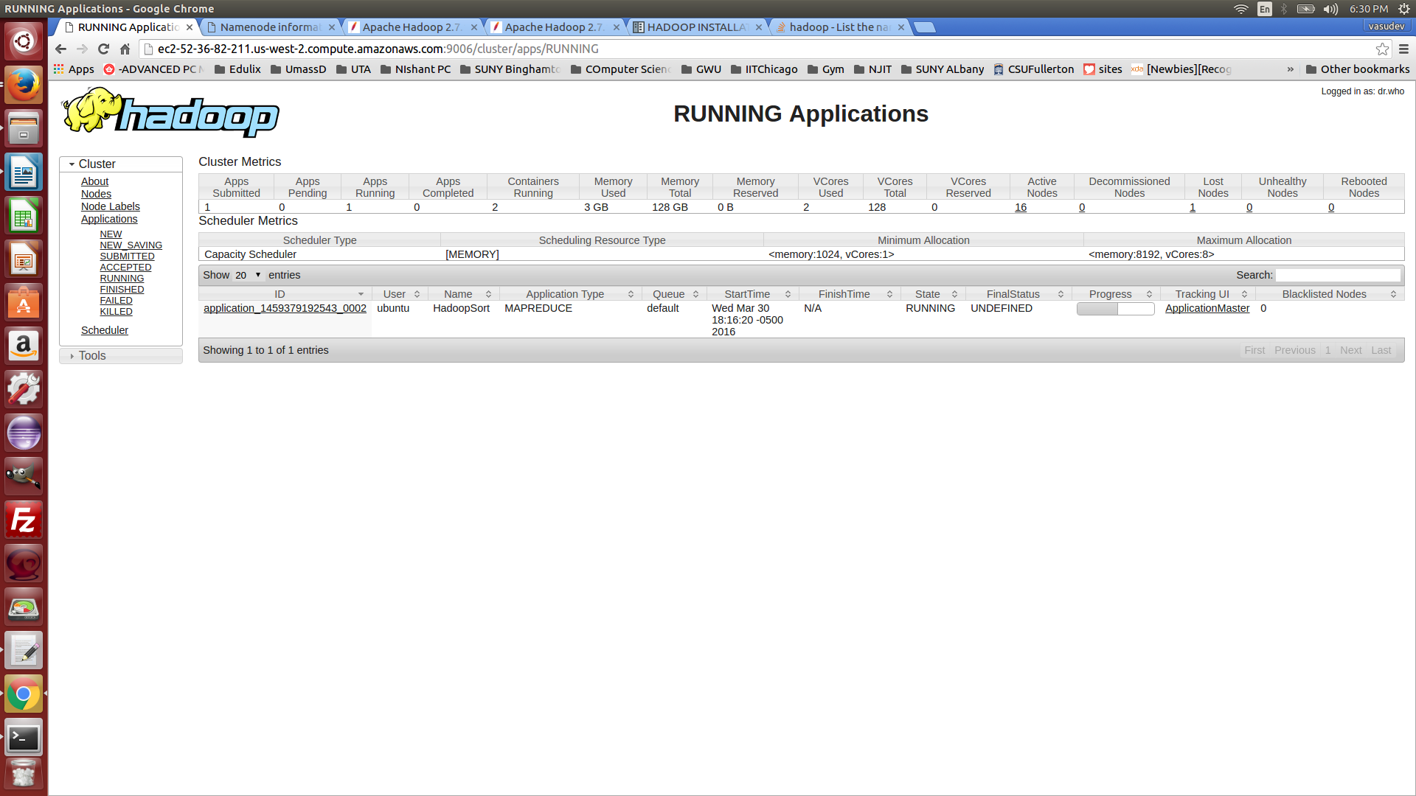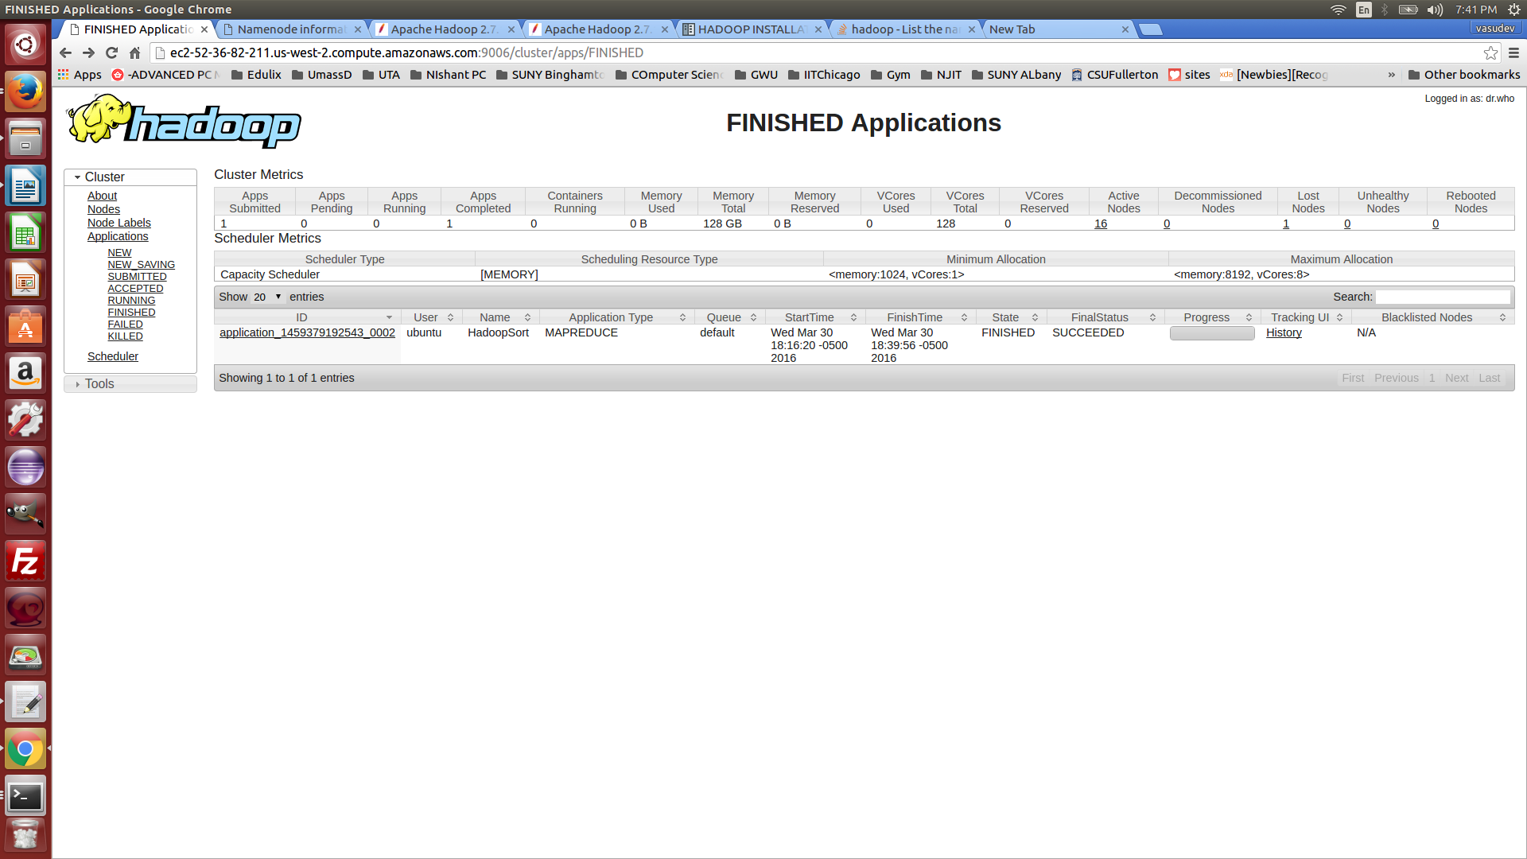

**Success state :**

**Valsort**

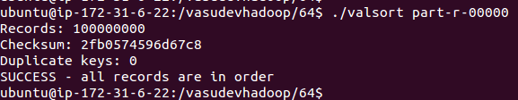

**Head and tail of sorted file**

