**How Medicare Spending per Beneficiary (MSPB) measure affects Hospitals’ Quality Scores**

- By Vasudha Gulati

# **Abstract**

**Objective:** The objective of this study is to determine what are the factors affecting Centers for Medicare and Medicaid Services (CMS) star ratings for patient experience in US hospitals and the focus of this study is on the hospital Medicare Spending per Beneficiary (MSPB) Measure considering rural-urban continuum codes and cost of index. Our hypothesis is better the patient’s experience in the hospital, the lower should be healthcare spending by the payer. **Methods:** Using the CMS Hospital Compare data set, 2021 US Hospital data for CMS hospital star ratings and the hospital Medicare Spending per Beneficiary (MSPB) Measure is analyzed. For the study, I have tested the association using a correlation matrix and linear regression, considering other variables also such as Hospital Emergency Services, Group score measures, Cost of Index, and Rural-Urban continuum codes. **Results:** The study shows a decrease in MSPB scores when there is an overall increase in hospital patient experience ratings. **Conclusion:** Results confirmed that better hospital patient experience is associated with lower Medicare spending.

# **Introduction**

## **Industry Description**

The healthcare industry in the United States is huge and continues to expand as the population grows. To improve patient satisfaction and the quality of care they receive, a variety of businesses and healthcare facilities collaborate, sometimes at a significant cost. US healthcare is more expensive than most countries. Although the COVID-19 pandemic exacerbated the trend of rising healthcare costs, these expenditures had already been rising for some time prior to the outbreak. Healthcare costs have increased over the past few decades, rising from 5% of GDP in 1960 to 18% in 2021 in relation to the size of the economy. In 2021, U.S. healthcare spending reached $4.3 trillion, which averages to about $12,900 per person. (PPGF,2021).

## **Problem Description**

When it comes to healthcare, no one wants to spend more time at the doctor’s office or in inpatient care. Value-based healthcare models aim to deliver on this goal by moving us beyond fee-for-service models—which by default encourage more tests, more procedures, and more follow-up. Instead, providers will be compensated by payers for clinical outcomes linked to cost containment, not for the quantity of care they provide. Healthcare organizations must implement strategies that effectively track quality metrics and improve care by demonstrating evidence-based outcomes in order to succeed in the transition.

Health systems are required to submit quality measurements to the Centers for Medicare and Medicaid Services (CMS), commercial payers, and accrediting organizations. Hospital quality metrics are a collection of benchmarks created by CMS to measure organizational structures, patient outcomes, and healthcare processes.

Our goal here is to determine the impact of Medicare spending per beneficiary (MSPB) on hospitals’ star ratings. The Medicare Spending Per Beneficiary (MSPB) indicator compares hospital efficiency to that of the median hospital throughout the country. The MSPB measure specifically evaluates Medicare Part A and Part B payments for services rendered by hospitals during the course of an episode that lasts from three days before an inpatient hospital admission to 30 days following discharge. Price-standardized and risk-adjusted payments are a part of this measure. (QualitynetCMS,2022).

Along with the MSPB Scores, we looked at other aspects of hospital quality like Mortality, Safety, Readmission, Patient Experience, and Timely and Effective care. These group measures are defined by the CMS and are important to be considered while calculating the Hospital Quality Scores. For each measure group, there is a defined weightage that is assigned by CMS. The weighted average of the hospital's scores for each measure group is used to calculate a summary score for each hospital. The weight given to each measure group is shown in the table below. Following that, k-means clustering within each peer group is used to assign hospitals to star ratings using the hospital summary score. (CMSGov,2022).

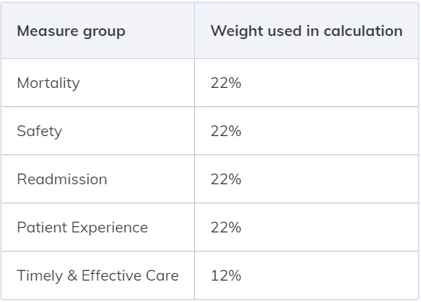

Figure 1 Measure Groups Weightage (CMSGov,2022)

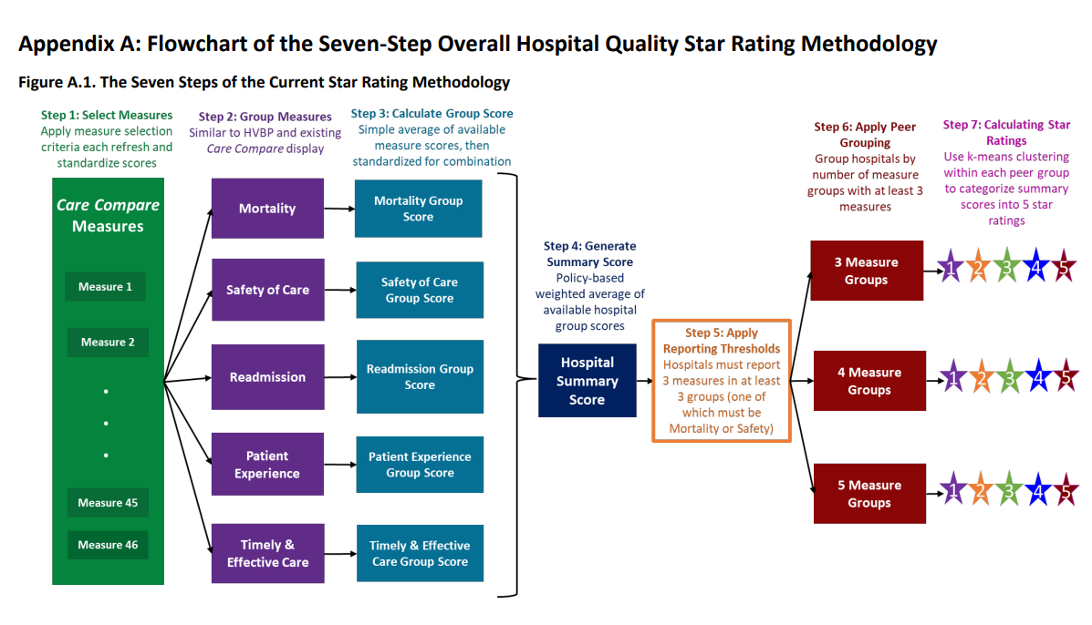

Figure 2 Overall Hospital Quality Score Methodology (QualityNetCMS,2022)

For our study, we also considered other factors like rural-urban continuum code values and Cost of Index. The rural-urban continuum codes are classified into four categories, Census Division. The 33 RUCA codes are aggregated into four categories: urban, large rural, small rural, and isolated (RUCA, Rural Health Research Center). The classification is as follows:

**Urban**: 1.0, 1.1, 2.0, 2.1, 3.0, 4.1, 5.1, 7.1, 8.1, 10.1;

**Large rural**: 4.0, 4.2, 5.0, 5.2, 6.0, 6.1;

**Small rural**: 7.0, 7.2, 7.3, 7.4, 8.0, 8.2, 8.3, 8.4, 9.0, 9.1, 9.2;

**Isolated**: 10.0, 10.2, 10.3, 10.4, 10.5, 10.6.

Our analysis is entirely based on the RUCA values 1(Urban), 4(Large Rural), 7(Small Rural), and 10(Isolated).

## **Organization Sponsors**

Under the guidance of:

Dr. Venugopal Balijepally

Associate Professor of Management Information Systems, School of Business Administration, Oakland University.

## **System Capabilities**

The objective of this study is to understand the association between patient experience and healthcare spending at the hospital level using the Centers for Medicare and Medicaid Services (CMS) star ratings for patient experience in US hospitals and the hospital Medicare Spending per Beneficiary (MSPB) Measure. Our hypothesis is: the better the patient’s experience in the hospital, the lower should be healthcare spending by the payer. The patient experience here is referred to as Hospital star rating and healthcare spending is MSPB Scores.

## **Business Benefits**

Star ratings can give you information and help you compare hospitals locally and nationwide, but patients should consider a variety of factors when choosing a hospital, like a physician’s guidance about their care plan. Along with the overall rating, we should look at other aspects of hospital quality like rates of infection and complications, and patient experience of care. MSPB measures are introduced in various programs by CMS to encourage hospitals and clinicians to improve the quality of inpatient care provided to all patients and adjust payment to hospitals based on the quality of care they deliver.

# **Project Deliverables**

## **Data Source:**

1. Hospital and MSPB data are taken from the CMS government website: <https://data.cms.gov/provider-data/topics/hospitals/overall-hospital-quality-star-rating/>
2. Rural-Urban Continuum codes data taken from the USDA website: <https://www.ers.usda.gov/data-products/rural-urban-continuum-codes.aspx>
3. Cost of Index data taken from Wise voter website: <https://wisevoter.com/state-rankings/cost-of-living-by-state/>

The analysis is based on the United States 2021 hospital-level data from the CMS Hospital Compare data set. Rural-Urban Continuum codes for the year 2021 are taken from USDA and the Cost of index is calculated based on the Wisevoter website. This study's sample, according to Hospital Compare data, is approximately 4649 hospitals.

A statistical analysis of the association between different factors/variables and the hospital star ratings is provided. The primary outcome measure for this study is healthcare spending as quantified by the MSPB Measure.

# **Methods Used for Analysis**

The major chunk of data is collected from the CMSGov website. Other variables like the Rural-Urban Continuum Codes and Cost of Index are taken from USDA, and Wisevoter respectively. The data is imported from these sources into Excel. After cleansing the Excel files separately, it was compiled together in MS Access. Through MS Access, the data is combined together and exported as an Excel file. That combined Excel file is used for statistical analysis in SAS Studio. The variable EmergencyServices is encoded into binary numbers to later use for statistical calculations. PowerBI is used to better understand the data by creating visualizations and gaining some insights from them. SPSS software is used to run the correlation matrix to determine the correlations among the variables.

## **Key Findings/Analysis Results**

1. **Numerical Summary**

From figure 3 we concluded, MSPB scores for the study ranged for 3000 hospitals, with a mean of 0.99 (SD = 0.08) and a median of 0.99. The star rating of a total of 3073 hospitals has a mean of 3.22 with a Std deviation of 1.12 and a Median of 3. Cost of Index is observed for 4649 records with a mean value of 103.30, a median of 99, and a Std Dev of 18.32.

1. **Boxplots and Histogram:**
2. **MSPB Scores and hospital star ratings**

Created a boxplot between MSPB Score and Hospital star ratings. Boxplot clearly shows more outliers for the Hospital rating = “3” and “5” values which means there are values that lie outside the overall distribution pattern and can affect the overall data. The diamonds in the boxplot represent the average of the MSPB Scores which in this case is closer to the mean value. The average MSPB score is higher in the case of Hospital rating = “3”. And clearly the boxplots show that the when MSPB score decreases then there is an increase in the Hospital quality scores. [Figure4]

1. **Cost of Index and hospital star ratings**

The boxplot clearly shows more outliers for the Hospital rating = “3”, “4” and “5” values which means there are cost of index values that lie outside the overall distribution pattern and can affect the overall data. The diamonds in the boxplot represent the average of the cost of index which in this case is higher than the mean value. The average cost of index is higher in the case of Hospital rating = “1”. Boxplot clearly depicts the higher cost of index for lower Hospital star ratings. [Figure5]

1. **Correlation Matrix:**

We ran a Correlation matrix in SPSS to understand correlations between Hospital’s overall rating and different independent variables. As our focus is on a hospital’s overall ratings, we analyzed its significance with other independent variables. The correlation is based on different continuum code values (**Urban**: 1.0, **Large Rural**: 4.0, **Small Rural**: 7.0, and **Isolated**: 10.0)

**Correlations with RUCA=1**

The correlation is based on the RUCA with value 1 which indicates Urban areas and number of hospitals used for this study is 2331 hospitals. According to the correlation matrix, Hospital’s Overall Rating is positively correlated with Readmission and Timely & Effective Care. It is negatively correlated with Mortality, Safety, MSPB Score, and Cost Index. It indicates lower mortality, safety, MSPB scores, and cost of index in urban areas will lead to higher hospital star ratings.

It has been validated by another study published in science direct, hospitals in the least disadvantaged neighborhoods compared to hospitals in the most disadvantaged neighborhoods had lower scores on mortality, safety, patient experience, effectiveness, summary, and overall star rating (Nwana N., Chan W., 2022).



Figure 6 Correlations between different variables with RUC = 1

**Correlations with RUCA=4**

This correlation is based on the RUCA value 4 which indicates Large Rural areas, the number of hospitals used for this study is 692. According to the correlation matrix, the Hospital’s Overall Rating is negatively correlated with Mortality and MSPB Score. The lower the Mortality rate and MSPB scores in large rural areas, the higher would be hospital quality scores.



Figure 7 Correlations between different variables with RUC = 4

**Correlations with RUCA=7**

This correlation is based on the RUCA value 4 which indicates Small Rural areas, the number of hospitals used for this study is 795. According to the correlation matrix, Hospital’s Overall Rating is positively correlated with Timely & Effective Care. The higher the timely and effective care in small rural areas and better would be the patient’s experience.



Figure 8 Correlations between different variables with RUC = 7

**Correlations with RUCA=10**

This correlation is based on the RUCA value 10 which indicates Isolated areas, the number of hospitals used for this study is 478. According to the correlation matrix, the Hospital’s Overall Rating is negatively correlated with MSPB Score. The lower the MSPB scores in isolated areas, the better would be the patient’s experience.



Figure 9 Correlations between different variables with RUC = 10

1. **Regression Model:**
2. **Multiple Regression Model with RUCA=1**

The regression model is build based on the RUCA=1 which indicates Urban areas. As per the analysis, the model is statistically significant because the p-value is <0.0001 which is less than alpha (0.05). [Figure 11]

Adj R-square is 12.3% which indicates, 12% of the variation in “Hospital overall rating” is explained by all the independent variables. [Figure 12]

**Regression Equation of Line Fit:** [Figure 13]

Y = 7.89 + (-0.20)*X1 + (-4.65)*X2 + (-0.15)*X3 + (-0.69)*X4 + (-0.12)*X5 + (0.08)*X6 + (0.001)*X7

Where, Y is Hospital Overall Rating, X1 is EmergencyServices, X2 is MSPBScore, X3 is CountFacilityMORT, X4 is CountFacilitySafety, X5 is CountFacilityREADM, X6 is CountFacilityTE, and X7 is costIndex.

It is validated by my parameter estimates that MSPB Score, Mortality, Safety, Readmission, and Timely & Effective care are significant predictors of Hospital star ratings for the Urban areas.

According to the residual graph, the residuals appear to be uniformly distributed. [Figure 14]

1. **Multiple Regression Model with RUCA=4**

The regression model is build based on the RUCA=4 which indicates large rural areas. As per the analysis, the model is statistically significant because the p-value is 0.0020 which is less than alpha (0.05). [Figure 15]

Adj R-square is 3.8% which indicates, 3.8% of the variation in “Hospital overall rating” is explained by all the independent variables. [Figure 16]

**Regression Equation of Line Fit:** [Figure 17]

Y = 4.51 + (-0.22)*X1 + (-1.67)*X2 + (-0.155)*X3 + (-0.78)*X4 + (0.13)*X5 + (0.046)*X6 + (0.0004)*X7

Where, Y is Hospital Overall Rating, X1 is EmergencyServices, X2 is MSPBScore, X3 is CountFacilityMORT, X4 is CountFacilitySafety, X5 is CountFacilityREADM, X6 is CountFacilityTE, and X7 is costIndex.

It is validated by parameter estimates that MSPB Score, Mortality, and Readmission are significant predictors of Hospital star ratings for large rural areas.

According to the residual histogram graph, the residuals appear to be uniformly distributed. [Figure 18]

1. **Multiple Regression Model with RUCA=7**

The regression model is build based on the RUCA=7 which indicates small rural areas. As per the analysis, the model is statistically significant because the p-value is 0.0139 which is less than alpha (0.05). [Figure 19]

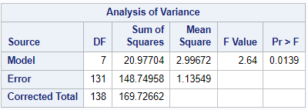

Figure 19 Multiple Regression Analysis Snippet from SAS Studio

Adj R-square is 7.7% which indicates, 7.7% of the variation in “Hospital overall rating” is explained by all the independent variables. [Figure 20]

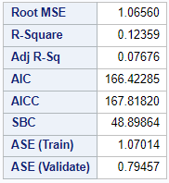

Figure 20 Different Measures snippet

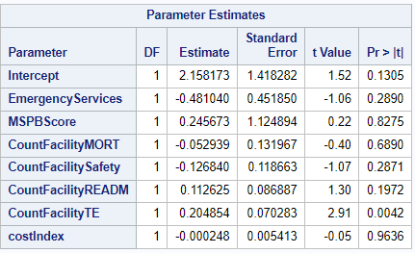

Figure 21 Parameter Estimates from the Regression Model

**Regression Equation of Line Fit:** [Figure 21]

Y = 2.158 + (-0.48)*X1 + (0.25)*X2 + (-0.05)*X3 + (-0.13)*X4 + (-0.11)*X5 + (0.20)*X6 + (0.0002)*X7

Where, Y is Hospital Overall Rating, X1 is EmergencyServices, X2 is MSPBScore, X3 is CountFacilityMORT, X4 is CountFacilitySafety, X5 is CountFacilityREADM, X6 is CountFacilityTE, and X7 is costIndex.

It is validated by parameter estimates that Timely & Effective care is the significant predictor of Hospital star ratings for small rural areas.

According to the residual histogram graph, the residuals appear to be uniformly distributed. [Figure 22]

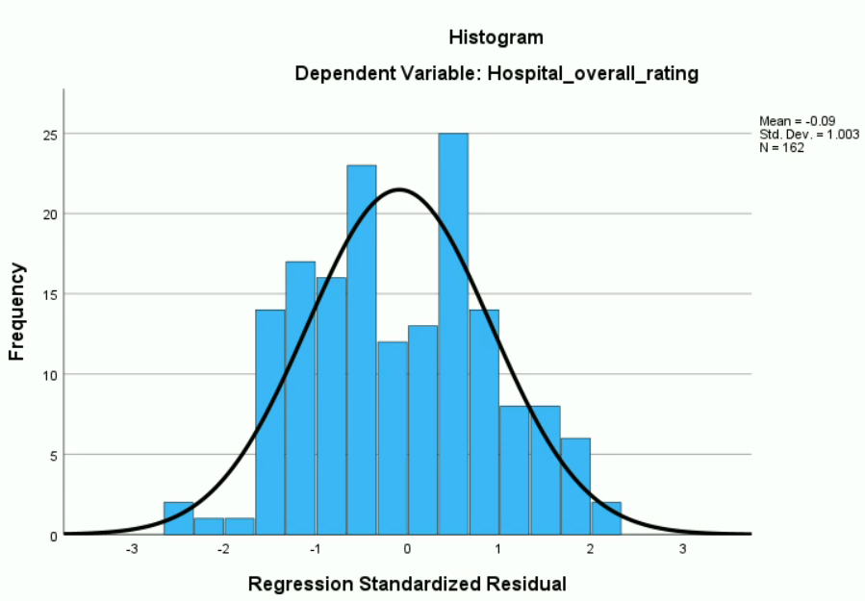

Figure 22 Residual Graph

1. **Multiple Regression Model with RUCA=10**

The regression model is build based on the RUCA=10 which indicates isolated areas. As per the analysis, the model is statistically significant because the p-value is 0.0368 which is less than alpha (0.05). [Figure 23]

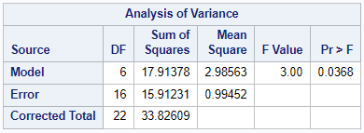

Figure 23 Multiple Regression Analysis Snippet from SAS Studio

Adj R-square is 35% which indicates, 35% of the variation in “Hospital overall rating” is explained by all the independent variables. [Figure 24]

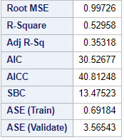

Figure 24 Different Measures snippet

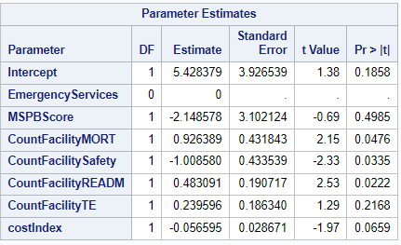

Figure 25 Parameter Estimates from the Regression Model

**Regression Equation of Line Fit:** [Figure 25]

Y = 5.43 + (0)*X1 + (-2.15)*X2 + (0.93)*X3 + (-1.01)*X4 + (0.48)*X5 + (0.24)*X6 + (-0.06)*X7

Where, Y is Hospital Overall Rating, X1 is EmergencyServices, X2 is MSPBScore, X3 is CountFacilityMORT, X4 is CountFacilitySafety, X5 is CountFacilityREADM, X6 is CountFacilityTE, and X7 is costIndex.

It is validated by parameter estimates that Mortality, Safety, and Readmission are significant predictors of Hospital star ratings for isolated areas.

According to the residual histogram graph, the residuals appear to be uniformly distributed. [Figure 26]

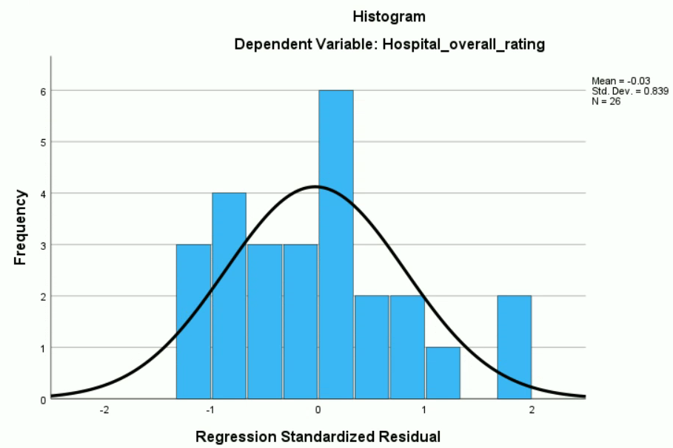

Figure 26 Residual graph

# **Solution Evaluation**

In hospitals and health systems across the United States, quality of care is probably the most important thing. After all, no healthcare provider wants to be known for providing subpar services in an unsafe and dirty environment. Fortunately, health systems are required to report quality measures by the Centers for Medicare and Medicaid Services (CMS), commercial payors, and accrediting organizations. The Centers for Medicare and Medicaid Services (CMS) defines these metrics as a set of standards for quantifying processes, outcomes, organizational structures, and other aspects of healthcare. Hospital operations are dependent on these metrics. This data is used by leaders and decision-makers to, among other things, improve the patient experience, reduce readmissions, and reduce serious complications (Definitive Health Care). A 2012 UC Davis study found that patients who reported the highest satisfaction also had higher hospital admission rates, higher out-of-pocket costs, and a higher mortality rate. Researchers suggested that these patients were more likely to receive duplicative, unnecessary, or even improper care. The findings of the research suggest that quality scores are an effective tool for helping patients choose where to receive care. (Eastwood B., 2017)

# **Lessons Learned**

The focus of our study is to understand how different factors affect the hospital quality scores which determine the patient’s experience in the hospital. Through our study, we were able to analyze that the MSPB scores negatively affect the Hospital’s quality scores, which concludes that lower Medicare spending will lead to better patient experience. Our regression model analysis shows that MSPB scores have a high impact on the urban and large rural areas for determining hospital quality scores. Lower Medicare spending in urban and large rural areas will lead to higher Hospital’s quality scores.

# **Limitations and Future Scope**

## **Limitations**

1. There is also some missing data that we tried to ignore during analysis which might have affected the accuracy of the calculations.
2. Amongst several other parameters, this study focused only on understanding the relationship between MSPB Scores and Hospital quality scores with several independent or co-dependent variables.
3. The cost of index considered for the analysis was based on the state because there wasn’t sufficient data available by zip code or county.

## **Future Scope**

1. The analysis was based on 2021 Hospital data including 4649 hospitals. It can further be analyzed based on past years’ data.
2. Other independent variables like Hospital Consumer Assessment of Healthcare Providers and Systems (HCAHPS) measure, Trauma Centers, Number of Beds, etc., can also be considered to do hypothesis testing to understand the association with Hospital Quality scores.
3. Detailed analysis can be performed on measure groups (Mortality, Safety, Readmission, Timely and Effective Care, and Patient Experience) to understand their association with Hospital quality scores.

# **Appendixes**

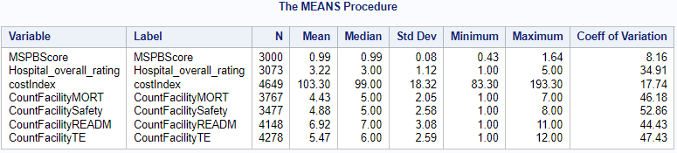

Figure 3 Descriptive Statistics of all the variables

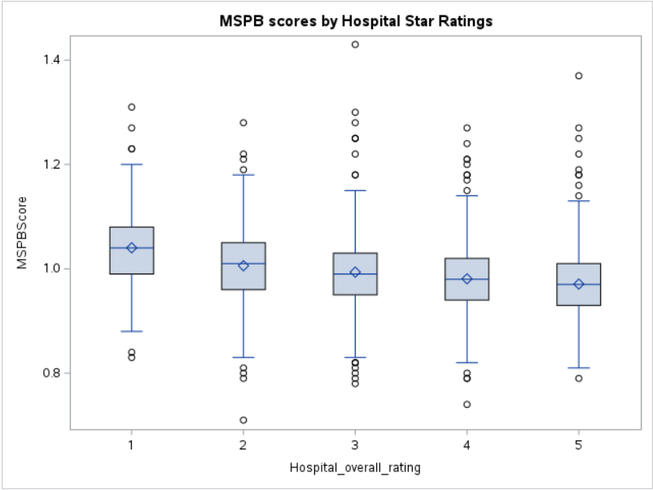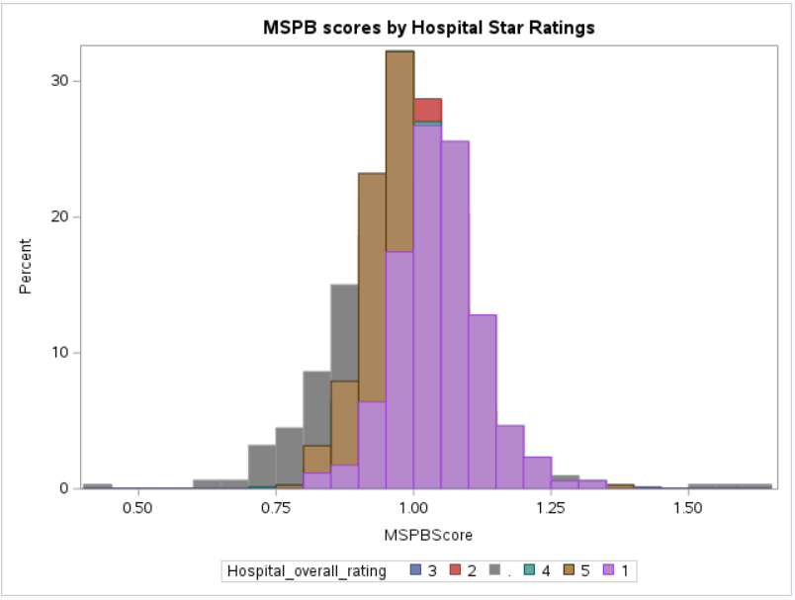

Figure 4 Data distribution between MSPB Scores and Hospital Star Rating

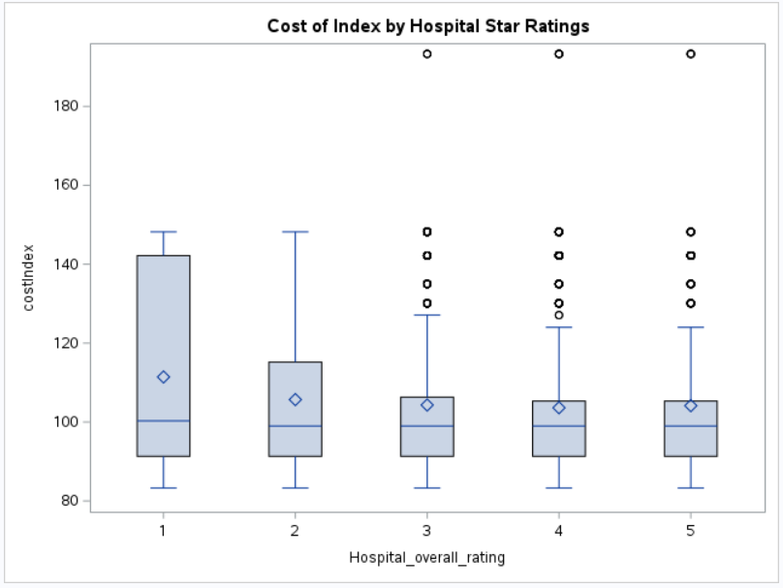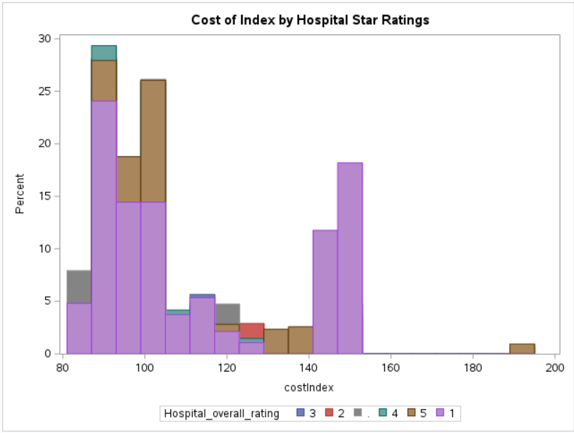

Figure 5 Data distribution between Cost of Index and Hospital Star Rating



Repeated - Figure 6 Correlations between different variables with RUC = 1



Repeated - Figure 7 Correlations between different variables with RUC = 4



Repeated - Figure 8 Correlations between different variables with RUC = 7



Repeated - Figure 9 Correlations between different variables with RUC = 10

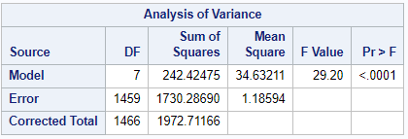

Figure 11 Multiple Regression Analysis Snippet from SAS Studio

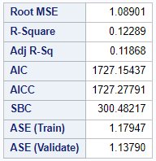

Figure 12 Different Measures snippet

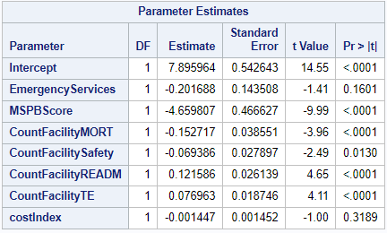

Figure 13 Parameter Estimates from the Regression Model

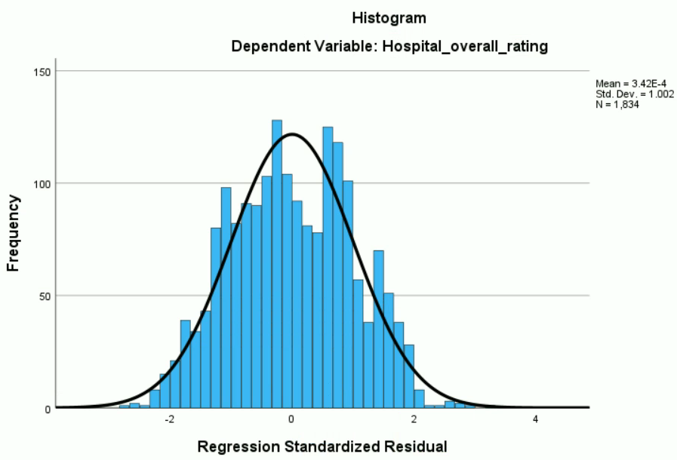

Figure 14 Residual graph

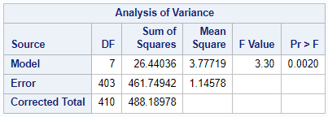

Figure 15 Multiple Regression Analysis Snippet from SAS Studio

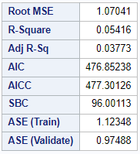

Figure 16 Different Measures snippet

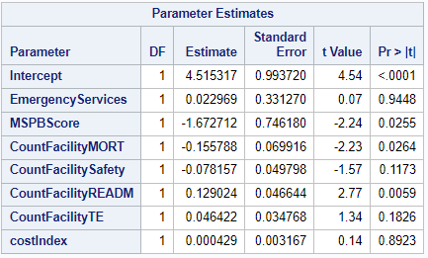

Figure 17 Parameter Estimates from the Regression Model

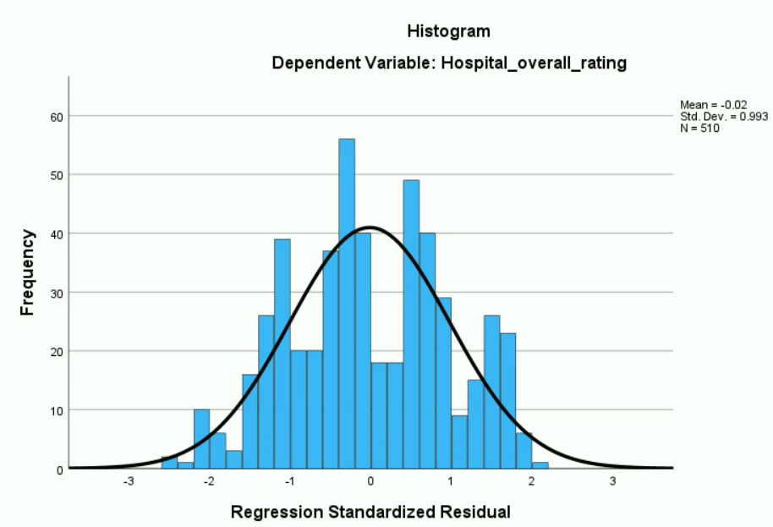

Figure 18 Residual Graph



Figure 19 Multiple Regression Analysis Snippet from SAS Studio



Figure 20 Different Measures snippet



Figure 21 Parameter Estimates from the Regression Model



Figure 22 Residual Graph



Figure 23 Multiple Regression Analysis Snippet from SAS Studio



Figure 24 Different Measures snippet



Figure 25 Parameter Estimates from the Regression Model



Figure 26 Residual graph

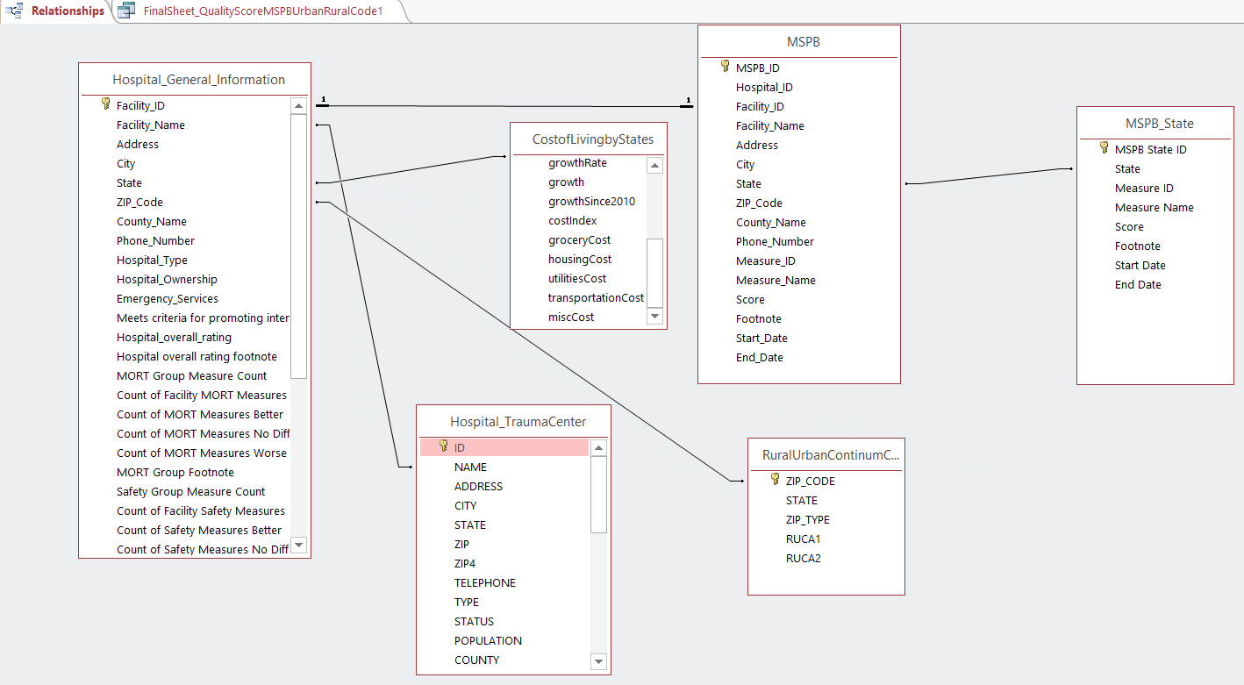

Figure 27 Relationships created in MS Access

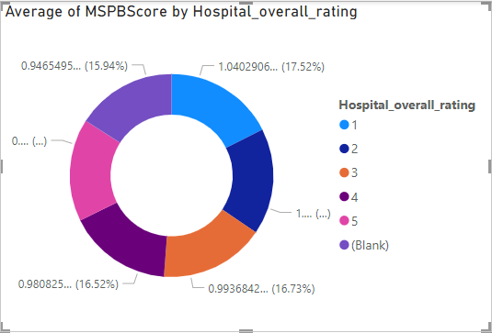

Figure 28 Average MSPB score for Hospital Star Rating - 2021 - PowerBI

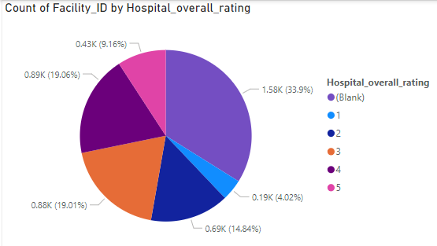

Figure 29 Hospital count by Hospital Star Ratings – PowerBI

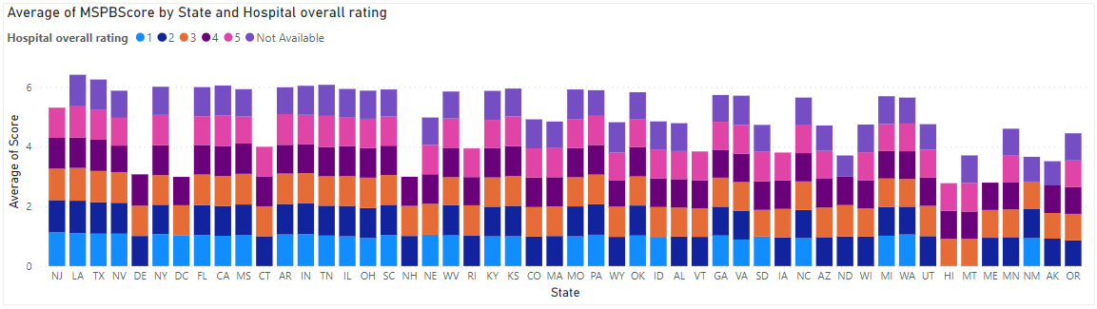

Figure 30 Average MSPB Score State-wise by Hospital Star Ratings – PowerBI

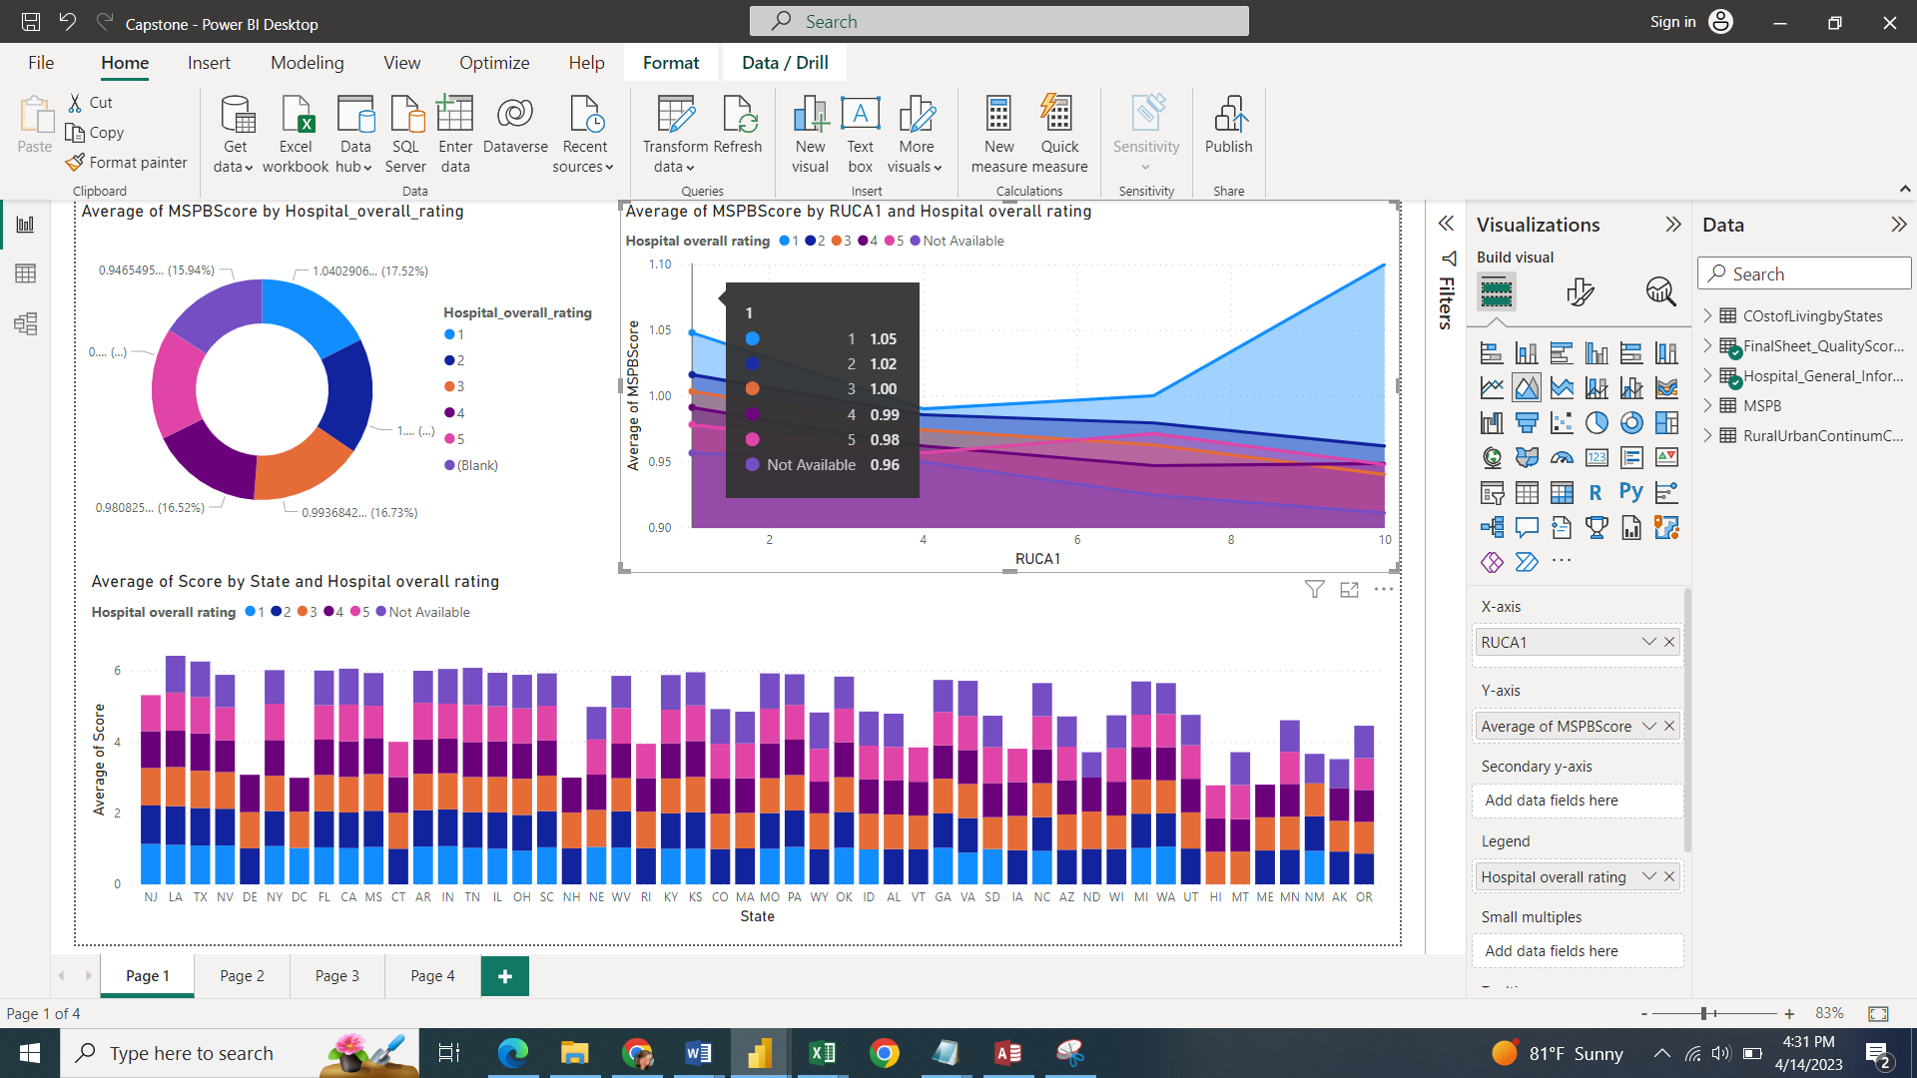

Figure 31 Average MSPB Scores with respect to Quality Scores and RUCA values 1,4,7 and 10 - PowerBI

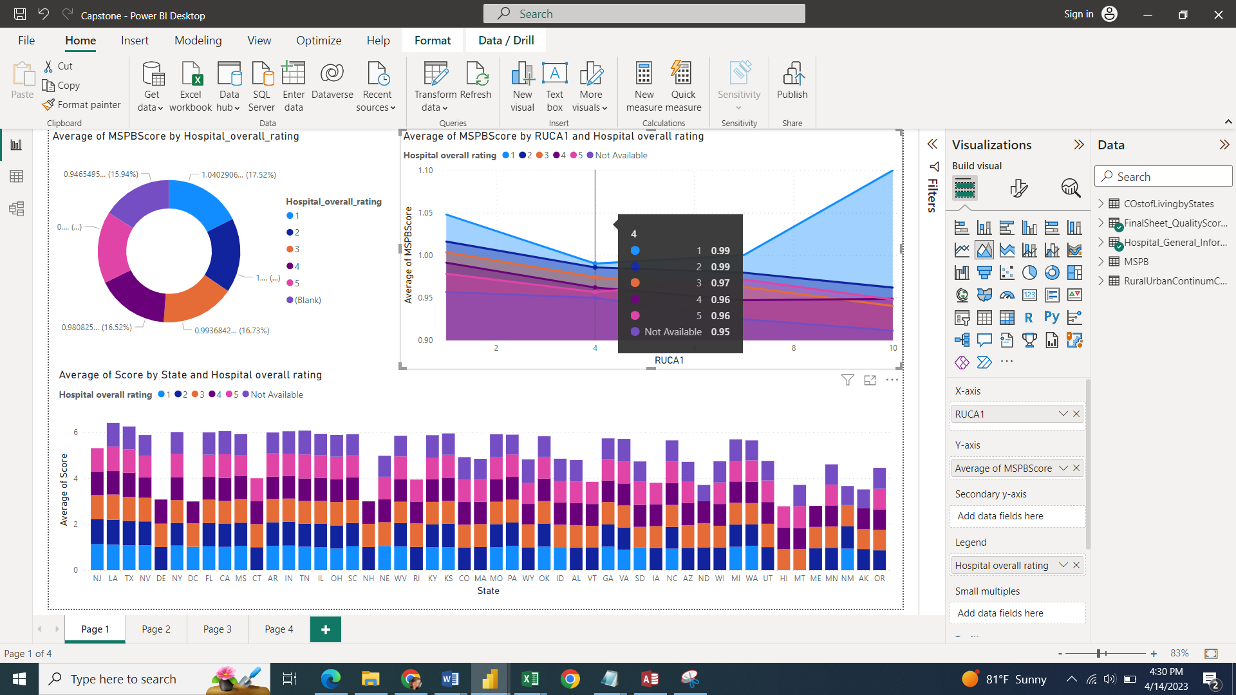

Figure 32 Average MSPB Scores with respect to Quality Scores and RUCA = 4 – PowerBI

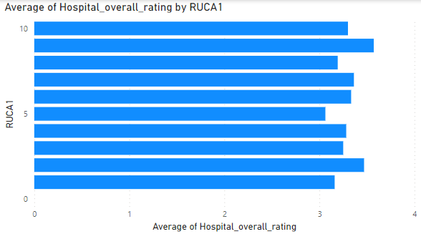

Figure 33 Average Hospital Quality Score by RUCA's - PowerBI

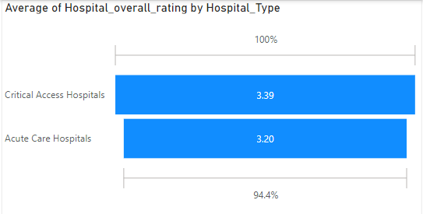

Figure 34 Average Hospital quality scores by Hospital Type – PowerBI

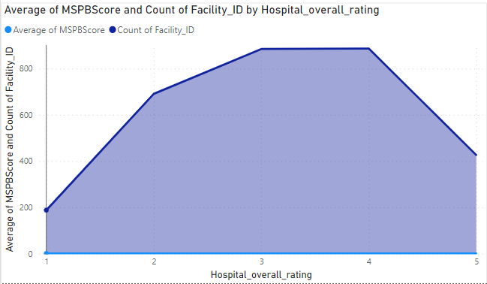

Figure 35 Average MSPB Score and Hospital Count by Hospital Quality Scores – PowerBI

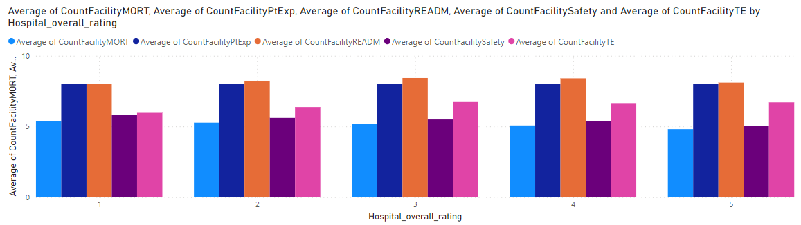

Figure 36 Average Hospital Quality scores by different Measure groups - PowerBI

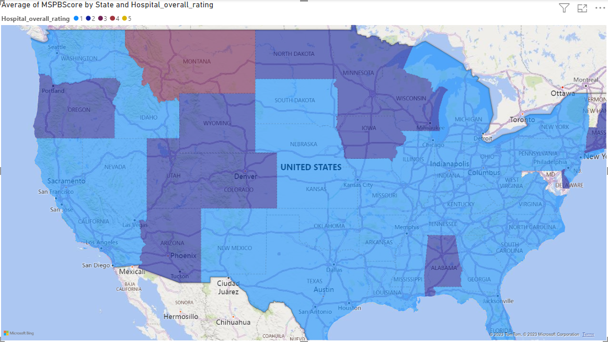

Figure 37 State-wise graph with respect to average Hospital Quality Scores - PowerBI

# **References**

1. CMS.gov, The Centers for Medicare & Medicaid Services, Overall hospital quality star rating, <https://data.cms.gov/provider-data/topics/hospitals/overall-hospital-quality-star-rating/>
2. CMS.gov, QualityNet, “Medicare Spending Per Beneficiary (MSPB) Measure” (2021), <https://qualitynet.cms.gov/inpatient/measures/mspb>
3. Kang YS., Tzeng HM., Zhang T., Rural Disparities in Hospital Patient Satisfaction: Multilevel Analysis of the Massachusetts AHA, SID, and HCAHPS Data 7(4) (607-614) (2020), <https://www.ncbi.nlm.nih.gov/pmc/articles/PMC7534133/>
4. Nwane N., Chan W., Langabeer J., Kash B., Krause TM., Does hospital location matter? Association of neighborhood socioeconomic disadvantage with hospital quality in US metropolitan settings (2022), <https://www.sciencedirect.com/science/article/pii/S1353829222001721>
5. Trzeciak S, Gaughan JP, Bosire J, Angelo M, Holzberg AS, Mazzarelli AJ., Association Between Medicare Star Ratings for Patient Experience and Medicare Spending per Beneficiary for US Hospitals. J Patient Exp. (2017) Mar;4(1):17-21., <https://pubmed.ncbi.nlm.nih.gov/28725856/>
6. Nwana N., Chan W., Langabeer J., Kash B., Krause TM., Does hospital location matter? Association of neighborhood socioeconomic disadvantage with hospital quality in US metropolitan settings, V78 (2022), <https://www.sciencedirect.com/science/article/pii/S1353829222001721#bib47>
7. RUCA Rural Health Research Center, <https://depts.washington.edu/uwruca/ruca-maps.php>
8. Spivack SB., Qin L., Herrin J., Goutos D., Schreiber M., Fleisher LA., Venkatesh AB., Bernheim S. , Assessing Hospital Quality Scores By Proportion Of Patients Dually Eligible For Medicare And Medicaid (2023), <https://www.healthaffairs.org/doi/abs/10.1377/hlthaff.2022.00362>
9. Chaulk D., Tran T., Neeley A. & Giardino A. (2021), Children’s hospital quality ratings: where are we and can we do better? , Hospital Practice, 405-412, <https://www.tandfonline.com/doi/abs/10.1080/21548331.2022.2050650?journalCode=ihop20>
10. Patient Engagement Hit, Can Hospital Ratings Systems Truly Portray Hospital Quality? (2019), <https://patientengagementhit.com/news/can-hospital-ratings-systems-truly-portray-hospital-quality>
11. The New York Times, Which Metrics on Hospital Quality Should Patients Pay Attention To? (2017), <https://www.nytimes.com/2017/07/24/upshot/which-metrics-on-hospital-quality-should-patients-pay-attention-to.html>
12. Relias Media, Patient Satisfaction vs. Quality Scores: What They Really Mean (2016), <https://www.reliasmedia.com/articles/139159-patient-satisfaction-vs-quality-scores-what-they-really-mean>
13. PPF, WHY ARE AMERICANS PAYING MORE FOR HEALTHCARE? (2021), <https://www.pgpf.org/blog/2023/01/why-are-americans-paying-more-for-healthcare>
14. AMA, Trends in health care spending (2020), <https://www.ama-assn.org/about/research/trends-health-care-spending>
15. Definitive Health Care, Why hospital quality performance is valuable to you, <https://www.definitivehc.com/blog/why-hospital-quality-performance-is-valuable-to-you#:~:text=These%20metrics%20are%20vital%20to,serious%20complications%20among%20other%20things>.
16. Eastwood B., Hospital quality scores really do reflect patient outcomes (2017), MIT Management Sloan School, <https://mitsloan.mit.edu/ideas-made-to-matter/hospital-quality-scores-really-do-reflect-patient-outcomes>