Phase 1

Ideation & Discovery

Date | 25.06.2026
Team ID | NIL
Project Name | An employee requests installation of licensed software through the Service Catalog
Maximum Marks | 4

Empathize & Discover Introduction
The Software Installation Request Automation project aims to digitize and automate the manual, email-based process of requesting software within the organization. By utilizing ServiceNow's Service Catalog, Flow Designer, and Business Rules, this project creates a structured, auditable, and rapid fulfillment lifecycle for end-users.

Problem Statement
Currently, employees experience severe delays when requesting licensed software. The process relies on unstructured emails, manual manager approvals, and lacks visibility. This results in lost productivity, frustrated end-users, and compliance risks for the IT department regarding software licenses.

Customer Problem Statement
I am an employee trying to install licensed software for my work, but I have to wait weeks and send multiple emails because approvals get lost, which makes me feel frustrated and unproductive.

Problem Statement Canvas
The canvas outlines the context of the user, the problem they face (manual IT tickets), the emotional impact (frustration), and the measurable business impact (lost hours).

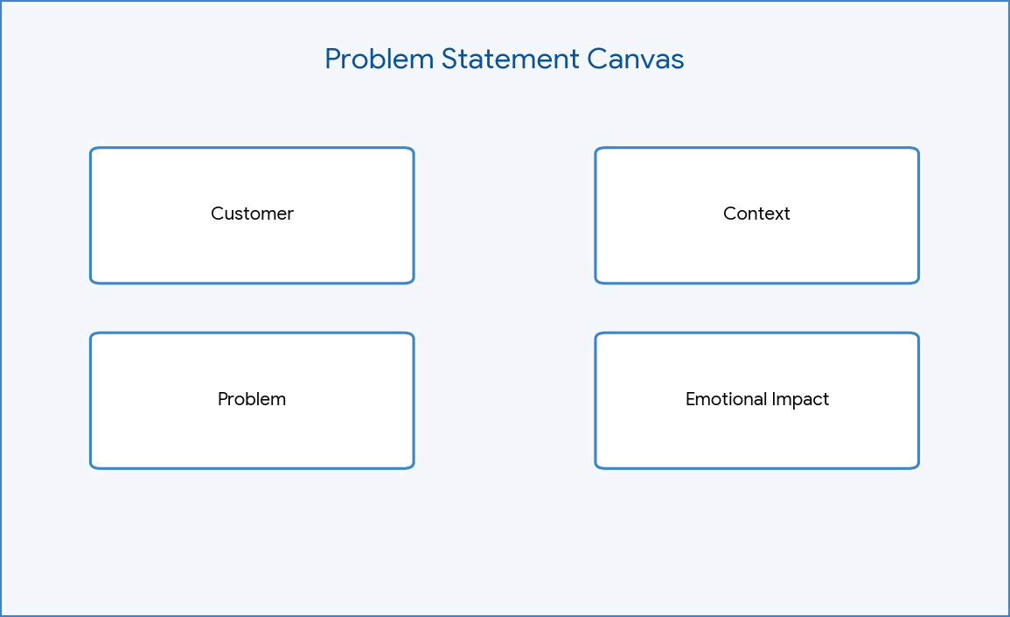

Figure: Problem Statement Canvas

Empathy Map
The Empathy Map highlights that users THINK 'Why is this so slow?', HEAR colleagues complaining about IT, SEE clunky manual forms, and SAY 'I'll just ping IT directly on Slack.'
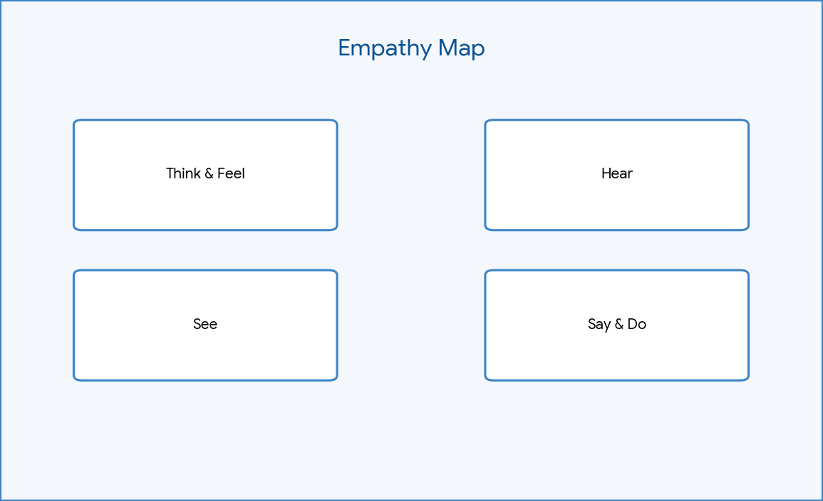

Empathize & Discover
During discovery, we mapped the friction points. The lack of standardized forms means IT agents spend hours chasing down justification and specific version numbers.

User Behaviour
Users typically attempt to bypass the formal queue by directly messaging IT staff, or they submit incomplete requests that require multiple follow-ups.

User Attitudes
Users view the current IT procurement process as a bureaucratic bottleneck rather than an enabling service.

User Goals
To obtain required software quickly, cleanly, and with full transparency on the request's status.

User Challenges
Navigating unstructured approval chains and lacking visibility into whether their manager has actually approved the request.

Existing System
The existing system relies on manual incident creation or raw emails sent to a generic IT inbox. Approvals are gathered via reply-all chains.

Brainstorming Session
Ideas included: 1) A Service Catalog Item, 2) Flow Designer automation for approvals, 3) Automated SCTASK generation, 4) Business rules for license tracking.

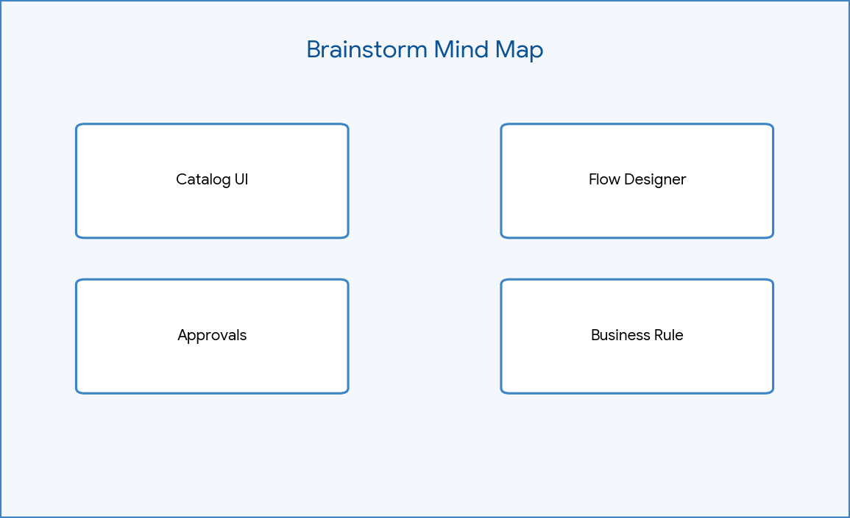

Figure: Brainstorm Mind Map

Idea Listing
1. Intuitive Catalog UI. 2. Auto-route to line managers. 3. Auto-create IT Tasks. 4. Auto-generate incidents for license shortages.

Idea Grouping
Ideas were grouped into Frontend (UI/UX), Logic (Flows & Approvals), and Exception Handling (Business Rules).

Idea Prioritization
Prioritized building the Catalog Item and Flow Designer first (High Value, Low Effort) and left complex CMDB integrations for future phases.

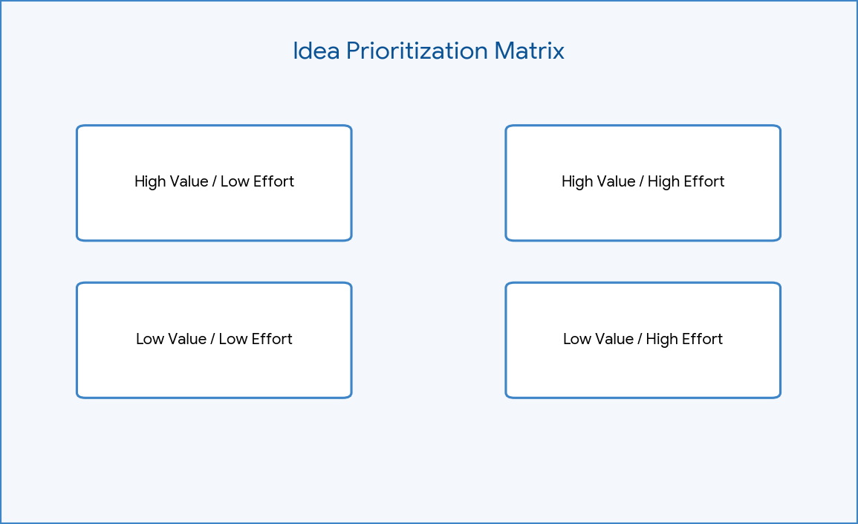

Figure: Priority Matrix

Stakeholder Analysis
Key stakeholders include End Users (requesters), Software Support (fulfillment), IT Management

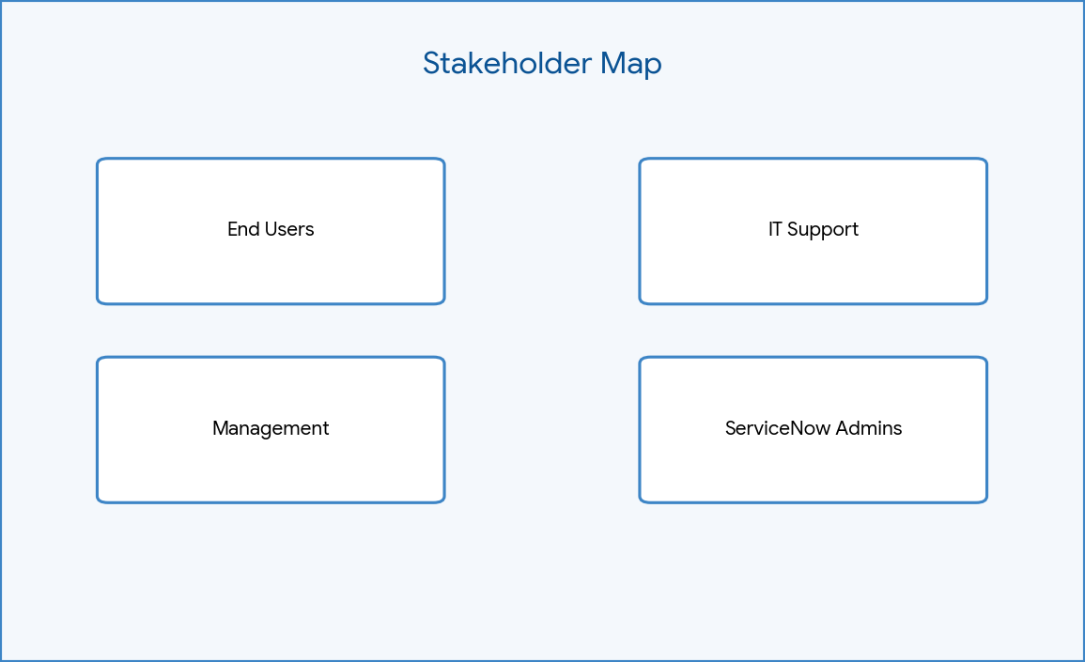

(approvers), and ServiceNow Admins (developers).

Figure: Stakeholder Map

Root Cause Analysis
The fishbone diagram reveals the root cause of delays is 'Process' (lack of automation) and 'Technology' (reliance on email).
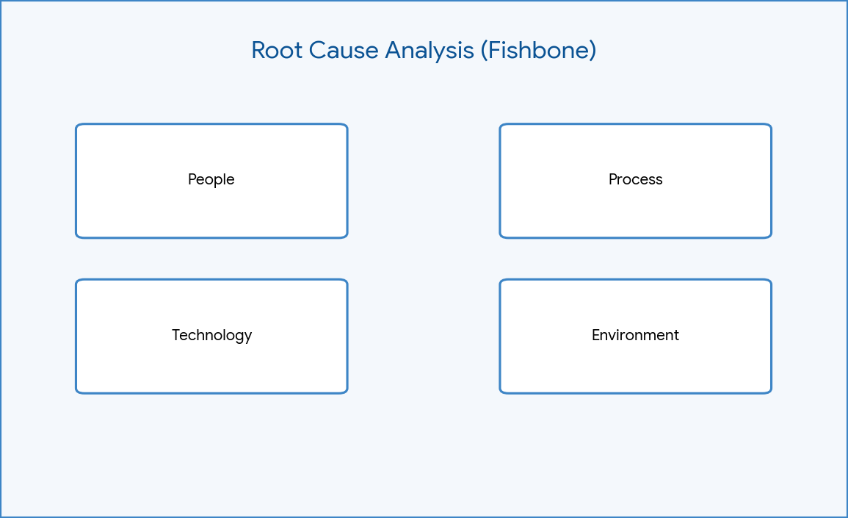

Figure: Fishbone Diagram

Phase Summary
Phase 1 successfully defined the problem space. Moving forward, the project will focus on designing the Service Catalog item and the automated workflow to solve these issues.

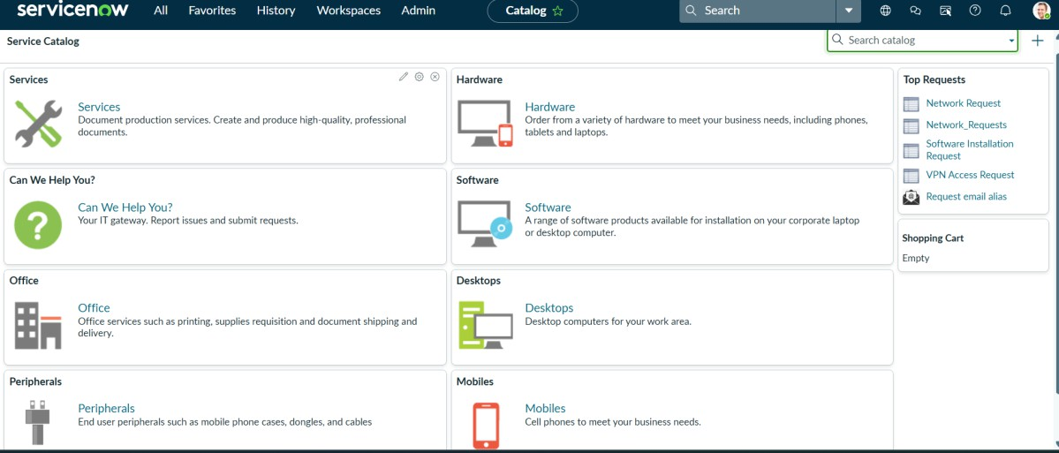
Figure: Service Catalog landing page

