Phase 2

Core Requirements & Design

Date | 26.06.2026
Team ID | NIL
Project Name | An employee requests installation of licensed software through the Service Catalog
Maximum Marks | 4

Requirements Analysis & Solution Design Introduction
Phase 2 translates the ideation phase into concrete system requirements within ServiceNow. We define the specific data fields, variables, and process flows necessary for the Software Installation Request catalog item.

Customer Journey Map
The journey transitions from the user searching the Service Portal, filling out the structured form, receiving an automated 'Awaiting Approval' notification, to final fulfillment.
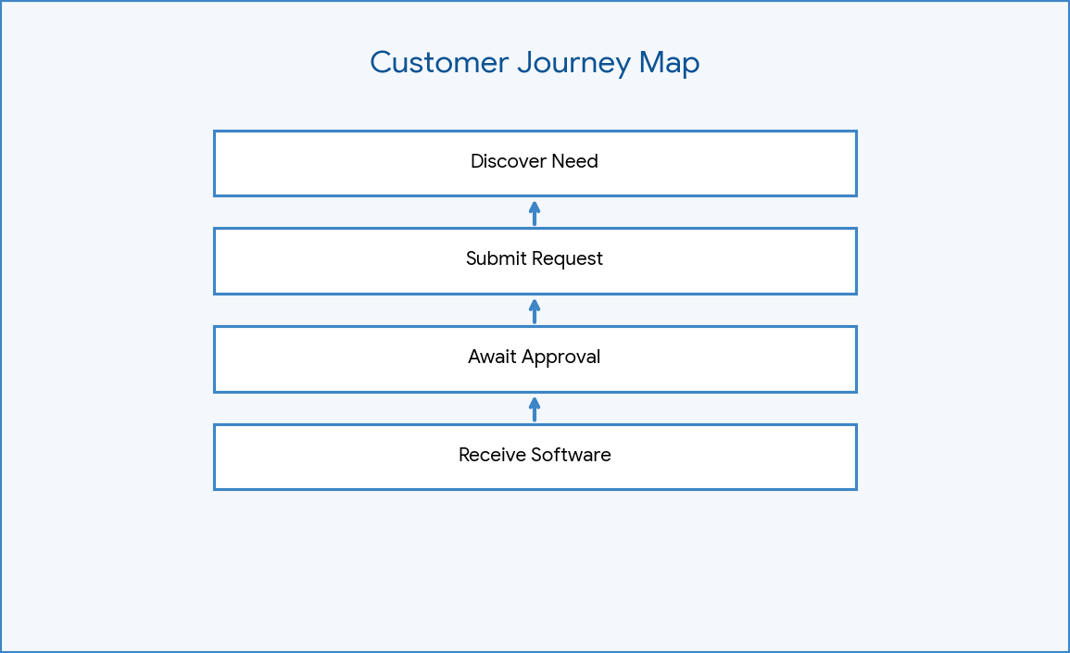

Figure: Customer Journey Map

Functional Requirements
1. A Catalog Item named 'Software Installation Request'. 2. Four distinct variables (Software Name, Version, Justification, Urgency). 3. Automated routing to the 'Software Support' group for approval.

Non-Functional Requirements
The system must be highly available, maintain strict role-based access control (only approved managers can approve), and ensure fast load times on the Service Portal.

Epic vs User Stories
Epic: Automate Software Provisioning. User Story 1: As a user, I want a form to select my software. User Story 2: As a manager, I want to approve requests with one click.

Requirement Traceability
Each requirement maps directly to a ServiceNow component. R1 (Form) -> sc_cat_item. R2 (Approvals)
-> Flow Designer. R3 (Exception) -> Business Rule.

Data Flow Diagram Level 0
Shows the high-level flow of data from the User (inputs variables) -> ServiceNow System (processes logic) -> IT Fulfillment (receives SCTASK).
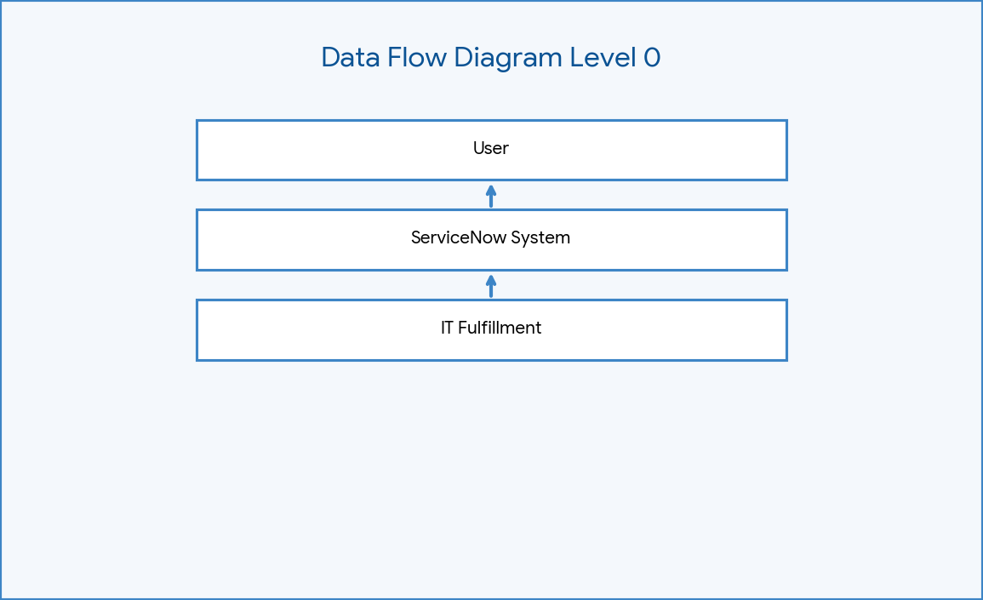

Figure: DFD Level 0

Data Flow Diagram Level 1
Details the specific table interactions: sc_req_item receives the submission, triggers sysapproval_approver, which cascades to sc_task.

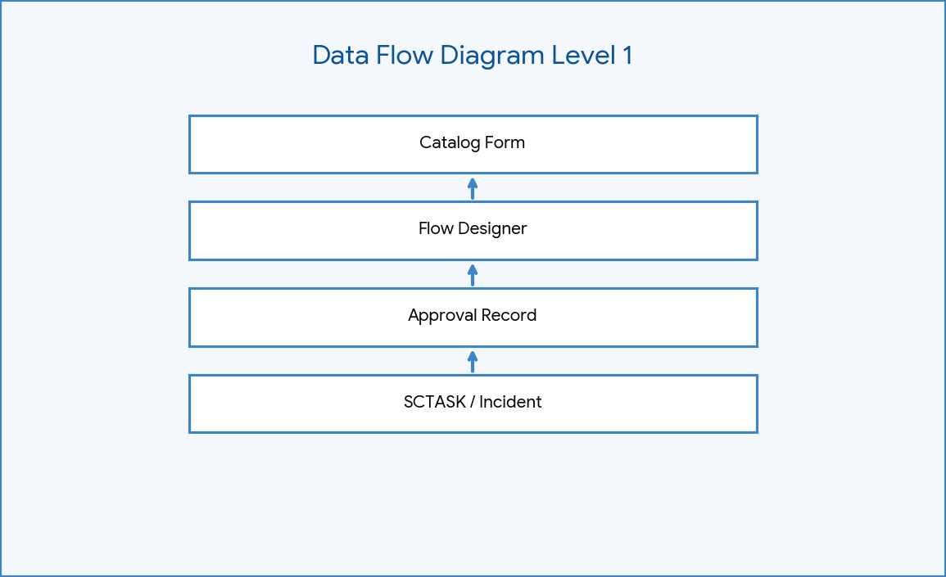

Figure: DFD Level 1

Use Case Diagram
Illustrates actors (User, Manager, IT Agent) and their specific interactions with the ServiceNow application.
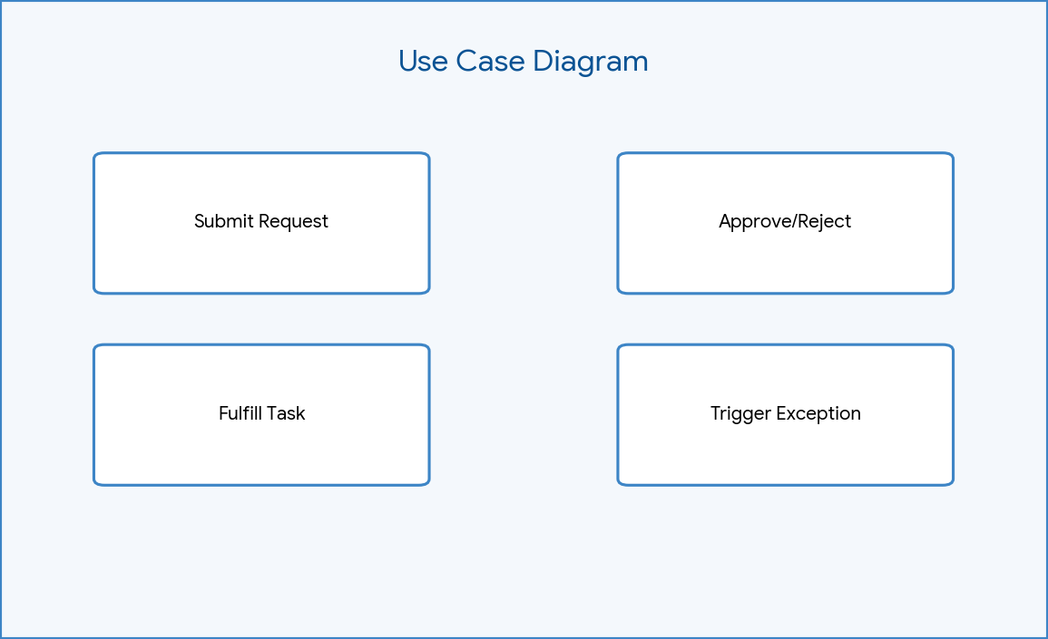

Figure: Use Case Diagram

User Story Mapping
Organizes stories by release priority. MVP includes the basic form and Flow Designer. V2 includes the Business Rule exception handling.
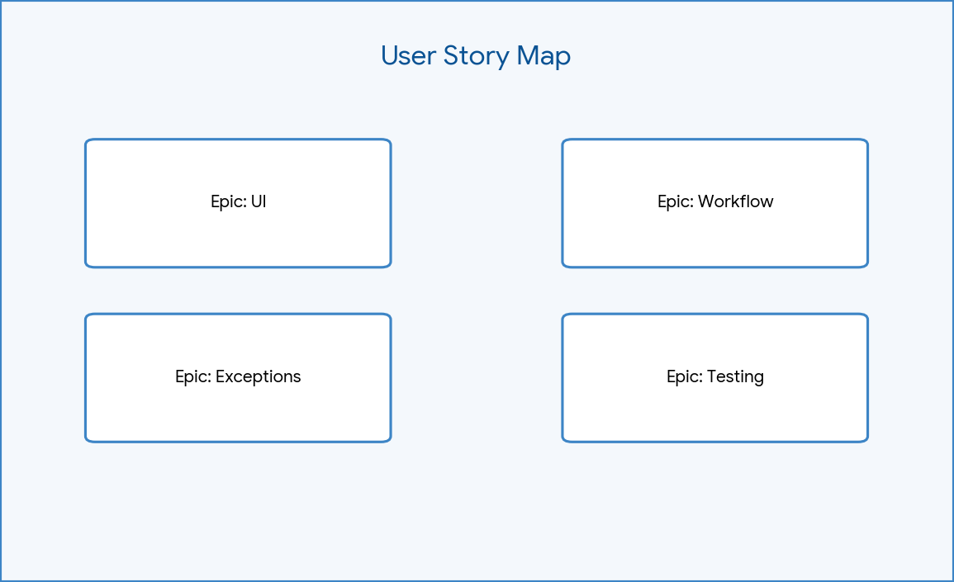

Figure: User Story Map

Acceptance Criteria
The system must generate a REQ, a linked RITM, pause for Approval, generate an SCTASK upon approval, and close the RITM when the task is closed.

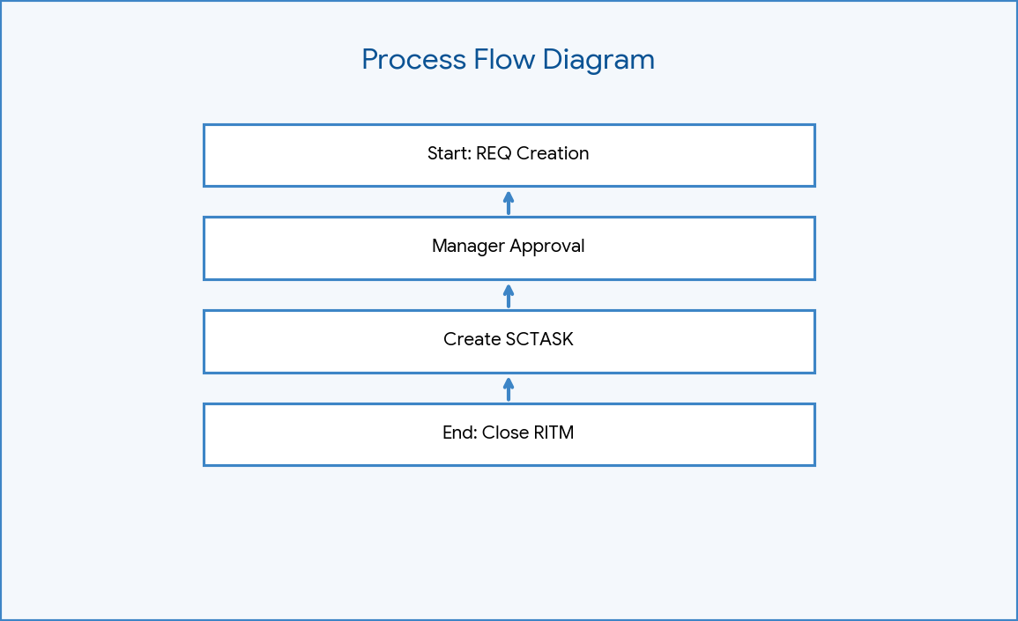

Figure: Process Flow Diagram

Release Planning
Release 1.0 will deploy the Scoped Application containing the Catalog Item, Variables, and the primary Flow Designer logic.

Phase Summary
Phase 2 established the structural blueprint. The variables (software_name, version_required, license_justification, urgency) and logic flow are now ready for technical implementation.
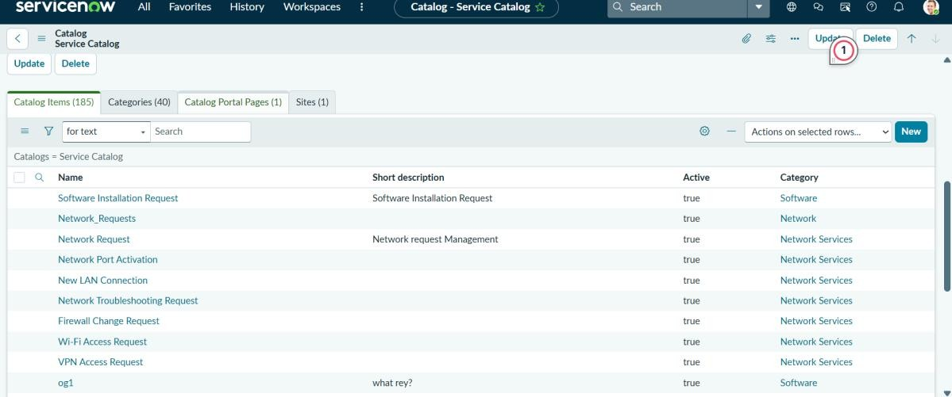

Figure: Catalog Item

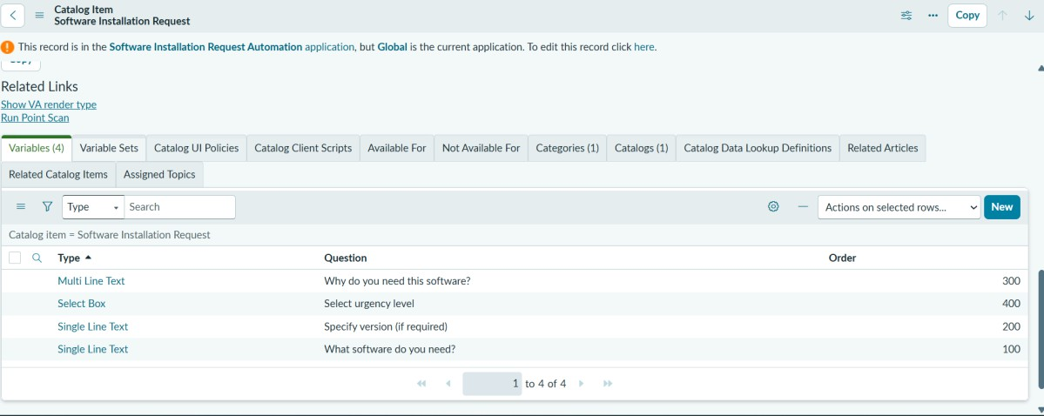

Figure: Variables
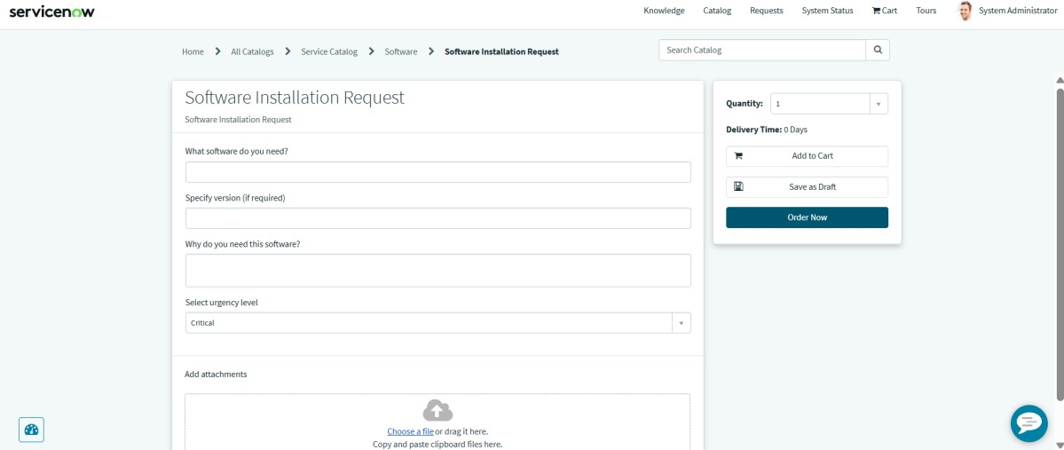
Figure: Service Portal Form

