Phase 3

Technical Architecture & Validation Fit

Date | 27.06.2026
Team ID | NIL
Project Name | An employee requests installation of licensed software through the Service Catalog
Maximum Marks | 4

Solution Architecture Introduction
This phase details the technical realization of the project in ServiceNow Studio. It covers the creation of the scoped application, the Flow Designer implementation, and the Server-Side JavaScript Business Rule.

Problem–Solution Fit
The solution directly fits the problem by standardizing data intake (Catalog Item variables) and eliminating manual routing (Flow Designer).
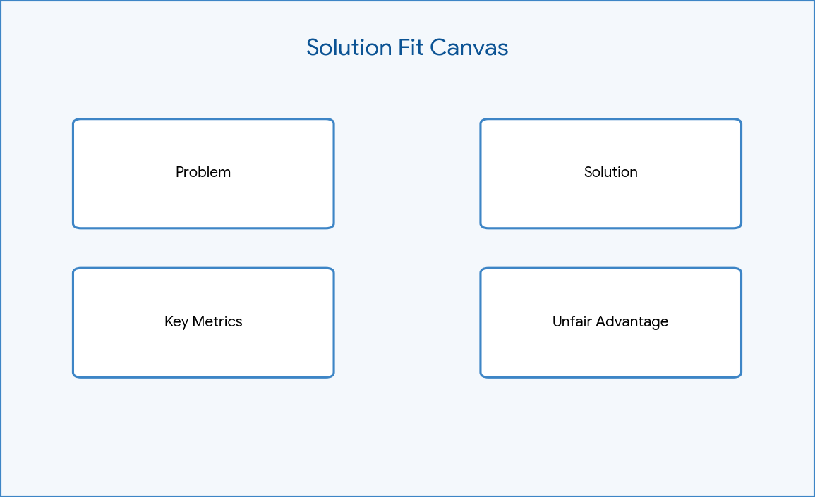

Figure: Solution Fit Canvas

Customer Segment
Internal corporate employees, line managers, and the IT 'Software Support' fulfillment team.

Jobs to be Done
1. Capture structured software requests. 2. Enforce managerial approval. 3. Dispatch installation tasks. 4. Monitor license availability.

Constraints
Must operate within a scoped application to prevent global namespace pollution. Must utilize out-of-the-box (OOTB) tables (REQ/RITM/SCTASK).

Proposed Solution
A ServiceNow Service Catalog item connected to a Flow Designer workflow, supplemented by an advanced Business Rule for exception handling.

Novelty
Pivoting from Legacy Workflow Editor to the modern Flow Designer ensures long-term platform support and easier maintainability.

Social Impact
Reduces IT friction, lowering workplace stress and improving employee satisfaction.

Business Model
Internal IT Service Management optimization; reduces operational expenditure (OpEx) by saving IT helpdesk hours.

Technology Stack
ServiceNow Platform, Flow Designer, Server-Side JavaScript (ES5 - Rhino engine), GlideRecord API.
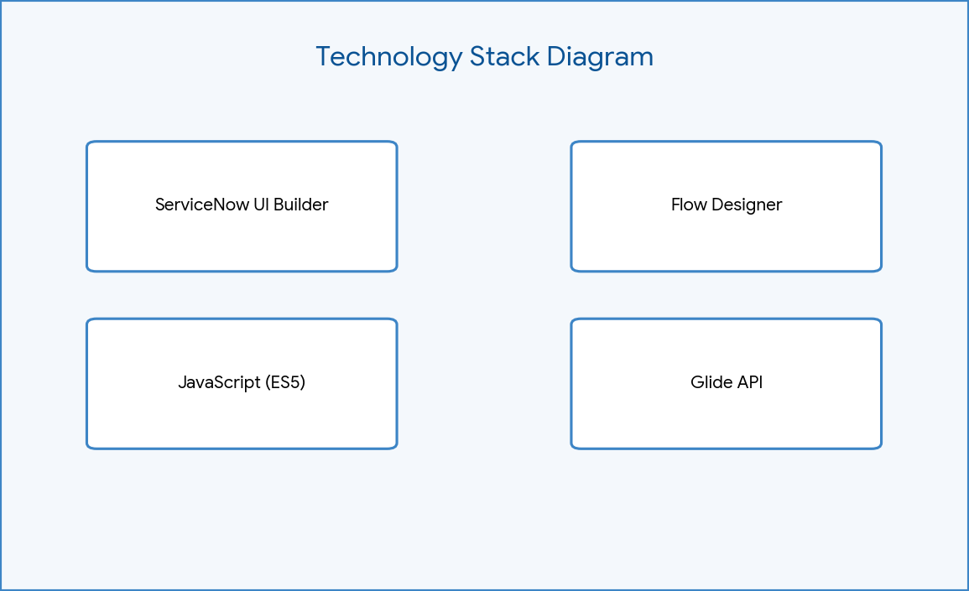

Figure: Technology Stack Diagram

Technical Architecture
Built entirely within the `Software Installation Request Automation` scoped app. Utilizes the Request Management architecture (sc_request -> sc_req_item -> sc_task).
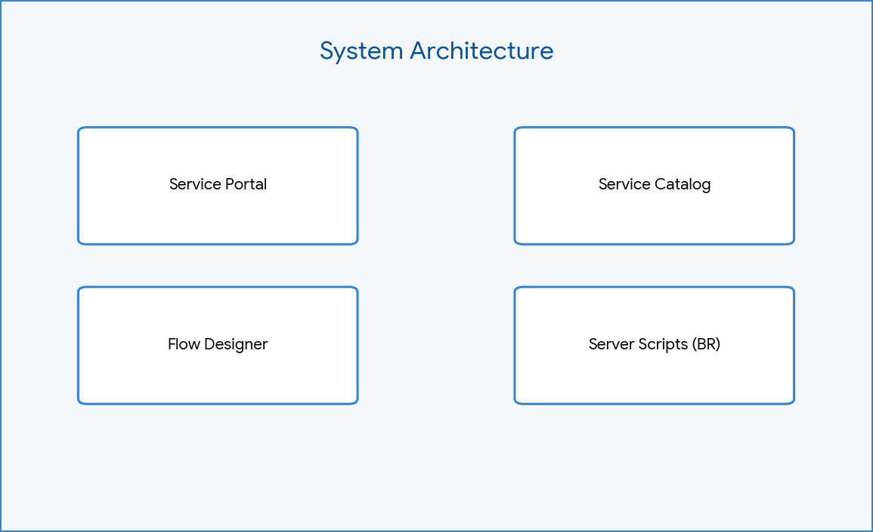

Figure: System Architecture

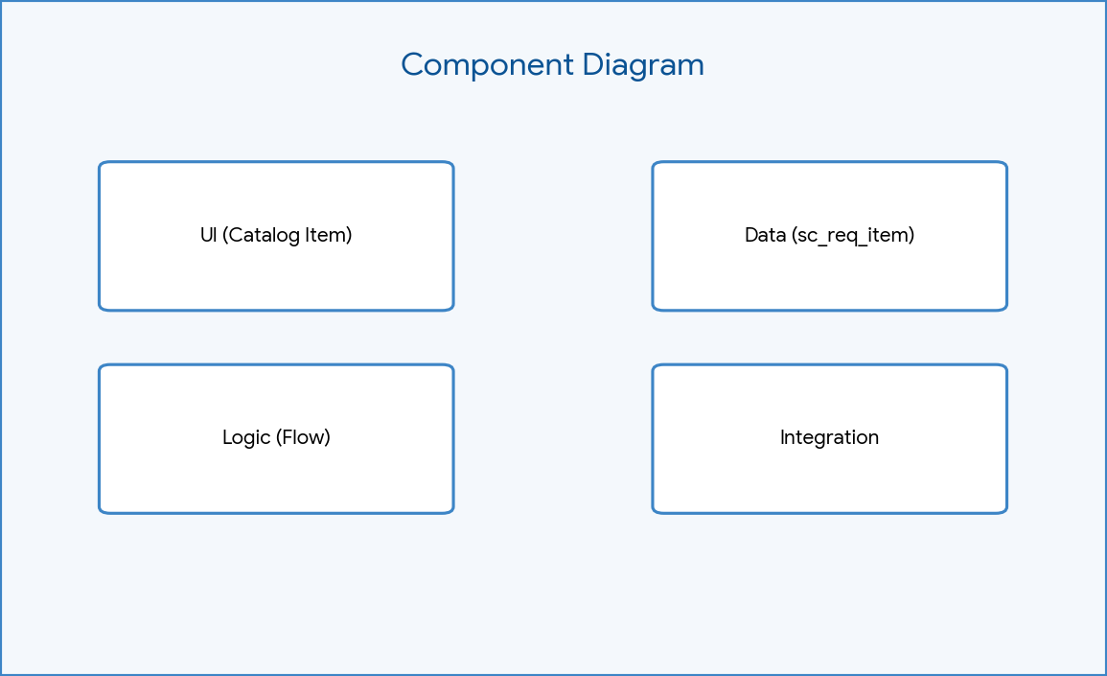

Figure: Component Diagram
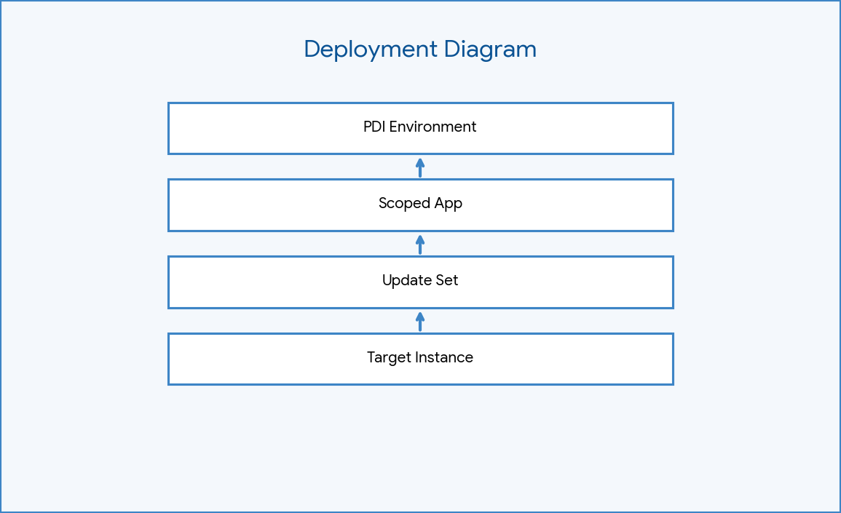

Figure: Deployment Diagram

Flow Designer Architecture
Trigger: Service Catalog. Action 1: Get Catalog Variables. Action 2: Ask for Approval (Software Support). Logic: If Approved -> Create Catalog Task (Wait for completion). Else -> Update Record (State = Closed Incomplete).
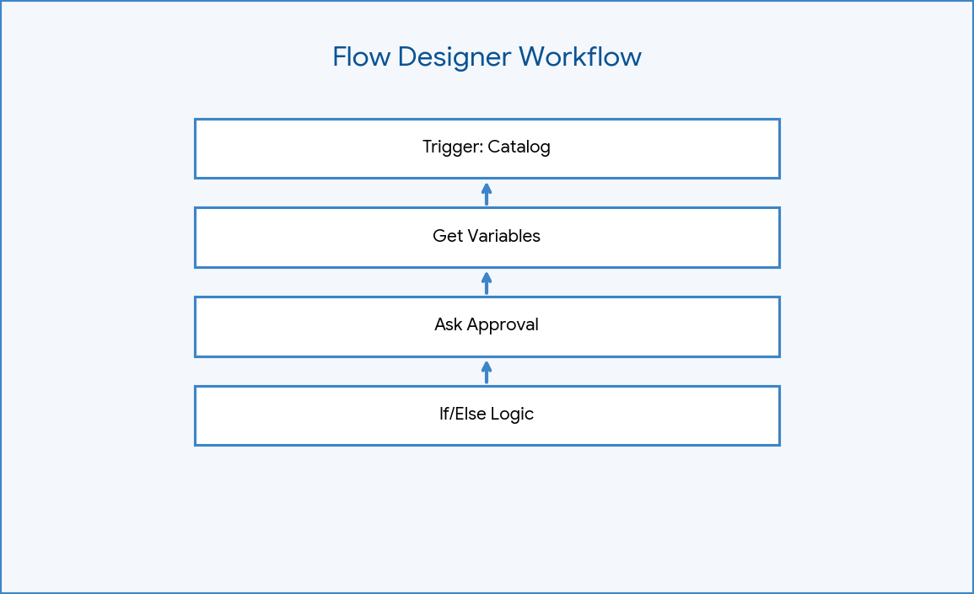

Figure: Flow Designer Workflow

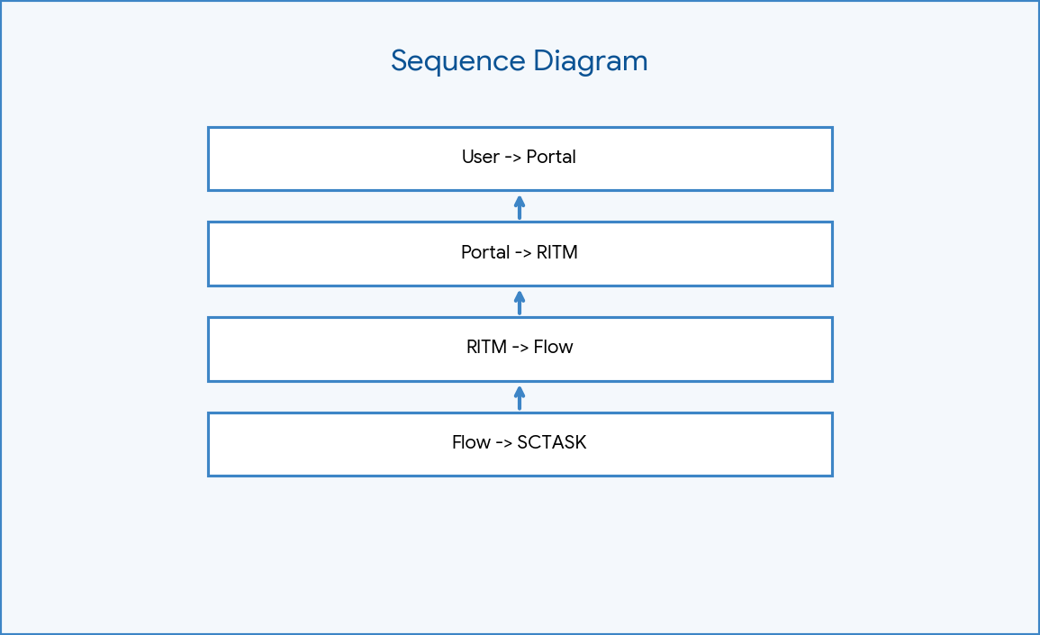

Figure: Sequence Diagram

Business Rule Logic
Advanced Business Rule on `sc_req_item`. When to run: After Update, Condition: State changes to 'Pending'. Script executes a GlideRecord insert on the `incident` table to report a license shortage.
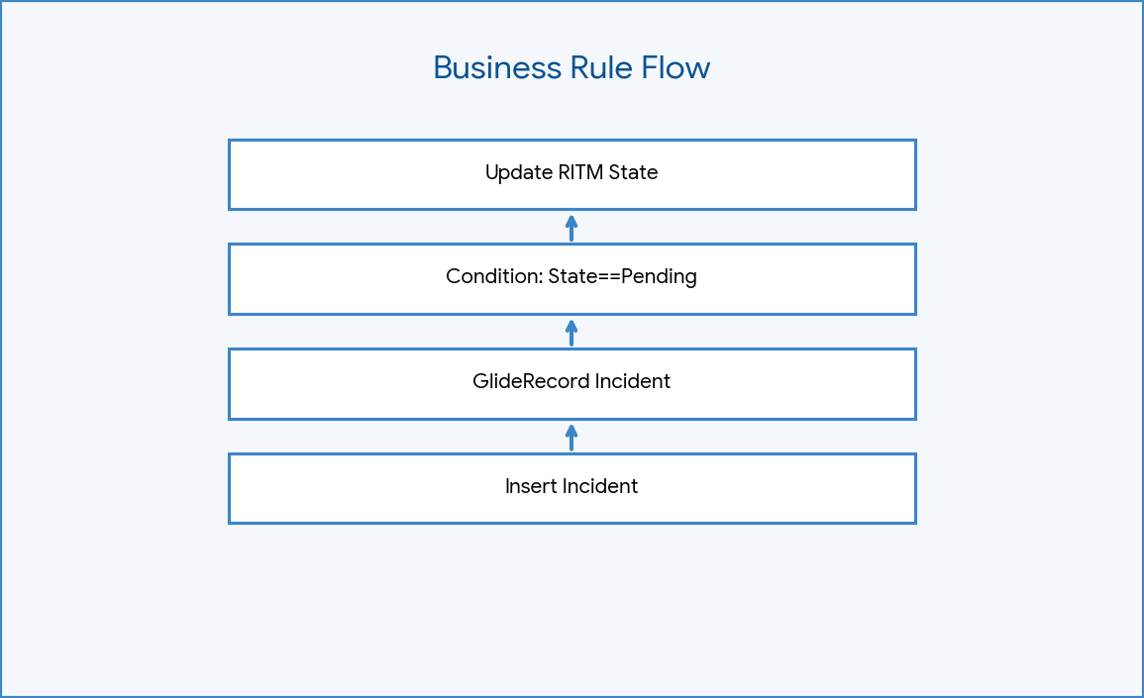

Figure: Business Rule Flow

Data Flow
Variables flow from the Portal to the RITM. Flow Designer extracts these variables and maps them to the generated SCTASK for the IT agent.

Security
Roles restrict who can approve tasks. The scoped application encapsulates logic securely. Variables are sanitized by the ServiceNow platform.

Scalability
Using Flow Designer allows seamless scaling. Additional approvals (e.g., Director level for high-cost software) can be added as sequential steps without coding.

Performance
Using an 'After' Business Rule ensures the database transaction completes quickly before the incident logic runs, preserving user-facing UI performance.

Phase Summary
Phase 3 successfully defined the core technical engine. The system leverages modern Flow Designer for standard operations and robust JavaScript for edge-case license issues.

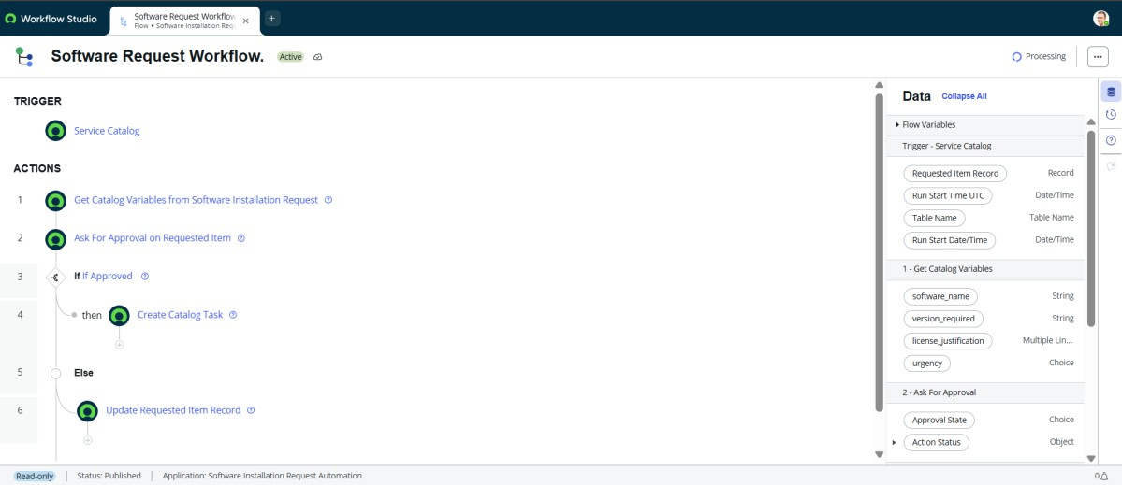

Figure: Flow Designer

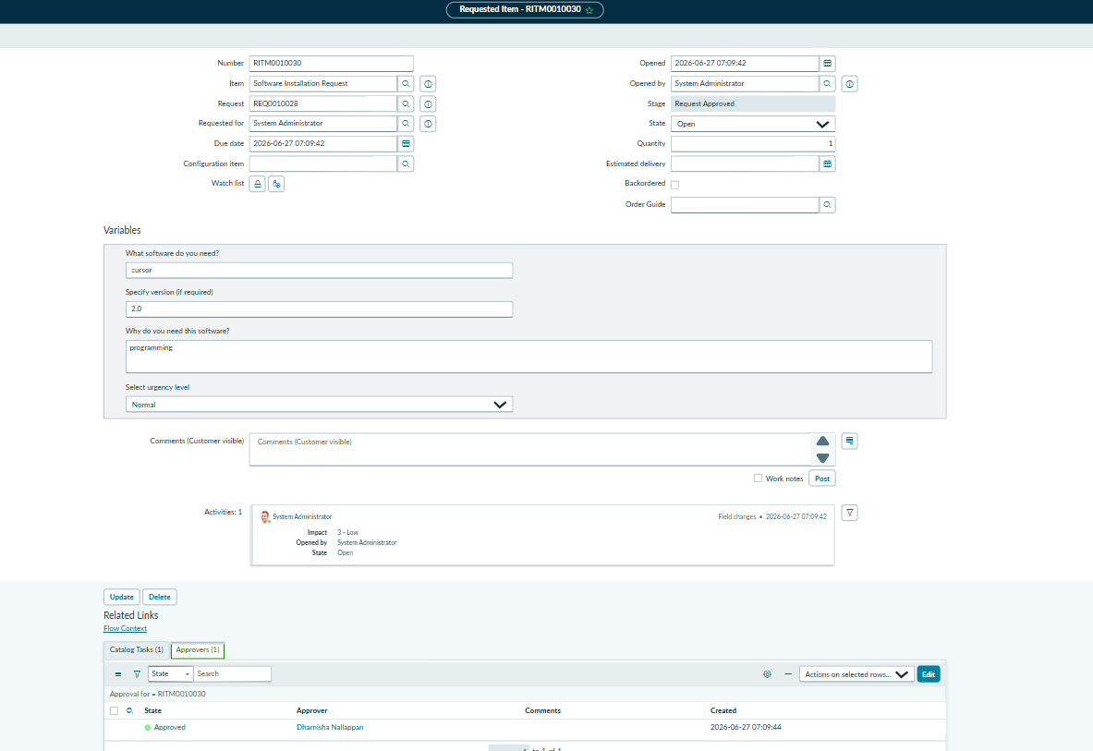

Figure: Approval Action
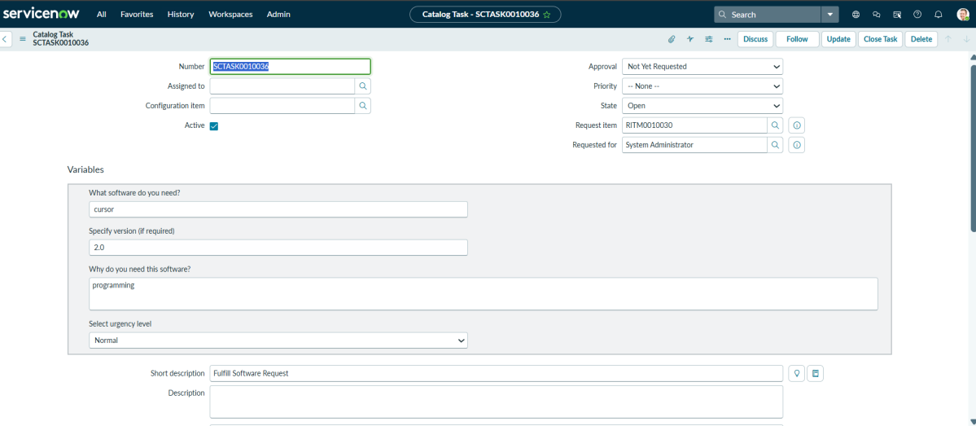

Figure: Catalog Task

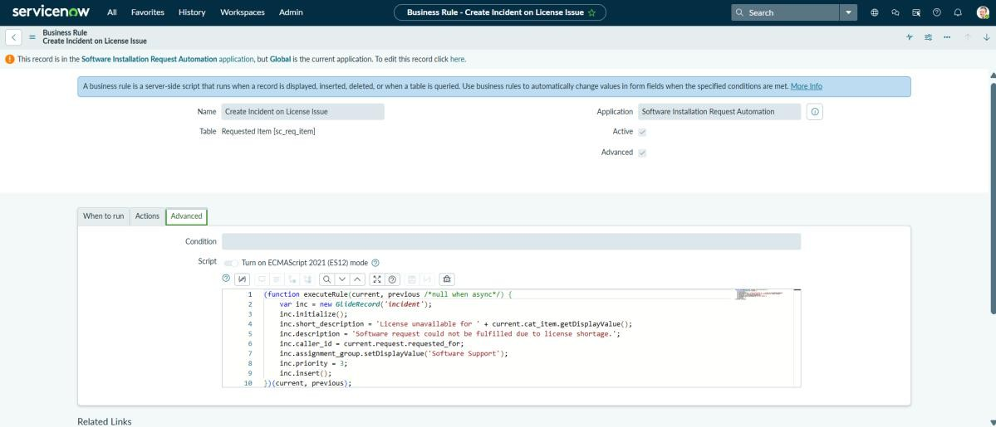

Figure: Business Rule
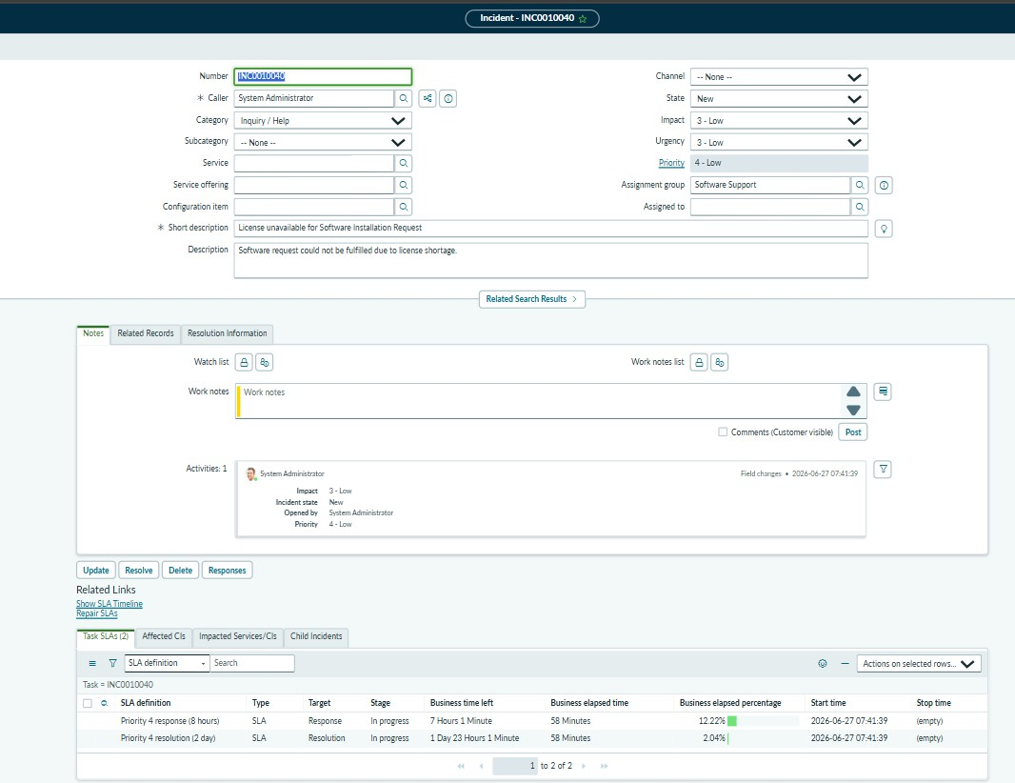
Figure: Incident Creation

