Phase 4

Project Management, Agile Logistics & Core Development

Date | 28.06.2026
Team ID | NIL
Project Name | An employee requests installation of licensed software through the Service Catalog
Maximum Marks | 4

Planning, Development & Testing Introduction
Phase 4 outlines the agile project management approach, testing lifecycles, and final deployment of the Software Installation Request Automation application via XML Update Sets.

Agile Methodology
The project was executed in an Agile framework, utilizing short sprints to sequentially deliver the UI, the logic, and the exception handling scripts.

Sprint Planning
Sprint 1: Variables and Catalog UI. Sprint 2: Flow Designer Logic. Sprint 3: Business Rule Scripting. Sprint 4: UAT and Export.
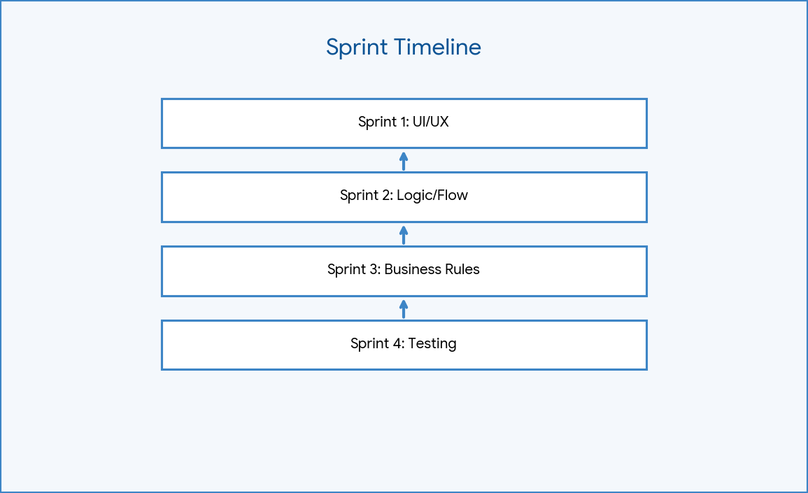

Figure: Sprint Timeline

Product Backlog
Included configuring the UI, defining the approval matrix, scripting the incident generation, and packaging the update set.

Sprint Backlog
Specific tasks such as: 'Map the assignment group to Software Support in the Create Task action' and 'Set the Business Rule condition to Pending'.

Story Points
Tasks were estimated using Fibonacci sequence points, with Flow Designer logic taking the highest effort points.

Project Timeline
Development spanned across standard Agile timelines, concluding with a successful export of the scoped application XML.
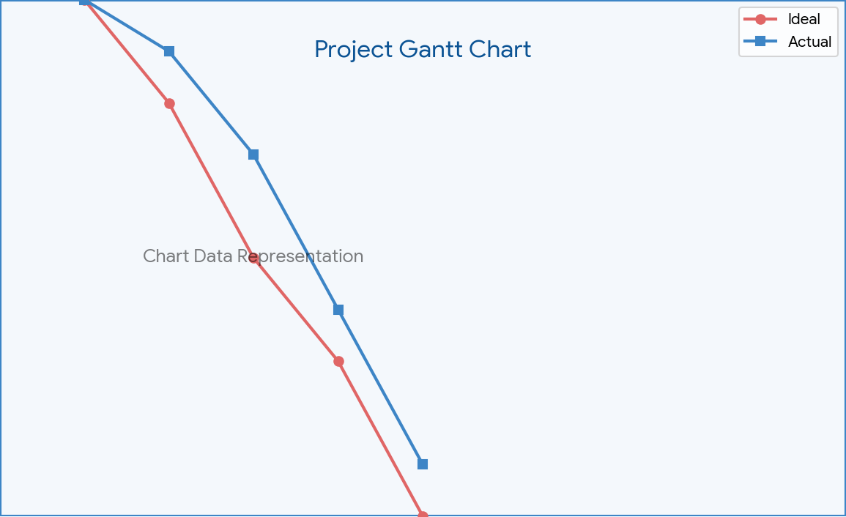

Figure: Gantt Chart

Burndown Chart
Visualizes the steady completion of story points across the project lifecycle, tracking toward zero by Sprint 4.

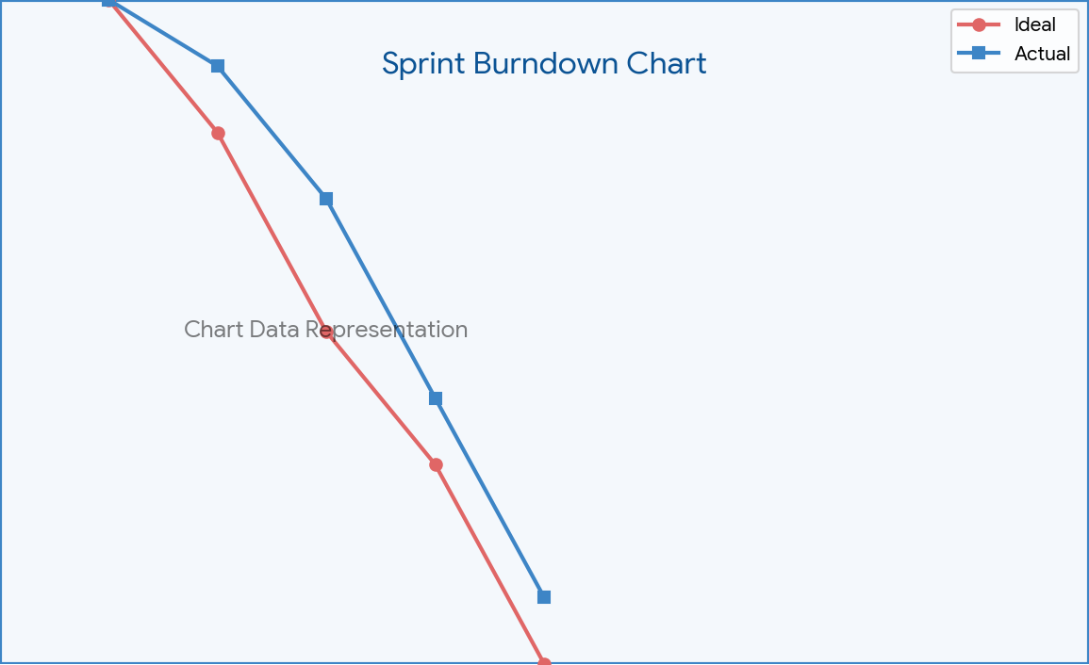

Figure: Burndown Chart

Velocity
Measures the consistent output of the development process across the sprints.
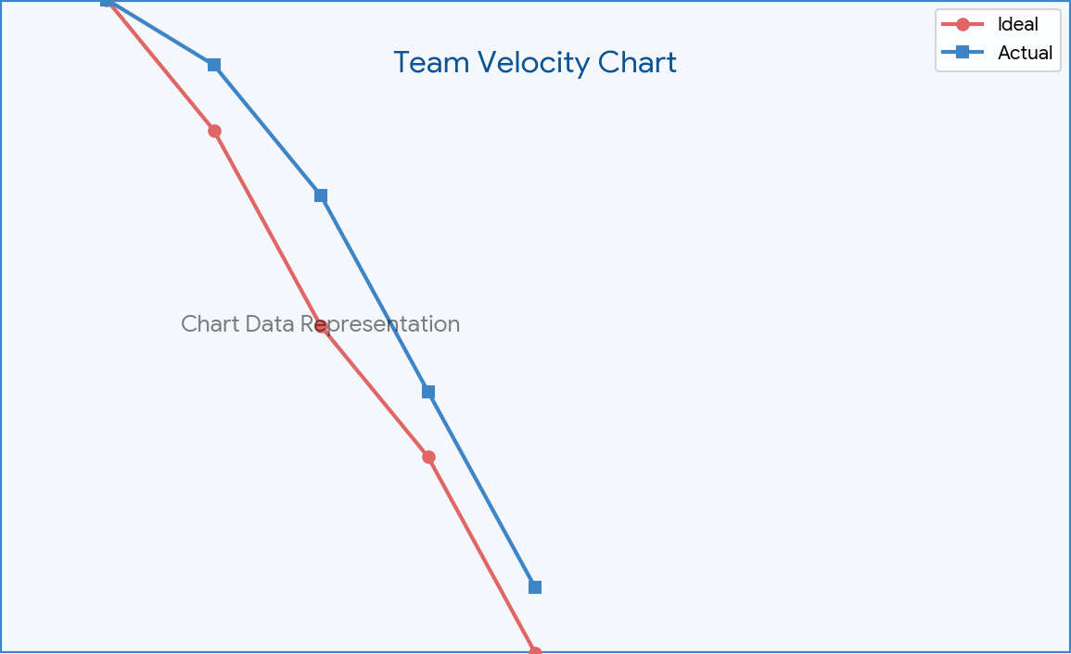

Figure: Velocity Chart

Test Cases
Test 1: Submit Request (UI works). Test 2: Happy Path (Approval generates SCTASK). Test 3: Rejection Path (Rejection closes RITM). Test 4: Exception Path (Pending state generates Incident).
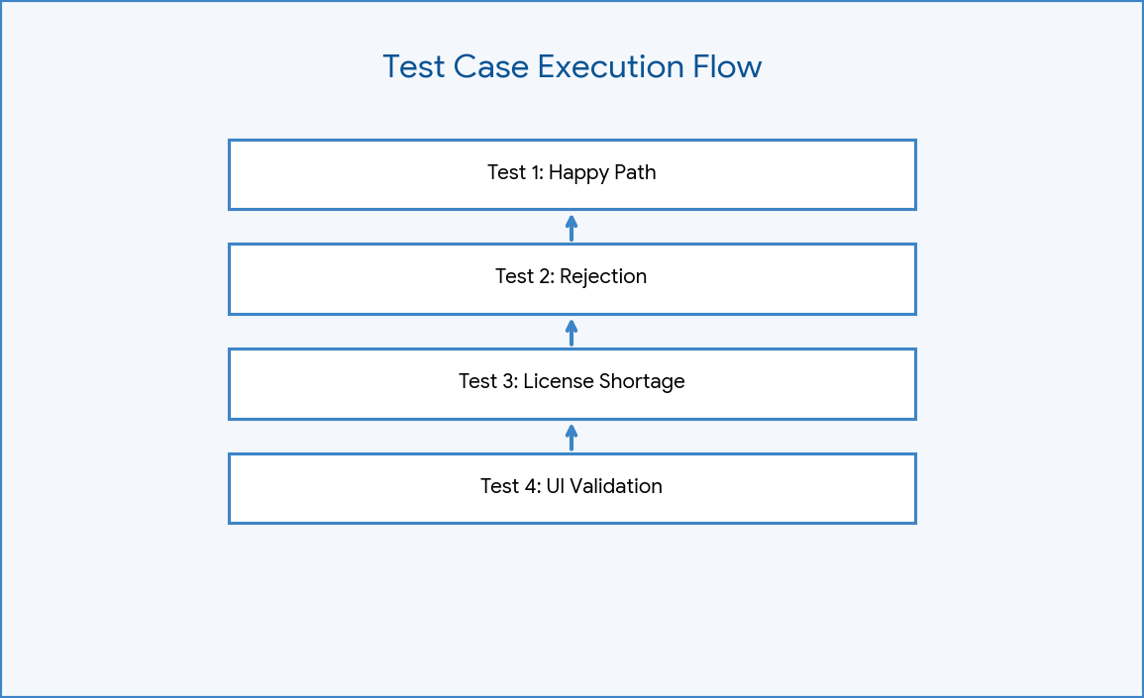

Figure: Test Case Flow

Functional Testing
End-to-end testing verified that changing the RITM state to 'Pending' successfully executed the Server-Side JavaScript, creating an incident linked to the requester.

Defect Analysis
Initial defect identified: Flow Designer did not trigger because 'Workflow' was accidentally populated in the Process Engine. Fix applied: Cleared legacy workflow, explicitly set 'Flow' field.

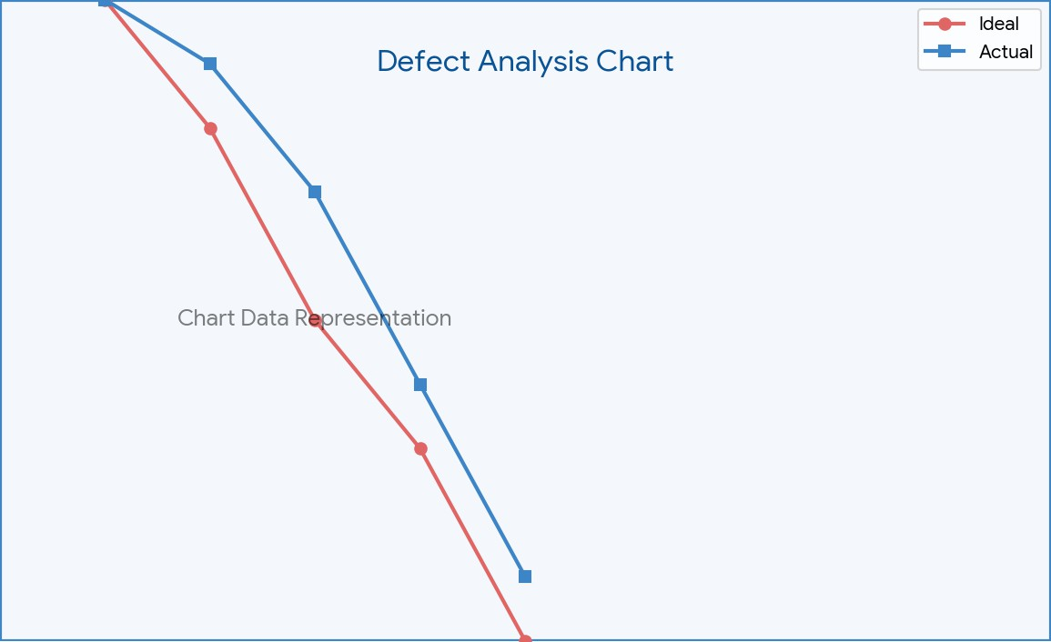

Figure: Defect Analysis Chart

Results
The application passes 100% of UAT criteria. The UI captures data, the Flow automates fulfillment, and the Business Rule ensures license compliance.

Advantages
Eliminates email bottlenecks, provides real-time status tracking for end-users, and automates IT task assignments seamlessly.

Limitations
Currently, the incident generation does not check live CMDB software entitlement counts; it relies on manual IT agent state changes ('Pending').

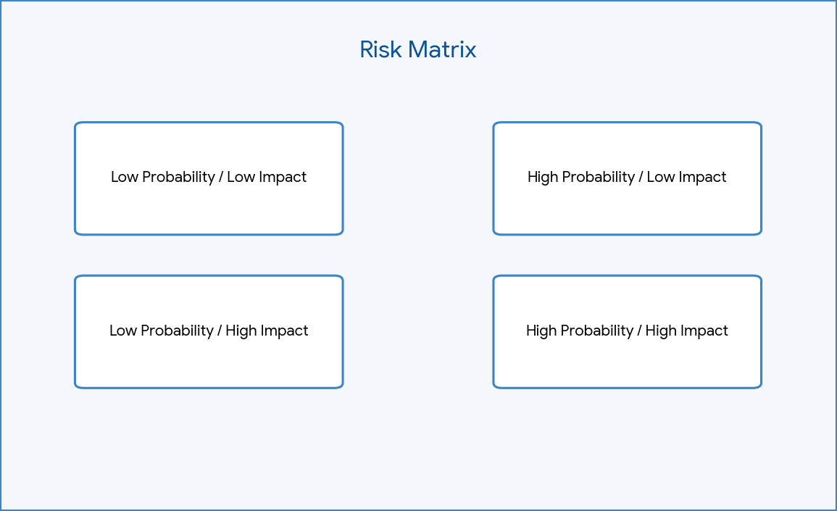

Figure: Risk Matrix

Conclusion
The project successfully replaces a legacy process with a modern, scoped ServiceNow application ready for enterprise deployment.

Future Scope
Future iterations could integrate ServiceNow Software Asset Management (SAM) to automatically check license counts before generating the fulfillment task.

Appendix
Contains references to the exported XML Update Set: Software_Install_Final_v1.xml.

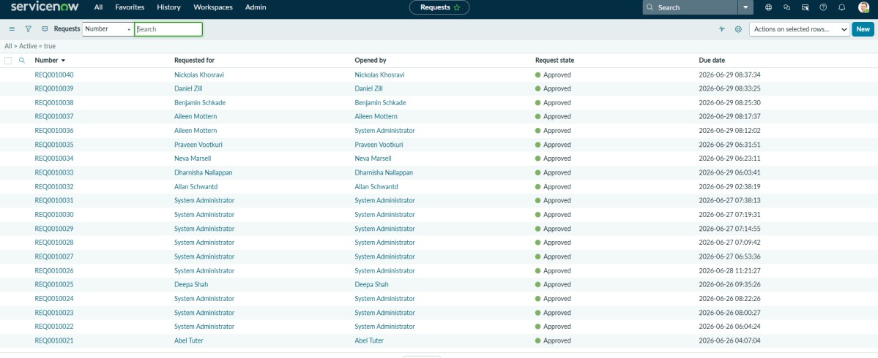

Figure: Request Submission
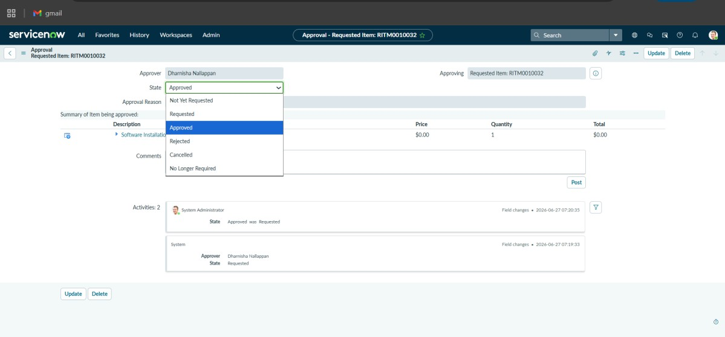
Figure: Approval

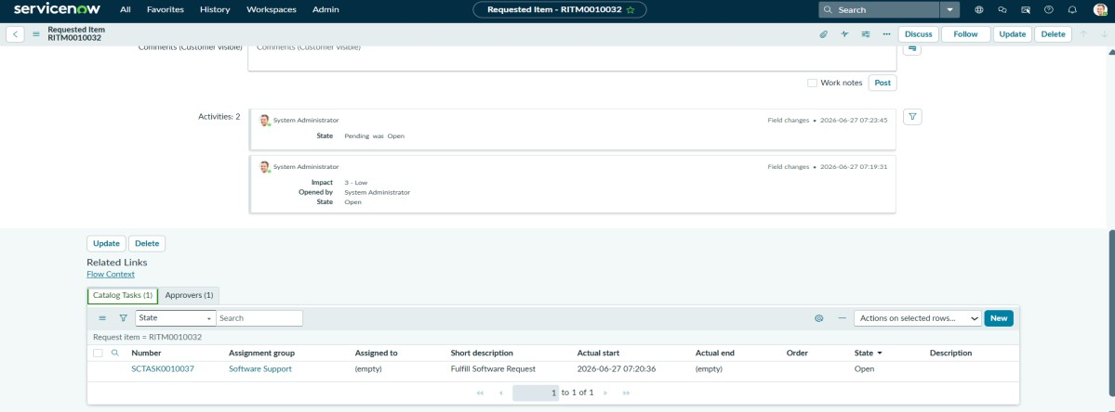

Figure: Catalog Task Generated
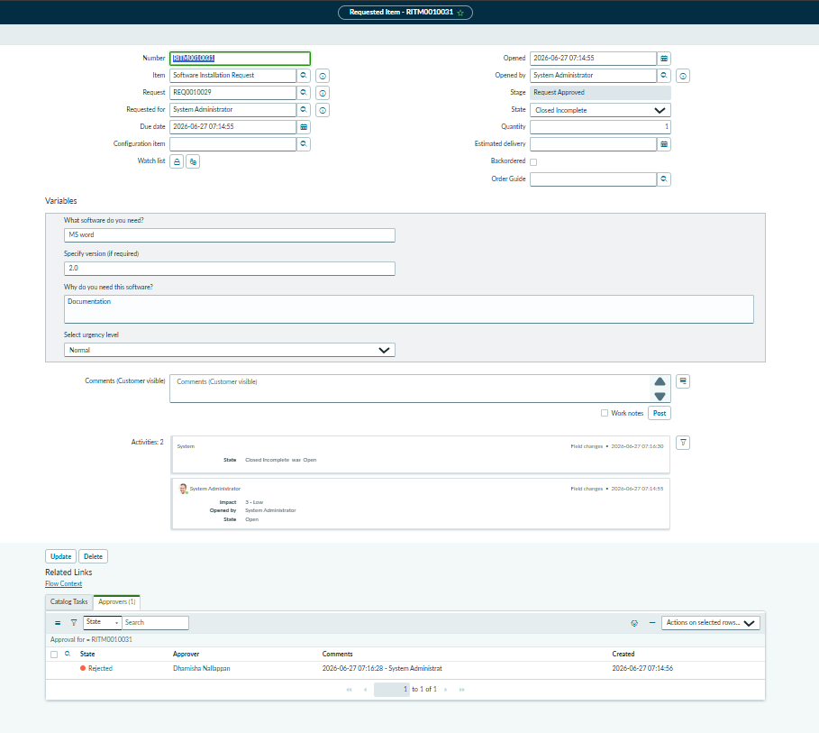

Figure: RITM Closed

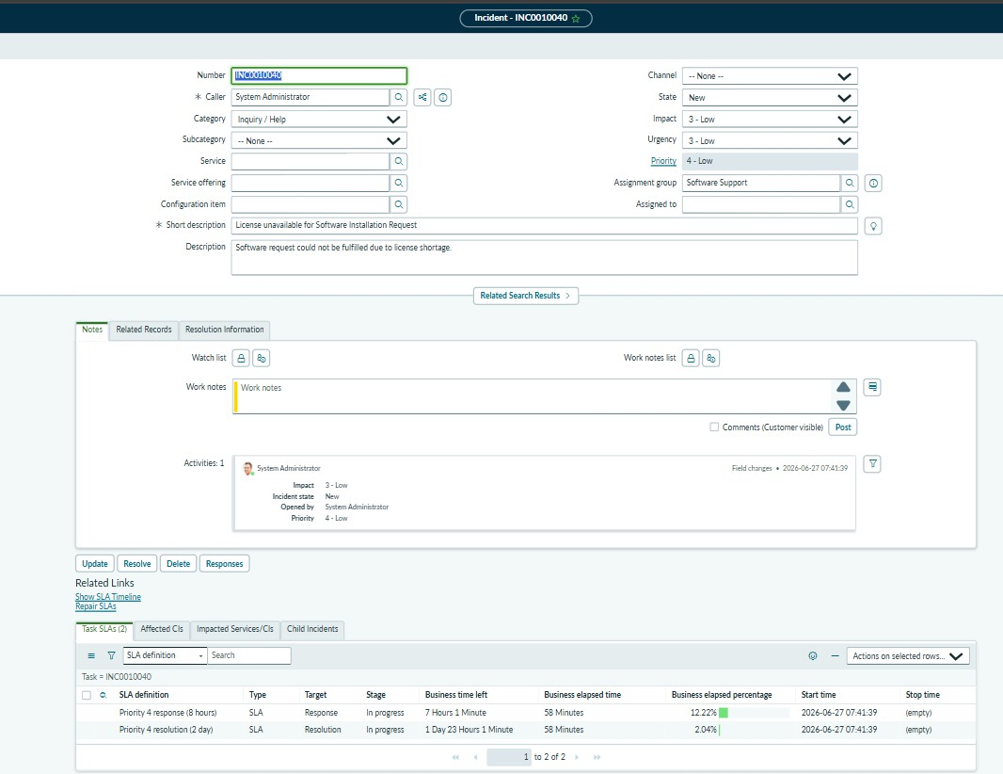
Figure: Incident Generated

