Collaborative_Group_Project.R

narah

2019-05-19

car_info <- read.csv(url("http://mlr.cs.umass.edu/ml/machine-learning-databases/auto-mpg/auto-mpg.names"), header=FALSE)  
car_Info_dataset = read.csv(url("http://mlr.cs.umass.edu/ml/machine-learning-databases/autos/imports-85.data"), header=FALSE)  
  
#str(car_Info_dataset)  
##Filter(function(car_Info_dataset) !any(car_Info_dataset=="?"), df)  
##elect(df, -contains("PERMISSIONS"))  
#install.packages("dbplyr")  
library(party)

## Loading required package: grid

## Loading required package: mvtnorm

## Loading required package: modeltools

## Loading required package: stats4

## Loading required package: strucchange

## Loading required package: zoo

##   
## Attaching package: 'zoo'

## The following objects are masked from 'package:base':  
##   
## as.Date, as.Date.numeric

## Loading required package: sandwich

library(dbplyr)  
library(dplyr)

##   
## Attaching package: 'dplyr'

## The following objects are masked from 'package:dbplyr':  
##   
## ident, sql

## The following objects are masked from 'package:stats':  
##   
## filter, lag

## The following objects are masked from 'package:base':  
##   
## intersect, setdiff, setequal, union

car_Info_dataset_scrubbed = select(car_Info_dataset, -contains("?"))  
  
#View(car_Info_dataset_scrubbed)  
car_Info_dataset_scrubbed = na.omit(car_Info_dataset_scrubbed)  
plot(car_Info_dataset_scrubbed$V1, car_Info_dataset_scrubbed$V2)# + car_Info_dataset_scrubbed$V3 + car_Info_dataset_scrubbed$V4 + car_Info_dataset_scrubbed$V5 + car_Info_dataset_scrubbed$V6 + car_Info_dataset_scrubbed$V7)  
#meanCarMPG = mean(car_Info_dataset_scrubbed$V1 , na.rm=T)  
  
#Cabline(h=meanCarMPG)  
  
model_car_Info_dataset = lm(car_Info_dataset_scrubbed$V1 ~ car_Info_dataset_scrubbed$V2 + car_Info_dataset_scrubbed$V3 + car_Info_dataset_scrubbed$V4 + car_Info_dataset_scrubbed$V5 + car_Info_dataset_scrubbed$V6 + car_Info_dataset_scrubbed$V7)  
summary(model_car_Info_dataset)

##   
## Call:  
## lm(formula = car_Info_dataset_scrubbed$V1 ~ car_Info_dataset_scrubbed$V2 +   
## car_Info_dataset_scrubbed$V3 + car_Info_dataset_scrubbed$V4 +   
## car_Info_dataset_scrubbed$V5 + car_Info_dataset_scrubbed$V6 +   
## car_Info_dataset_scrubbed$V7)  
##   
## Residuals:  
## Min 1Q Median 3Q Max   
## -1.51775 -0.06648 0.00000 0.11599 1.28351   
##   
## Coefficients:  
## Estimate Std. Error t value  
## (Intercept) 1.44785 0.57539 2.516  
## car_Info_dataset_scrubbed$V2101 -1.71806 0.48936 -3.511  
## car_Info_dataset_scrubbed$V2102 -1.95466 0.73304 -2.666  
## car_Info_dataset_scrubbed$V2103 -0.78592 0.40967 -1.918  
## car_Info_dataset_scrubbed$V2104 0.13587 0.46335 0.293  
## car_Info_dataset_scrubbed$V2106 -2.23546 0.40716 -5.490  
## car_Info_dataset_scrubbed$V2107 -1.65706 0.65189 -2.542  
## car_Info_dataset_scrubbed$V2108 -1.55718 0.48977 -3.179  
## car_Info_dataset_scrubbed$V2110 -1.52033 0.52901 -2.874  
## car_Info_dataset_scrubbed$V2113 0.66249 0.51347 1.290  
## car_Info_dataset_scrubbed$V2115 -0.35784 0.47474 -0.754  
## car_Info_dataset_scrubbed$V2118 -0.70674 0.45465 -1.554  
## car_Info_dataset_scrubbed$V2119 -0.69645 0.52364 -1.330  
## car_Info_dataset_scrubbed$V2121 0.82449 0.92740 0.889  
## car_Info_dataset_scrubbed$V2122 -0.14488 0.36751 -0.394  
## car_Info_dataset_scrubbed$V2125 -0.35320 0.40202 -0.879  
## car_Info_dataset_scrubbed$V2128 -1.73762 0.45483 -3.820  
## car_Info_dataset_scrubbed$V2129 -0.41926 0.53476 -0.784  
## car_Info_dataset_scrubbed$V2134 0.10073 0.45642 0.221  
## car_Info_dataset_scrubbed$V2137 -1.25866 0.42010 -2.996  
## car_Info_dataset_scrubbed$V2142 1.31469 0.62502 2.103  
## car_Info_dataset_scrubbed$V2145 0.89023 0.46359 1.920  
## car_Info_dataset_scrubbed$V2148 0.27991 0.54463 0.514  
## car_Info_dataset_scrubbed$V2150 1.16439 0.47919 2.430  
## car_Info_dataset_scrubbed$V2153 0.55837 0.40710 1.372  
## car_Info_dataset_scrubbed$V2154 0.38500 0.50147 0.768  
## car_Info_dataset_scrubbed$V2158 0.58403 0.45821 1.275  
## car_Info_dataset_scrubbed$V2161 -0.54816 0.25579 -2.143  
## car_Info_dataset_scrubbed$V2164 1.60407 0.46014 3.486  
## car_Info_dataset_scrubbed$V2168 -0.62489 0.42279 -1.478  
## car_Info_dataset_scrubbed$V2186 0.98538 0.56109 1.756  
## car_Info_dataset_scrubbed$V2188 -0.50519 0.41756 -1.210  
## car_Info_dataset_scrubbed$V2192 0.49481 0.41756 1.185  
## car_Info_dataset_scrubbed$V2194 0.17586 0.51780 0.340  
## car_Info_dataset_scrubbed$V2197 1.49413 0.51205 2.918  
## car_Info_dataset_scrubbed$V2231 -1.80411 0.62339 -2.894  
## car_Info_dataset_scrubbed$V2256 1.33503 0.55282 2.415  
## car_Info_dataset_scrubbed$V265 -1.44191 0.42188 -3.418  
## car_Info_dataset_scrubbed$V274 0.01921 0.40791 0.047  
## car_Info_dataset_scrubbed$V277 -0.09376 0.61223 -0.153  
## car_Info_dataset_scrubbed$V278 -1.30595 0.66510 -1.964  
## car_Info_dataset_scrubbed$V281 -0.09376 0.61223 -0.153  
## car_Info_dataset_scrubbed$V283 -1.02839 0.70942 -1.450  
## car_Info_dataset_scrubbed$V285 -1.63631 0.54375 -3.009  
## car_Info_dataset_scrubbed$V287 -0.50587 0.51205 -0.988  
## car_Info_dataset_scrubbed$V289 -1.61628 0.73265 -2.206  
## car_Info_dataset_scrubbed$V290 -1.42412 0.60634 -2.349  
## car_Info_dataset_scrubbed$V291 -0.38742 0.40215 -0.963  
## car_Info_dataset_scrubbed$V293 -0.50929 0.40897 -1.245  
## car_Info_dataset_scrubbed$V294 1.43802 0.33064 4.349  
## car_Info_dataset_scrubbed$V295 -0.04459 0.46785 -0.095  
## car_Info_dataset_scrubbed$V298 -0.17551 0.92740 -0.189  
## car_Info_dataset_scrubbed$V3audi -0.11981 0.44232 -0.271  
## car_Info_dataset_scrubbed$V3bmw -0.52092 0.43059 -1.210  
## car_Info_dataset_scrubbed$V3chevrolet -0.42198 0.85929 -0.491  
## car_Info_dataset_scrubbed$V3dodge 0.21897 0.55940 0.391  
## car_Info_dataset_scrubbed$V3honda 1.12058 0.52146 2.149  
## car_Info_dataset_scrubbed$V3isuzu -0.29136 0.42068 -0.693  
## car_Info_dataset_scrubbed$V3jaguar -1.15273 0.47163 -2.444  
## car_Info_dataset_scrubbed$V3mazda -0.17823 0.51999 -0.343  
## car_Info_dataset_scrubbed$V3mercedes-benz -1.01595 0.44657 -2.275  
## car_Info_dataset_scrubbed$V3mercury -0.63756 0.59937 -1.064  
## car_Info_dataset_scrubbed$V3mitsubishi 0.82411 0.41144 2.003  
## car_Info_dataset_scrubbed$V3nissan 1.20662 0.49255 2.450  
## car_Info_dataset_scrubbed$V3peugot -0.03539 0.43862 -0.081  
## car_Info_dataset_scrubbed$V3plymouth 0.07893 0.52259 0.151  
## car_Info_dataset_scrubbed$V3porsche 0.41713 0.39332 1.061  
## car_Info_dataset_scrubbed$V3renault 0.10857 0.48390 0.224  
## car_Info_dataset_scrubbed$V3saab 0.77990 0.60435 1.290  
## car_Info_dataset_scrubbed$V3subaru 1.43090 0.72908 1.963  
## car_Info_dataset_scrubbed$V3toyota -0.09162 0.50238 -0.182  
## car_Info_dataset_scrubbed$V3volkswagen 0.06748 0.39107 0.173  
## car_Info_dataset_scrubbed$V3volvo -1.48056 0.54302 -2.727  
## car_Info_dataset_scrubbed$V4gas 0.07313 0.16819 0.435  
## car_Info_dataset_scrubbed$V5turbo 0.04007 0.12844 0.312  
## car_Info_dataset_scrubbed$V6four 0.15953 0.42150 0.378  
## car_Info_dataset_scrubbed$V6two 1.18027 0.45842 2.575  
## car_Info_dataset_scrubbed$V7hardtop -0.68489 0.31781 -2.155  
## car_Info_dataset_scrubbed$V7hatchback -1.10377 0.29530 -3.738  
## car_Info_dataset_scrubbed$V7sedan -1.16477 0.31857 -3.656  
## car_Info_dataset_scrubbed$V7wagon -1.49514 0.34338 -4.354  
## Pr(>|t|)   
## (Intercept) 0.013136 *   
## car_Info_dataset_scrubbed$V2101 0.000624 ***  
## car_Info_dataset_scrubbed$V2102 0.008687 **   
## car_Info_dataset_scrubbed$V2103 0.057359 .   
## car_Info_dataset_scrubbed$V2104 0.769825   
## car_Info_dataset_scrubbed$V2106 2.17e-07 ***  
## car_Info_dataset_scrubbed$V2107 0.012256 *   
## car_Info_dataset_scrubbed$V2108 0.001864 **   
## car_Info_dataset_scrubbed$V2110 0.004772 **   
## car_Info_dataset_scrubbed$V2113 0.199378   
## car_Info_dataset_scrubbed$V2115 0.452412   
## car_Info_dataset_scrubbed$V2118 0.122627   
## car_Info_dataset_scrubbed$V2119 0.185949   
## car_Info_dataset_scrubbed$V2121 0.375707   
## car_Info_dataset_scrubbed$V2122 0.694101   
## car_Info_dataset_scrubbed$V2125 0.381338   
## car_Info_dataset_scrubbed$V2128 0.000210 ***  
## car_Info_dataset_scrubbed$V2129 0.434531   
## car_Info_dataset_scrubbed$V2134 0.825692   
## car_Info_dataset_scrubbed$V2137 0.003303 **   
## car_Info_dataset_scrubbed$V2142 0.037447 *   
## car_Info_dataset_scrubbed$V2145 0.057116 .   
## car_Info_dataset_scrubbed$V2148 0.608209   
## car_Info_dataset_scrubbed$V2150 0.016536 *   
## car_Info_dataset_scrubbed$V2153 0.172670   
## car_Info_dataset_scrubbed$V2154 0.444099   
## car_Info_dataset_scrubbed$V2158 0.204831   
## car_Info_dataset_scrubbed$V2161 0.034065 *   
## car_Info_dataset_scrubbed$V2164 0.000679 ***  
## car_Info_dataset_scrubbed$V2168 0.141937   
## car_Info_dataset_scrubbed$V2186 0.081526 .   
## car_Info_dataset_scrubbed$V2188 0.228633   
## car_Info_dataset_scrubbed$V2192 0.238275   
## car_Info_dataset_scrubbed$V2194 0.734710   
## car_Info_dataset_scrubbed$V2197 0.004185 **   
## car_Info_dataset_scrubbed$V2231 0.004495 **   
## car_Info_dataset_scrubbed$V2256 0.017196 *   
## car_Info_dataset_scrubbed$V265 0.000855 ***  
## car_Info_dataset_scrubbed$V274 0.962515   
## car_Info_dataset_scrubbed$V277 0.878535   
## car_Info_dataset_scrubbed$V278 0.051821 .   
## car_Info_dataset_scrubbed$V281 0.878535   
## car_Info_dataset_scrubbed$V283 0.149689   
## car_Info_dataset_scrubbed$V285 0.003172 **   
## car_Info_dataset_scrubbed$V287 0.325110   
## car_Info_dataset_scrubbed$V289 0.029222 *   
## car_Info_dataset_scrubbed$V290 0.020420 *   
## car_Info_dataset_scrubbed$V291 0.337235   
## car_Info_dataset_scrubbed$V293 0.215360   
## car_Info_dataset_scrubbed$V294 2.82e-05 ***  
## car_Info_dataset_scrubbed$V295 0.924216   
## car_Info_dataset_scrubbed$V298 0.850209   
## car_Info_dataset_scrubbed$V3audi 0.786952   
## car_Info_dataset_scrubbed$V3bmw 0.228657   
## car_Info_dataset_scrubbed$V3chevrolet 0.624238   
## car_Info_dataset_scrubbed$V3dodge 0.696151   
## car_Info_dataset_scrubbed$V3honda 0.033584 *   
## car_Info_dataset_scrubbed$V3isuzu 0.489860   
## car_Info_dataset_scrubbed$V3jaguar 0.015926 *   
## car_Info_dataset_scrubbed$V3mazda 0.732362   
## car_Info_dataset_scrubbed$V3mercedes-benz 0.024624 *   
## car_Info_dataset_scrubbed$V3mercury 0.289530   
## car_Info_dataset_scrubbed$V3mitsubishi 0.047362 *   
## car_Info_dataset_scrubbed$V3nissan 0.015693 *   
## car_Info_dataset_scrubbed$V3peugot 0.935820   
## car_Info_dataset_scrubbed$V3plymouth 0.880194   
## car_Info_dataset_scrubbed$V3porsche 0.290957   
## car_Info_dataset_scrubbed$V3renault 0.822846   
## car_Info_dataset_scrubbed$V3saab 0.199287   
## car_Info_dataset_scrubbed$V3subaru 0.051929 .   
## car_Info_dataset_scrubbed$V3toyota 0.855592   
## car_Info_dataset_scrubbed$V3volkswagen 0.863287   
## car_Info_dataset_scrubbed$V3volvo 0.007328 **   
## car_Info_dataset_scrubbed$V4gas 0.664451   
## car_Info_dataset_scrubbed$V5turbo 0.755604   
## car_Info_dataset_scrubbed$V6four 0.705722   
## car_Info_dataset_scrubbed$V6two 0.011208 *   
## car_Info_dataset_scrubbed$V7hardtop 0.033093 *   
## car_Info_dataset_scrubbed$V7hatchback 0.000282 ***  
## car_Info_dataset_scrubbed$V7sedan 0.000377 ***  
## car_Info_dataset_scrubbed$V7wagon 2.77e-05 ***  
## ---  
## Signif. codes: 0 '***' 0.001 '**' 0.01 '*' 0.05 '.' 0.1 ' ' 1  
##   
## Residual standard error: 0.4793 on 124 degrees of freedom  
## Multiple R-squared: 0.9099, Adjusted R-squared: 0.8518   
## F-statistic: 15.66 on 80 and 124 DF, p-value: < 2.2e-16

abline(model_car_Info_dataset,col = "red")

## Warning in abline(model_car_Info_dataset, col = "red"): only using the  
## first two of 81 regression coefficients

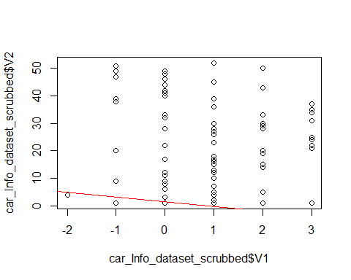

plot(model_car_Info_dataset)

## Warning: not plotting observations with leverage one:  
## 37, 43, 76, 107, 126, 154, 155, 181, 191

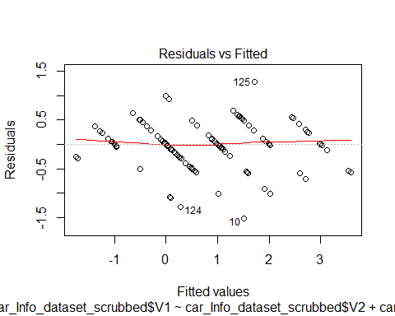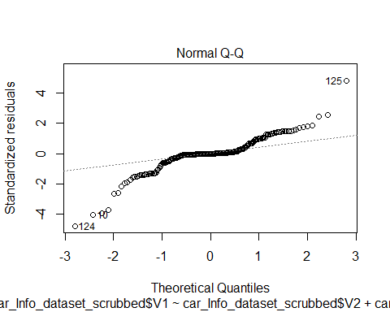

## Warning: not plotting observations with leverage one:  
## 37, 43, 76, 107, 126, 154, 155, 181, 191

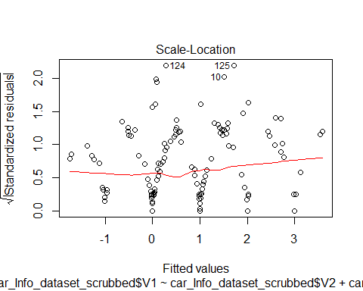

## Warning in sqrt(crit * p * (1 - hh)/hh): NaNs produced

## Warning in sqrt(crit * p * (1 - hh)/hh): NaNs produced

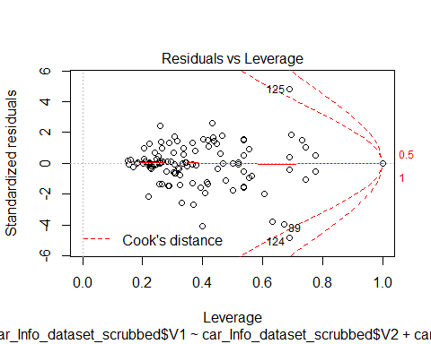

cis = car_Info_dataset_scrubbed  
plot(car_Info_dataset_scrubbed$V1,car_Info_dataset_scrubbed$V2)  
#meanCarMPG = mean(car_Info_dataset_scrubbed$V1)  
#meanCarMP  
#abline(h=meanCarMPG)  
model_car_Info_dataset_2 = lm(car_Info_dataset_scrubbed$V1 ~ car_Info_dataset_scrubbed$V2 + car_Info_dataset_scrubbed$V3)  
summary(model_car_Info_dataset_2)

##   
## Call:  
## lm(formula = car_Info_dataset_scrubbed$V1 ~ car_Info_dataset_scrubbed$V2 +   
## car_Info_dataset_scrubbed$V3)  
##   
## Residuals:  
## Min 1Q Median 3Q Max   
## -1.7347 0.0000 0.0000 0.1136 1.8393   
##   
## Coefficients:  
## Estimate Std. Error t value  
## (Intercept) 2.333e+00 3.483e-01 6.699  
## car_Info_dataset_scrubbed$V2101 -2.131e+00 6.006e-01 -3.548  
## car_Info_dataset_scrubbed$V2102 -3.131e+00 7.845e-01 -3.991  
## car_Info_dataset_scrubbed$V2103 -1.115e+00 5.056e-01 -2.206  
## car_Info_dataset_scrubbed$V2104 1.009e+00 4.921e-01 2.050  
## car_Info_dataset_scrubbed$V2106 -2.467e+00 4.916e-01 -5.019  
## car_Info_dataset_scrubbed$V2107 -2.131e+00 7.768e-01 -2.743  
## car_Info_dataset_scrubbed$V2108 -1.804e+00 5.995e-01 -3.008  
## car_Info_dataset_scrubbed$V2110 -3.038e+00 5.944e-01 -5.110  
## car_Info_dataset_scrubbed$V2113 7.424e-01 5.790e-01 1.282  
## car_Info_dataset_scrubbed$V2115 -2.576e-01 5.240e-01 -0.492  
## car_Info_dataset_scrubbed$V2118 -7.729e-01 5.357e-01 -1.443  
## car_Info_dataset_scrubbed$V2119 -2.653e-01 6.511e-01 -0.407  
## car_Info_dataset_scrubbed$V2121 1.581e+00 1.135e+00 1.393  
## car_Info_dataset_scrubbed$V2122 1.786e-02 4.160e-01 0.043  
## car_Info_dataset_scrubbed$V2125 -1.261e+00 4.415e-01 -2.857  
## car_Info_dataset_scrubbed$V2128 -9.702e-01 4.879e-01 -1.989  
## car_Info_dataset_scrubbed$V2129 7.424e-01 5.790e-01 1.282  
## car_Info_dataset_scrubbed$V2134 1.581e+00 5.064e-01 3.122  
## car_Info_dataset_scrubbed$V2137 -1.841e+00 4.995e-01 -3.686  
## car_Info_dataset_scrubbed$V2142 3.000e+00 6.966e-01 4.306  
## car_Info_dataset_scrubbed$V2145 6.332e-01 5.651e-01 1.121  
## car_Info_dataset_scrubbed$V2148 -9.446e-01 6.095e-01 -1.550  
## car_Info_dataset_scrubbed$V2150 2.542e+00 4.754e-01 5.348  
## car_Info_dataset_scrubbed$V2153 7.386e-01 5.055e-01 1.461  
## car_Info_dataset_scrubbed$V2154 -2.653e-01 6.027e-01 -0.440  
## car_Info_dataset_scrubbed$V2158 -8.742e-15 5.507e-01 0.000  
## car_Info_dataset_scrubbed$V2161 -3.125e-01 2.883e-01 -1.084  
## car_Info_dataset_scrubbed$V2164 1.000e+00 5.507e-01 1.816  
## car_Info_dataset_scrubbed$V2168 5.040e-01 4.827e-01 1.044  
## car_Info_dataset_scrubbed$V2186 5.000e-01 6.745e-01 0.741  
## car_Info_dataset_scrubbed$V2188 -2.500e-01 5.225e-01 -0.478  
## car_Info_dataset_scrubbed$V2192 7.500e-01 5.225e-01 1.435  
## car_Info_dataset_scrubbed$V2194 1.196e+00 5.995e-01 1.996  
## car_Info_dataset_scrubbed$V2197 2.581e+00 6.146e-01 4.199  
## car_Info_dataset_scrubbed$V2231 -8.036e-01 7.358e-01 -1.092  
## car_Info_dataset_scrubbed$V2256 1.839e+00 6.662e-01 2.761  
## car_Info_dataset_scrubbed$V265 -1.419e+00 5.182e-01 -2.738  
## car_Info_dataset_scrubbed$V274 -5.306e-01 4.898e-01 -1.083  
## car_Info_dataset_scrubbed$V277 -4.191e-01 7.481e-01 -0.560  
## car_Info_dataset_scrubbed$V278 -3.131e+00 7.768e-01 -4.031  
## car_Info_dataset_scrubbed$V281 -4.191e-01 7.481e-01 -0.560  
## car_Info_dataset_scrubbed$V283 -1.131e+00 8.149e-01 -1.388  
## car_Info_dataset_scrubbed$V285 -3.131e+00 6.006e-01 -5.213  
## car_Info_dataset_scrubbed$V287 5.809e-01 6.146e-01 0.945  
## car_Info_dataset_scrubbed$V289 -3.131e+00 8.513e-01 -3.678  
## car_Info_dataset_scrubbed$V290 -1.419e+00 7.481e-01 -1.897  
## car_Info_dataset_scrubbed$V291 -4.191e-01 4.912e-01 -0.853  
## car_Info_dataset_scrubbed$V293 -7.500e-01 4.608e-01 -1.628  
## car_Info_dataset_scrubbed$V294 8.393e-01 3.907e-01 2.148  
## car_Info_dataset_scrubbed$V295 -3.229e-01 5.811e-01 -0.556  
## car_Info_dataset_scrubbed$V298 5.809e-01 1.135e+00 0.512  
## car_Info_dataset_scrubbed$V3audi -1.333e+00 4.926e-01 -2.707  
## car_Info_dataset_scrubbed$V3bmw -2.083e+00 4.608e-01 -4.521  
## car_Info_dataset_scrubbed$V3chevrolet -1.914e+00 1.022e+00 -1.873  
## car_Info_dataset_scrubbed$V3dodge -3.887e-01 6.339e-01 -0.613  
## car_Info_dataset_scrubbed$V3honda 7.975e-01 6.006e-01 1.328  
## car_Info_dataset_scrubbed$V3isuzu -1.583e+00 4.608e-01 -3.436  
## car_Info_dataset_scrubbed$V3jaguar -2.544e+00 5.274e-01 -4.825  
## car_Info_dataset_scrubbed$V3mazda -2.076e+00 5.240e-01 -3.962  
## car_Info_dataset_scrubbed$V3mercedes-benz -2.333e+00 4.926e-01 -4.737  
## car_Info_dataset_scrubbed$V3mercury -1.333e+00 6.966e-01 -1.914  
## car_Info_dataset_scrubbed$V3mitsubishi -7.195e-02 4.415e-01 -0.163  
## car_Info_dataset_scrubbed$V3nissan -5.298e-01 5.466e-01 -0.969  
## car_Info_dataset_scrubbed$V3peugot -2.134e+00 4.337e-01 -4.922  
## car_Info_dataset_scrubbed$V3plymouth -1.068e+00 6.027e-01 -1.772  
## car_Info_dataset_scrubbed$V3porsche 1.667e-01 4.608e-01 0.362  
## car_Info_dataset_scrubbed$V3renault -1.333e+00 5.507e-01 -2.421  
## car_Info_dataset_scrubbed$V3saab -1.609e+00 6.227e-01 -2.584  
## car_Info_dataset_scrubbed$V3subaru 7.975e-01 8.149e-01 0.979  
## car_Info_dataset_scrubbed$V3toyota -1.914e+00 5.631e-01 -3.399  
## car_Info_dataset_scrubbed$V3volkswagen -1.173e+00 4.486e-01 -2.614  
## car_Info_dataset_scrubbed$V3volvo -3.010e+00 6.215e-01 -4.844  
## Pr(>|t|)   
## (Intercept) 5.51e-10 ***  
## car_Info_dataset_scrubbed$V2101 0.000538 ***  
## car_Info_dataset_scrubbed$V2102 0.000109 ***  
## car_Info_dataset_scrubbed$V2103 0.029144 *   
## car_Info_dataset_scrubbed$V2104 0.042304 *   
## car_Info_dataset_scrubbed$V2106 1.65e-06 ***  
## car_Info_dataset_scrubbed$V2107 0.006930 **   
## car_Info_dataset_scrubbed$V2108 0.003145 **   
## car_Info_dataset_scrubbed$V2110 1.10e-06 ***  
## car_Info_dataset_scrubbed$V2113 0.202000   
## car_Info_dataset_scrubbed$V2115 0.623754   
## car_Info_dataset_scrubbed$V2118 0.151479   
## car_Info_dataset_scrubbed$V2119 0.684324   
## car_Info_dataset_scrubbed$V2121 0.165909   
## car_Info_dataset_scrubbed$V2122 0.965828   
## car_Info_dataset_scrubbed$V2125 0.004969 **   
## car_Info_dataset_scrubbed$V2128 0.048824 *   
## car_Info_dataset_scrubbed$V2129 0.202000   
## car_Info_dataset_scrubbed$V2134 0.002208 **   
## car_Info_dataset_scrubbed$V2137 0.000332 ***  
## car_Info_dataset_scrubbed$V2142 3.21e-05 ***  
## car_Info_dataset_scrubbed$V2145 0.264515   
## car_Info_dataset_scrubbed$V2148 0.123547   
## car_Info_dataset_scrubbed$V2150 3.81e-07 ***  
## car_Info_dataset_scrubbed$V2153 0.146387   
## car_Info_dataset_scrubbed$V2154 0.660530   
## car_Info_dataset_scrubbed$V2158 1.000000   
## car_Info_dataset_scrubbed$V2161 0.280275   
## car_Info_dataset_scrubbed$V2164 0.071676 .   
## car_Info_dataset_scrubbed$V2168 0.298310   
## car_Info_dataset_scrubbed$V2186 0.459838   
## car_Info_dataset_scrubbed$V2188 0.633088   
## car_Info_dataset_scrubbed$V2192 0.153513   
## car_Info_dataset_scrubbed$V2194 0.048021 *   
## car_Info_dataset_scrubbed$V2197 4.89e-05 ***  
## car_Info_dataset_scrubbed$V2231 0.276763   
## car_Info_dataset_scrubbed$V2256 0.006588 **   
## car_Info_dataset_scrubbed$V265 0.007027 **   
## car_Info_dataset_scrubbed$V274 0.280647   
## car_Info_dataset_scrubbed$V277 0.576307   
## car_Info_dataset_scrubbed$V278 9.35e-05 ***  
## car_Info_dataset_scrubbed$V281 0.576307   
## car_Info_dataset_scrubbed$V283 0.167556   
## car_Info_dataset_scrubbed$V285 6.99e-07 ***  
## car_Info_dataset_scrubbed$V287 0.346304   
## car_Info_dataset_scrubbed$V289 0.000341 ***  
## car_Info_dataset_scrubbed$V290 0.060038 .   
## car_Info_dataset_scrubbed$V291 0.395067   
## car_Info_dataset_scrubbed$V293 0.105975   
## car_Info_dataset_scrubbed$V294 0.033548 *   
## car_Info_dataset_scrubbed$V295 0.579414   
## car_Info_dataset_scrubbed$V298 0.609561   
## car_Info_dataset_scrubbed$V3audi 0.007692 **   
## car_Info_dataset_scrubbed$V3bmw 1.35e-05 ***  
## car_Info_dataset_scrubbed$V3chevrolet 0.063342 .   
## car_Info_dataset_scrubbed$V3dodge 0.540771   
## car_Info_dataset_scrubbed$V3honda 0.186522   
## car_Info_dataset_scrubbed$V3isuzu 0.000789 ***  
## car_Info_dataset_scrubbed$V3jaguar 3.81e-06 ***  
## car_Info_dataset_scrubbed$V3mazda 0.000121 ***  
## car_Info_dataset_scrubbed$V3mercedes-benz 5.53e-06 ***  
## car_Info_dataset_scrubbed$V3mercury 0.057786 .   
## car_Info_dataset_scrubbed$V3mitsubishi 0.870792   
## car_Info_dataset_scrubbed$V3nissan 0.334189   
## car_Info_dataset_scrubbed$V3peugot 2.51e-06 ***  
## car_Info_dataset_scrubbed$V3plymouth 0.078705 .   
## car_Info_dataset_scrubbed$V3porsche 0.718147   
## car_Info_dataset_scrubbed$V3renault 0.016836 *   
## car_Info_dataset_scrubbed$V3saab 0.010855 *   
## car_Info_dataset_scrubbed$V3subaru 0.329530   
## car_Info_dataset_scrubbed$V3toyota 0.000893 ***  
## car_Info_dataset_scrubbed$V3volkswagen 0.009984 **   
## car_Info_dataset_scrubbed$V3volvo 3.51e-06 ***  
## ---  
## Signif. codes: 0 '***' 0.001 '**' 0.01 '*' 0.05 '.' 0.1 ' ' 1  
##   
## Residual standard error: 0.6033 on 132 degrees of freedom  
## Multiple R-squared: 0.8481, Adjusted R-squared: 0.7653   
## F-statistic: 10.24 on 72 and 132 DF, p-value: < 2.2e-16

abline(model_car_Info_dataset_2,col = "red")

## Warning in abline(model_car_Info_dataset_2, col = "red"): only using the  
## first two of 73 regression coefficients

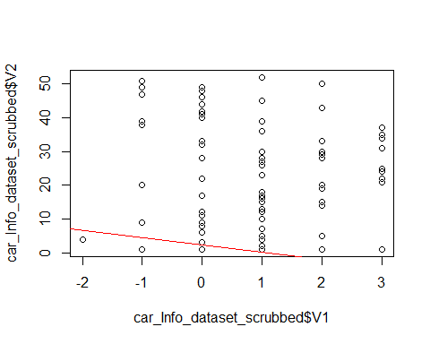

plot(model_car_Info_dataset_2)

## Warning: not plotting observations with leverage one:  
## 37, 43, 76, 107, 126, 154, 155, 181, 191

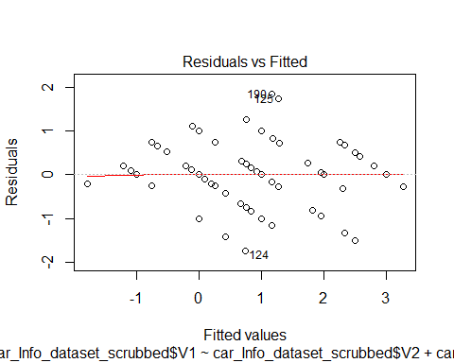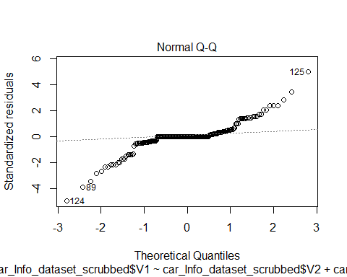

## Warning: not plotting observations with leverage one:  
## 37, 43, 76, 107, 126, 154, 155, 181, 191

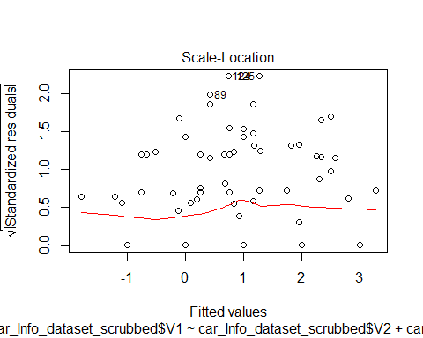

## Warning in sqrt(crit * p * (1 - hh)/hh): NaNs produced  
  
## Warning in sqrt(crit * p * (1 - hh)/hh): NaNs produced

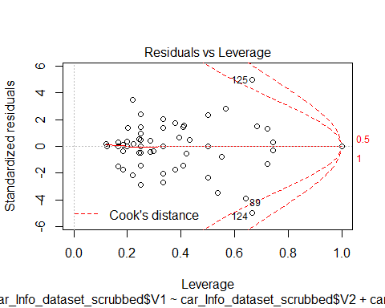

termplot(model_car_Info_dataset_2)

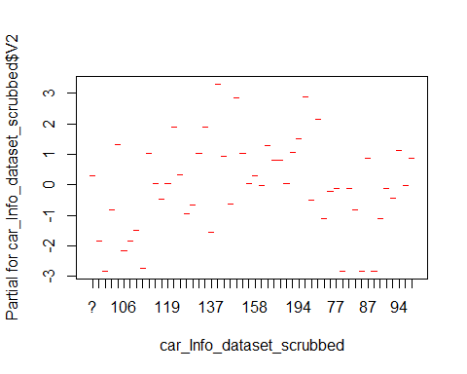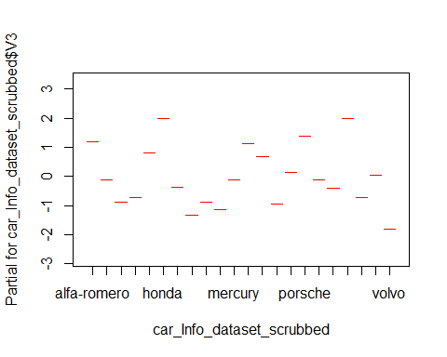

###http://mlr.cs.umass.edu/ml/machine-learning-databases/car/car.data  
car_Eval_dataset = read.csv(url("http://mlr.cs.umass.edu/ml/machine-learning-databases/car/car.data"), header=FALSE)  
  
set.seed(1728)  
ind <- sample(2, nrow(car_Eval_dataset), replace=T, prob=c(0.7, 0.3))  
car_Eval_dataset.train <- car_Eval_dataset[ind==1, ]  
car_Eval_dataset.test <- car_Eval_dataset[ind==2, ]  
  
  
car_Eval_dataset.formula <- car_Eval_dataset$V1 ~ car_Eval_dataset$V2 + car_Eval_dataset$V3 + car_Eval_dataset$V4 + car_Eval_dataset$V5 + car_Eval_dataset$V6 + car_Eval_dataset$V7  
car_Eval_dataset.ctree <- ctree(car_Eval_dataset.formula, data=car_Eval_dataset.train)  
car_Eval_dataset.ctree

##   
## Conditional inference tree with 14 terminal nodes  
##   
## Response: car_Eval_dataset$V1   
## Inputs: car_Eval_dataset$V2, car_Eval_dataset$V3, car_Eval_dataset$V4, car_Eval_dataset$V5, car_Eval_dataset$V6, car_Eval_dataset$V7   
## Number of observations: 1728   
##   
## 1) car_Eval_dataset$V7 == {good, vgood}; criterion = 1, statistic = 189.133  
## 2) car_Eval_dataset$V2 == {high, med}; criterion = 0.997, statistic = 15.109  
## 3) car_Eval_dataset$V7 == {vgood}; criterion = 0.988, statistic = 9.544  
## 4) car_Eval_dataset$V2 == {high}; criterion = 0.988, statistic = 9.5  
## 5)* weights = 13   
## 4) car_Eval_dataset$V2 == {med}  
## 6)* weights = 26   
## 3) car_Eval_dataset$V7 == {good}  
## 7)* weights = 23   
## 2) car_Eval_dataset$V2 == {low}  
## 8)* weights = 72   
## 1) car_Eval_dataset$V7 == {acc, unacc}  
## 9) car_Eval_dataset$V7 == {unacc}; criterion = 0.999, statistic = 21.041  
## 10) car_Eval_dataset$V6 == {high, med}; criterion = 0.991, statistic = 21.514  
## 11) car_Eval_dataset$V4 == {2}; criterion = 1, statistic = 69.991  
## 12)* weights = 384   
## 11) car_Eval_dataset$V4 == {4, more}  
## 13) car_Eval_dataset$V5 == {small}; criterion = 0.996, statistic = 23.715  
## 14)* weights = 130   
## 13) car_Eval_dataset$V5 == {big, med}  
## 15)* weights = 120   
## 10) car_Eval_dataset$V6 == {low}  
## 16)* weights = 576   
## 9) car_Eval_dataset$V7 == {acc}  
## 17) car_Eval_dataset$V2 == {high, vhigh}; criterion = 1, statistic = 152.301  
## 18) car_Eval_dataset$V2 == {high}; criterion = 1, statistic = 30.882  
## 19) car_Eval_dataset$V6 == {med}; criterion = 0.963, statistic = 10.158  
## 20)* weights = 49   
## 19) car_Eval_dataset$V6 == {high}  
## 21)* weights = 56   
## 18) car_Eval_dataset$V2 == {vhigh}  
## 22)* weights = 72   
## 17) car_Eval_dataset$V2 == {low, med}  
## 23) car_Eval_dataset$V6 == {high}; criterion = 1, statistic = 43.17  
## 24)* weights = 102   
## 23) car_Eval_dataset$V6 == {med}  
## 25) car_Eval_dataset$V5 == {big, med}; criterion = 1, statistic = 47.69  
## 26)* weights = 77   
## 25) car_Eval_dataset$V5 == {small}  
## 27)* weights = 28

plot(car_Eval_dataset.ctree)

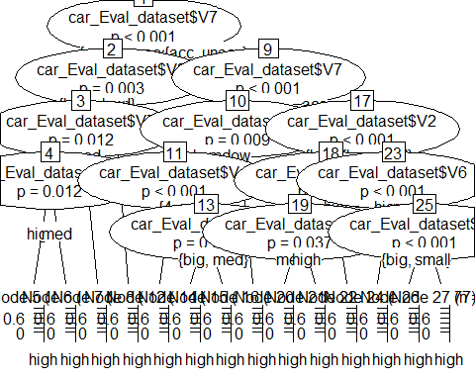

pred <- predict(car_Eval_dataset.ctree, newdata = car_Eval_dataset.test)  
  
table(pred, car_Eval_dataset$V2,dnn = c("pred", "V1"))

## V1  
## pred high low med vhigh  
## high 296 318 341 240  
## low 62 86 63 72  
## med 0 0 0 0  
## vhigh 74 28 28 120