SHOPEZ : E-commerce Application

ER DIAGRAM
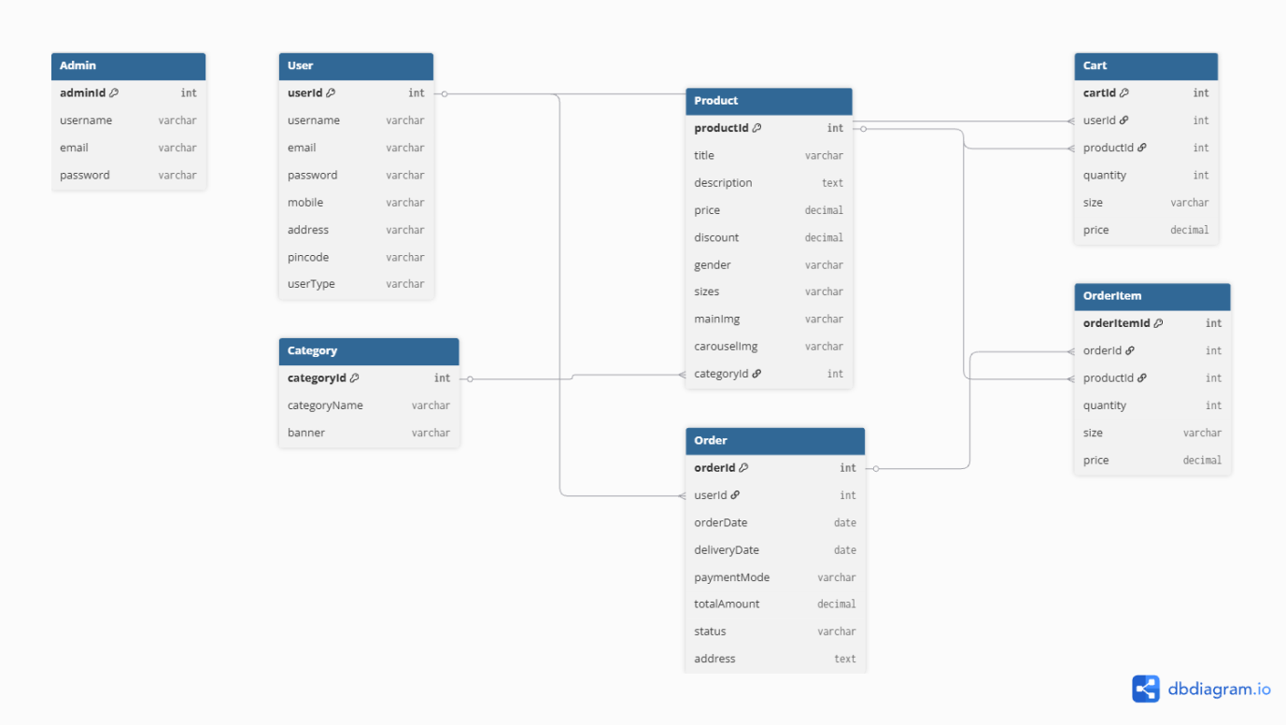
- The Admin manages product categories and products.
- Each Category contains multiple products.
- The Product entity stores product details such as title, description, price, discount, images, sizes, and category.
- A User can add multiple products to the cart.
- A User can place multiple orders.
- Each Order can contain multiple Order Items.
- Order Item links products with orders and stores quantity, size, and price.
- The database follows a normalized structure to reduce data redundancy.
- Foreign keys are used to maintain relationships and ensure data integrity.
- The ER model supports essential e-commerce functionalities such as:
  - User Authentication
  - Product Management
  - Category Management
  - Shopping Cart
  - Order Processing
  - Payment and Delivery Tracking

