**Software Requirements Specification**

**for**

**Mess Management System**

**Version 2.0 approved**

**Prepared by -** Gurram Vasu (17CS30014) Harsh Pritam Sanapala (17CS30016)

**Indian Institute of Technology, Kharagpur**

**13 March, 2019**

**Table of Contents**

**Table of Contents 2**

**Revision History 3**

**1. Introduction 4**

1.1 Purpose 4

1.2 Document Conventions 4

1.3 Intended Audience and Reading Suggestions 4

1.4 Product Scope 4

1.5 References 4

**2. Overall Description 5**

2.1 Product Perspective 5

2.2 Product Functions 5

2.3 User Classes and Characteristics 5

2.4 Operating Environment 6

2.5 Design and Implementation Constraints 6

2.6 User Documentation 6

2.7 Assumptions and Dependencies 6

**3. External Interface Requirements 3**

3.1 User Interfaces 6

3.2 Hardware Interfaces 6

3.3 Software Interfaces 6

**4. System Features 10**

4.1 Creating an account 10

4.2 Login 10

4.3 Maintaining attendance, salary info of mess workers 11

4.4 Leave application 11

4.5 Grocery info 11

4.6 Approval of leave application 12

4.7 Student preference list 12

4.8 Complaint portal 12

**5. Other Nonfunctional Requirements 13**

5.1 Performance Requirements 13

5.2 Safety Requirements 13

5.3 Security Requirements 13

5.4 Software Quality Attributes 14

5.5 Business Rules 14

**6. Other Requirements 14**

**Appendix A: Glossary 14**

**Appendix B: Analysis Models 14**

**Revision History**

|  |  |  |  |
| --- | --- | --- | --- |
| **Name** | **Date** | **Reason For Changes** | **Version** |
| **<>** | 06.03.2019 | Initial Version | 1.0 |
| v2 | 13.03.2019 | second version | 2.0 |

# Introduction

## Purpose

The purpose of this document is to present a detailed description of the Mess Management System. It will explain the purpose and features of the system, the interfaces of the system, what the system will do, the constraints under which it must operate and what kind of system interactions take place.

## Document Conventions

When you read this manual, certain words are represented in different fonts, typefaces, sizes, and weights. This highlighting is systematic, different words are represented in the same style to indicate their inclusion in a specific category.

## Intended Audience and Reading Suggestions

This document gives an overview of the functionality of the product. It describes the informal requirements and is used to establish a context for the technical requirements specification for developers, programmers, testers, project managers and describes in technical terms the details of the functionality of the product.

## Product Scope

We can make a software where each mess worker can login using a username and password, where they can view their daily attendance, their salary and can also apply for leave. The manager can also login to this to approve leaves. Each student can maintain an account here and login with their username and password to get the information about their preference they kept and also see the monthly mess charge. They would also be able to find any mess fines and see if their mess duties. They could also complain against the mess in the online complaint register.

This system would reduce the strenuous work of the mess and also be a fair system where the students would pay for what they eat. It would be lot easier if everything would be present at a same place and open for everyone to have a look at into the mess working system and reduce the tiresome and time-consuming work of maintaining handwritten lists.

## References

IEEE Software Requirement Specification Template.

# Overall Description

## Product Perspective

IIT Kharagpur has many halls, each of which has a mess in which vast number of workers work every day. It takes a lot of effort to maintain records of each worker and not only this, each mess maintains a list of groceries they buy every day, but the most interesting thing is how they manage to do everything manually, though it is a tiresome and time- consuming work. We can make a user friendly software which can manage the functioning of the administration of hostel mess which will reduce the tiresome work of handwritten lists.

## Product Functions

* A separate login options for mess workers, manager, students.
* Record of attendance of the worker, their salary.
* An option to apply for leave for mess workers.
* An attendance list and leave applications of all the mess workers accessible only to the manager.
* A list of groceries, its price, quantity available and their status of delivery.
* A menu list available to all the students.
* A list of food from which student can choose their preference.
* Information about their preference, monthly mess charge, mess fines and mess duties.
* A complaint portal for the students.

## User Classes and Characteristics

* Mess Worker
  + The mess workers should be able to login with their username and password.
  + They can view their daily attendance, salary
  + They can apply for leave.
* Mess Manager
  + The mess manager should be able to login with his/her username and password.
  + An attendance list and leave applications of all the mess workers accessible only to the manager.
  + The manager should be able to view the complaints in the complaint portal.
  + The manager should be able to view the list of groceries, its price, quantity available and their status of delivery.
* Students
  + A menu list is available to all the students.
  + A list of food from which student can choose their preference.
  + Information about their preference, monthly mess charge, mess fines and mess duties.
  + A complaint portal for the students.

## Operating Environment

The software will be a web based system in which a server will store all the information of mess workers, manager, students and other data which will be customizable by the respective users. The user end will be a graphical interface.

## Design and Implementation Constraints

The software will be developed for pc having necessary prerequisites only.

## User Documentation

Will be attached later.

## Assumptions and Dependencies

It is assumed that the software developed will be compatible with the hardware in use.

# External Interface Requirements

## User Interfaces

All options will be displayed in a menu based format. It will be specifically designed with their users in mind.

## Hardware Interfaces

A web server will be required so that the students and the mess admin can connect to it to exchange information. The server will have a database to store all the data entries. The Server will have to have a high speed ethernet connection to the college's local network.

## Software Interfaces

The front end will be a GUI based program made by using swing in java.

The below screenshots are just examples of what basic interface our software is supposed to have.

3.3.1 Login page :

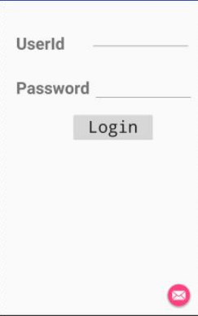

3.3.2 Selecting menu for Students :

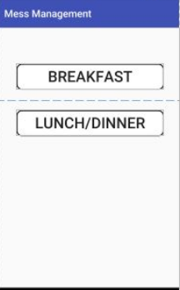

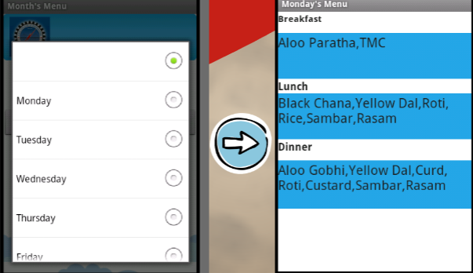

3.3.3 Complaint portal for students :

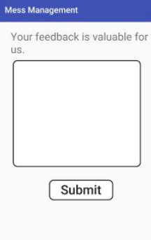

3.3.4 Viewing mess charges (for students) :

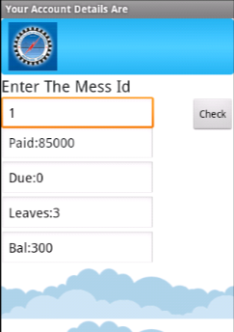

3.3.5 Applying leave by mess workers :

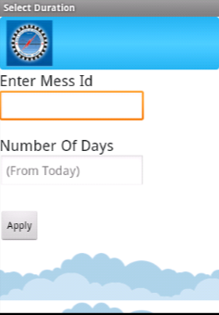

# System Features

## Creating an account

4.1.1 Description and Priority:

It is mandatory for every user to create an account to be able to use this software.

4.1.2 Stimulus/Response Sequences:

Depending upon the type of user, it will require different details of the user. Such as email id, roll number for students, phone number, address for workers etc.

4.1.3 Functional Requirements

REQ-1: Select type of user.

REQ-2: Store the user details

REQ-3: Dialogue box for selecting a secure username and password.

REQ-4: If the username is already in use, then display some error.

## Login

4.2.1 Description and priority:

If the user already has an account, he/she should be able to login with their username password.

4.2.2 Stimulus/Response Sequences:

Depending upon the type of user it will require the username and password of the user. If the username doesn’t exist, he/she would be prompted to sign up (create an account).

4.2.3 Functional Requirements

REQ-1: Select type of user.

REQ-2: Dialogue box for entering username and password.

REQ-3: Check the database.

REQ-4: If the username doesn’t exist, then prompt the user to create an account.

REQ-5: If the user has forgotten his/her password then he is redirected to a link where you need to confirm your identity to proceed further.

## Maintaining attendance, salary of mess workers

4.3.1 Description and priority:

The mess worker would be able to view their attendance, salary information.

4.3.2 Stimulus/Response Sequences:

It just displays the attendance and salary information of the mess worker after he/she logs in.

4.3.3 Functional Requirements

REQ-1: Option to view attendance or salary information.

## Leave application

4.4.1 Description and priority:

The mess worker would be able to apply for leave if applicable.

4.4.2 Stimulus/Response Sequences:

The system checks the number of leave days left from the database. If there are no leave days available, it won’t proceed to the application.

4.4.3 Functional Requirements

REQ-1: Option to check for number of available leave days.

REQ-2: A leave application which would require the number of days and the reason for leave.

## Grocery Info:

4.5.1 Description and priority:

It would contain the list of groceries along with their cost, quantity available. The delivery information is also available.

4.5.2 Stimulus/Response Sequences:

The manager should be able to track the delivery of the groceries and must be able to view the usage and availability of the present groceries.

4.5.3 Functional Requirements

REQ-1: The list of available and unavailable groceries.

REQ-2: Option to request for unavailable items.

REQ-3: Option to view the delivery information.

## Approval of Leave Applications:

4.6.1 Description and priority:

It would contain the leave applications of mess workers.

4.6.2 Stimulus/Response Sequences:

The manager approves/disapproves the applications based on worker requirements on specific days.

4.6.3 Functional Requirements

REQ-1: It would sort the applications according to their dates.

REQ-2: Approve /Disapprove option.

REQ-3: Reason for disapproval is provided by the manager.

## Student Preference Lists :

4.7.1 Description and priority:

This has the list of food items available for the following week and the student will be required to set his/her preference of items.

4.7.2 Stimulus/Response Sequences:

The students must select their preference from the given list of food items.

4.7.3 Functional Requirements

REQ-1: The list of available items in the mess.

REQ-2: A separate list of the preferences.

## Complaint Portal :

4.8.1 Description and priority:

This registers complaints from the students and transfers these complaints to the complaint box of the manager.

4.8.2 Stimulus/Response Sequences:

The complaints of the students are registered and saved in the database.

The manager checks his complaint box and provides feedback.

4.8.3 Functional Requirements

REQ-1: A complaint portal of students.

REQ-2: Different sections for different types of complaints(like cleanliness,food quality etc.)

REQ-3: A Feedback box for the manager.

# Other Nonfunctional Requirements

## Performance Requirements

Performance requirements define acceptable response times for system functionality

* The load time for the user interface shall not take long time, especially while viewing the mess menu by the students.
* The login information shall be verified fast.
* Queries such as grocery information, salary information shall return results quickly.

## Safety Requirements

The information will be saved in two different locations so that we could recover from it when there is an extensive damage to the database.

## Security Requirements

The server on which the Mess Management System resides will have its own security to prevent unauthorized write or delete access. There will be no restriction on read access.

In case a password is forgotten, the student and the mess workers can approach the admin (Mess Manager).

If the user has not logged in for more than 6 months, his/her account will be deleted in order to save storage and prevent any misuse of their personal details.

## Software Quality Attributes

As the software deals with a small dataset, it is less prone to data congestion and it will be able to handle any number of users simultaneously.

## Business Rules

* The user must be having a unique ID number (ex. roll number for students) provided by IIT Kharagpur in order to register in this software.

# Other Requirements

A brief maintenance check must be done periodically in order to make sure that the information provided is reliable such as grocery information, delivery information, salary information etc.

**Appendix A: Glossary**

* REQ = Requirement

**Appendix B: Analysis Models**

Will be added in the subsequent versions.