**PROJECT ON**



**Car Parking System**



**Submitted in partial fulfillment of the requirement for the award of the degree of**

**BACHELOR OF COMPUTER APPLICATIONS**

**Submitted by:**

**Vasu kamboj**  **20151052**

***Under the Guidance of***

**Mr.** **Kamlesh Chandra Purohit**

**Assistant Professor**



**Department of Computer Applications**

**Graphic Era (Deemed to be University)**

**Dehradun, Uttarakhand**

**MAY-2023**





**CANDIDATE’S DECLARATION**

I hereby certify that the work which is being presented in the Synopsis entitled **“Implementation of IOT”** in partial fulfillment of the requirements for the award of the Degree of Bachelor of Computer Applicationsin the Department of Computer Applications of the Graphic Era (Deemed to be University), Dehradun shall be carried out by the undersigned under the supervision of **Mr.** **Kamlesh Chandra Purohit , Assistant Professor**, Department of Computer Applications, Graphic Era (Deemed to be University), Dehradun.

Vasu kamboj 20151052 ___________

Signature Signature

**Supervisor** **Head of the Department**

**Internal Evaluation (By DPRC Committee)**

**Status of the Synopsis:** Accepted / Rejected

**Any Comments:**

**Name of the Committee Members: Signature with Date**

**Table of Contents**

|  |  |  |  |
| --- | --- | --- | --- |
| **Chapter No.** | | **Description** | **Page No.** |
| Chapter 1 | | Introduction and Problem Statement |  |
| Chapter 2 | | Hardware and software requirements |  |
| Chapter 3 | | Objectives |  |
| Chapter 4 | | Algorithm |  |
|  |
|  | | References |  |

**Chapter 1**

**Introduction and Problem Statement**

* 1. **Introduction**

An IoT based car parking system is a vehicle parking management system to ease the search for a vacant parking spot in a parking lot . The system utilizes various sensors and microcontrollers with capability for detecting parked vehicles and to update the data in real-time .

**The proposed design:**

As mentioned above, the proposed smart parking lot circuit will be equipped with several sensors, inexpensive microcontrollers and any vehicle owner can check if there is a vacant space in a parking lot using a lcd screen displayed outside the parking lot.

In conclusion, the main purpose of a vehicle parking system is to save time and reduce hassle for motorists to find a parking lot with a vacant parking spot; otherwise a driver may need to spend their time to find if there are any vacant parking spot left or should they move on to an another parking lot and this situation may put many motorists to mental stress especially those who are in an urgent circumstances.

* 1. **Problem Statement**

• Parking management influences drivers search time and cost for parking spaces.

• It may also causes traffic congestion.

• Finding a parking space in most metropolitan areas, especially during the rush hours, is difficult for drivers.

• Difficulty arises from not knowing where the available spaces may be at that time.

By using ultrasonic sensors be able to keep a record of the number of cars parked inside of a parking garage. Consequently, once a car enters a parking garage followed by a parking space, a ping ultrasonic sensor will then be able to determine if a car is parked in the space or not. This information would then be relayed to update the network.

**Chapter 2**

**Hardware Requirements:**

1. **Barrier Gates**: Physical barriers or gates to control the entry and exit of vehicles.
2. Ticket Dispensers: Automated machines that issue parking tickets to incoming vehicles.
3. Ticket Readers: Devices that can scan and validate parking tickets during exit.
4. Payment Terminals: Machines or systems that accept payments from customers, including cash, credit/debit cards, or mobile payment methods.
5. **Sensors**: Various types of sensors, such as ultrasonic or magnetic sensors, to detect the presence of vehicles in parking spaces.
6. Cameras: Surveillance cameras for security, monitoring, and license plate recognition purposes.
7. **LCD Displays**: Displays to provide information such as available parking spaces, directions, or payment details.
8. **Power Supply**: Sufficient power infrastructure to support all the hardware components, including backup power sources in case of outages.
9. Management System: A central server or computer system to manage and control the entire parking system, handle transactions, and store data.

**SOFTWARE :**

Arduino Ide.

**Components Required**

* [Arduino UNO](https://techatronic.com/what-is-arduino-brief-description/)
* [Two IR sensors](https://techatronic.com/what-is-an-ir-sensor/)
* [Servo motor](https://techatronic.com/tutorial-to-understand-the-working-of-servo-motors-using-arduino/)
* Jumper wires and a breadboard
* [16×2 LCD](https://techatronic.com/interface-lcd-with-arduino-16x2/) and an [I2C module](https://techatronic.com/lcd-interfacing-with-arduino-using-i2c/)
* USB cable for uploading the code

Example-

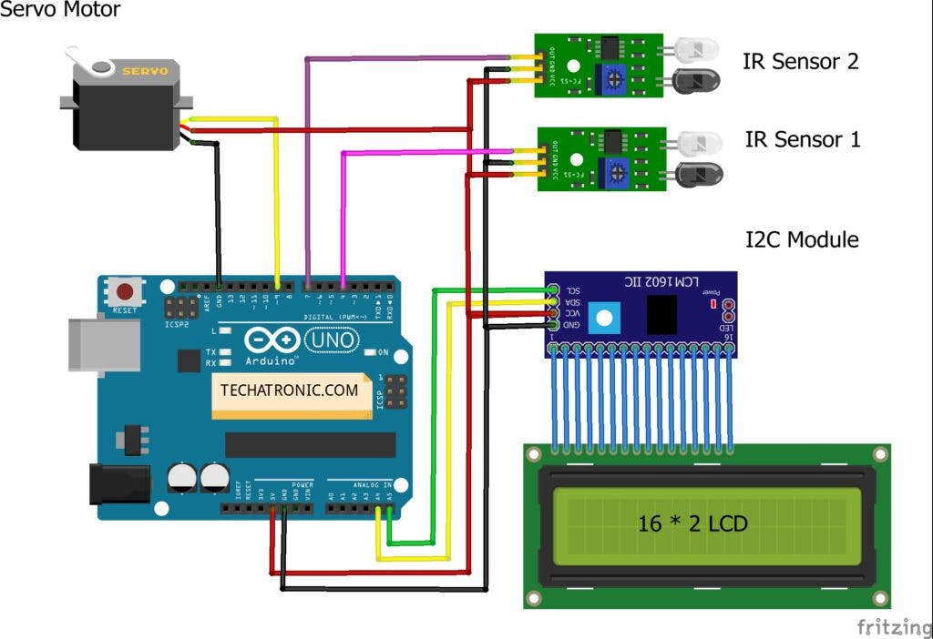

**Chapter 3**

**Objectives:**

Parking space reservation can help drivers to reduce the search time dramatically.

• With the real-time reservation service, the drivers can find and reserve their desired vacant parking spaces quickly. Therefore, the gasoline and time in search of vacant parking space is reduced.

• It reduces time in search of vacant parking spaces is reduced so it reduces traffic congestion caused due that.

**Chapter 4**

**Algorithm**

• Start.

• Turn on the power supply.

• IR sensor will get activated.

• Space detection will start.

• If space is detected data sends and stored on cloud by sending system status

• LED will start showing the number of parking slots.

• Display on front LCD that the slot is booked.

• LED indication will get off.

• IR sensor will open a gate.

• End.

