***Automation & Linux Lab -2***

*Name - Vasu Kansal*

*Sapid - 500094156*

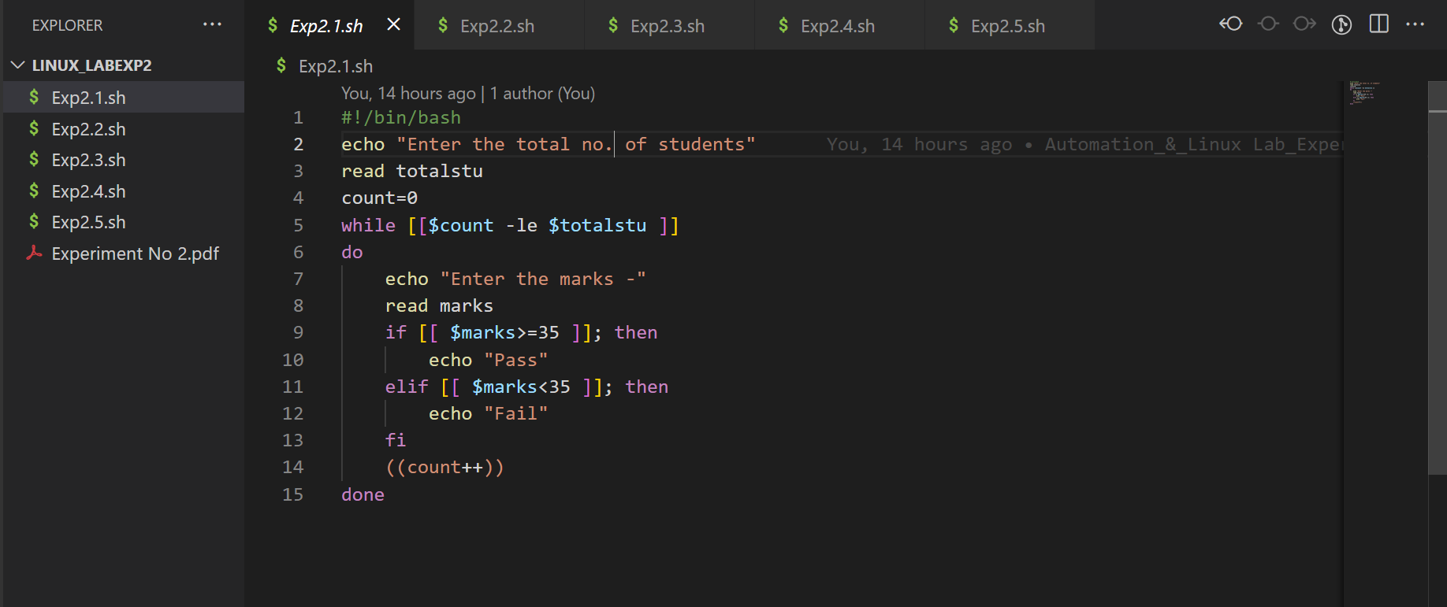

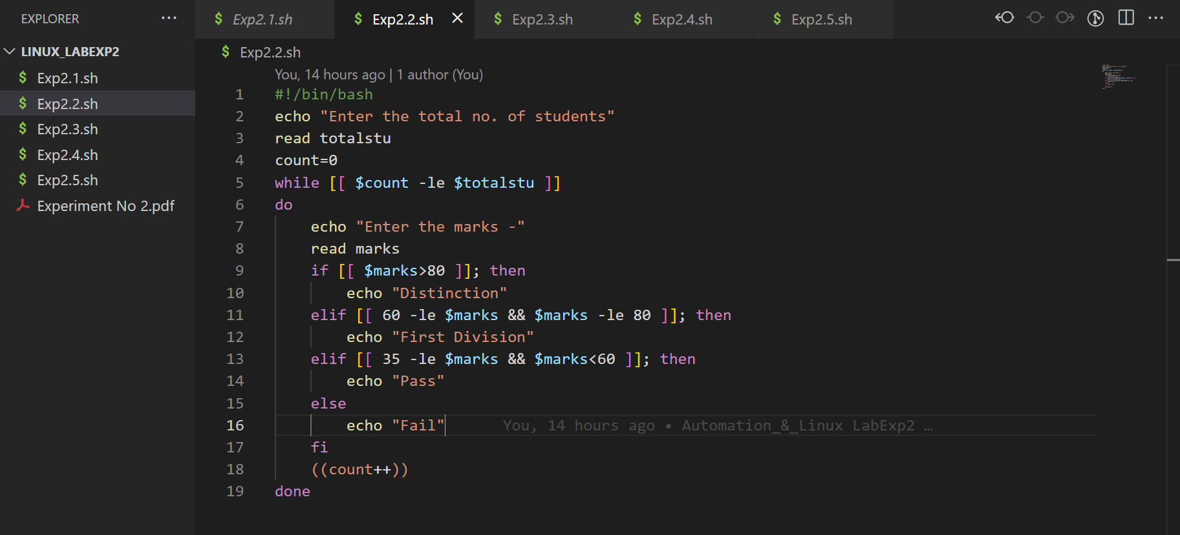

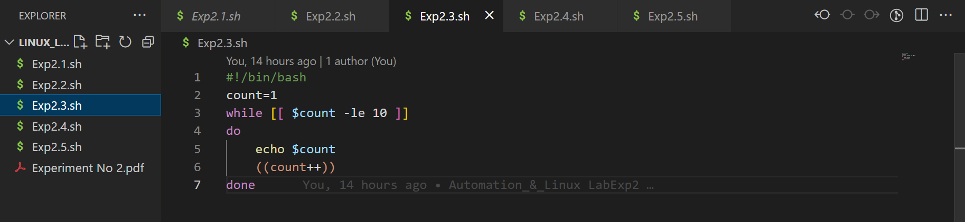

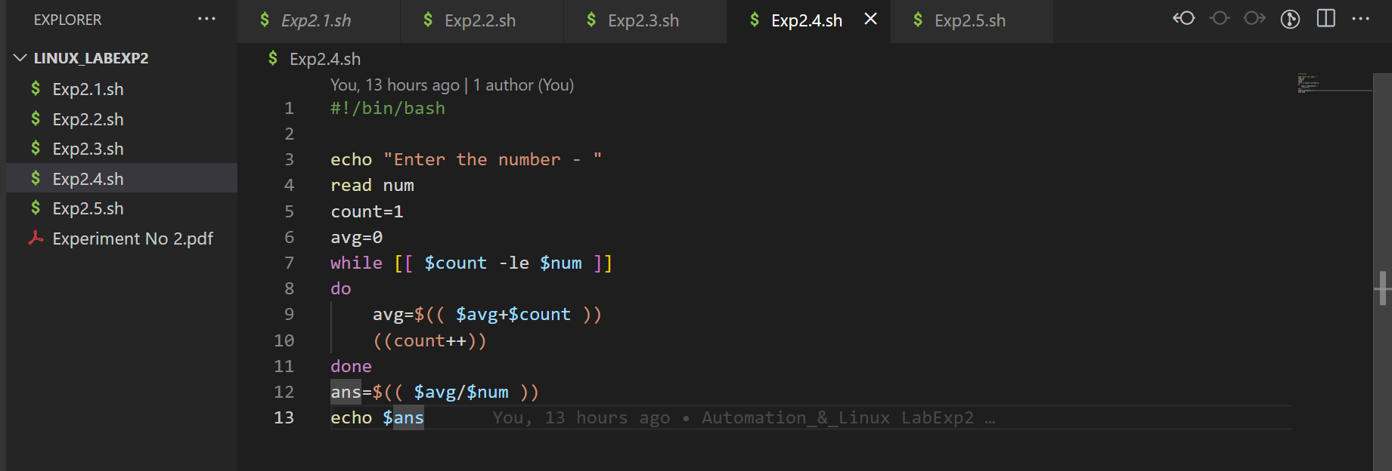

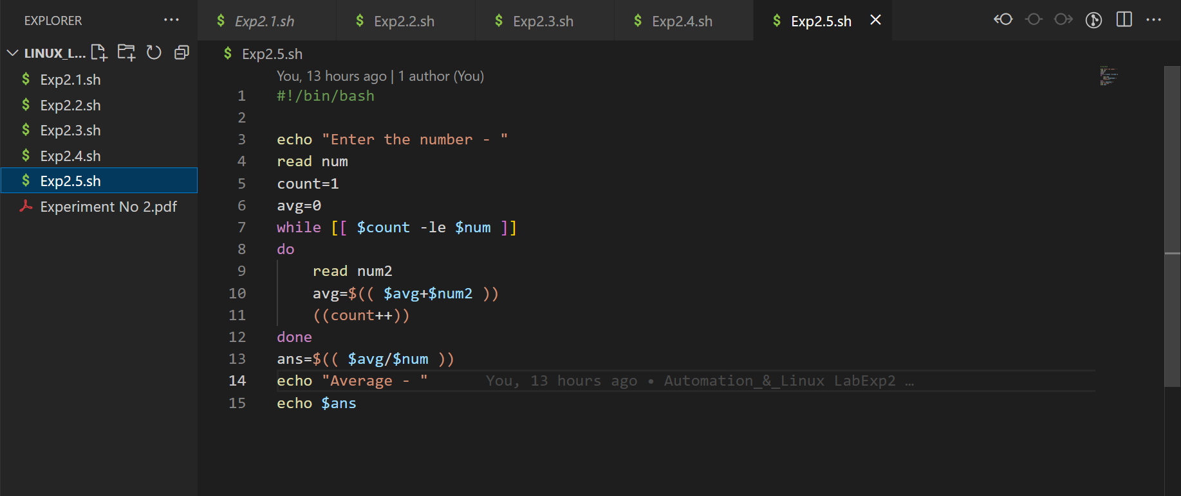

***Automation & Linux***

***Lab 3***

*Name - Vasu Kansal*

*Sap id - 500094156*

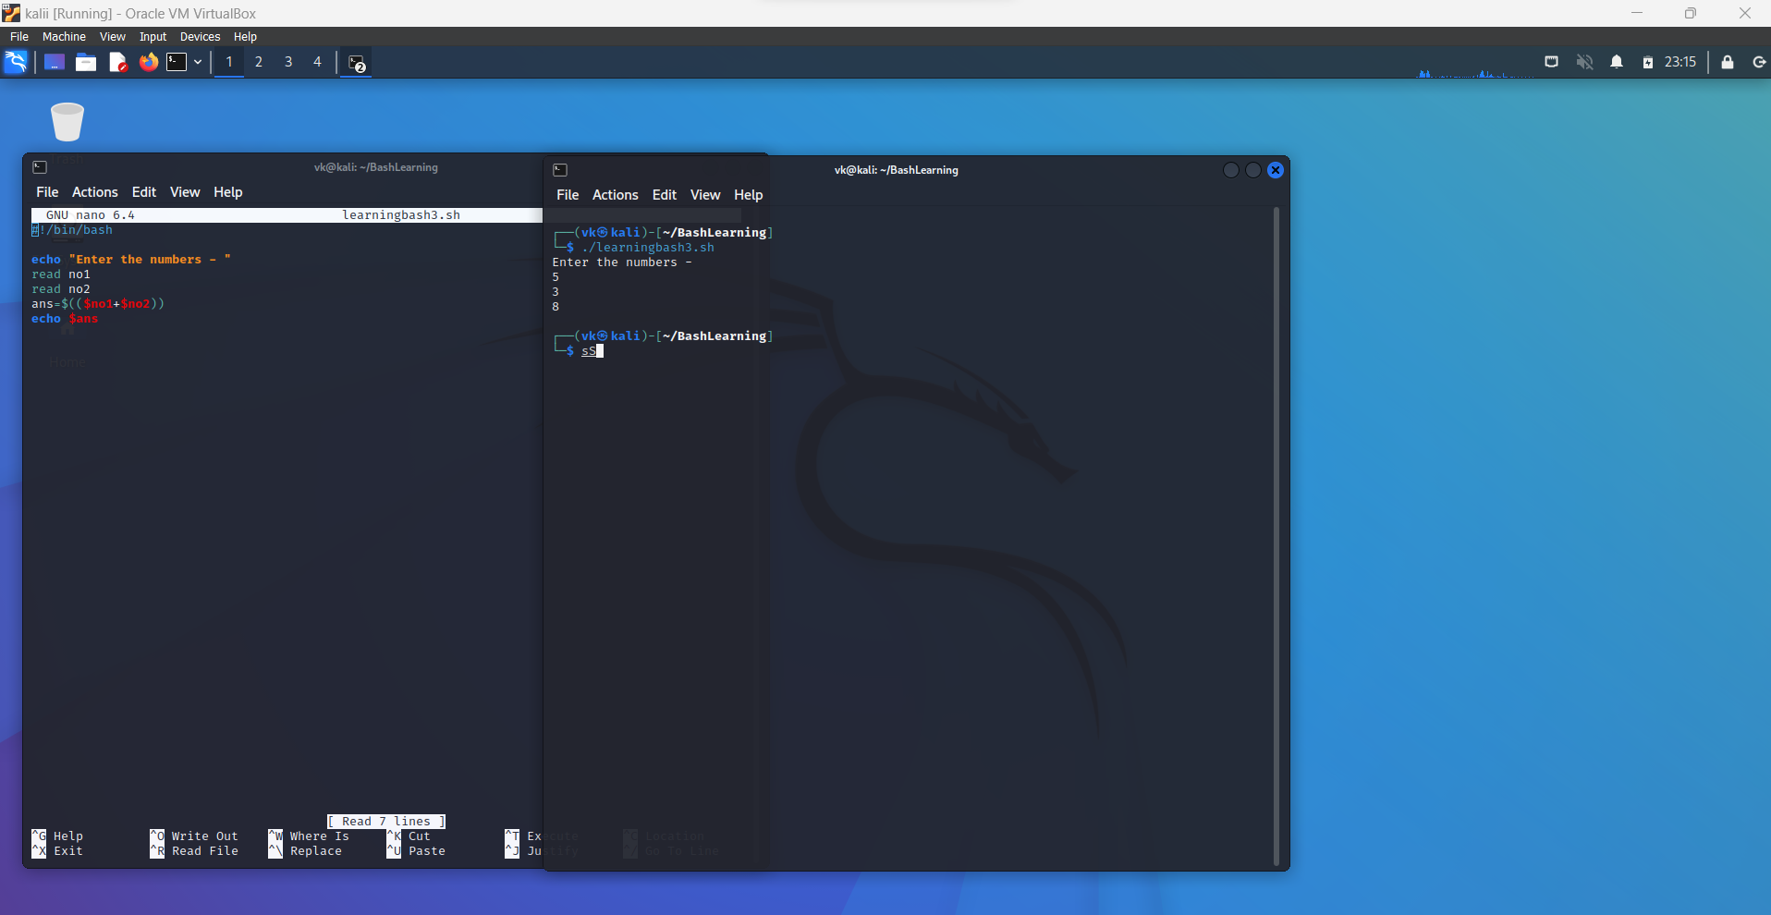

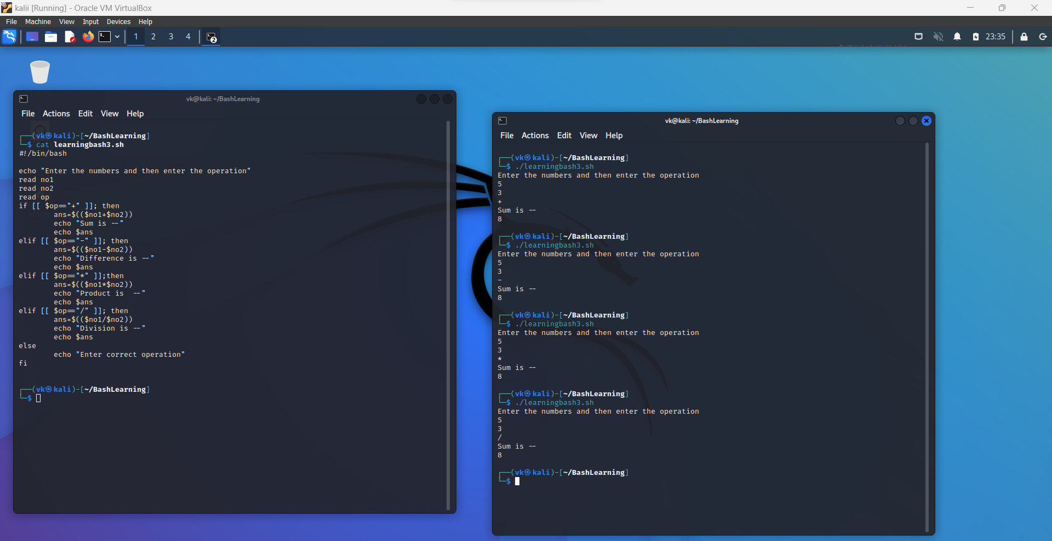

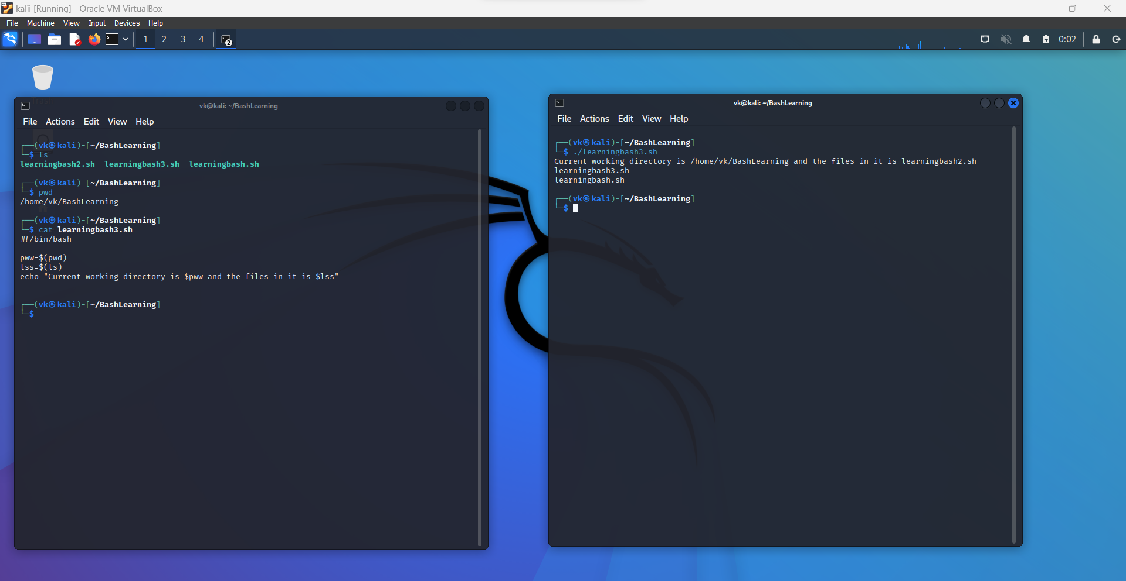

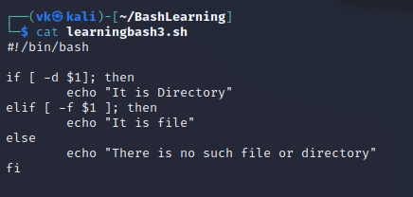

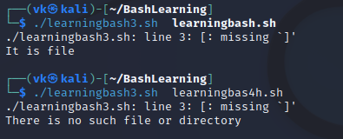

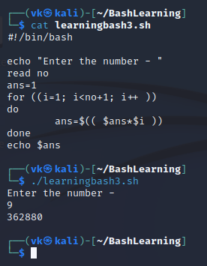

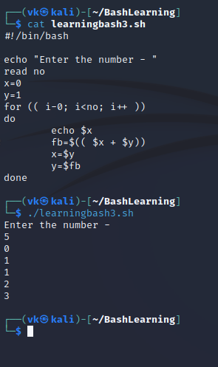

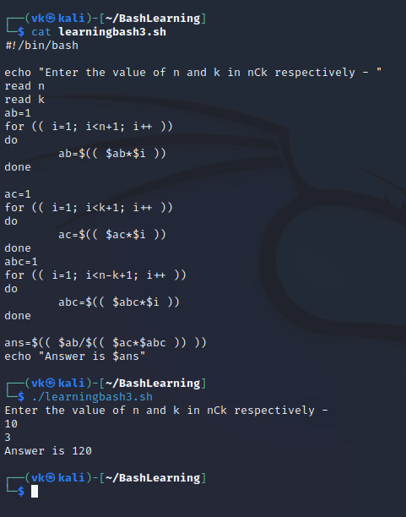

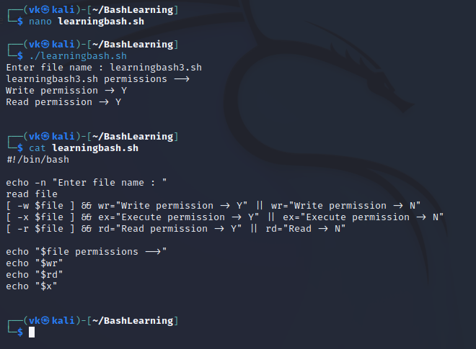



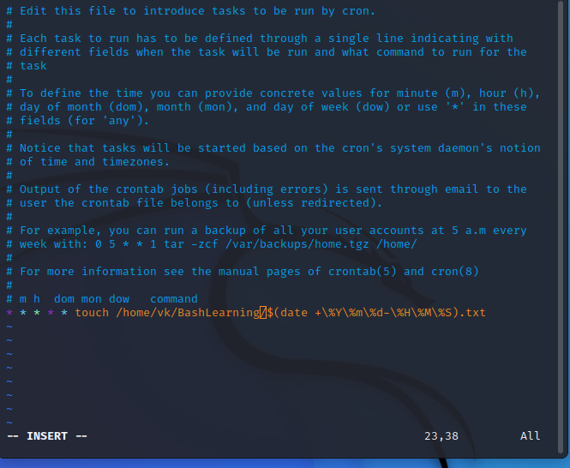

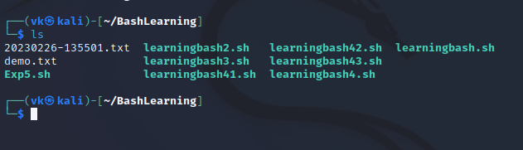

***Automation_&_LinuxLab***

***Exp - 4***

*Name - Vasu Kansal*

*Sapid - 500094156*

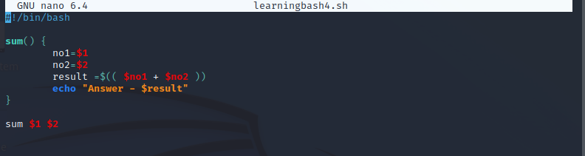

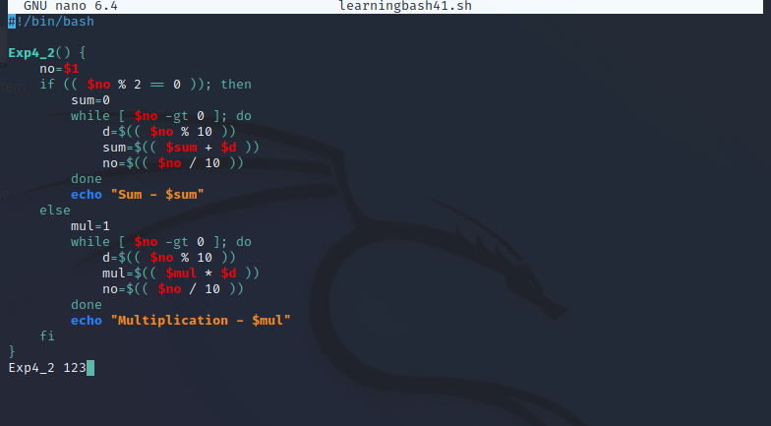

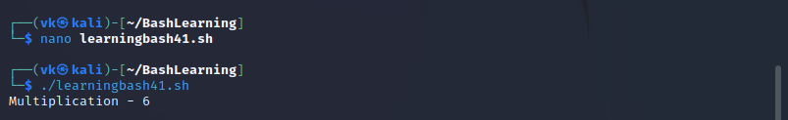

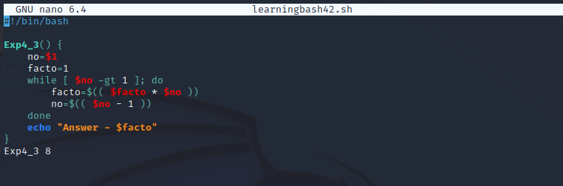

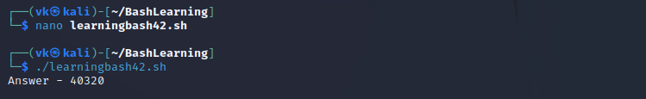

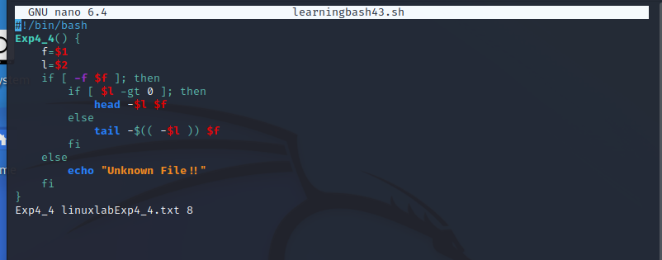

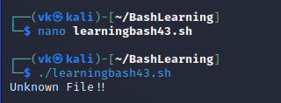

***Linux Lab Exp - 6***

***Name - Vasu Kansal***

***Sapid - 500094156***

Q1.

#!/bin/bash

read -p "To Search - " sear

read -p "To Replace: " rep

for a in `ls *.txt`

do

sed -i "s/$sear/$rep/g" $a

done

Q2.

#!/bin/bash

read -p "To Check - " ch

if [[ $ch =~ ^[a-zA-Z0-9]+$ ]]

then

echo "Ok"

else

echo "Not Ok"

fi

Q3.

#!/bin/bash

read ab

echo "LC: " `echo $ab | tr [:upper:] [:lower:]`

echo "UC: " `echo $ab | tr [:lower:] [:upper:]`

echo "First UC Letter: " `echo $ab | sed 's/\(.\)/\u\1/'`

***Experiment -7***

***DAL***

*Name - Vasu Kansal*

*Sap id - 50094156*

1.

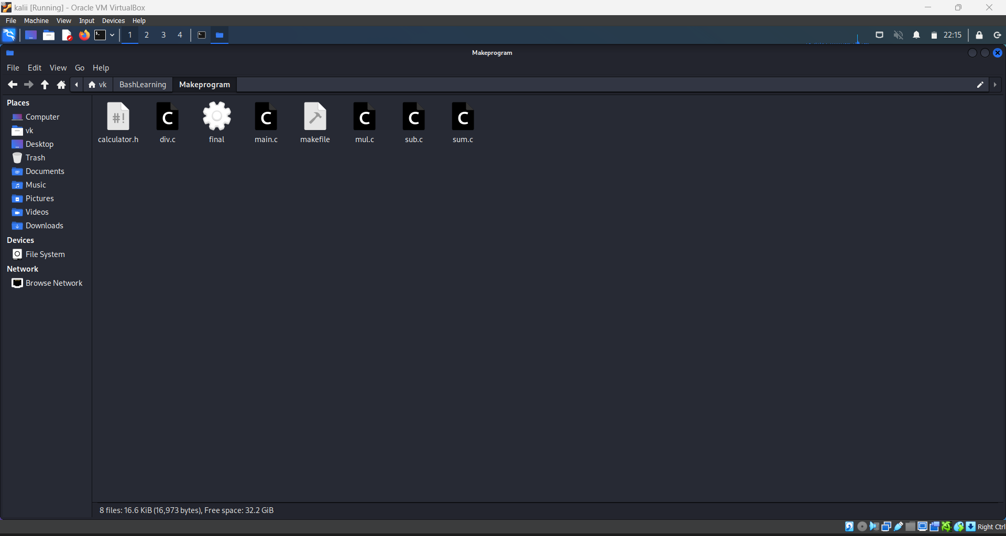

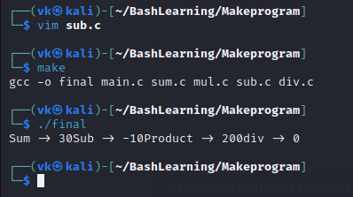

2.

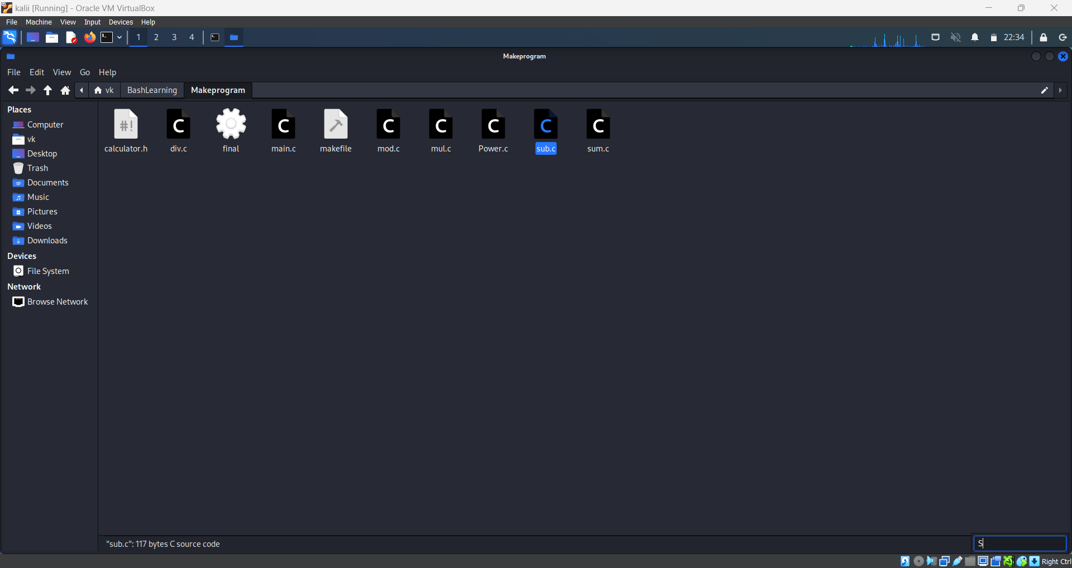

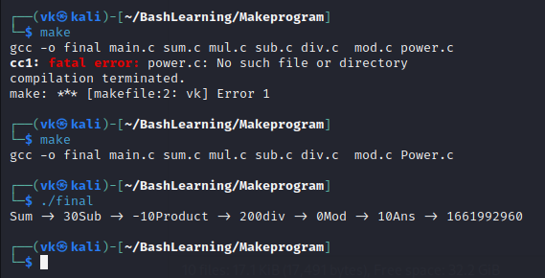

3.

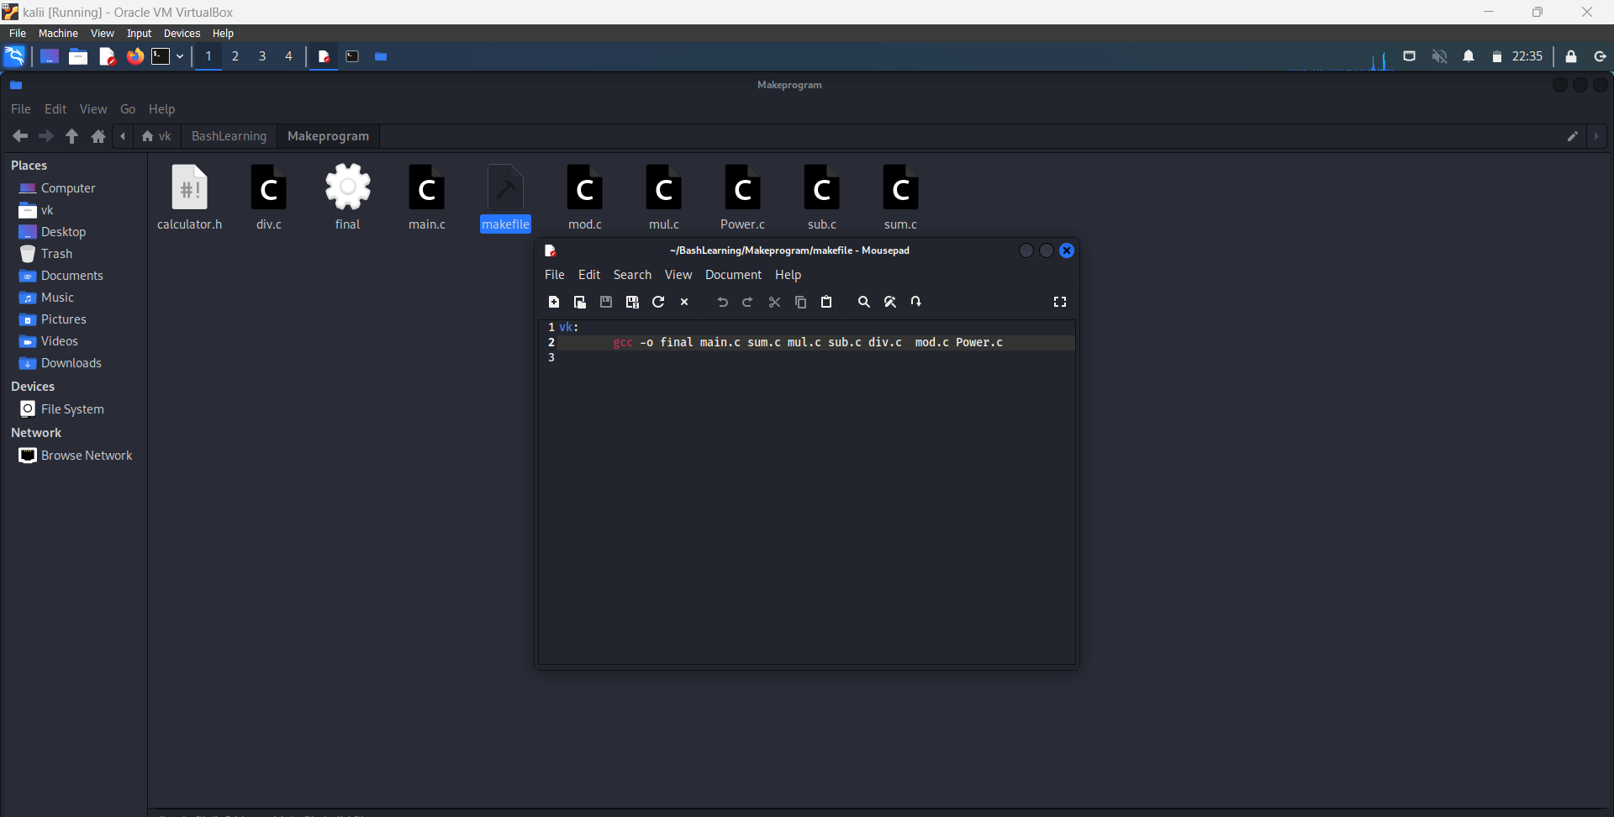

4.

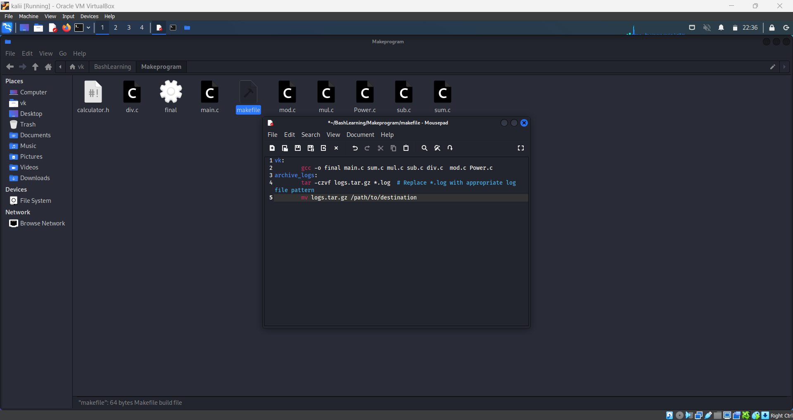

5.

7. a=10

8. b=20

9.

10. #Check whether they are equal

11. if [ $a == $b ]

12. then

13. echo "a is equal to b"

14. fi

15.

16. #Check whether they are not equal

17. if [ $a != $b ]

18. then

19. echo "a is not equal to b"

20. fi

***Lab - 9***

***DAL***

*Name - Vasu Kansal*

*Sap id - 500094156*

**Hostname**

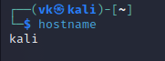

**IFCONFIG**

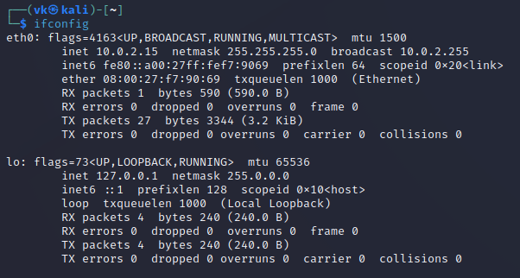

**Route**



**Ip**

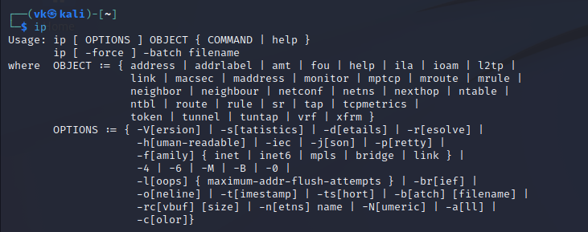

**Ss**

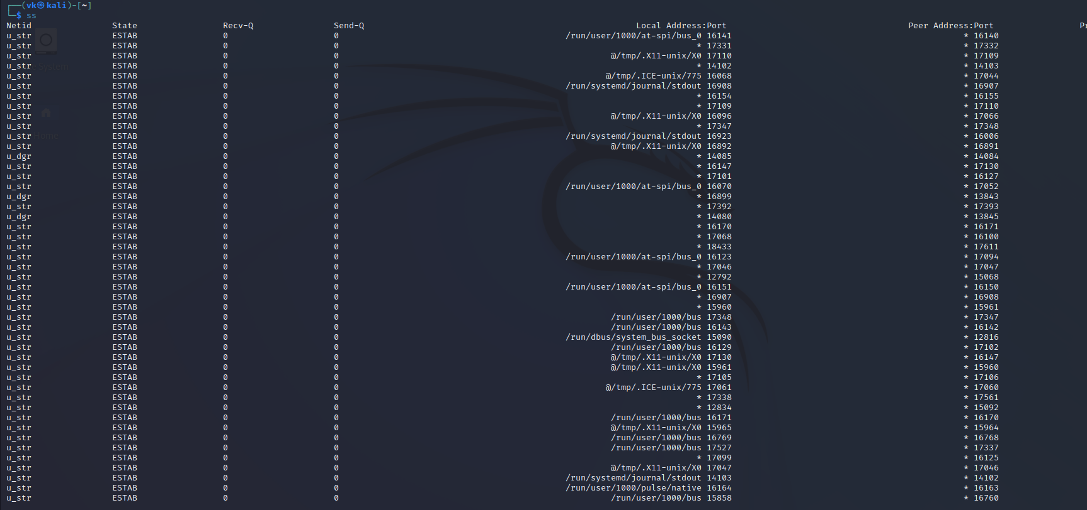

**Nmcli**

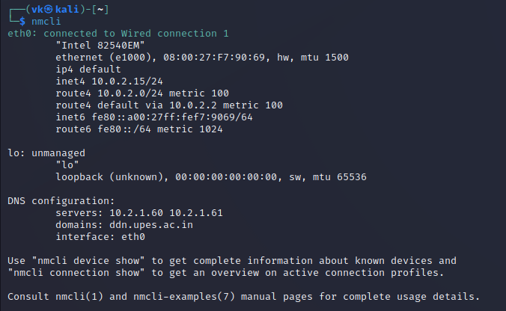

***Lab - 8***

***DAL***

*Name - Vasu Kansal*

*Sap id - 500094156*

**More**



**/boot**



**/etc**

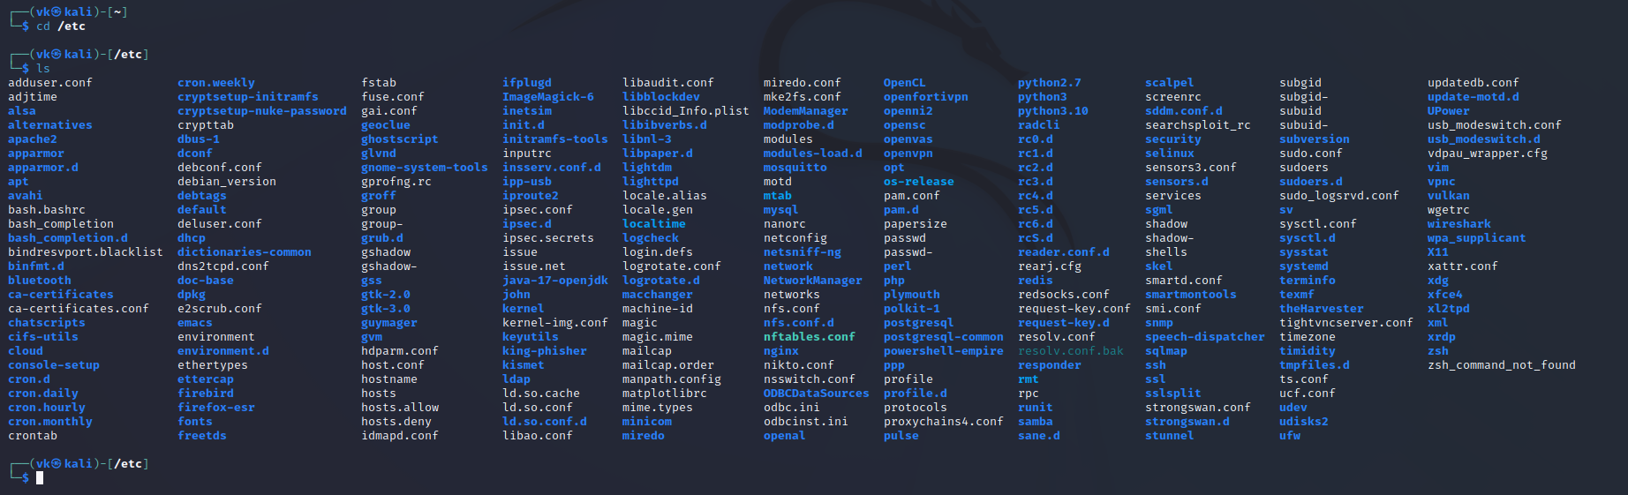

**/sys**

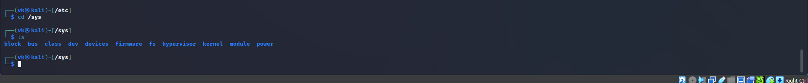

**/var**

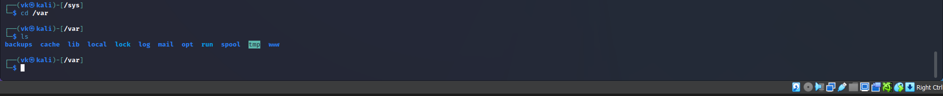

**/var ls -l**

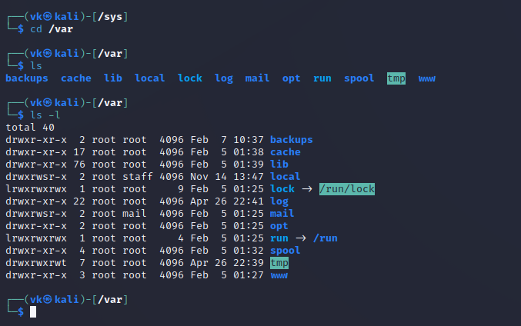

**Add a user**

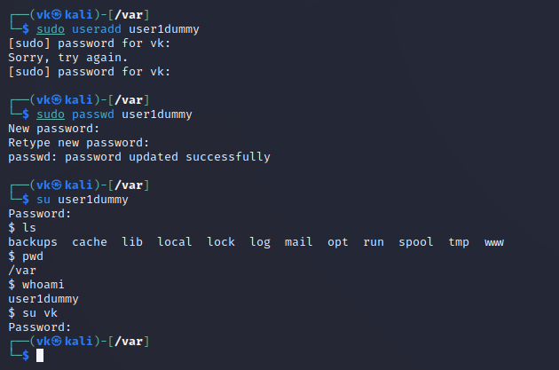

**Delete user**

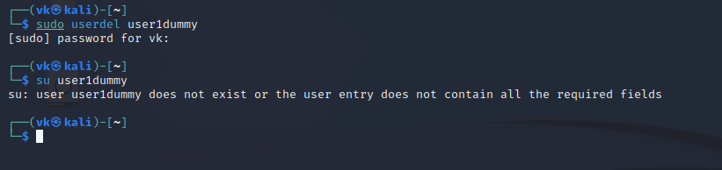

**Add Group**

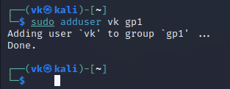

**Delete from group**

