***DevOps & Source Code Mgt. Assignment 2 Solution***

*Name - Vasu Kansal*

*Sap id - 500094156*

***Simple Array Sum***

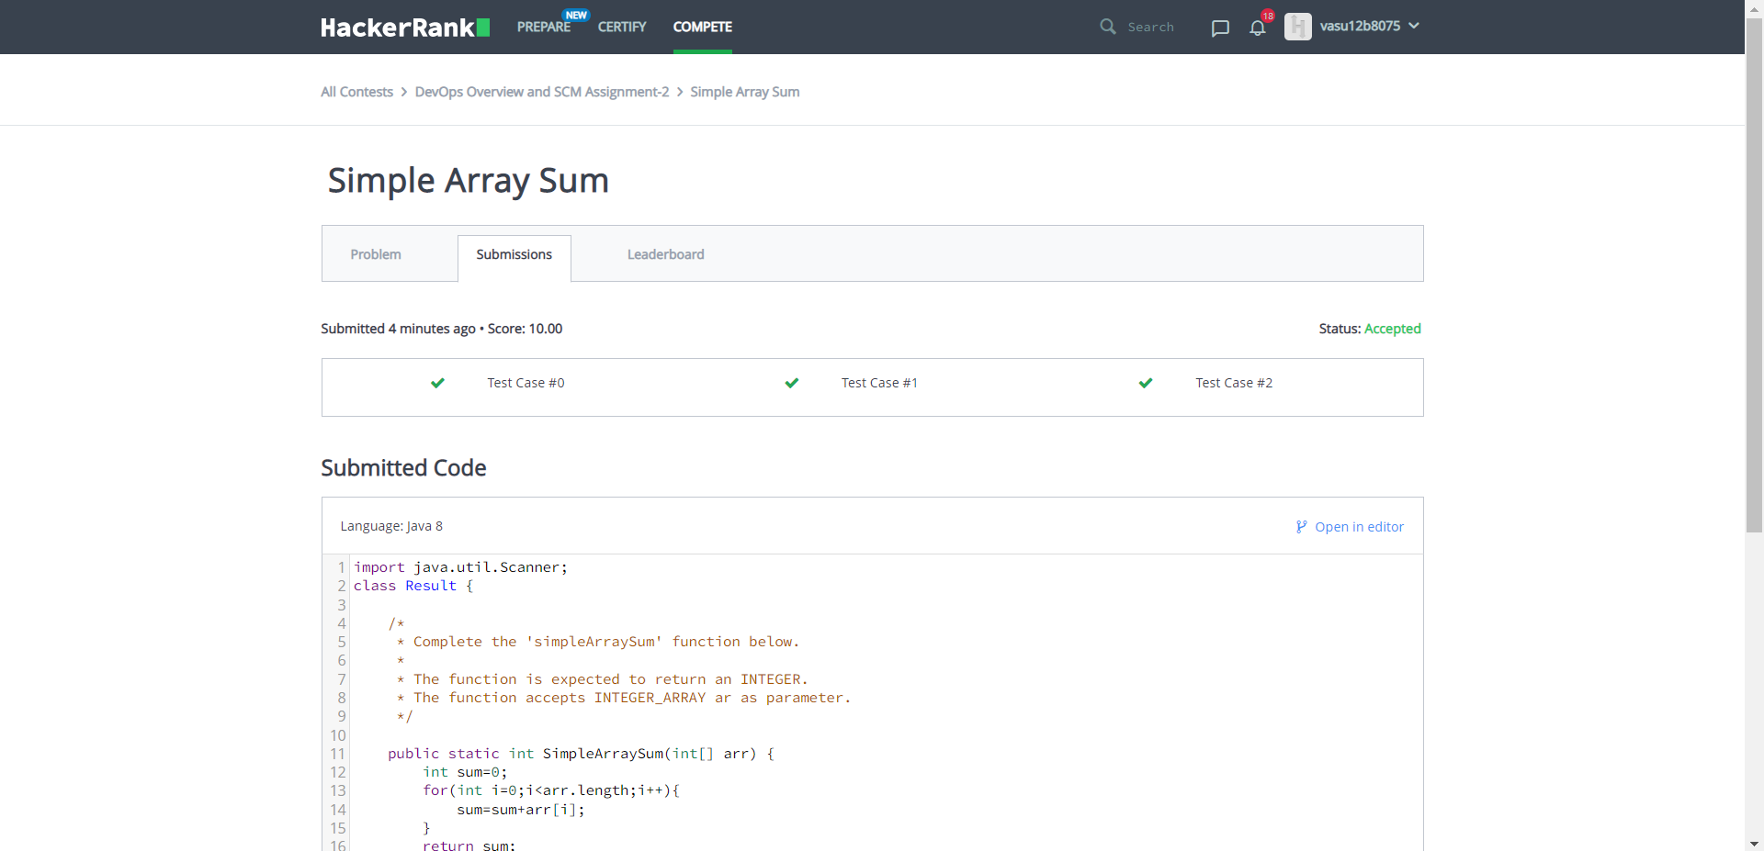

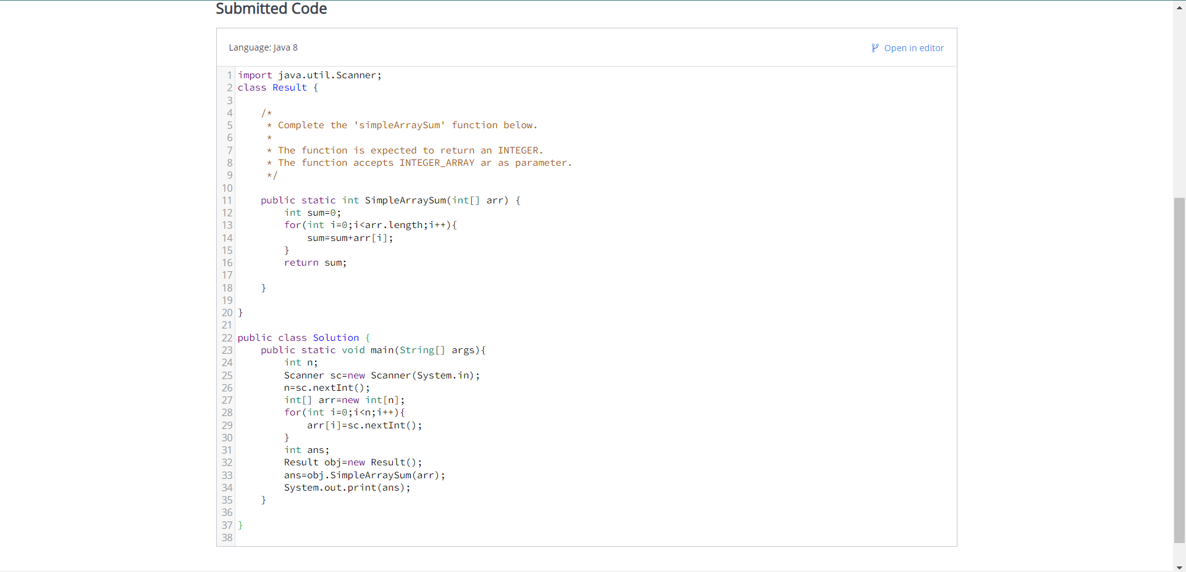

***Min-Max Sum***

