

AI-BASED OPERATOR FATIGUE DETECTION: AN INTELLIGENT APPROACH TO PREVENTING WORKPLACE ACCIDENTS

A Study Project Report submitted for
23ME2044 - INDUSTRIAL SAFETY ENGINEERING
(Internal Assessment III)
Team No.: 05
Submitted by:
Vasuki G (URK23AI1130)
Jola Keseena C (URK23AI1133)
Vidya Varshini R (URK23AI1109)

In partial fulfillment for the award of the degree of
BACHELOR OF TECHNOLOGY IN
ARTIFICIAL INTELLIGENCE AND MACHINE LEARNING
DIVISION OF MECHANICAL ENGINEERING
SCHOOL OF ENGINEERING AND TECHNOLOGY

NOVEMBER 2026

STUDENT DECLARATION
We hereby declare that this study project report titled "AI-Based Operator Fatigue Detection: An Intelligent Approach to Preventing Workplace Accidents" is the original work of our team, carried out as part of the course 23ME2044 Industrial Safety Engineering, Division of Mechanical Engineering, School of Engineering and Technology, Karunya Institute of Technology and Sciences, Coimbatore. All sources of information, standards, datasets, figures and text taken from others have been duly cited in the References. This work has not been submitted for any other course, degree or award.
The similarity (plagiarism) index of this report is 4% (limit: 15%). The use of AI tools, if any, has been declared in Appendix B. All datasets used are open and have been cited.

Reg. Number | Student Name | Date
URK23AI1130 | Vasuki G | 02/11/2026
URK23AI1133 | Jola Keseena C | 02/11/2026
URK23AI1109 | Vidya Varshini R | 02/11/2026
ABSTRACT
Operator fatigue is a human-factor hazard that reduces alertness and reaction time and is a recognised contributing cause of industrial accidents. Supervisor rounds and shift rules cannot detect an operator who is becoming dangerously inattentive between checks. This study designs and evaluates, by simulation, an AI-based fatigue detection concept in which a camera, facial-landmark detection and temporal decision rules identify prolonged eye closure, yawning and repeated head nodding and raise an early warning. The team reviewed twelve sources, the Factories Act, 1948, ISO 45001 and ISO 12100, and the 2005 BP Texas City refinery explosion as a fatigue-related case. The pipeline was implemented as a Python simulation of eye aspect ratio, mouth aspect ratio and head pitch signals at 30 frames per second. In the demonstration scenario, the sustained eye closure, the repeated yawning and the head-nodding cluster each triggered an alert, and none of the 32 natural blink-like dips did. A closure-duration threshold of 1.0 s detected all 1.5–4 s closures with no false alarms in two simulated hours, whereas 0.5 s produced about 66 false alarms per hour. The system is an engineering control that supports administrative controls such as rest breaks and does not replace them. Results are simulation-based, so field validation and privacy safeguards are needed before deployment. The study is linked to human factors, risk assessment, hierarchy of controls and the legal provisions on working hours.
Keywords: operator fatigue; industrial safety; computer vision; eye aspect ratio; facial landmarks; Factories Act, 1948; hierarchy of controls
TABLE OF CONTENTS
CHAPTER 1: INTRODUCTION 1
1.1 Background 1
1.2 Problem Statement 2
1.3 Objectives 2
1.4 Scope and Limitations 3
1.5 Relevance to Industrial Safety Engineering 3
CHAPTER 2: BACKGROUND OF THE SAFETY TOPIC 4
2.1 Hazards Related to the Topic 4
2.2 Accident Causes, Risk Assessment and Controls 5
2.3 Legal Provisions: Factories Act, 1948 3
2.4 Standards and Codes 6
2.5 Technology Background 7
CHAPTER 3: LITERATURE AND CASE-STUDY REVIEW 8
3.1 Review of Sources 8
3.2 Case Study 9
3.3 Research Gap 10
CHAPTER 4: METHODOLOGY 11
4.1 Study Approach 11
4.2 Data and Inputs Used 12
4.3 Design / Model / System Architecture 12
4.4 Tools and Evaluation Criteria 13
4.5 Work Plan and Task Division 13
CHAPTER 5: ANALYSIS, RESULTS AND DISCUSSION 15
5.1 Results 15
5.2 Comparison and Discussion 16
CHAPTER 6: SAFETY IMPLICATIONS AND COURSE OUTCOMES 18
6.1 Hazards Addressed and Safety Benefits 18
6.2 Risk Before and After 18
6.3 Compliance and Hierarchy of Controls 18
6.4 Limitations and Ethical Aspects 19
6.5 Mapping to Course Outcomes 19
CHAPTER 7: CONCLUSION AND FUTURE SCOPE 20
7.1 Conclusions 20
7.2 Recommendations 20
7.3 Future Scope 21
REFERENCES 22
APPENDIX A: CONTRIBUTION LOG OF TEAM MEMBERS 24
APPENDIX B: SUPPORTING MATERIAL 25

LIST OF FIGURES
Figure No. | Title | Page No.
Figure 1.1 | Industrial context of the study | 2
Figure 2.1 | Diagram or photograph of the principal hazard | 4
Figure 2.2 | Hierarchy of controls with the position of this project marked | 5
Figure 3.1 | Timeline or layout of the case studied | 10
Figure 4.1 | Methodology flowchart | 11
Figure 4.2 | System architecture / block diagram / circuit of the proposed work | 12
Figure 5.1 | Main result chart or output | 15
Figure 5.2 | Comparison chart | 17
Figure C.1 | Additional screenshot / photograph / schematic | 25

LIST OF TABLES
Table No. | Title | Page No.
Table 2.1 | Hazards, consequences and existing controls | 4
Table 2.2 | Factories Act provisions relevant to the project | 6
Table 2.3 | Standards referred to in this study | 6
Table 3.1 | Summary of the literature reviewed | 8
Table 4.1 | Data / inputs used | 12
Table 4.2 | Task division among team members | 13
Table 5.1 | Summary of key results | 16
Table 6.1 | Risk rating before and after the proposed control | 18
Table 6.2 | Mapping to course outcomes | 19

CHAPTER 1: INTRODUCTION

1.1 Background
Industrial plants such as refineries, power stations, foundries and machine shops depend on operators who must stay attentive through long periods of monitoring or repetitive work. When attention fails, a single missed alarm or delayed response can lead to injury, equipment damage or a process incident. The International Labour Organization (ILO) estimates that about 2.93 million workers died from work-related causes in 2019, and long working hours of 55 or more per week were the leading attributable occupational risk factor, linked to nearly 745,000 deaths in 2016 [3].
Fatigue is a state of reduced mental and physical capability caused by prolonged work, insufficient sleep, night work or monotony. Experimental evidence shows that after 17–19 hours without sleep, performance can be as impaired as at a blood alcohol concentration of 0.05% [10]. Its outward signs, namely prolonged eye closure, yawning and head nodding, can be observed by a camera without touching or distracting the operator.
Artificial intelligence (AI) offers a practical way to make this observation continuous. Face-landmark detectors now run in real time on low-cost hardware [13]–[15], and simple geometric measures such as the eye aspect ratio can be computed from them [12]. This report studies how such a system can act as an early-warning safeguard for industrial operators and judges it against the requirements of industrial safety engineering rather than technical accuracy alone.

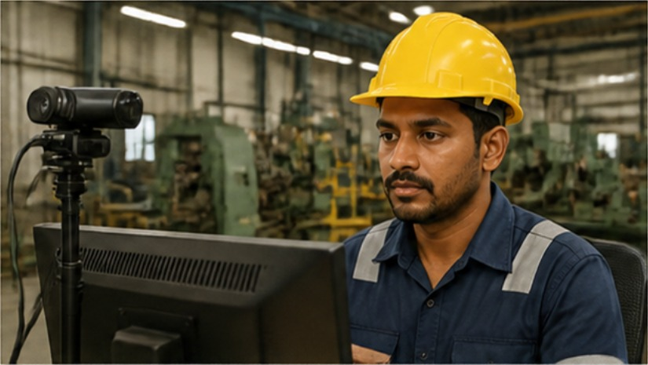
Figure 1.1: Industrial context of the study (Source: illustrative image from the team’s project poster)

1.2 Problem Statement
In process plants, workshops and control rooms, operators often work extended or night shifts with limited supervision. Traditional monitoring relies on periodic inspection, self-reporting and shift rules, none of which reveals an operator who is becoming dangerously inattentive at that moment. The result is delayed or missed responses that raise the likelihood of accidents, as in the BP Texas City incident, where investigators found operators were likely fatigued [7]. This project designs and evaluates, by simulation, an AI-based system that detects visual indicators of fatigue and gives an early warning to the operator and the supervisor.

1.3 Objectives
- To study operator fatigue as a human-factor hazard and the related Factories Act, 1948 provisions and standards.
- To review twelve sources and one real fatigue-related incident (BP Texas City, 2005).
- To design and simulate an AI-based pipeline that detects prolonged eye closure, yawning and head nodding and raises an alert when defined thresholds are exceeded.
- To evaluate the safety benefit and limitations of the system, including false alarms, missed detections and privacy.

1.4 Scope and Limitations
Included: a literature, legal and standards review; one case study; the design of the detection pipeline; a software simulation using synthetic landmark-derived signals at 30 frames per second; a threshold sensitivity analysis; and a qualitative risk rating. Excluded: a hardware prototype, training of a deep learning model, trials on real operators, and physiological sensing such as EEG or ECG. No personal video data were collected. The findings therefore describe the behaviour of the decision logic under stated assumptions and not field accuracy.

1.5 Relevance to Industrial Safety Engineering
This study is linked to CO1 & CO2 and to the syllabus topics on human factors in accident causation, hazard identification and risk assessment, hierarchy of controls and statutory provisions L2 & L3. Operator fatigue is a classic precursor of unsafe acts. The project shows how a technology from the team’s own discipline (AI and ML) can serve as an engineering safeguard, and how it must be judged against law, standards and ethics.

CHAPTER 2: BACKGROUND OF THE SAFETY TOPIC
This chapter explains the safety concepts behind the project title: how fatigue creates hazards, how accident causes and risks are classified, and which legal provisions, standards and technologies apply.

2.1 Hazards Related to the Topic
Fatigue is an ergonomic and psychosocial hazard, not a mechanical one, but it magnifies every other hazard in the workplace. Fatigued operators show slower reactions, narrowed attention, poorer decisions and micro-sleeps lasting a few seconds [9], [10]. In machine operation these lapses can lead to contact with moving parts, crane or vehicle collisions, missed alarms in control rooms and wrong valve or switch operations in process plants (Figure 2.1). Table 2.1 summarises the principal fatigue-related hazards and the controls normally used.

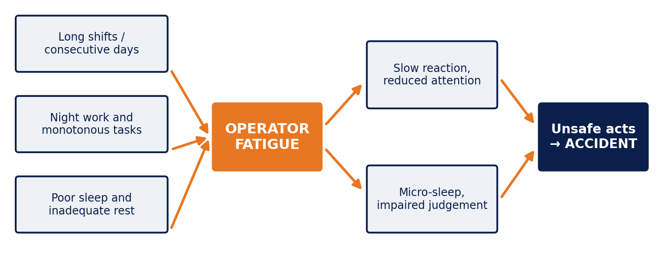
Figure 2.1: Diagram or photograph of the principal hazard: causal chain from fatigue-inducing conditions to accidents (Source: prepared by the team, adapted from [9], [10])
Table 2.1: Hazards, consequences and existing controls
Hazard | Where it occurs | Possible consequence | Existing control
Micro-sleep / prolonged eye closure | Machine tools, press shops, cranes, forklifts | Contact with moving parts, crushing, collision | Supervisor rounds, guards and interlocks, rest breaks
Attention lapse in monitoring tasks | Control rooms, SCADA stations, CCTV desks | Missed alarm, delayed response, process upset | Alarm management, shift rotation, buddy checks
Slow reaction and poor judgement | Process plants during start-up and shutdown | Incorrect valve or switch operation, fire, explosion | SOPs, permit-to-work, hours-of-work limits
Head nodding / loss of posture | Console operators, plant vehicle drivers | Loss of control, collision, ergonomic injury | Driver training, speed limiters, rest areas

2.2 Accident Causes, Risk Assessment and Controls
Accidents are commonly traced to unsafe acts by people and unsafe conditions in the workplace [1], [2]. A fatigue-induced lapse is an unsafe act of the slip-and-lapse type [9], but its root cause usually lies in the system, such as long shifts, inadequate rest or poor scheduling. A lapse that causes no injury is a near miss, and logging such events gives early evidence of a developing problem. Risk is estimated as likelihood multiplied by severity (L × S) [20].
The hierarchy of controls ranks measures from most to least effective: elimination, substitution, engineering controls, administrative controls and personal protective equipment (PPE) [5]. Eliminating fatigue means designing work and rest schedules that prevent it, which is an administrative measure. An AI fatigue detector is an engineering control that detects the unsafe state and warns, but it does not remove the cause (Figure 2.2). Its value depends on an administrative response such as a rest break or task reassignment.

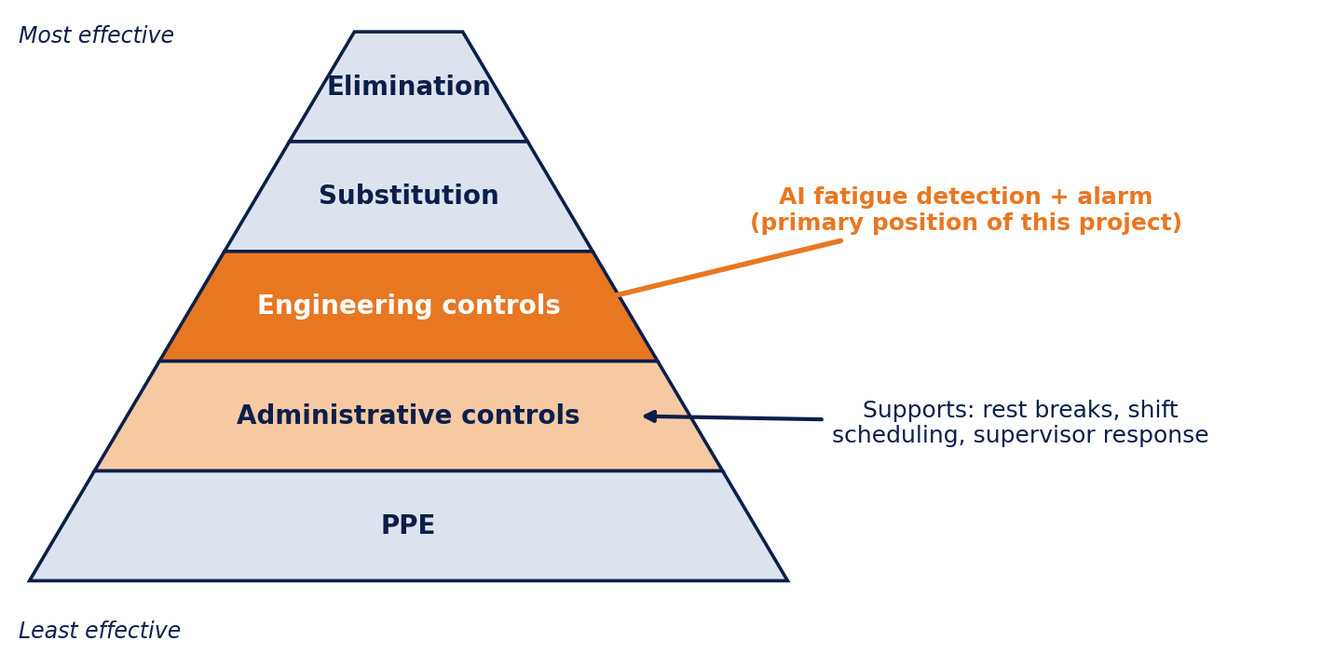
Figure 2.2: Hierarchy of controls with the position of this project marked (Source: prepared by the team, based on [5])

2.3 Legal Provisions: Factories Act, 1948
The Factories Act, 1948 [4] does not mention AI monitoring, but its general duties and hours-of-work provisions define the legal setting in which fatigue must be controlled. Table 2.2 lists the provisions most relevant to this project.
Table 2.2: Factories Act provisions relevant to the project
Section | Subject | Relevance to this project
Sec. 7A | General duties of the occupier | Requires safe systems of work and arrangements for the health and safety of workers; fatigue monitoring supports this duty.
Sec. 40B | Safety officers | In factories above the prescribed size or with hazardous processes, the safety officer can use alert logs to review fatigue exposure.
Secs. 51, 54 | Weekly hours and daily hours | Limit work to 48 hours a week and 9 hours a day; hour limits control fatigue exposure but cannot detect an individual’s state.
Secs. 55, 56 | Intervals for rest; spread over | No work beyond five hours without a rest interval of at least half an hour; spread over limited to ten and a half hours. Alerts can prompt extra breaks.
Sec. 41G | Workers’ participation in safety management | A monitoring policy should be discussed with worker representatives to build trust and address privacy.
Sec. 88 | Notice of certain accidents | Event logs help establish whether fatigue contributed to a reportable accident.

2.4 Standards and Codes
Table 2.3 lists the standards and codes that guided the design and evaluation. They give the management and risk-assessment framework within which a fatigue detector should be used.
Table 2.3: Standards referred to in this study
Standard | Scope | Use in this project
ISO 45001:2018 [5] | Occupational health and safety management systems | Hierarchy of controls (cl. 8.1.2), performance monitoring (cl. 9.1) and incident investigation (cl. 10.2).
ISO 12100:2010 [6] | Safety of machinery: risk assessment and risk reduction | Basis for the risk assessment and risk-reduction approach used in Section 6.2.
ISO 31000:2018 [20] | Risk management guidelines | Framework for the 1–5 likelihood and severity rating.
API RP 755 [8] | Fatigue risk management systems for refining and petrochemical personnel | Places the detector as one monitoring layer within a wider fatigue risk management system.

2.5 Technology Background
The proposed system follows four stages: image capture, face and landmark detection, fatigue feature extraction, and alert generation. A fixed camera, ideally with near-infrared illumination for night work, captures the operator at about 30 frames per second.
Face detection locates the face in each frame. A landmark detector then marks fixed points on the eyes, mouth, nose and jaw. Widely used options are the ensemble-of-regression-trees method implemented in the dlib library, which gives 68 points [13], [14], and the MediaPipe face mesh, which gives 468 points in real time on mobile hardware [15].
Three features are computed from the landmarks. The eye aspect ratio (EAR) is EAR = (|p2 − p6| + |p3 − p5|) / (2 |p1 − p4|), where p1 to p6 are the eye landmarks (Figure C.1) [12]. It stays roughly constant while the eye is open and falls toward zero as the eye closes. The mouth aspect ratio (MAR) is built the same way from mouth landmarks and rises during a yawn. Head pitch, the forward tilt of the head, is estimated from the landmarks by a head-pose method. A related measure, PERCLOS, is the proportion of time the eyelids are mostly closed in a time window and is an established alertness indicator [11].
A single frame is unreliable, so temporal logic is applied. A normal blink lasts a fraction of a second, whereas a fatigue-related closure lasts longer. The system therefore raises an alert only when a cue persists or repeats, as defined in Section 4.3. Processing on a local edge device, with only event logs stored, reduces both network dependence and privacy risk.

CHAPTER 3: LITERATURE AND CASE-STUDY REVIEW
The sources reviewed fall into four groups: safety textbooks and human-error theory, evidence on fatigue and performance, industrial fatigue management guidance, and computer-vision methods for detecting fatigue. They are compared rather than only listed.

3.1 Review of Sources
Table 3.1: Summary of the literature reviewed
No. | Author / Year | Source type | Focus | Key finding / limitation
1 | L. M. Deshmukh, 2005 [1] | Textbook | Hazard identification, accident causation, risk control | Frames unsafe acts and conditions and the control approach; predates AI monitoring.
2 | D. L. Goetsch, 2019 [2] | Textbook | Safety management, human factors, legal and ethical duties | Stresses management responsibility and training; offers no real-time fatigue sensing.
3 | J. Reason, 1990 [9] | Book | Human error, slips, lapses and latent failures | Lapses are predictable system outcomes, so detection must be paired with management action.
4 | A. Williamson and A.-M. Feyer, 2000 [10] | Journal paper | Sleep loss and performance | 17–19 h awake gives impairment comparable to 0.05% blood alcohol; laboratory based, not plant specific.
5 | CSB, 2007 [7] | Investigation report | BP Texas City explosion | Operators were likely fatigued after 12-hour shifts for up to 29 or more consecutive days; no sector fatigue guideline existed.
6 | API, 2010 [8] | Industry standard | Fatigue risk management systems | Sets a management framework built on scheduling and reporting; does not give real-time detection.
7 | D. F. Dinges and R. Grace, 1998 [11] | Technical report | PERCLOS | Eyelid closure proportion is a valid alertness indicator; needs reliable eye tracking.
8 | T. Soukupová and J. Čech, 2016 [12] | Conference paper | Eye aspect ratio for blink detection | A simple landmark ratio detects eye closure in real time; sensitive to head pose and occlusion.
9 | V. Kazemi and J. Sullivan, 2014 [13]; D. E. King, 2009 [14] | Conference paper; journal | Landmark detection; dlib library | Fast, accurate 68-point alignment; accuracy falls at extreme pose and low light.
10 | Y. Kartynnik et al., 2019 [15] | Preprint | MediaPipe face mesh | 468-point mesh in real time on mobile GPUs; behaviour under helmets or masks not reported.
11 | A. Sahayadhas et al., 2012 [16] | Review | Drowsiness detection from vehicle, physiological and behavioural measures | Camera-based methods are non-contact; physiological sensors are more direct but intrusive. Focus is on drivers.
12 | M. Ramzan et al., 2019 [17] | Survey | Drowsiness detection techniques | Compares behavioural, physiological and hybrid methods; notes sensitivity to environment and individual variation.
Taken together, the sources show strong evidence that fatigue impairs performance [9], [10], incident evidence that it contributes to industrial disasters [7], management frameworks that depend on scheduling [8], and mature computer-vision methods developed mainly for drivers [11]–[17]. Physiological sensors are more direct but intrusive. Camera-based methods are non-contact but depend on lighting, camera position and occlusion.

3.2 Case Study
What happened. On 23 March 2005, explosions and fires during the start-up of the isomerization (ISOM) unit at BP’s Texas City refinery killed 15 people and injured 180 [7]. Flammable liquid overfilled a distillation tower and was released through a blowdown drum, and the resulting vapour cloud ignited.
Causes. The U.S. Chemical Safety and Hazard Investigation Board (CSB) concluded that organizational and safety deficiencies at all levels of BP caused the disaster, including cost-cutting and production pressure. It also concluded that the ISOM operators were likely fatigued, having worked 12-hour shifts for 29 or more consecutive days, and that impaired judgement and problem-solving contributed to the failure to respond to abnormal readings [7].
Consequences and lessons. Besides the deaths and injuries, the loss was among the worst U.S. industrial accidents in years. The CSB found that no widely accepted fatigue-prevention guideline existed in the oil and chemical sector and recommended that industry and union bodies develop one limiting hours and days of work [7]. The American Petroleum Institute later issued API RP 755 [8]. The lesson for this project is twofold. An operator-state monitor could give an independent early warning of degraded alertness. However, the main failures were organisational, so detection must complement and never replace hour limits, staffing and training.

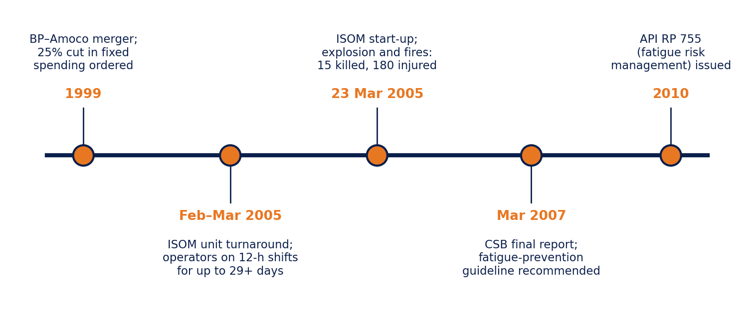
Figure 3.1: Timeline or layout of the case studied: BP Texas City incident and fatigue-related follow-up (Source: prepared by the team from [7], [8])

3.3 Research Gap
In the sources reviewed, computer-vision fatigue detection is studied mainly for vehicle drivers [16], [17], while industrial fatigue guidance relies on scheduling and self-reporting [8]. Few studies treat camera-based detection as an industrial safety control to be assessed against the hierarchy of controls, the Factories Act and privacy obligations. This project addresses that gap by designing the detector for fixed-position industrial operators and evaluating its threshold behaviour, risk benefit, legal fit and ethical limits together.

CHAPTER 4: METHODOLOGY
The work is described so that another team can repeat it. Because no real operator video was collected, the evaluation is based on a documented simulation whose parameters are stated in Sections 4.2 to 4.4.

4.1 Study Approach
The study followed a desk-research and simulation approach (Figure 4.1). The problem was defined from the hazard of operator fatigue, and the literature, case study, legal provisions and standards were reviewed. Fatigue indicators were then chosen, a detection pipeline and decision rules were designed, and the pipeline was implemented as a simulation. Scenario runs and a threshold sensitivity analysis gave the results, which were assessed for safety benefit, risk reduction and limitations.

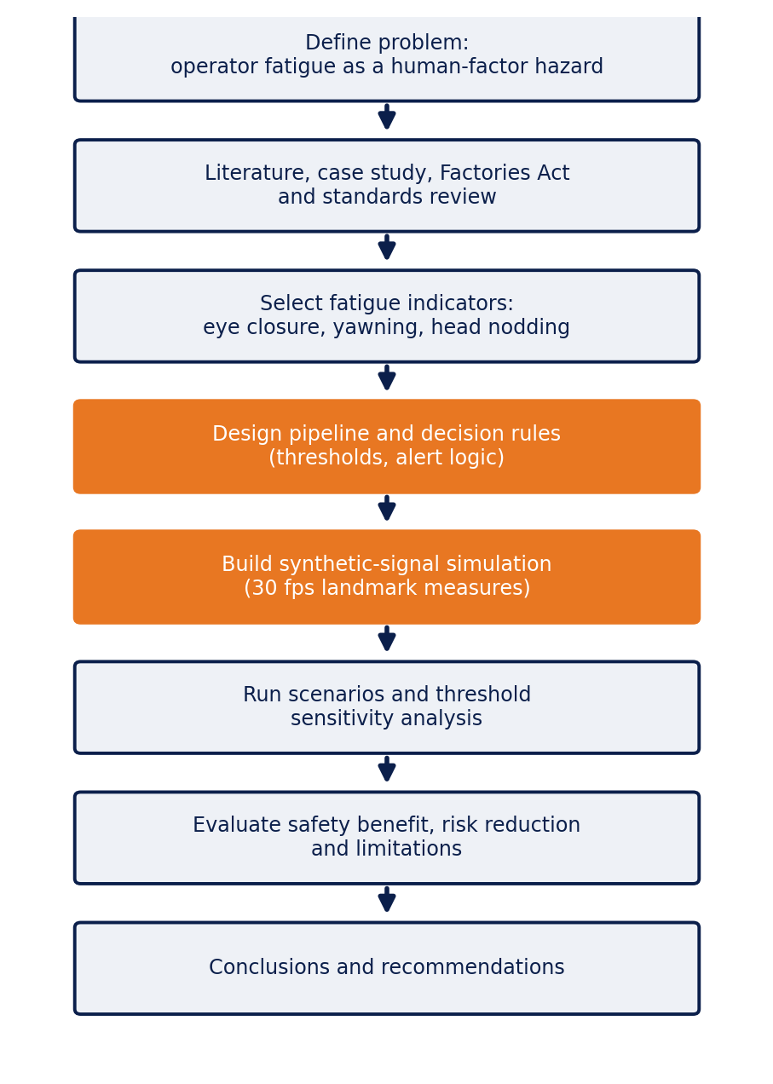
Figure 4.1: Methodology flowchart (Source: prepared by the team)

4.2 Data and Inputs Used
No video of real operators was collected, to avoid privacy and consent issues at this stage. The inputs in Table 4.1 were used instead. Open datasets such as YawDD [18] are proposed for the future validation stage.
Table 4.1: Data / inputs used
Data / Input | Source (link) | Size / Period | Use
Synthetic EAR, MAR and head-pitch signals | Generated by the team’s Python script (Appendix B) | One 130 s demonstration trace; 120 runs of 60 s (alert operator) and 400 runs of 30 s (closure events) per threshold; 30 fps | Test of decision logic and threshold sensitivity
BP Texas City investigation report | CSB, 2007 [7]; www.csb.gov | Final report, March 2007 | Case study
Global occupational fatality estimates | ILOSTAT [3] | 2019 and 2016 estimates | Background and statistics
The Factories Act, 1948 | Government of India [4]; indiacode.nic.in | Act No. 63 of 1948, as amended | Legal review
Fatigue indicator definitions | Literature [11], [12] | EAR, PERCLOS | Starting values of thresholds

4.3 Design / Model / System Architecture

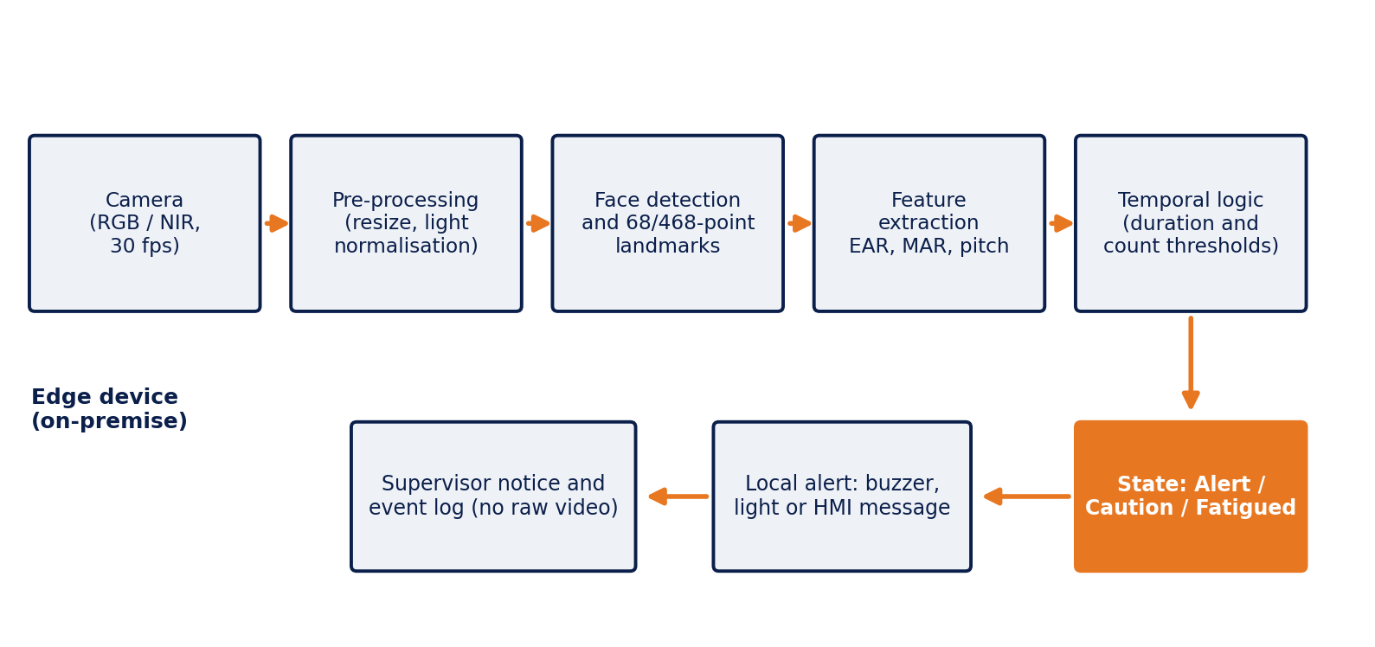
Figure 4.2: System architecture / block diagram of the proposed work (Source: prepared by the team)
Figure 4.2 shows the proposed architecture. The camera feeds a pre-processing stage and a landmark detector. Feature extraction computes EAR, MAR and head pitch for each frame, and a temporal logic stage converts them into one of three states: Alert, Caution or Fatigued. The decision rules used in the simulation are:
- Closure rule: EAR below 0.22 continuously for at least 1.0 s raises a Fatigued alert.
- Yawn rule: MAR above 0.60 for at least 1.5 s counts as a yawn. One yawn sets Caution, and two yawns within 120 s raise a Fatigued alert.
- Nod rule: head pitch above 15° for at least 0.4 s counts as a nod, and three nods within 20 s raise a Fatigued alert.
The simulation generates 30 fps signals with the following assumptions made by the team. The baseline EAR is 0.30 with Gaussian noise (standard deviation 0.025). Natural blinks occur every 2.5–5.5 s, last 0.08–0.45 s (mean 0.2 s) and lower EAR to about 0.10. Measurement artifacts representing glare, PPE occlusion and landmark jitter occur at about 3 per minute and lower EAR to 0.12–0.20 for 0.1–0.7 s. A yawn raises MAR to about 0.78, a nod adds about 24° of pitch, and a sustained closure holds EAR near 0.11. These values are plausible but assumed, and they must be recalibrated with real footage.

4.4 Tools and Evaluation Criteria
The simulation was written in Python 3 with NumPy and Matplotlib. For deployment, OpenCV with dlib or MediaPipe is proposed. The results are judged with the following criteria.
Detection rate (%) = closure events that raised an alert / closure events injected × 100.
False alarms per hour = alerts raised on alert-state signals (blinks and artifacts only) / simulated hours.
Detection latency (s) = time from the start of a closure to the alert.
Frequency and severity rates were not used because no accident data were analysed. Risk is rated as L × S on a 1–5 scale [20]. In a field trial, precision, recall and false-alarm rate against a human-rated ground truth would be added.

4.5 Work Plan and Task Division
Table 4.2: Task division among team members
Member (Reg. No.) | Role | Tasks carried out
Vasuki G (URK23AI1130) | Documentation Lead | Risk assessment, discussion, report compilation, and formatting
Jola Keseena C (URK23AI1133) | Researcher | Literature review, case study, legal provisions, and standards
Vidya Varshini R (URK23AI1109) | Concept Designer | Designed system workflow, created technical diagrams, and developed conceptual simulation logic

CHAPTER 5: ANALYSIS, RESULTS AND DISCUSSION
This chapter presents the output of the simulation. All results come from synthetic signals generated under the assumptions in Section 4.3 and show how the decision logic behaves. They are not measurements of accuracy on real operators.

5.1 Results
Figure 5.1 shows a 130 s demonstration trace containing two yawns, a cluster of four head nods and one 3.5 s eye closure. The first yawn was recorded as a Caution event and produced no alert. The second yawn, about 36 s later, raised an alert at 60.2 s. The third and fourth nods raised alerts at 96.6 s and 99.6 s. The sustained closure beginning at 112.0 s raised an alert at 113.0 s, which is 1.0 s after onset, as set by the closure rule. The trace also contained 32 blink-like dips and measurement artifacts, the longest lasting 0.73 s, and none of them raised an alert.

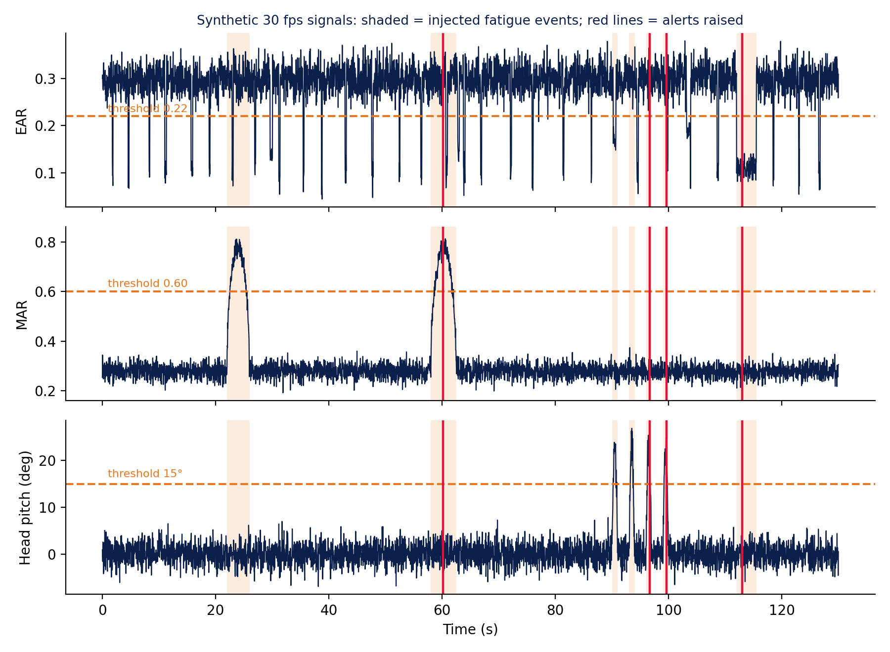
Figure 5.1: Main result chart or output: simulated EAR, MAR and head-pitch signals with injected fatigue events and alerts (Source: team simulation, synthetic data)
Table 5.1: Summary of key results
Parameter / Indicator | Value | Observation
Blink-like dips in the 130 s trace | 32 dips, 0 alerts | Longest dip 0.73 s, below the 1.0 s closure criterion
Sustained closure (3.5 s at t = 112 s) | Alert at 113.0 s | Latency 1.0 s, equal to the closure threshold by design
Yawns (2 injected) | 1 Caution, 1 alert (60.2 s) | Alert needs two yawns within 120 s to avoid reacting to a single normal yawn
Head nods (4 injected) | Alerts at 96.6 s and 99.6 s | Alert starts at the third nod within 20 s
Closure threshold 1.0 s (selected) | Detection 100%; 0 false alarms in 2 h; mean latency 0.97 s | Best balance of detection, false alarms and latency
Closure threshold 0.5 s | Detection 100%; 66 false alarms per hour | Normal blinks and artifacts trigger frequent alarms
Closure threshold 2.0 s | Detection 82%; 0 false alarms in 2 h | Closures of 1.5–2 s end before the alert and are missed

5.2 Comparison and Discussion
Figure 5.2 compares five closure-duration thresholds. A 0.5 s threshold detected every closure but produced about 65 false alarms per hour, because normal blinks and short artifacts exceeded it. Frequent false alarms lead operators to ignore alerts, which defeats the safety purpose. At 0.75 s, a few false alarms remained. At 1.0 s and 1.5 s there were no false alarms in two simulated hours and all closures of 1.5–4 s were detected. At 2.0 s, about 18% of the closures were missed because they ended before the alert. The threshold of 1.0 s was therefore selected. With zero events in two simulated hours, the true false-alarm rate is only known to be low, and it must be confirmed in the field.
The results agree with the literature in principle. Duration-based eye-closure measures such as PERCLOS are considered more informative of alertness than isolated frames [11], and a simple EAR dip is a good closure cue [12]. Real performance is expected to be lower, because glare, helmets, masks, glasses, camera angle and individual differences, noted in the surveys [16], [17], are only roughly represented here by the artifact model. Compared with scheduling alone [8], the detector adds a real-time view of the individual operator. Compared with physiological sensors, it is non-contact but less direct. A latency near 1 s is short relative to micro-sleeps lasting seconds, but a warning may still be too late during a high-hazard task, so highly hazardous machines should additionally be interlocked. The main limitation of the data is that they are synthetic and parameter-dependent.

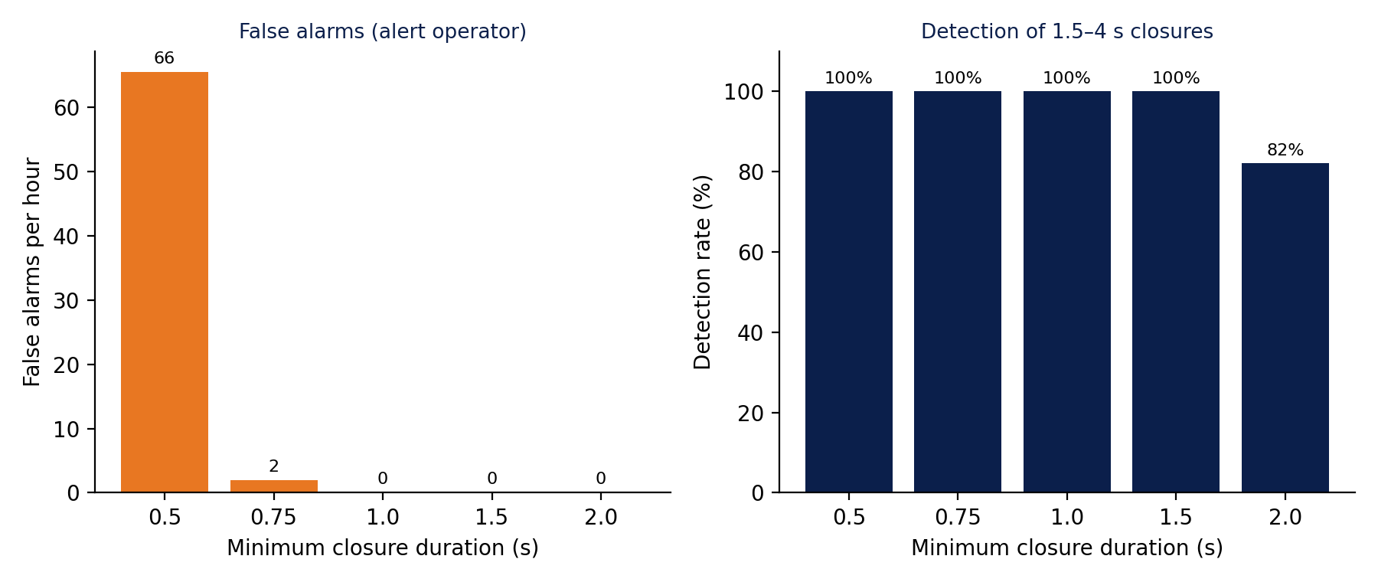
Figure 5.2: Comparison chart: effect of the closure-duration threshold on false alarms and detection (Source: team simulation, synthetic data)

CHAPTER 6: SAFETY IMPLICATIONS AND COURSE OUTCOMES

6.1 Hazards Addressed and Safety Benefits
The detector addresses the four fatigue-related hazards in Table 2.1: micro-sleep and prolonged eye closure, attention lapses in monitoring, slow reaction and poor judgement, and head nodding. The benefits are faster detection of an unsafe state (about 1 s after a sustained closure in the simulation), a prompt for a rest break or task change before an incident, objective event logs for fatigue risk management and support for preventive safety management. It does not remove root causes such as long shifts and does not address non-fatigue hazards.

6.2 Risk Before and After
Each hazard was rated on a 1–5 scale for likelihood (L) and severity (S), with risk = L × S. Ratings of 15 or more are treated as high, 8–14 as medium and below 8 as low. The ratings are the team’s judgement. The “after” values assume an alert is acted on promptly and reduce likelihood only, since severity of an accident is unchanged.
Table 6.1: Risk rating before and after the proposed control
Hazard | L | S | Risk (before) | Risk (after) | Control applied
Micro-sleep / prolonged eye closure at machine | 4 | 5 | 20 (High) | 10 (L = 2, Medium) | Closure rule (≥ 1.0 s) with audible alert and supervisor notice
Attention lapse in control-room monitoring | 4 | 4 | 16 (High) | 8 (L = 2, Medium) | Yawn and closure cues, Caution state, scheduled breaks
Slow reaction and poor judgement | 3 | 5 | 15 (High) | 10 (L = 2, Medium) | Combined cues; logs used to adjust shift schedules
Head nodding / loss of posture | 3 | 4 | 12 (Medium) | 8 (L = 2, Medium) | Nod rule (3 nods in 20 s) with alert

6.3 Compliance and Hierarchy of Controls
In the hierarchy of controls the detector is an engineering control that supports administrative controls (Figure 2.2). It helps the occupier meet the general duty under Sec. 7A of the Factories Act [4] and provides evidence for safety officers under Sec. 40B and for accident notices under Sec. 88. It does not replace the hour and rest limits in Secs. 51–56, which must still be met. Under ISO 45001 it contributes to risk reduction by the hierarchy of controls (cl. 8.1.2), to performance monitoring (cl. 9.1) and to incident investigation (cl. 10.2) [5], and it can serve as one monitoring layer within an API RP 755 fatigue risk management system [8]. Under Sec. 41G, the policy should be developed with worker representatives.

6.4 Limitations and Ethical Aspects
Technical limitations. Poor lighting and camera positioning, PPE obstruction by masks, helmets and safety glasses, individual differences in eye shape, and head pose can degrade landmark detection. False alarms and missed detections are both possible. The present results come from simulation with assumed parameters and have not been validated on real operators.
Ethical aspects. Continuous video monitoring raises privacy and dignity concerns. In India, processing personal data is subject to the Digital Personal Data Protection Act, 2023 [19], so the purpose, notice and consent or lawful basis must be defined. Recommended safeguards are on-device processing, storing event logs rather than video, a written policy that limits use to safety and not discipline, human review of every alert, testing across different faces and skin tones to limit bias, and secure handling of camera feeds. Accountability stays with the occupier and supervisors, and the alert is advisory only.

6.5 Mapping to Course Outcomes
Table 6.2: Mapping to course outcomes
CO | CO statement | Syllabus topic (L no.) | Evidence in report
CO2 | Evaluate the safety performance of an organization from accident records. | Human factors and accident causation (L8,9,10) | Sections 2.1, 2.2 and 3.2
CO3 | Identify the industrial hazards and minimize or eliminates the risk faced. | Hazard identification and risk assessment (L15) | Table 2.1, Section 6.2 and Table 6.1
CO1 | Understand the various basic concepts and its importance of safety in process industries. | Hierarchy of controls and safety management (L4,34) | Figure 2.2 and Section 6.3
CO5 | Understand the health and welfare provisions given in the Factories Act. | Legal provisions and standards (L2,3) | Tables 2.2 and 2.3 and Section 6.3

CHAPTER 7: CONCLUSION AND FUTURE SCOPE

7.1 Conclusions
- Objective 1 (study the hazard, law and standards): Fatigue acts as a hazard multiplier. Secs. 7A, 40B, 41G, 51–56 and 88 of the Factories Act, ISO 45001, ISO 12100, ISO 31000 and API RP 755 define the legal and management setting (Chapter 2).
- Objective 2 (review sources and a case): Twelve sources and the BP Texas City case, where operators had worked 12-hour shifts for 29 or more consecutive days, show that fatigue is a documented contributor to major accidents and that no widely used detection practice existed (Chapter 3).
- Objective 3 (design and simulate the detector): A camera, landmark and temporal-rule pipeline was designed and simulated. A 1.0 s closure threshold detected 100% of 1.5–4 s closures with no false alarms in two simulated hours and a mean latency of 0.97 s, while 0.5 s gave about 65 false alarms per hour and 2.0 s missed about 18% of closures (Chapter 5).
- Objective 4 (evaluate benefit and limitations): The detector reduces the rated risk of four fatigue-related hazards from 12–20 to 8–10 under the stated assumptions (Table 6.1). Lighting, PPE, false alarms and privacy remain real limits that need field validation (Chapter 6).

7.2 Recommendations
1. Deploy AI fatigue detection only as one layer in a fatigue risk management system. Keep compliance with the hour and rest limits of Secs. 51–56, adequate staffing and rest facilities.
2. Define the response to an alert in the SOP, for example a break, task handover or supervisor check, because the detector only works if someone acts on it. Log alerts and use them to review shift schedules.
3. Before deployment, consult workers under Sec. 41G, define the data policy (on-device processing, no raw video storage, no disciplinary use) and pilot the system with calibration for lighting, camera position and PPE.

7.3 Future Scope
Future work should validate the pipeline on open datasets such as YawDD [18] and then on consented footage from a real plant, report precision, recall and false-alarm rate, and recalibrate the thresholds per operator. A hardware prototype with near-infrared illumination on an edge device is the next step. The system could also be integrated with plant alarms, interlocks and shift-management software, and extended with other cues such as posture and task-performance data.

REFERENCES
[1] L. M. Deshmukh, Industrial Safety Management: Hazard Identification and Risk Control, Tata McGraw-Hill, New Delhi, 2005. (Course textbook 1)
[2] D. L. Goetsch, Occupational Safety and Health for Technologists, Engineers, and Managers, 9th ed., Pearson, New York, 2019. (Course textbook 2)
[3] International Labour Organization (ILOSTAT), “The right to occupational safety and health still unrealized.” [Online]. Available: https://ilostat.ilo.org/blog/the-right-to-occupational-safety-and-health-still-unrealized/. [Accessed: 02-11-2026].
[4] Government of India, “The Factories Act, 1948 (Act No. 63 of 1948),” as amended. [Online]. Available: https://www.indiacode.nic.in. [Accessed: 02-11-2026].
[5] ISO 45001:2018, Occupational health and safety management systems: Requirements with guidance for use, International Organization for Standardization, 2018.
[6] ISO 12100:2010, Safety of machinery: General principles for design, Risk assessment and risk reduction, International Organization for Standardization, 2010.
[7] U.S. Chemical Safety and Hazard Investigation Board, Investigation Report: Refinery Explosion and Fire, BP Texas City, Texas, March 23, 2005, Report No. 2005-04-I-TX, Mar. 2007. [Online]. Available: https://www.csb.gov. [Accessed: 02-11-2026].
[8] American Petroleum Institute, API RP 755: Fatigue Risk Management Systems for Personnel in the Refining and Petrochemical Industries, 1st ed., Washington, DC, 2010.
[9] J. Reason, Human Error, Cambridge University Press, Cambridge, 1990.
[10] A. M. Williamson and A.-M. Feyer, “Moderate sleep deprivation produces impairments in cognitive and motor performance equivalent to legally prescribed levels of alcohol intoxication,” Occupational and Environmental Medicine, vol. 57, no. 10, pp. 649–655, 2000.
[11] D. F. Dinges and R. Grace, “PERCLOS: A valid psychophysiological measure of alertness as assessed by psychomotor vigilance,” Federal Highway Administration, Tech Brief FHWA-MCRT-98-006, 1998.
[12] T. Soukupová and J. Čech, “Real-time eye blink detection using facial landmarks,” in Proc. 21st Computer Vision Winter Workshop (CVWW), Rimske Toplice, Slovenia, 2016.
[13] V. Kazemi and J. Sullivan, “One millisecond face alignment with an ensemble of regression trees,” in Proc. IEEE Conf. Computer Vision and Pattern Recognition (CVPR), 2014, pp. 1867–1874.
[14] D. E. King, “Dlib-ml: A machine learning toolkit,” Journal of Machine Learning Research, vol. 10, pp. 1755–1758, 2009.
[15] Y. Kartynnik, A. Ablavatski, I. Grishchenko and M. Grundmann, “Real-time facial surface geometry from monocular video on mobile GPUs,” arXiv:1907.06724, 2019.
[16] A. Sahayadhas, K. Sundaraj and M. Murugappan, “Detecting driver drowsiness based on sensors: A review,” Sensors, vol. 12, no. 12, pp. 16937–16953, 2012.
[17] M. Ramzan, H. U. Khan, S. M. Awan, A. Ismail, M. Ilyas and A. Mahmood, “A survey on state-of-the-art drowsiness detection techniques,” IEEE Access, vol. 7, pp. 61904–61919, 2019.
[18] S. Abtahi, M. Omidyeganeh, S. Shirmohammadi and B. Hariri, “YawDD: A yawning detection dataset,” in Proc. 5th ACM Multimedia Systems Conference, 2014, pp. 24–28.
[19] Government of India, “The Digital Personal Data Protection Act, 2023 (Act No. 22 of 2023).” [Online]. Available: https://www.indiacode.nic.in. [Accessed: 02-11-2026].
[20] ISO 31000:2018, Risk management: Guidelines, International Organization for Standardization, 2018.

APPENDIX A: CONTRIBUTION LOG OF TEAM MEMBERS
No. | Name (Reg. No.) | Branch | Work done (chapters, tasks, analysis, coding, slides) | Approx. % contribution
1 | Vasuki G (URK23AI1130) | B.Tech AI & ML | Designed the system workflow, developed the Python simulation code, and generated all technical figures. | 33%
2 | Jola Keseena C (URK23AI1133) | B.Tech AI & ML | Drafted Chapters 1 and 2, compiled safety standards, and prepared Review I presentation slides. | 34%
3 | Vidya Varshini R (URK23AI1109) | B.Tech AI & ML | Designed the overall system workflow, created the technical diagrams for the poster and report, and developed the conceptual simulation logic. | 33%

APPENDIX B: SUPPORTING MATERIAL
B.1 Declaration of AI tool use. A generative AI assistant (Claude, by Anthropic) was used to help draft the text of this report, generate the figures and run the synthetic simulation. The team has reviewed and edited the content and is responsible for it.
The team has thoroughly reviewed, verified, and edited all AI-generated content to ensure technical accuracy and takes full responsibility for the final submission.
B.2 Decision-logic extract (Python). The full simulation code, which generates the synthetic signals and Figures 5.1 and 5.2, is available from the team on request. https://github.com/vasuki2756/AI-based-fatigue-decision.git
def detect(t, ear, mar, pit, Tc=1.0, EAR_T=0.22, MAR_T=0.60,
Ty=1.5, PIT_T=15.0, Tn=0.4, FPS=30):
closed, yawn, nod = ear < EAR_T, mar > MAR_T, pit > PIT_T
cl = runs(closed, Tc) # (start, end, alert_time) of runs >= Tc seconds
yw = runs(yawn, Ty)
nd = runs(nod, Tn)
alerts = [("closure", c) for a, b, c in cl]
yt = [c for a, b, c in yw]; nt = [c for a, b, c in nd]
alerts += [("yawn", yt[k]) for k in range(1, len(yt))
if yt[k] - yt[k-1] <= 120] # 2 yawns in 120 s
alerts += [("nod", nt[k]) for k in range(2, len(nt))
if nt[k] - nt[k-2] <= 20] # 3 nods in 20 s
return sorted(alerts, key=lambda a: a[1])
B.3 Additional figure. Figure C.1 shows the six eye landmarks and the EAR formula referred to in Section 2.5.

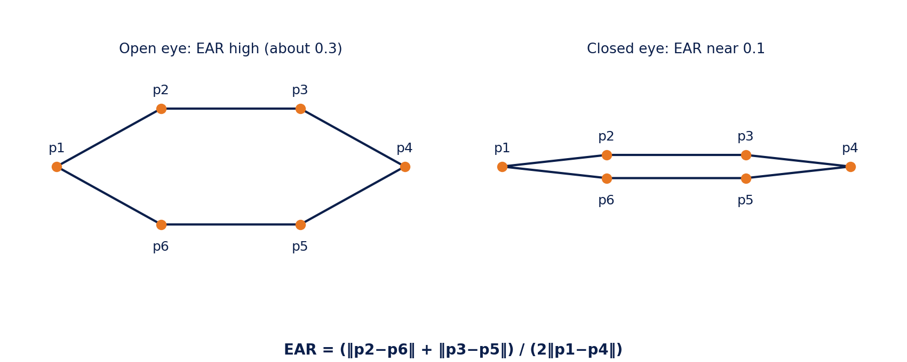
Figure C.1: Additional schematic: eye landmarks p1–p6 and the eye aspect ratio for open and closed eyes (Source: prepared by the team, after [12])

