eAge Innovations
Cognitive Radio Software Simulation Application
High-Level Design (HLD) and Low-Level Design (LLD)
Including Architecture and Design Diagrams
For technical review | Version 1.1 | September 2026
This document presents the high-level design and the low-level design of the Cognitive Radio software simulation application, together with architecture and design diagrams. The application is a software-only system that demonstrates channel sensing under jamming, Cognitive Radio decision-making (rules, machine learning, and hybrid modes), transmitter actuation, and operator-facing visualisation. The language and structure are intended for formal technical review.

List of figures
- Figure 1 — Layered High-Level Architecture
- Figure 2 — Cognitive Radio Closed-Loop Data Flow
- Figure 3 — Software Component Structure
- Figure 4 — Cognitive Radio Decision Flow (RULES / ML / HYBRID)
- Figure 5 — Single Simulation Step Sequence
- Figure 6 — Deployment View (Current Software Demonstration)

Part A — High-Level Design (HLD)

1. Objectives of the application
- Provide a configurable software model of N logical communication channels.
- Apply jam profiles so that channel quality degrades in a controlled and repeatable manner.
- Allow a receiver function to classify each channel as FREE, DEGRADED, or BLOCKED from measurements.
- Allow a Cognitive Radio engine to recommend channel(s) or advise an increase in transmit power.
- Allow a transmitter function to apply the recommendation (channel, power, hop set).
- Present the closed loop through a professional operator interface suitable for demonstration and review.
- Preserve clear interfaces so that hardware sensors and actuators may be connected subsequently without redesigning the decision engine.

2. Scope of the design
- In scope: PC-based simulation, operator user interface, rule-based and machine-learning decision paths, cognitive / adaptive hopping, and documentation of status codes.
- Out of scope for this design baseline: radiated radio-frequency transmission, physical antenna arrays, full Direct-Sequence Spread Spectrum waveform generation, and embedded FPGA or DSP deployment.
- The design is intentionally software-first so that Cognitive Radio behaviour can be reviewed before hardware integration.

3. Stakeholders and intended use
- Technical authority and programme reviewers — to inspect Cognitive Radio behaviour under jam.
- Defence scientists and officials — to observe sensing, decision, and protection in a controlled demonstration.
- Development engineers — to extend the simulation, machine-learning path, and later hardware adapters.

4. High-level architecture
The application is organised as a layered architecture. The presentation layer hosts the operator interface. The application orchestration layer advances the closed-loop simulation. The domain layer contains the channel model, receiver, Cognitive Radio engine, transmitter, hopping helpers, and machine-learning recommender. Shared data models define the contracts between these components.
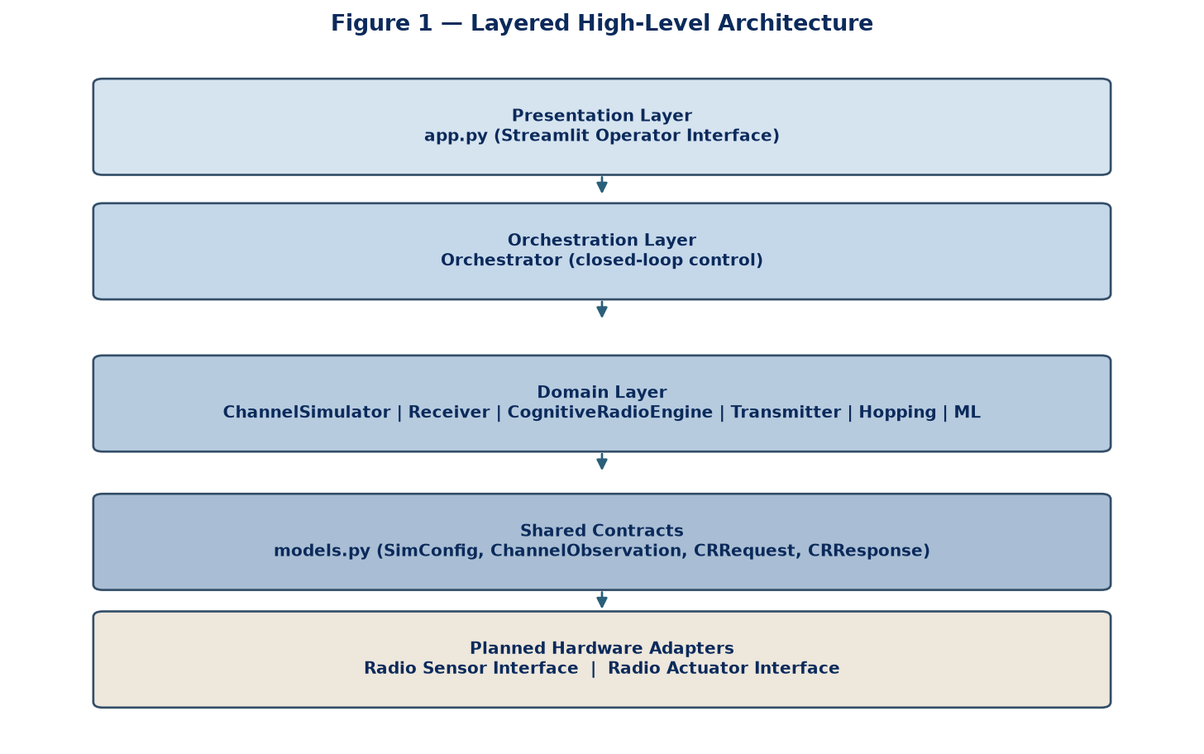
Figure 1. Layered high-level architecture of the Cognitive Radio software simulation.
Layer | Responsibility | Principal components
Presentation | Operator controls, channel map, status display, history | app.py (Streamlit)
Orchestration | Single-step closed loop; jam control; ML training trigger; history | Orchestrator
Domain — environment | Channel conditions, jam profiles, fading | ChannelSimulator
Domain — sensing | Build Cognitive Radio request from observations | Receiver
Domain — decision | Rules, ML, hybrid recommendation with safety | CognitiveRadioEngine, ChannelRecommenderML
Domain — actuation | Apply channel, power, and hop-set updates | Transmitter, hopping helpers
Shared contracts | Enumerations, observation and response structures, configuration | models.py

5. Closed-loop concept of operation
- The operator configures N, decision mode, hopping, thresholds, power limits, and seed.
- The operator injects or clears a jam profile, or toggles individual channels.
- On each simulation step, if hopping is enabled, the transmitter channel is selected from the current hop set using a documented pseudo-random sequence.
- The channel simulator produces per-channel observations under the current transmit allocation and jam state.
- The receiver packages observations into a Cognitive Radio request.
- The Cognitive Radio engine returns a response containing status code, message, recommended channels, action, optional power advice, and optional hop-set update.
- The transmitter applies the response.
- The presentation layer updates the channel map, metrics, decision panel, and history.
- The channel simulator then advances time (fade update and, if applicable, sweep-jam index).
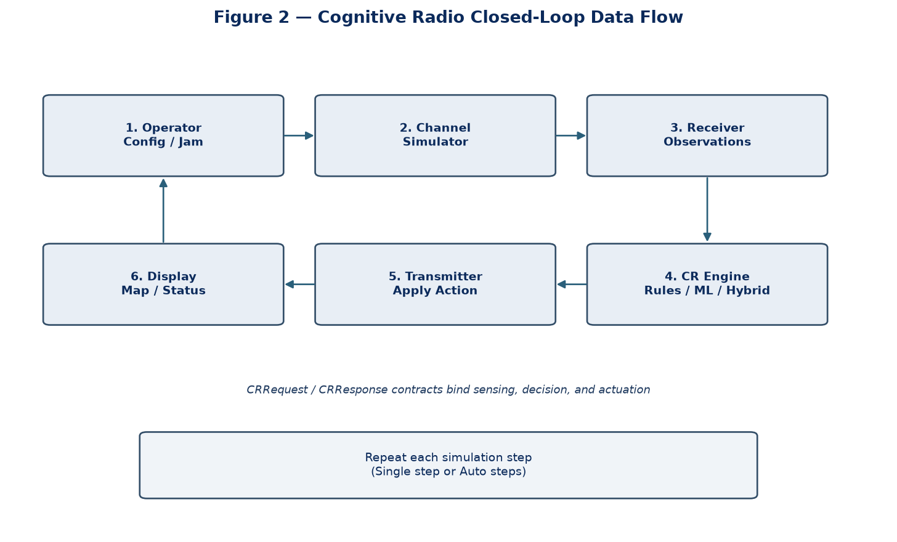
Figure 2. Closed-loop data flow from operator action through sensing, decision, actuation, and display.

6. High-level functional blocks
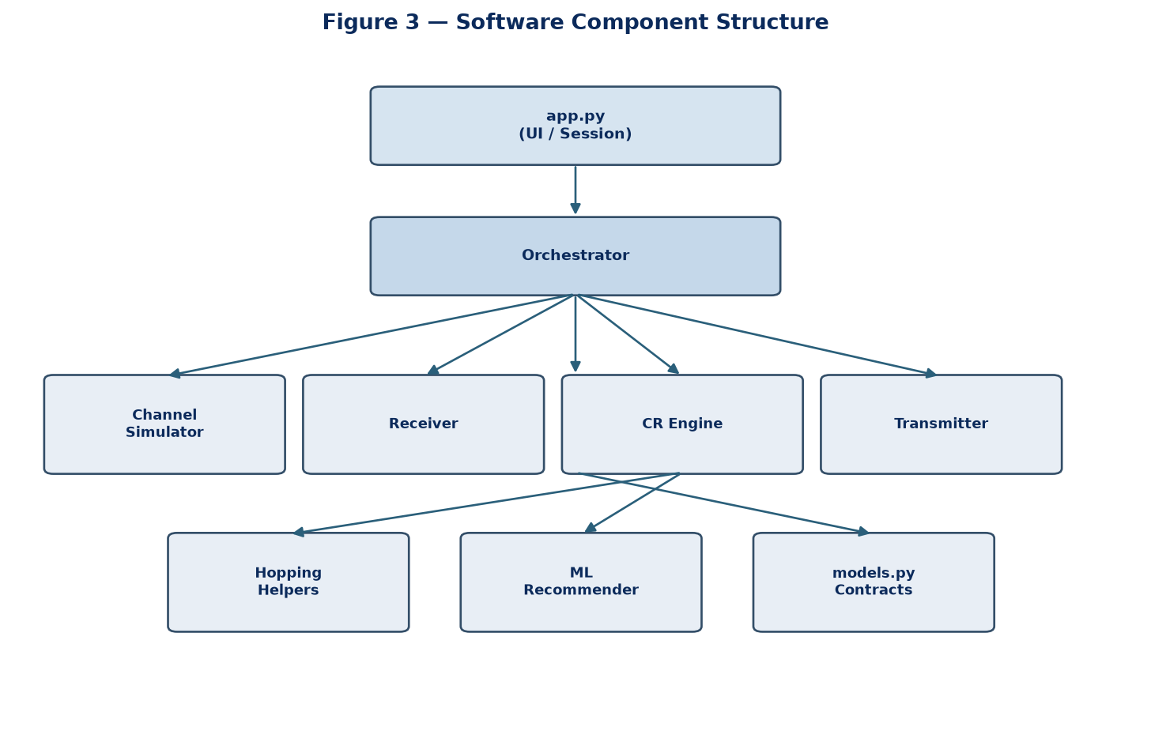
Figure 3. Principal software components and their structural relationships.

6.1 Channel / jam environment
- Models N logical channels with noise, path gain, jam power, and SINR.
- Supports jam profiles: NONE, SPOT, MULTI_SPOT, SWEEP, and BARRAGE.
- Does not provide an oracle jammer identity to the receiver; only measurable effects are exposed.

6.2 Receiver (sensing)
- Constructs a Cognitive Radio request from channel observations and current transmitter state.
- Channel state labels FREE, DEGRADED, and BLOCKED are produced from SINR thresholds configured in SimConfig.

6.3 Cognitive Radio engine (decision)
- Supports three decision modes: RULES, ML, and HYBRID.
- Always returns an inspectable response: status code, message, channels, action, and optional power advice.
- In HYBRID mode, machine-learning proposals are validated by safety rules (for example, a BLOCKED channel shall not be recommended).
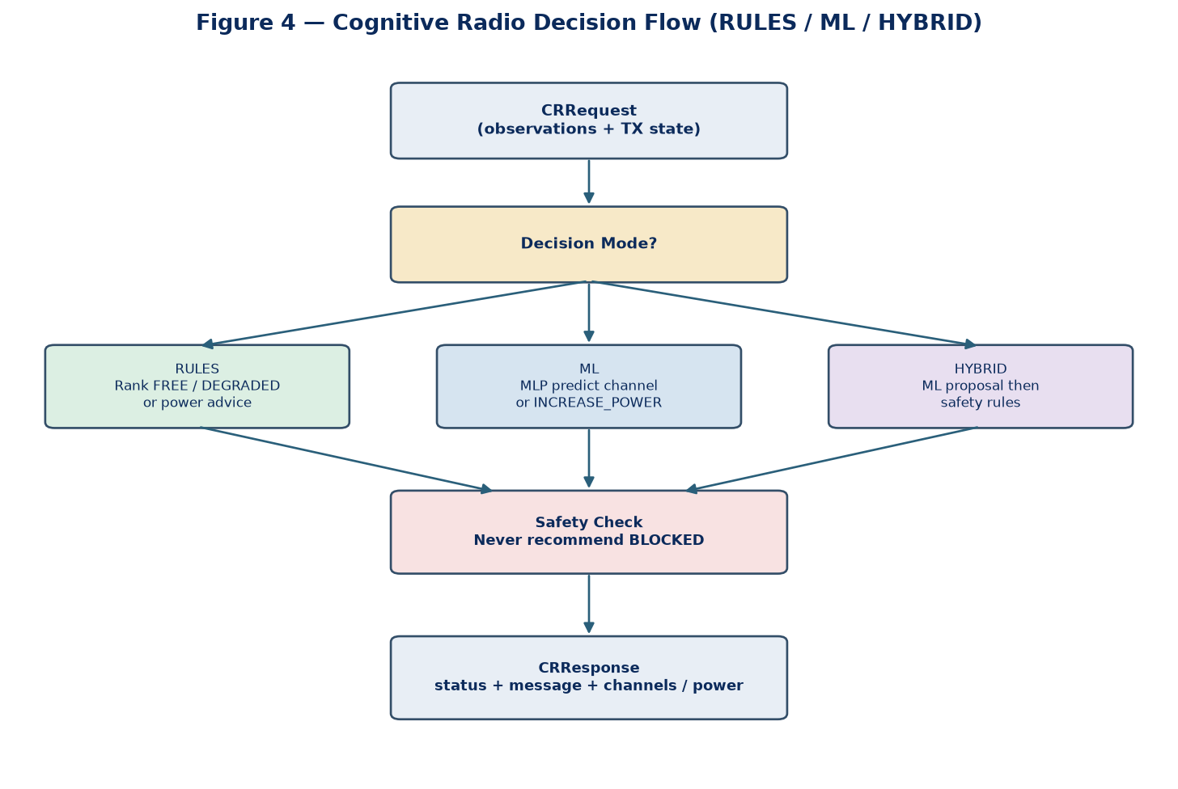
Figure 4. Decision flow for RULES, ML, and HYBRID modes, including the safety check.

6.4 Transmitter (actuation)
- Holds active channel, transmit power, hop set, and hop phase.
- Applies USE_CHANNELS, INCREASE_POWER, HOLD, or NO_SOLUTION actions from the engine response.

6.5 Hopping support
- Provides documented pseudo-random selection within the current hop set.
- Supports adaptive hop-set update by removing persistently blocked members and adding free or usable channels.

6.6 Machine-learning recommender
- Trains a supervised multi-layer perceptron on synthetic simulator cases.
- Predicts a recommended channel identifier or an increase-power action from the observation vector.
- Is retrained when configuration such as N is applied anew.

6.7 Operator interface
- Provides configuration controls, jam injection, single-step and auto-step execution, channel map, decision panels, and decision history.
- Is implemented as a Streamlit web application for demonstration on a local workstation.

7. External interfaces (present and planned)
- Present: browser-based operator interface to the Orchestrator.
- Present: internal Python module interfaces among channel, receiver, engine, transmitter, and ML components.
- Planned: Radio Sensor adapter — supply observations from hardware in place of ChannelSimulator.observe.
- Planned: Radio Actuator adapter — apply channel and power commands to hardware in place of Transmitter.apply.
- The Cognitive Radio request and response contracts are the stable boundary for those future adapters.
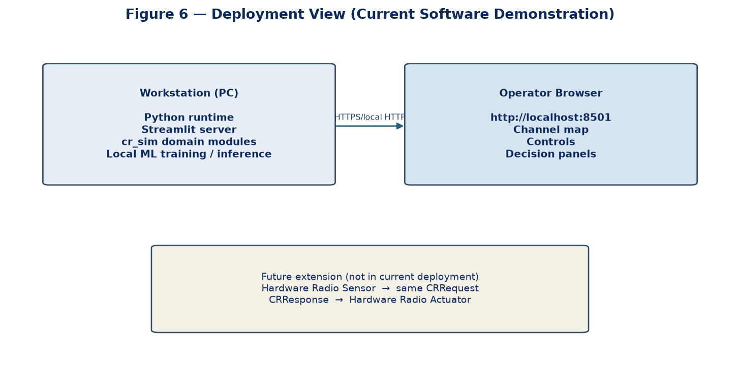
Figure 6. Current deployment on a workstation and browser, with planned hardware adapter path.

8. Non-functional design considerations
- Repeatability: a configurable seed supports fair comparison across runs.
- Inspectability: every decision carries a status code and a human-readable message.
- Safety: hybrid and ML paths retain rule-based overrides for unsafe proposals.
- Modularity: domain logic is independent of the Streamlit presentation layer.
- Demonstration suitability: dark professional theme and explicit channel-state visualisation for technical audiences.

Part B — Low-Level Design (LLD)

9. Source organisation
Path | Role
cognitive_radio_sim/app.py | Presentation layer; Streamlit UI and session control
cognitive_radio_sim/cr_sim/models.py | Enumerations and data contracts
cognitive_radio_sim/cr_sim/channel.py | ChannelSimulator — environment and jam
cognitive_radio_sim/cr_sim/receiver.py | Receiver — request construction
cognitive_radio_sim/cr_sim/transmitter.py | Transmitter — actuation state
cognitive_radio_sim/cr_sim/hopping.py | Pseudo-random hop and hop-set adaptation
cognitive_radio_sim/cr_sim/ml_models.py | ChannelRecommenderML — MLP train/predict
cognitive_radio_sim/cr_sim/cr_engine.py | CognitiveRadioEngine — RULES / ML / HYBRID
cognitive_radio_sim/cr_sim/orchestrator.py | Orchestrator — closed-loop step
cognitive_radio_sim/.streamlit/config.toml | Application theme configuration
cognitive_radio_sim/requirements.txt | Runtime dependencies

10. Configuration model (SimConfig)
- n_channels — number of logical channels N.
- noise_power — background noise used in interference calculation.
- base_path_gain — initial path gain per channel.
- jam_power — jammer power applied by active jam profiles.
- t_good_db — SINR threshold at or above which a channel is FREE.
- t_bad_db — SINR threshold below which a channel is BLOCKED.
- min_power_db / max_power_db / power_step_db — transmit power limits and step size.
- seed — random seed for repeatability.
- hop_enabled — enables cognitive / adaptive hopping behaviour.
- decision_mode — RULES, ML, or HYBRID.

11. Enumerations and core data contracts

11.1 ChannelState
- FREE — channel quality is acceptable for preferred use.
- DEGRADED — channel is impaired but may still be usable.
- BLOCKED — channel is not usable under current conditions.

11.2 JamProfile
- NONE — no jam applied.
- SPOT — high jam power on one or a few designated channels.
- MULTI_SPOT — several designated channels jammed concurrently.
- SWEEP — jammed channel index advances across simulation steps.
- BARRAGE — jam power applied across all channels.

11.3 DecisionMode and Action
- DecisionMode: RULES, ML, HYBRID.
- Action: USE_CHANNELS, INCREASE_POWER, HOLD, NO_SOLUTION.

11.4 ChannelObservation
- channel_id, signal_power, noise_power, jam_power, path_gain, sinr_db, state, is_active_tx.
- Represents one channel measurement after the environment model has been evaluated.

11.5 CRRequest
- observations — list of ChannelObservation.
- current_channel, current_power_db, max_power_db.
- hop_enabled, hop_set, n_channels.
- This is the input contract of the Cognitive Radio engine.

11.6 CRResponse
- status_code — machine-readable outcome (for example OK, DEGRADED_OK, INCREASE_POWER, ALL_BLOCKED).
- message — human-readable explanation.
- channels — recommended channel identifiers in priority order.
- action — required transmitter action.
- power_advice_db — optional advised power level.
- hop_set — optional updated hop-set membership.
- engine — which path produced the decision (RULES, ML, HYBRID, or safety fallback).
- detail — optional structured metadata such as ML confidence.

12. ChannelSimulator — low-level behaviour
- Maintains step counter, jam profile, manually jammed channel set, sweep index, and per-channel path gains.
- set_profile(profile, channels) configures jam behaviour.
- toggle_channel_jam(channel_id) adds or removes a channel from the manual jam set.
- clear_jam() resets jam state to NONE.
- observe(tx_channel, tx_power_db) computes per-channel signal, interference, SINR, and state.
- For the active transmit channel, signal power is derived from transmit power and path gain.
- Interference is noise_power plus jam_power.
- SINR in decibels is computed from the linear signal-to-interference ratio.
- State assignment uses t_good_db and t_bad_db.
- For non-transmit channels, a sensing proxy uses jam presence and a sensing SINR estimate to label FREE, DEGRADED, or BLOCKED.
- advance() increments the step, applies mild random fading to path gains, and advances the sweep index when SWEEP is active.

13. Receiver — low-level behaviour
- build_request(...) accepts observations and transmitter context.
- Returns a CRRequest object for the Cognitive Radio engine.
- Performs no independent decision; sensing and packaging are its sole responsibilities.

14. CognitiveRadioEngine — low-level behaviour

14.1 Public operations
- reconfigure(n_channels, seed) rebuilds the ML recommender for a new channel count.
- train_ml(n_samples) trains the supervised model on synthetic cases.
- decide(request, mode) returns a CRResponse according to RULES, ML, or HYBRID.

14.2 Rule baseline algorithm
- Rank FREE channels by descending SINR; if any exist, recommend the best and return OK.
- Otherwise rank DEGRADED channels by descending SINR; if any exist, recommend the best and return DEGRADED_OK.
- Otherwise, if current power is below maximum, return INCREASE_POWER with power advice.
- Otherwise return ALL_BLOCKED with action NO_SOLUTION.
- When hopping is enabled, adapt the hop set by removing blocked members and filling from free or degraded ranked lists.

14.3 Machine-learning path with safety
- If the model is not trained, fall back to the rule baseline with an explanatory message.
- Obtain an ML recommendation: channel identifier or increase-power.
- If increase-power is proposed and power headroom remains, return INCREASE_POWER.
- If a channel is proposed but is blocked or not among usable channels, override with the rule baseline (ML-SAFETY).
- Otherwise return OK or DEGRADED_OK with the ML-recommended channel and confidence detail.

14.4 Hybrid mode
- Invoke the ML-with-safety path first.
- Accept the result when the status is a recognised operational outcome.
- Otherwise fall back to rules and mark the engine as HYBRID-FALLBACK.

15. ChannelRecommenderML — low-level behaviour
- Uses scikit-learn MLPClassifier with hidden layers (64, 32), ReLU activation, and Adam solver.
- Standardises features with StandardScaler before training and inference.
- Feature vector composition: for each channel — SINR, encoded state, jam power; plus current power and remaining power headroom.
- Label space: channel identifiers 0…N−1, or −1 representing INCREASE_POWER.
- train_synthetic(n_samples) generates labelled cases from ChannelSimulator under varied jam profiles, including forced barrage cases for power-advice learning.
- predict(...) returns channel or increase-power together with confidence derived from class probabilities.

16. Transmitter — low-level behaviour
- State: channel, power_db, hop_set, hop_phase.
- reset() / reconfigure(config) restore initial actuation state for the configured N.
- apply(response, hop_enabled):
- If response.hop_set is provided, replace the local hop set with valid channel identifiers.
- If action is INCREASE_POWER, raise power_db by power_step_db without exceeding max_power_db.
- If action is HOLD, leave allocation unchanged.
- If action is USE_CHANNELS or NO_SOLUTION and channels are provided, set channel to the first recommended identifier.

17. Hopping helpers — low-level behaviour
- prng_index(seed, step, modulus) derives a deterministic index from a SHA-256 digest of seed and step.
- select_hop_channel(seed, step, hop_set) returns the hop-set member at that index.
- adapt_hop_set(hop_set, blocked, free_ranked, n_channels, target_size) removes blocked members and fills from ranked free channels to the target size.

18. Orchestrator — low-level step sequence
- If hopping is enabled and a hop set exists, set transmitter.channel using select_hop_channel.
- Call channel.observe(transmitter.channel, transmitter.power_db).
- Build CRRequest through receiver.build_request(...).
- Call engine.decide(request, config.decision_mode).
- Call transmitter.apply(response, hop_enabled).
- Record a StepResult containing step, observations, response, TX state, hop set, and jam profile.
- Append the result to history and call channel.advance().
- Return the StepResult to the presentation layer.
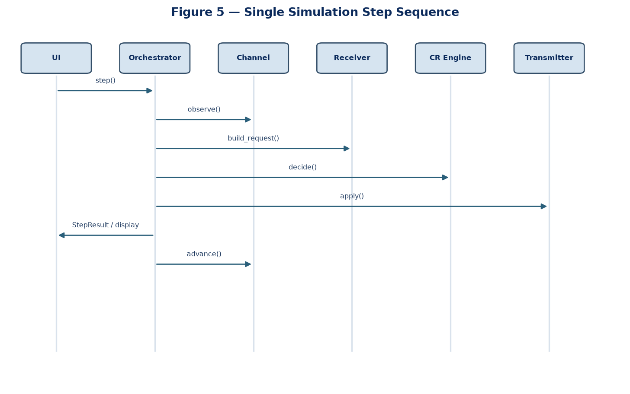
Figure 5. Sequence of calls within a single simulation step across UI, orchestrator, and domain modules.

19. Presentation layer (app.py) — low-level design
- Initialises Streamlit page configuration and applies professional dark-theme styling.
- Holds Orchestrator and last StepResult in st.session_state.
- On first load, constructs Orchestrator, trains the ML recommender, and executes an initial step.
- Sidebar controls: N, decision mode, hopping, jam power, SINR thresholds, maximum power, seed.
- Apply configuration rebuilds SimConfig, resets Orchestrator, retrains ML, and steps once.
- Jam injection controls: profile selection, target channels, Apply jam, Clear jam.
- Run controls: Single step, Run auto steps, Reset simulation.
- Main view: metrics, channel map cards, observation table, Cognitive Radio response panel, decision detail, closed-loop summary, quick jam toggles, and recent history.
- Channel cards are rendered per channel using Streamlit columns to ensure reliable display.

20. Status codes used by the design
Status code | Meaning
OK | At least one FREE channel is recommended
DEGRADED_OK | No FREE channel; a usable DEGRADED channel is recommended
INCREASE_POWER | All channels blocked at current power; increase power is advised
ALL_BLOCKED | No usable channel even at maximum allowed power
HOLD | Retain current allocation
INVALID_INPUT | Request observations are missing or invalid

21. Dependencies
- Python 3.10 or later is recommended.
- streamlit — operator interface.
- numpy — numerical arrays for channel and ML feature handling.
- pandas — tabular presentation of observations and history.
- scikit-learn — StandardScaler and MLPClassifier for the supervised recommender.

22. Extension points for subsequent work
- Replace ChannelSimulator.observe with a hardware sensor adapter producing ChannelObservation lists.
- Replace Transmitter.apply with a hardware actuator adapter consuming CRResponse.
- Add deeper reinforcement-learning policies behind the same decide() contract.
- Export spectrogram or sequence features for convolutional or recurrent sensing models.
- Retain CRRequest and CRResponse as the stable interface so presentation and orchestration remain unchanged.

23. Design summary
At high level, the application realises a Cognitive Radio closed loop: environment and jam, measurement-based sensing, inspectable decision, and transmitter actuation, presented through a professional operator interface. At low level, these responsibilities are partitioned into explicit modules and data contracts, with deterministic step sequencing in the Orchestrator and clearly defined RULES, ML, and HYBRID decision paths. The accompanying diagrams summarise architecture, data flow, components, decision logic, step sequencing, and deployment. The design supports formal review today and disciplined extension toward hardware connection thereafter.

24. Closing
This high-level and low-level design document, including the architecture and design diagrams, is submitted for technical review. Comments on architecture boundaries, decision contracts, or extension priorities will be used to refine the implementation while preserving the inspectable Cognitive Radio response format.
— End of HLD / LLD document (Version 1.1 with diagrams) —

