eAge Innovations — Defence SDR & Electronic Warfare Lab
Reference: EAGE-CR-PRES-2026-001 | Audience: Shri S. K. Sir & Senior Defence Scientists | September 2026

HOW TO PRESENT THE COGNITIVE RADIO SIMULATION
0.1 Document format: This guide uses numbered points only. Figures below are used in both this Word document and the companion PowerPoint.
0.2 Companion PowerPoint: Cognitive_Radio_Simulation_Presentation_for_Defence_Scientists.pptx
1. Objective of This Presentation
1.1 Primary goal: Show Sense–Decide–Act under jamming with agreed look-and-feel, interference capture, and cognitive dynamic FH.
1.2 Desired outcome: Panel understands the software decision twin and path to eADM / SDR integration.
1.3 Scope limit: Not a claim of airborne certification or full field RF trial.
1.4 SK priorities: Look-and-feel; capturing interference; dynamic FH based on cognitive decisions.
2. Figure 1 — Closed-Loop System Architecture
2.1 Purpose of figure: Use this diagram first to explain the closed loop before opening the live software.
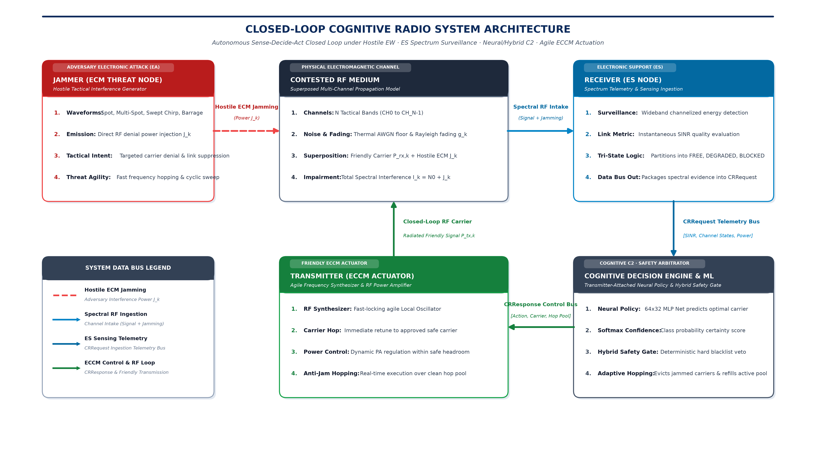
Figure 1: Closed-Loop Cognitive Radio System Architecture under Electronic Attack.
2.2 Narration point 1: Jammer injects hostile ECM power into the contested RF medium.
2.3 Narration point 2: Receiver performs ES sensing and issues CRRequest telemetry.
2.4 Narration point 3: Cognitive Decision Engine & ML apply hybrid safety and adaptive hop logic.
2.5 Narration point 4: Transmitter actuates approved carrier / power / hop set and closes the RF loop.
3. Figure 2 — Live Modular Node UI
3.1 Purpose of figure: Use this screenshot to show the agreed look-and-feel of Jammer, Receiver, and Transmitter with attached ML.
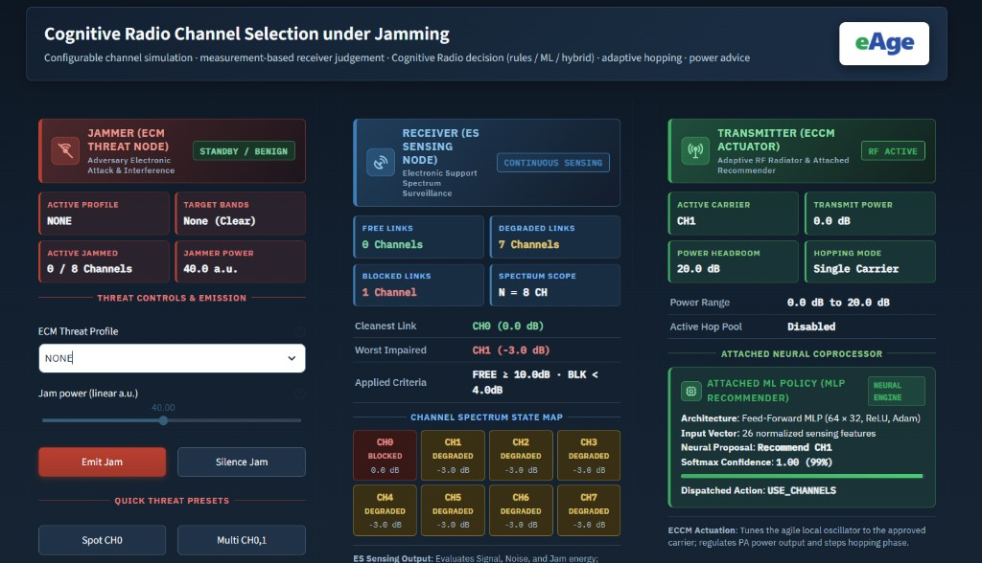
Figure 2: Live Cognitive Radio Simulation — Modular System Architecture & Node View.
3.2 Left panel — Jammer: ECM threat profile, jam power, emit/silence, quick Spot / Multi presets.
3.3 Centre panel — Receiver: FREE / DEGRADED / BLOCKED counts and Channel Spectrum State Map — this is interference capture.
3.4 Right panel — Transmitter: Active carrier, power, hopping mode, and Attached MLP Policy with proposal, confidence, and dispatched action.
3.5 Demo tip: While speaking, point physically to each coloured column so the panel links architecture (Figure 1) to live UI (Figure 2).
4. Before the Meeting — Preparation Checklist
4.1 Start the application: python -m streamlit run app.py --server.port 8501
4.2 Open browser: http://localhost:8501
4.3 Preferred view: System Architecture & Node View
4.4 Defaults: N=8; Decision engine=HYBRID; Hopping OFF initially; Light theme if bright room
4.5 Train ML once: Complete training before audience arrival
4.6 Reset jammer: NONE / clear for benign opening
4.7 Keep ready: This Word guide, the PowerPoint, Scenarios Brief, ML Q&A Brief
4.8 Projector: Browser zoom 110–125% if needed
4.9 Time budget: 20–25 minutes demo + 10–15 minutes questions
5. Opening Remarks
5.1 Greeting: Sir, today we demonstrate Cognitive Radio software simulation under contested EW conditions.
5.2 Positioning: PC software closed-loop twin; later eADM / SDR can replace the channel simulator using the same decision interfaces.
5.3 Three proofs: Interference capture; hybrid ML safety decisions; dynamic FH from cognitive decisions.
5.4 Invite interaction: Please interrupt to change jammer profile or decision mode.
6. Live Demonstration Sequence
6.1 Action: Show Figure 1 architecture, then switch to live UI (Figure 2).
6.2 Action: Benign baseline — jammer NONE — status OK.
6.3 Action: Spot jam active carrier — show BLOCKED capture and HYBRID alternate channel.
6.4 Action: Enable cognitive hopping — jam hop-set member — show eviction and refill.
6.5 Action: Barrage — show INCREASE_POWER within headroom.
6.6 Action: Explain Stages 2–3 of the Decision Engine trace (ML proposal + safety).
7. Machine Learning Speaking Points
7.1 Model: Supervised MLP 64×32, ReLU, Adam.
7.2 Input: 3N+2 features (N=8 → 26 normalised sensing features).
7.3 Output: Channel recommendation or INCREASE_POWER with Softmax confidence.
7.4 Preferred mode: HYBRID — ML proposes, deterministic safety validates.
7.5 Assurance: ML is advisory; safety gate prevents hops into BLOCKED channels.
8. Closing Statement
8.1 Closing: Sir, the simulation presents the agreed look-and-feel; captures interference through ES sensing; decides with hybrid ML under safety; and performs dynamic FH based on cognitive decisions. We request guidance for the next eADM laboratory step.
8.2 End: Thank you, Sir. We are ready for questions.

Prepared by: eAge Innovations Technical Engineering Team
For presentation to: Shri S. K. Sir & Senior Defence Scientists

