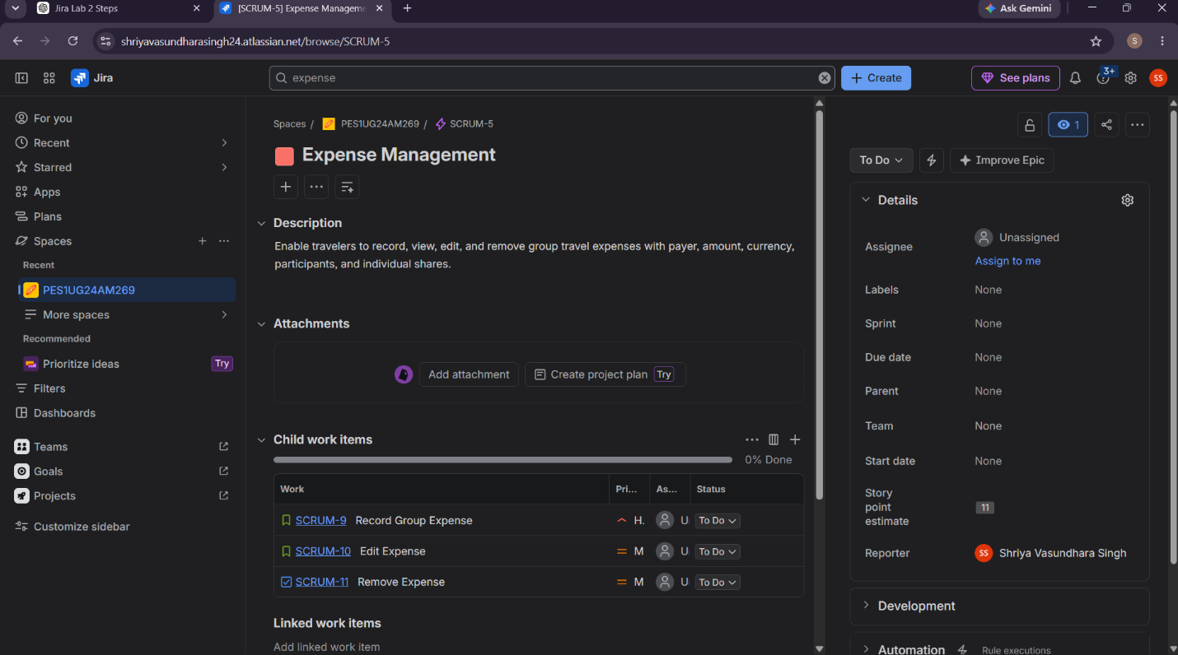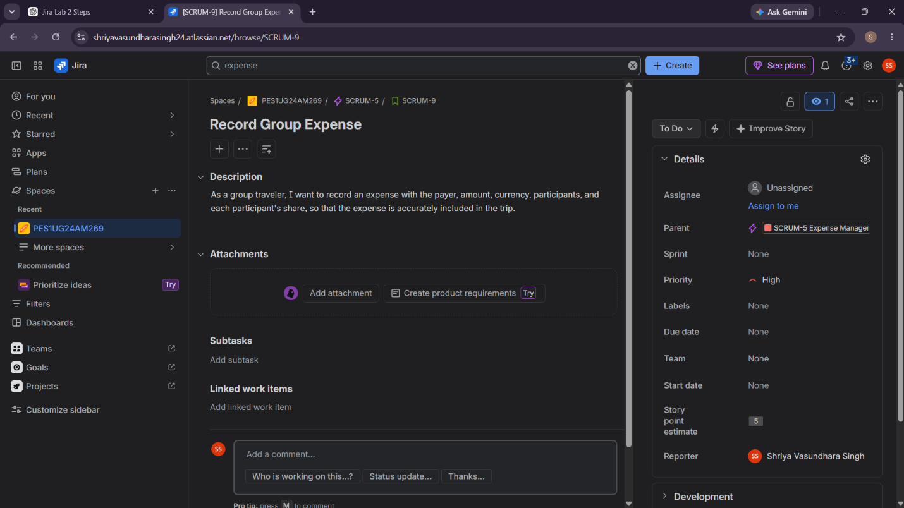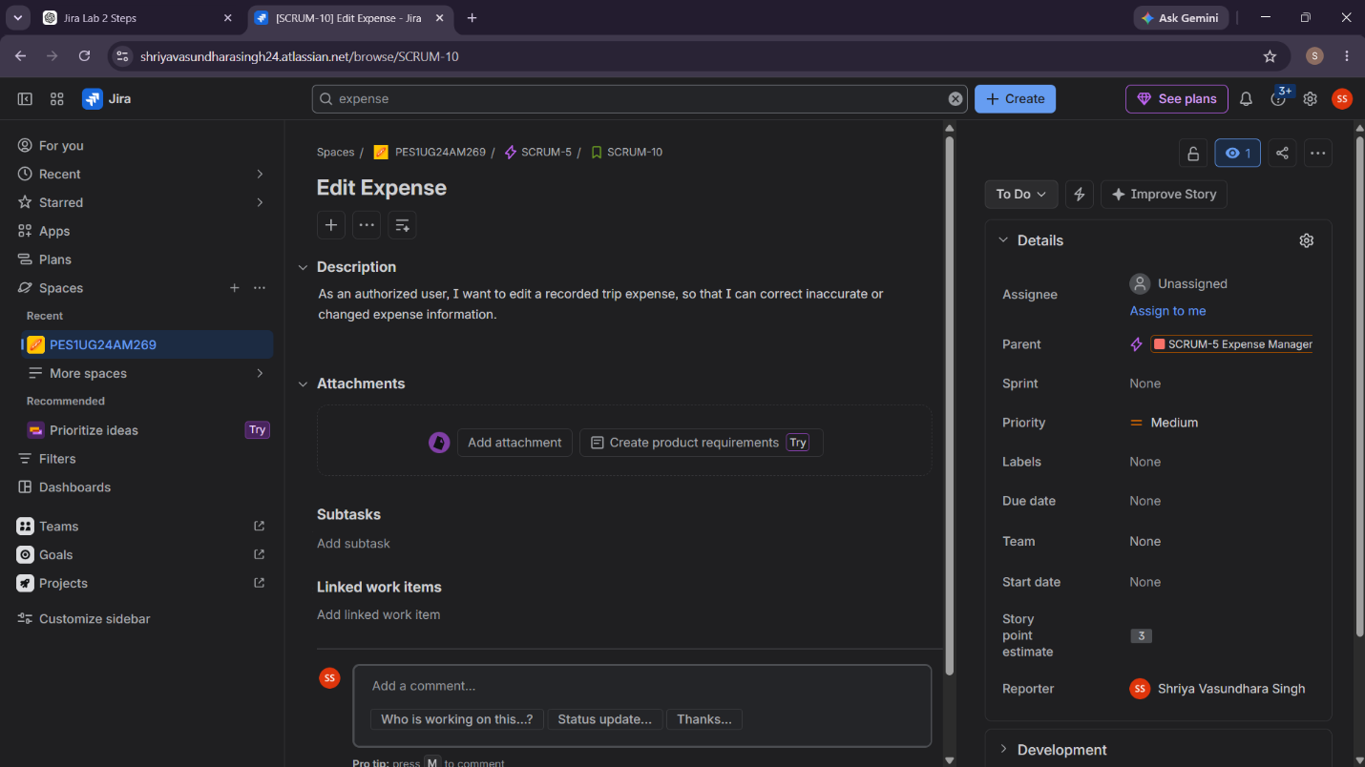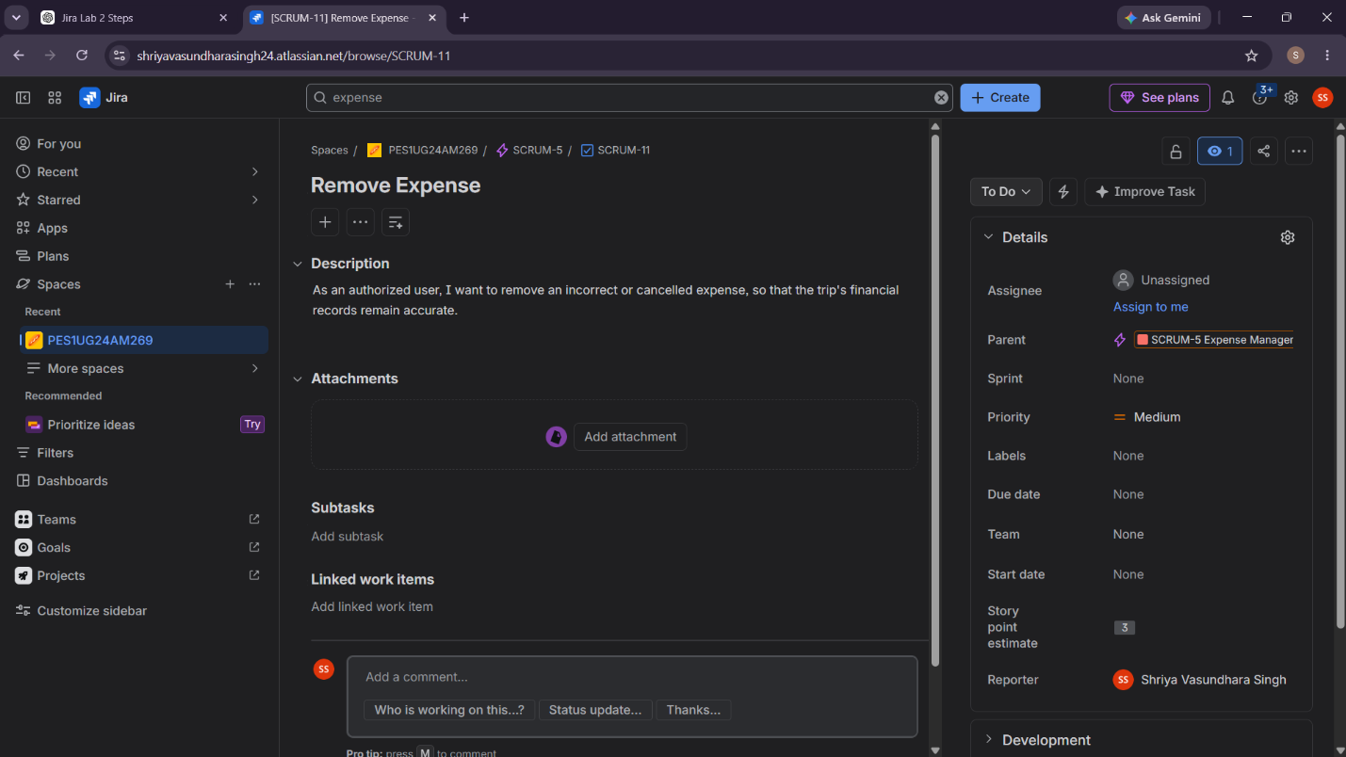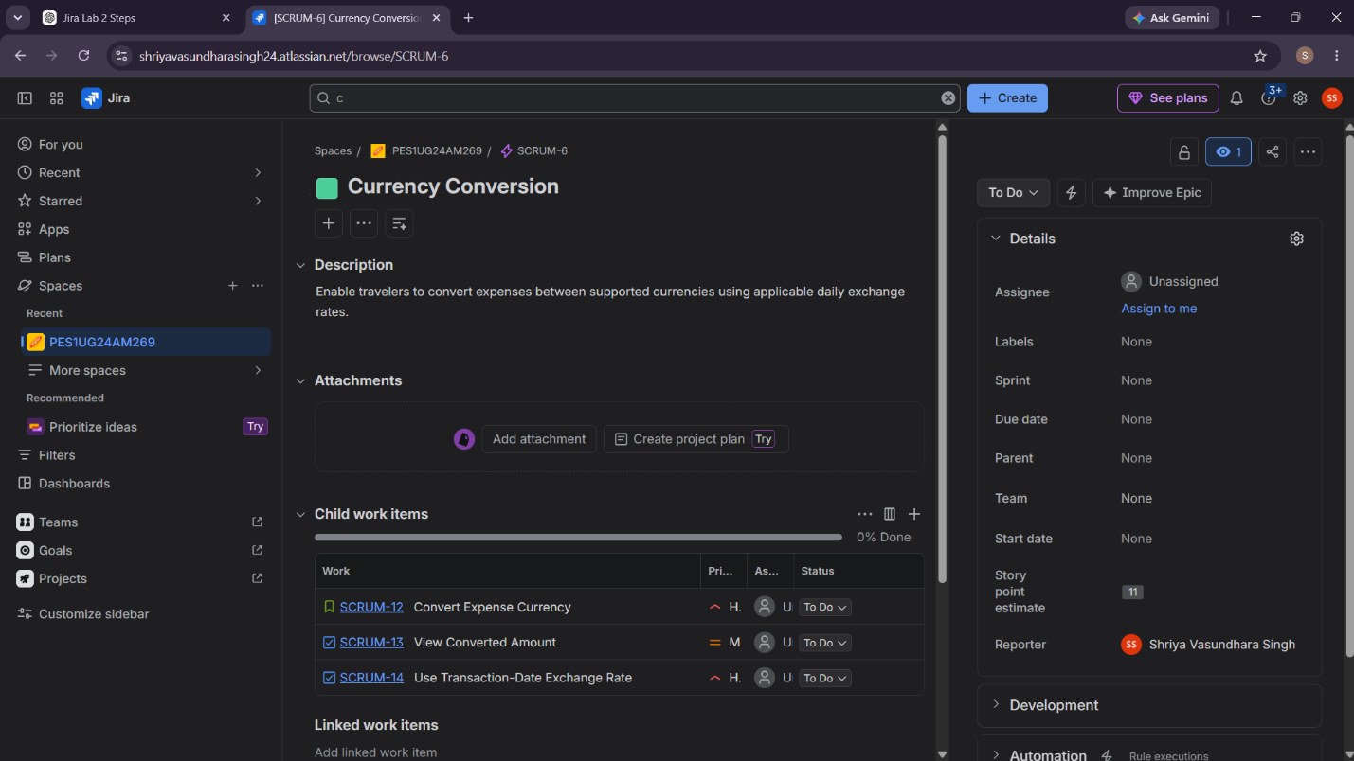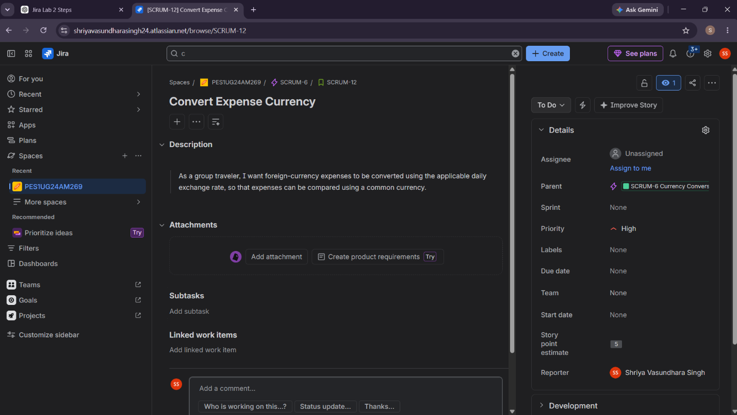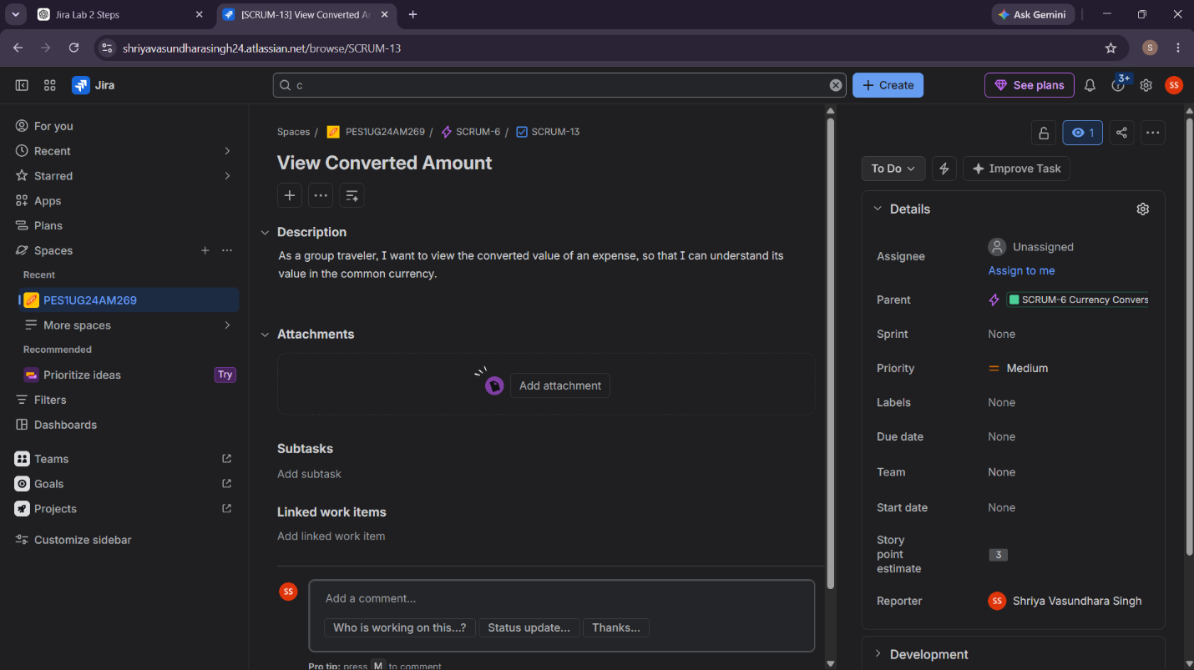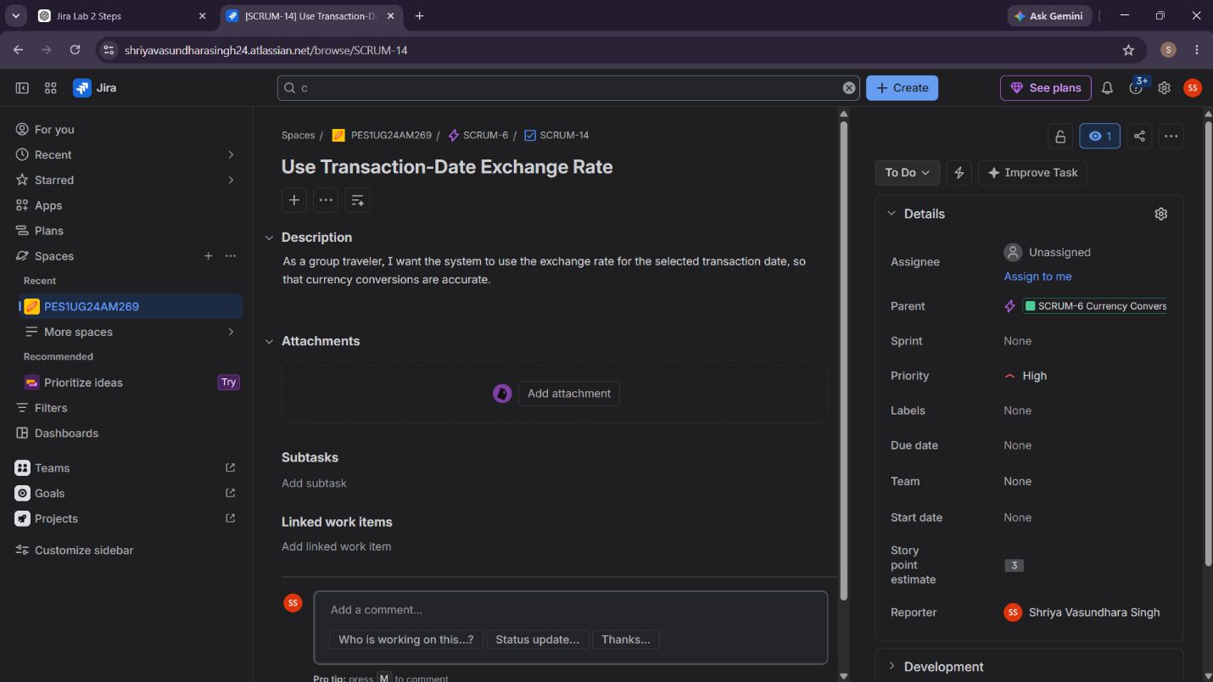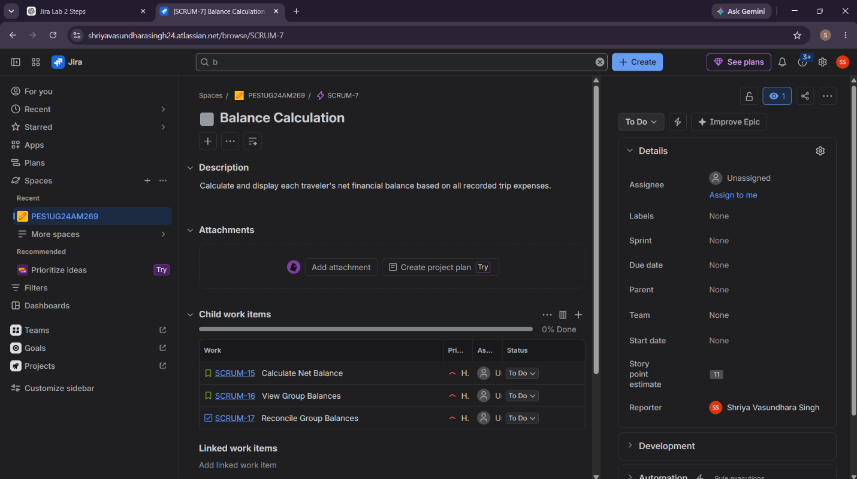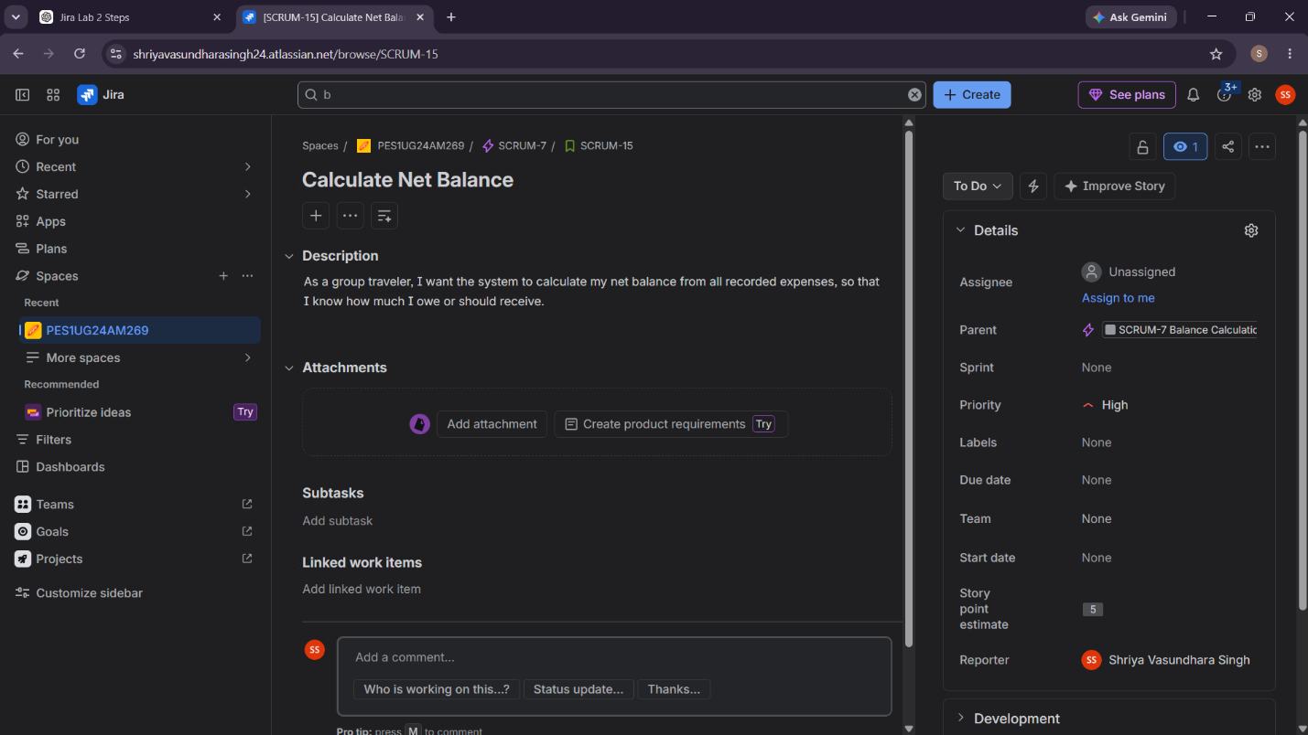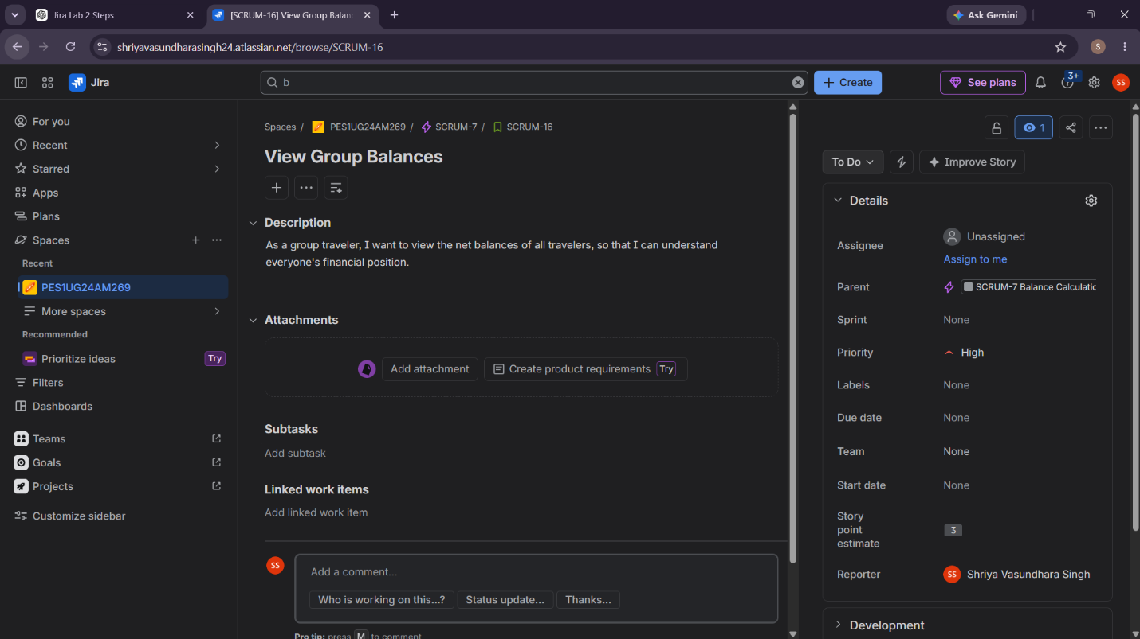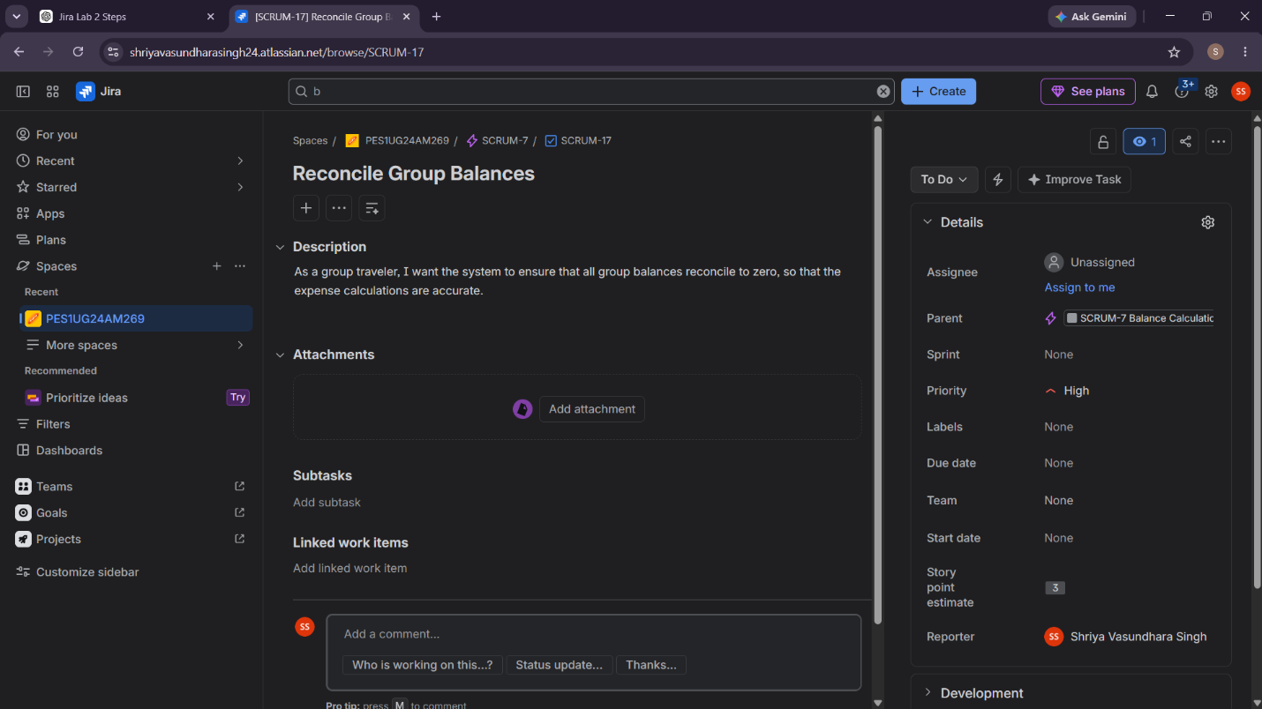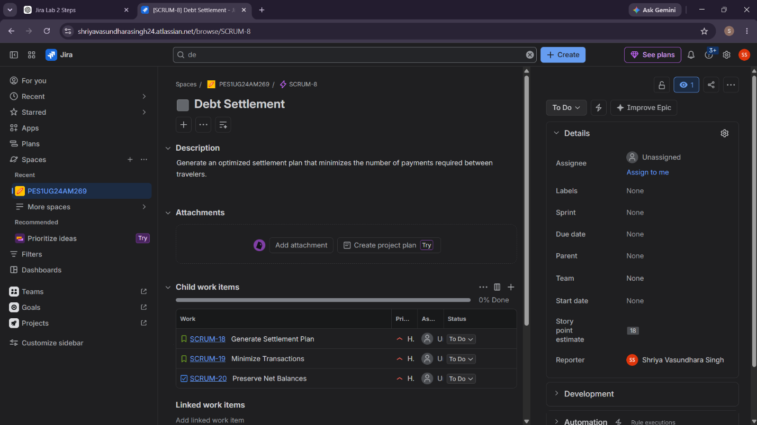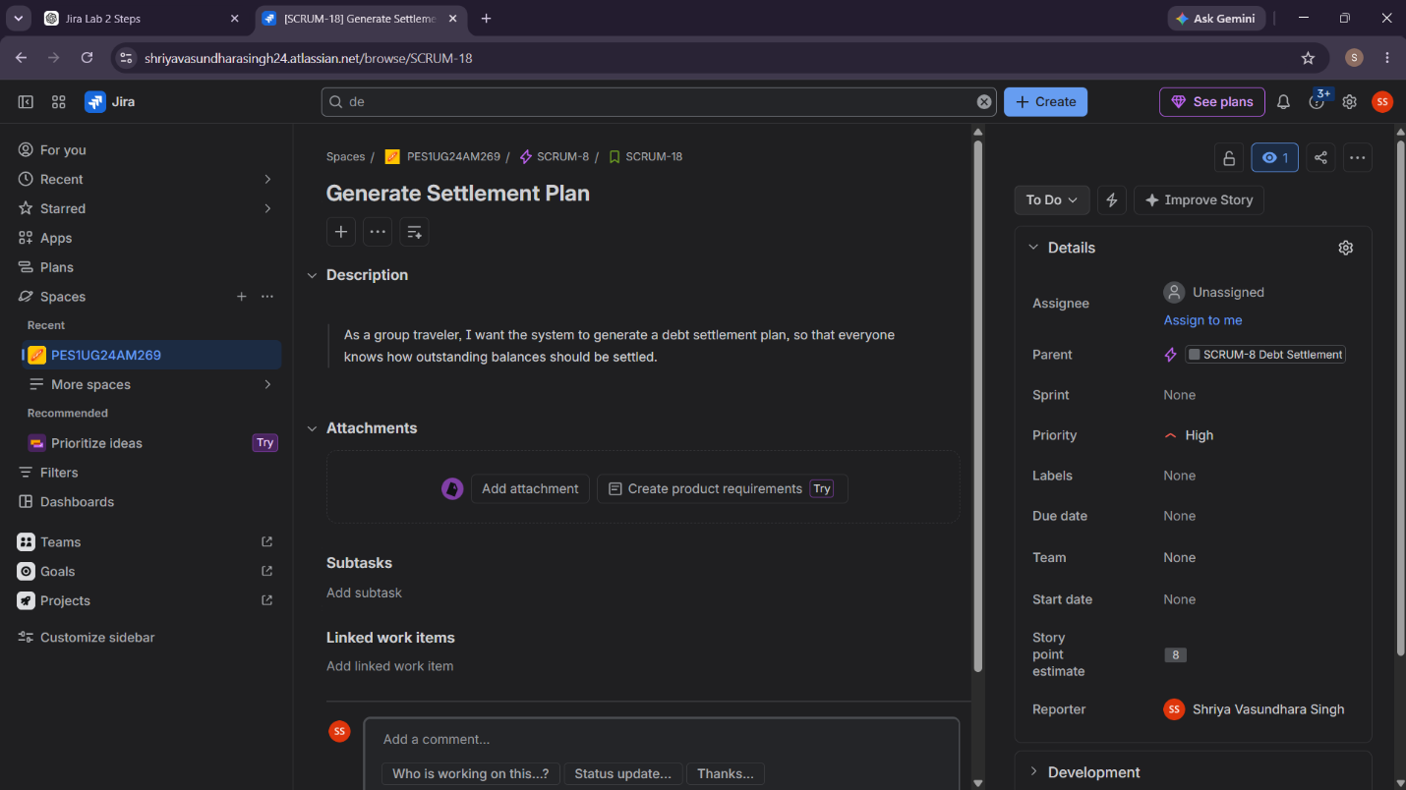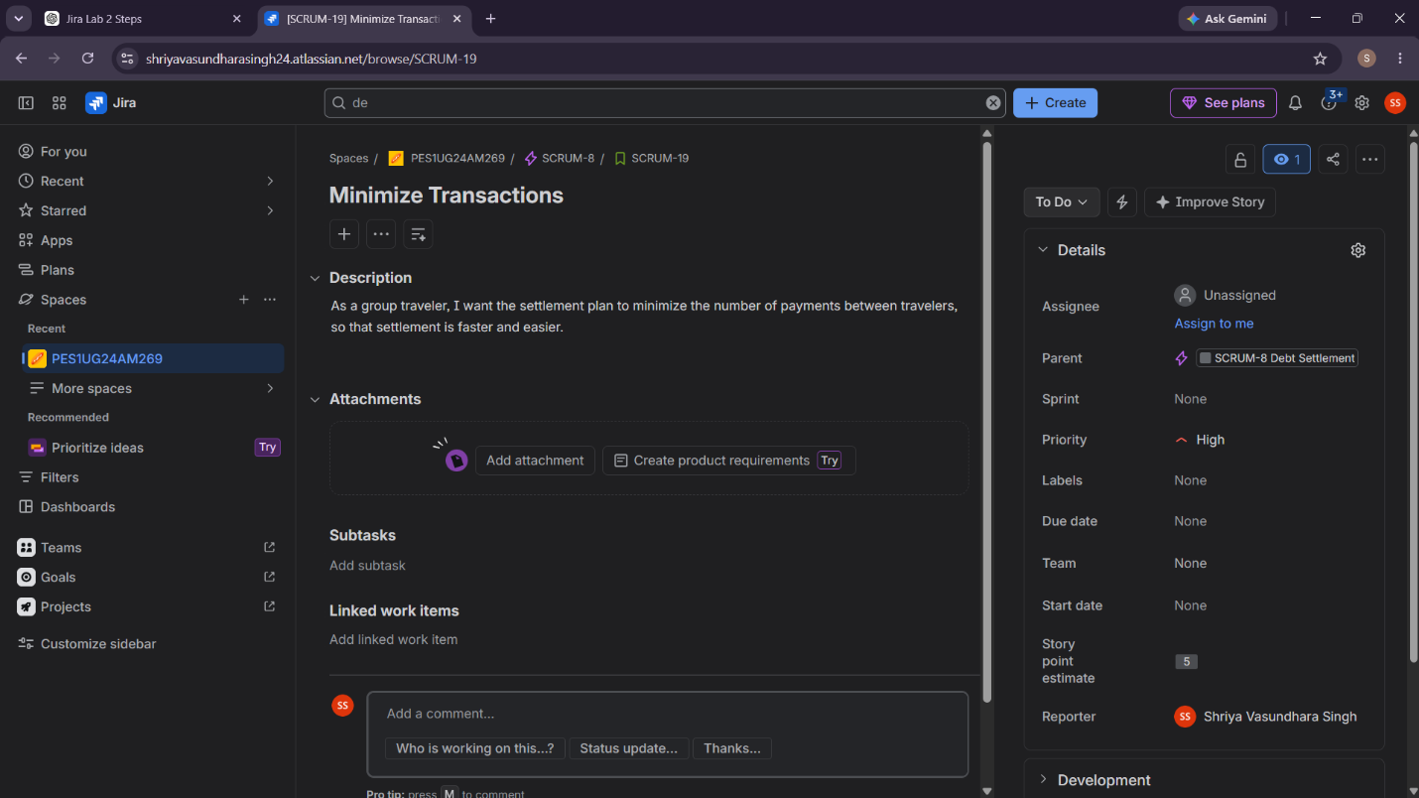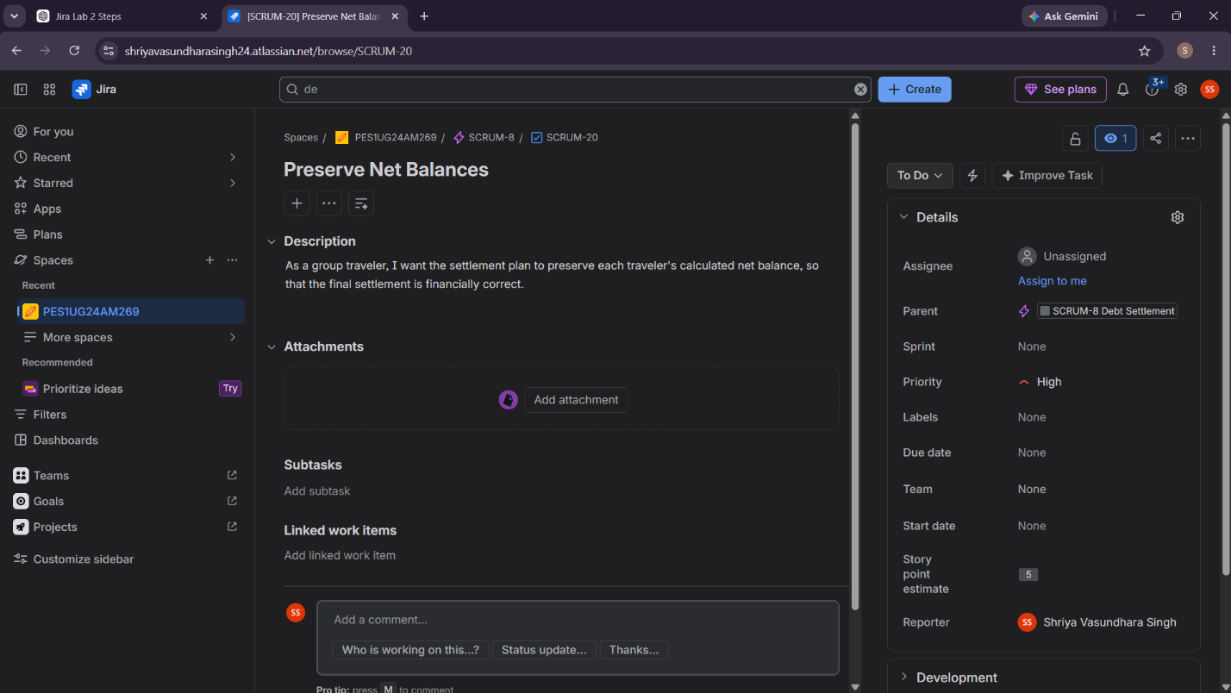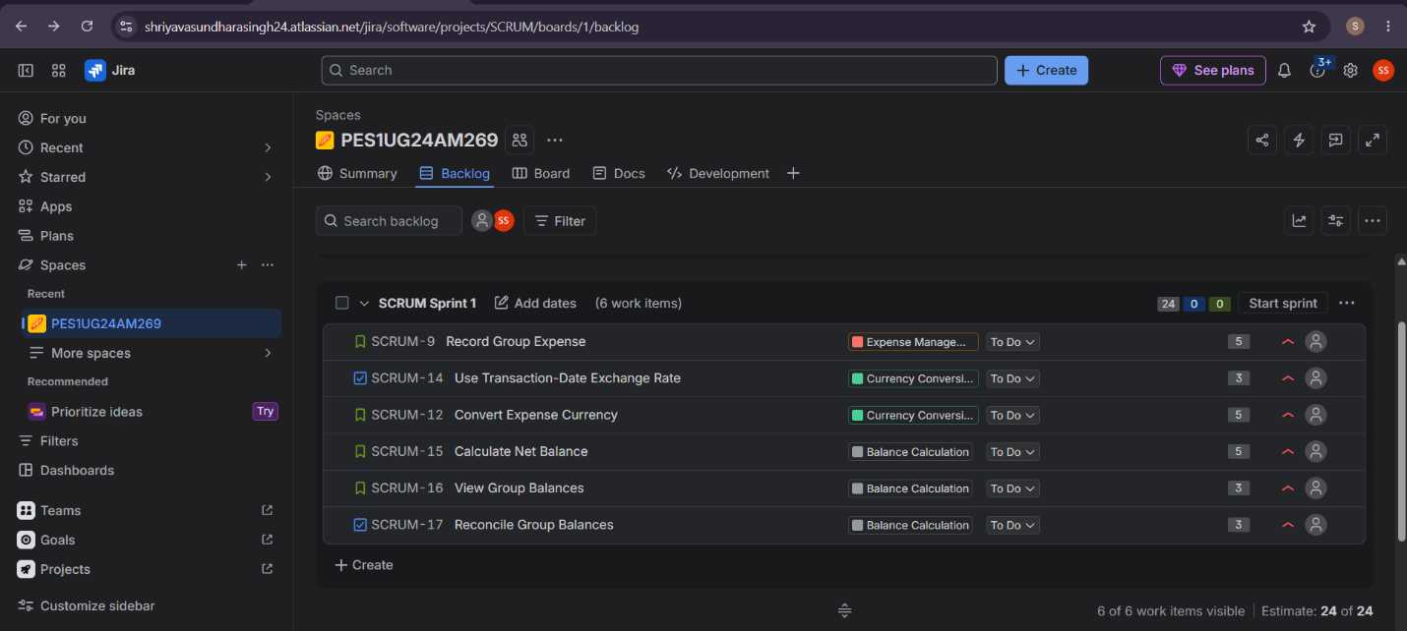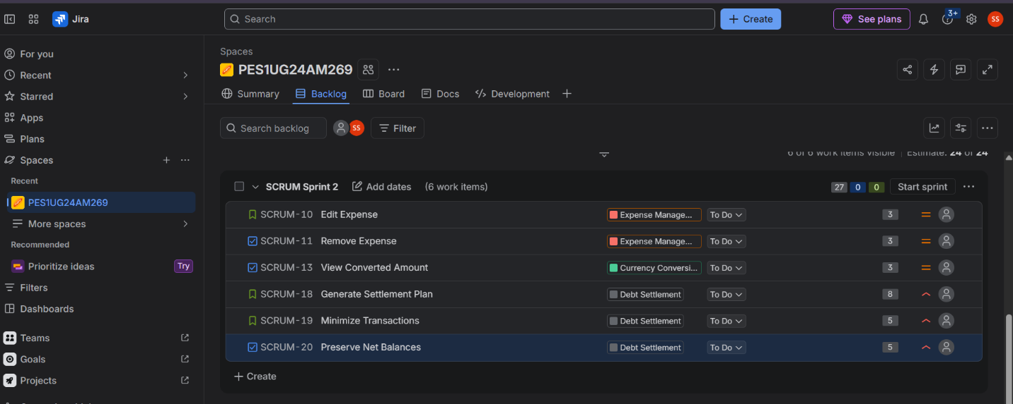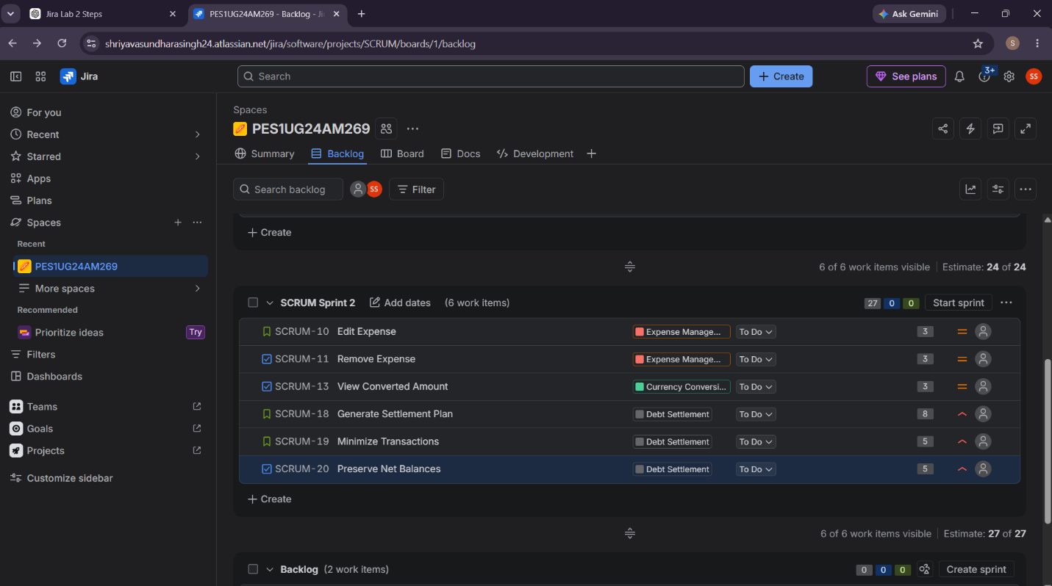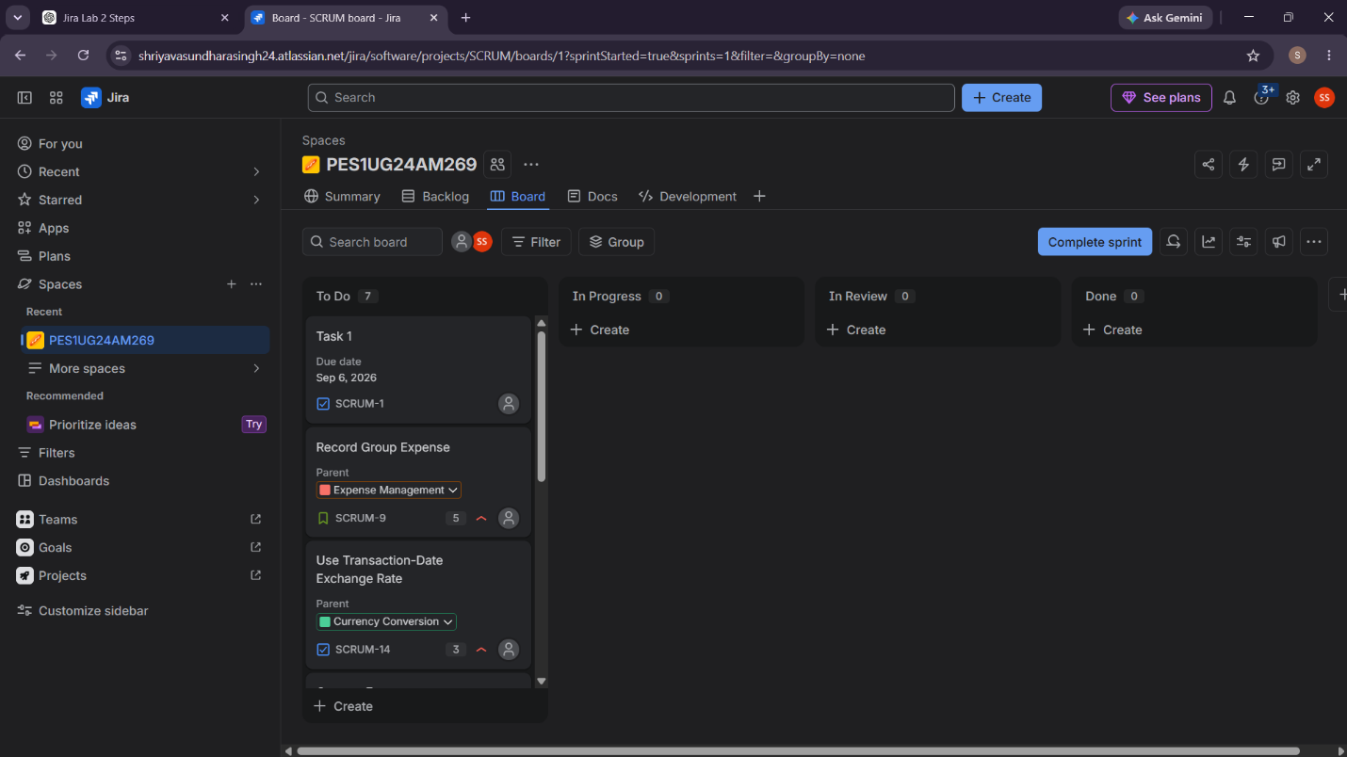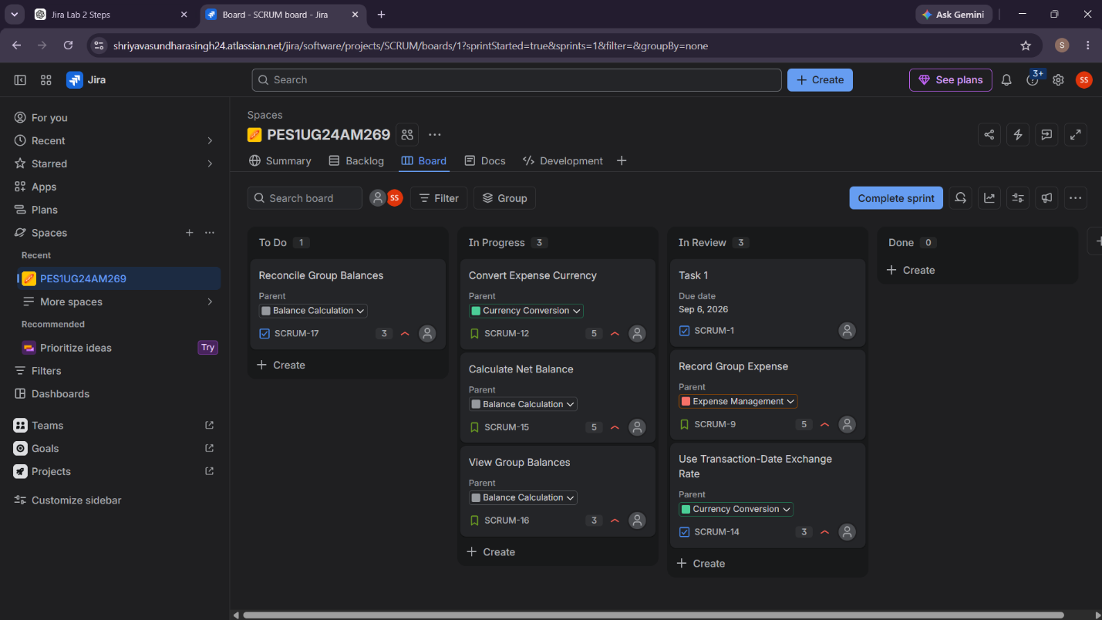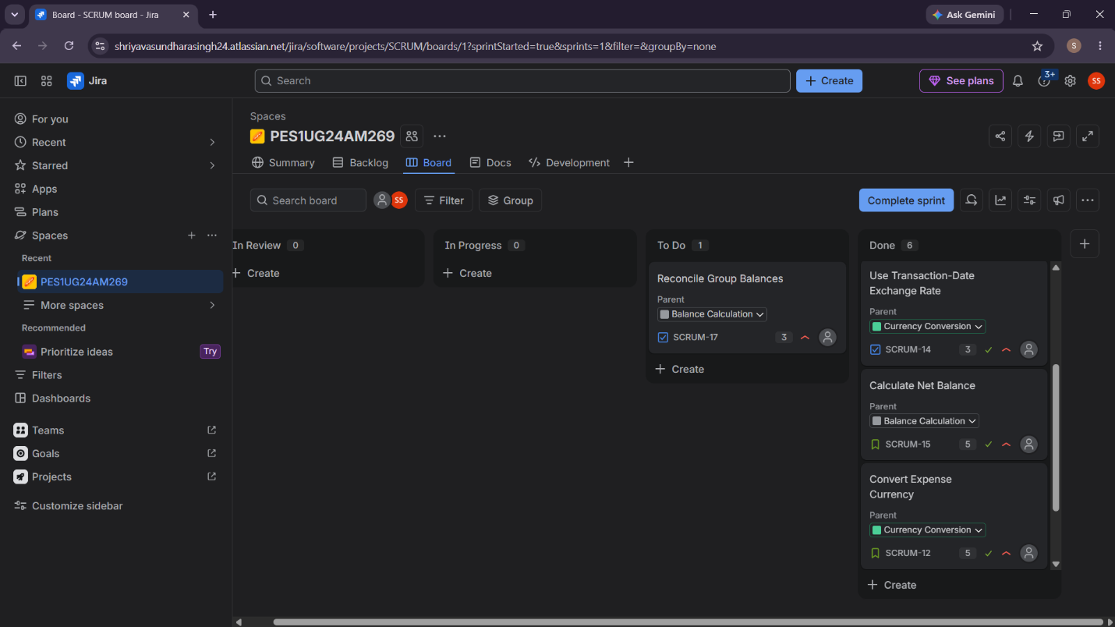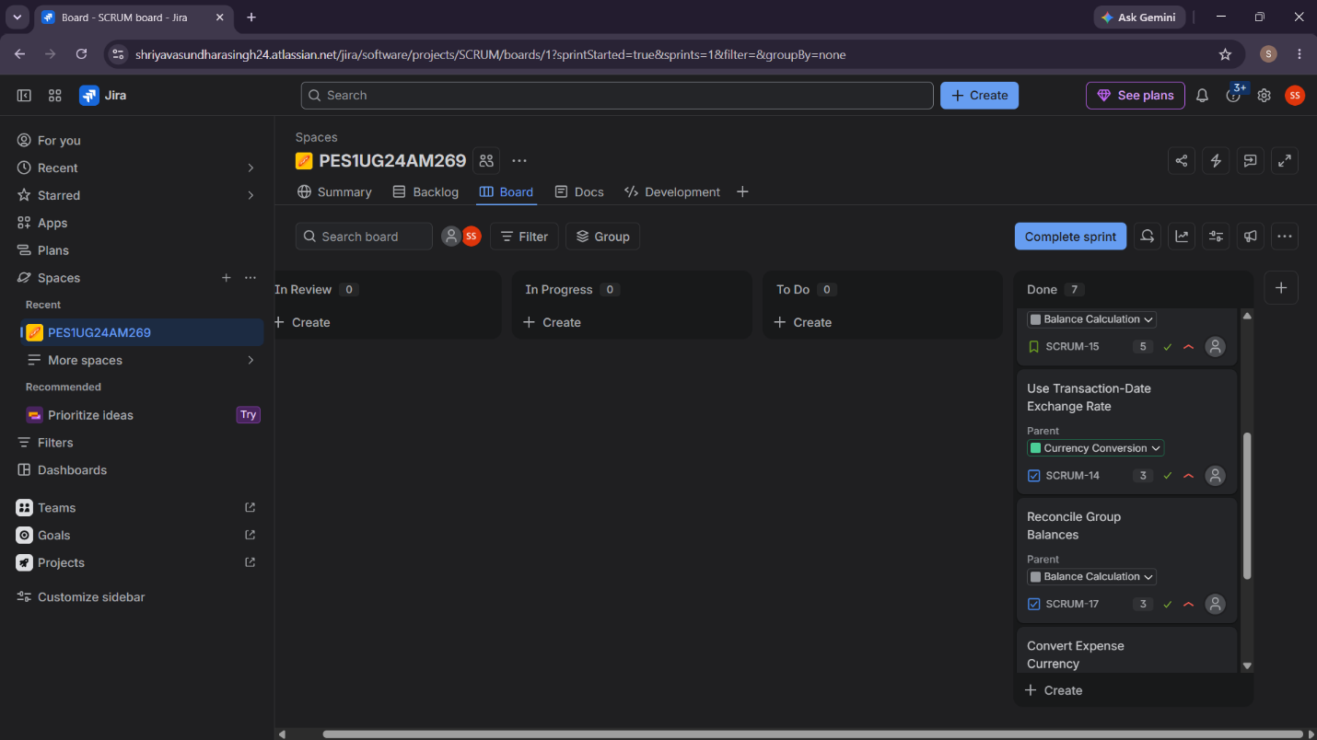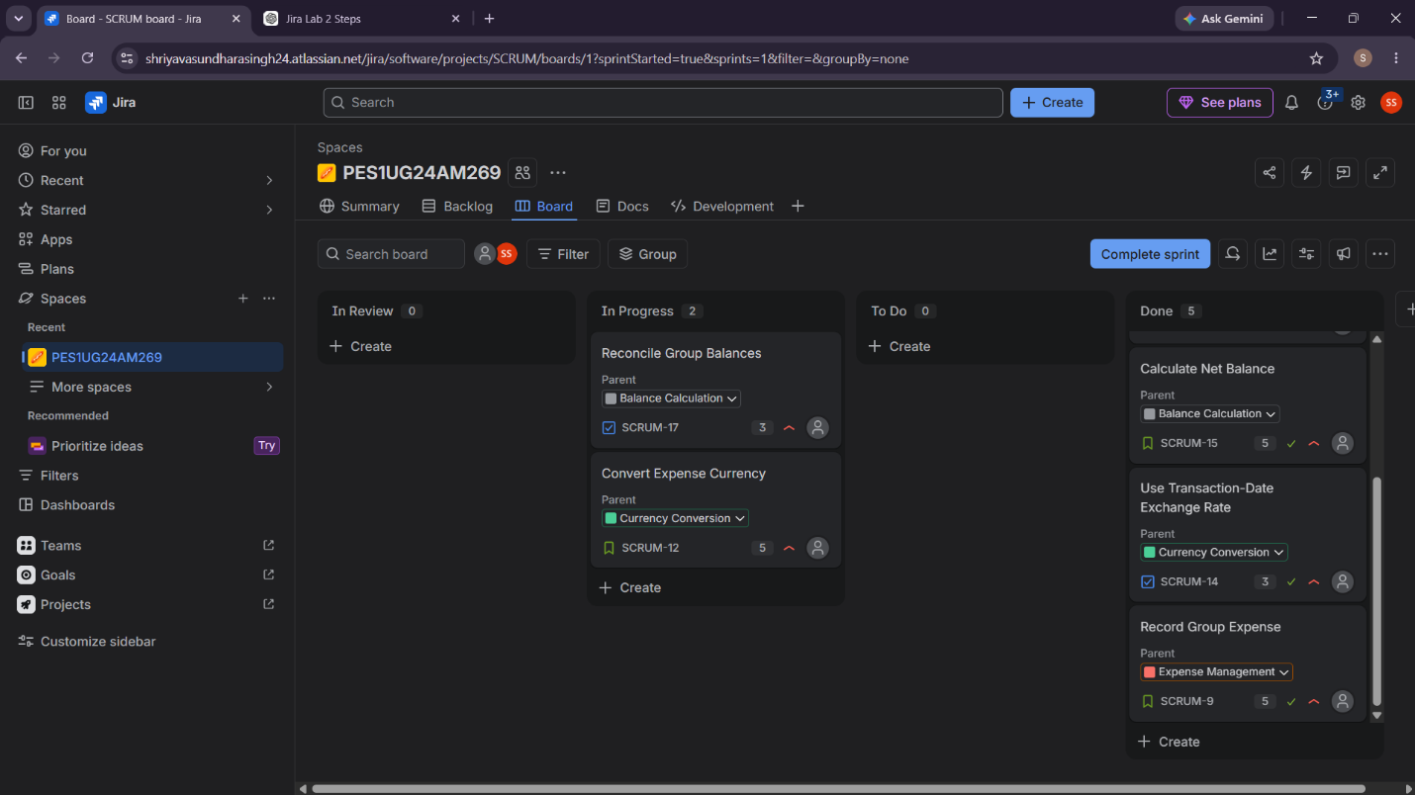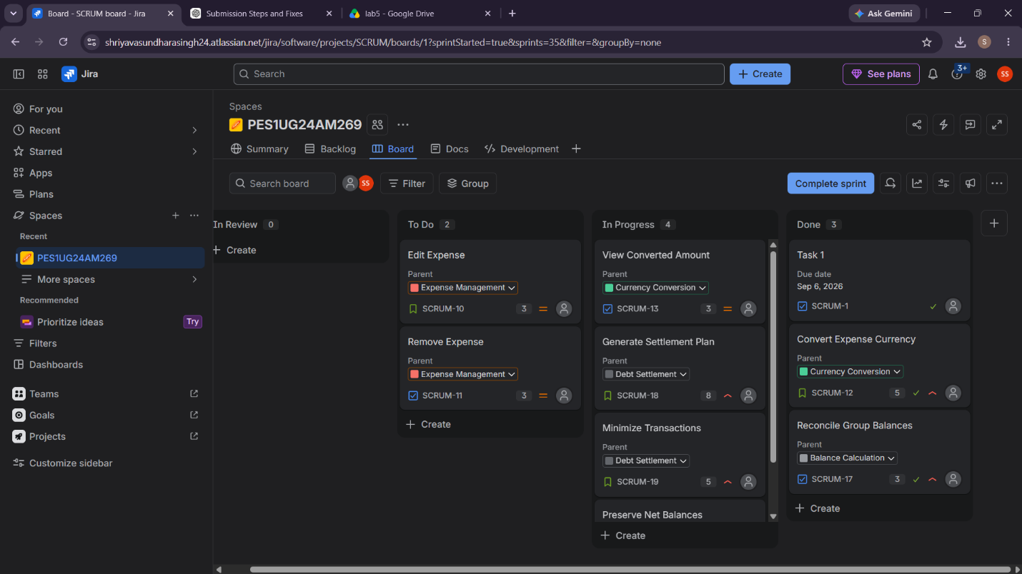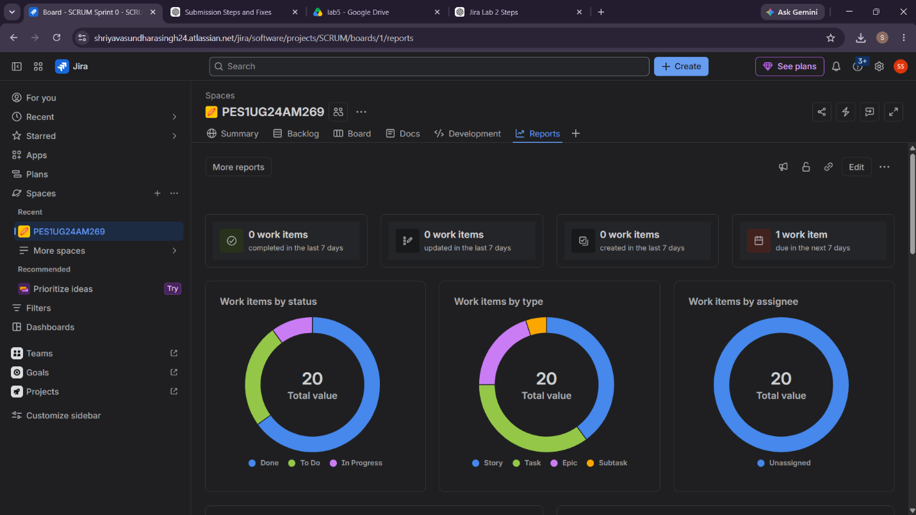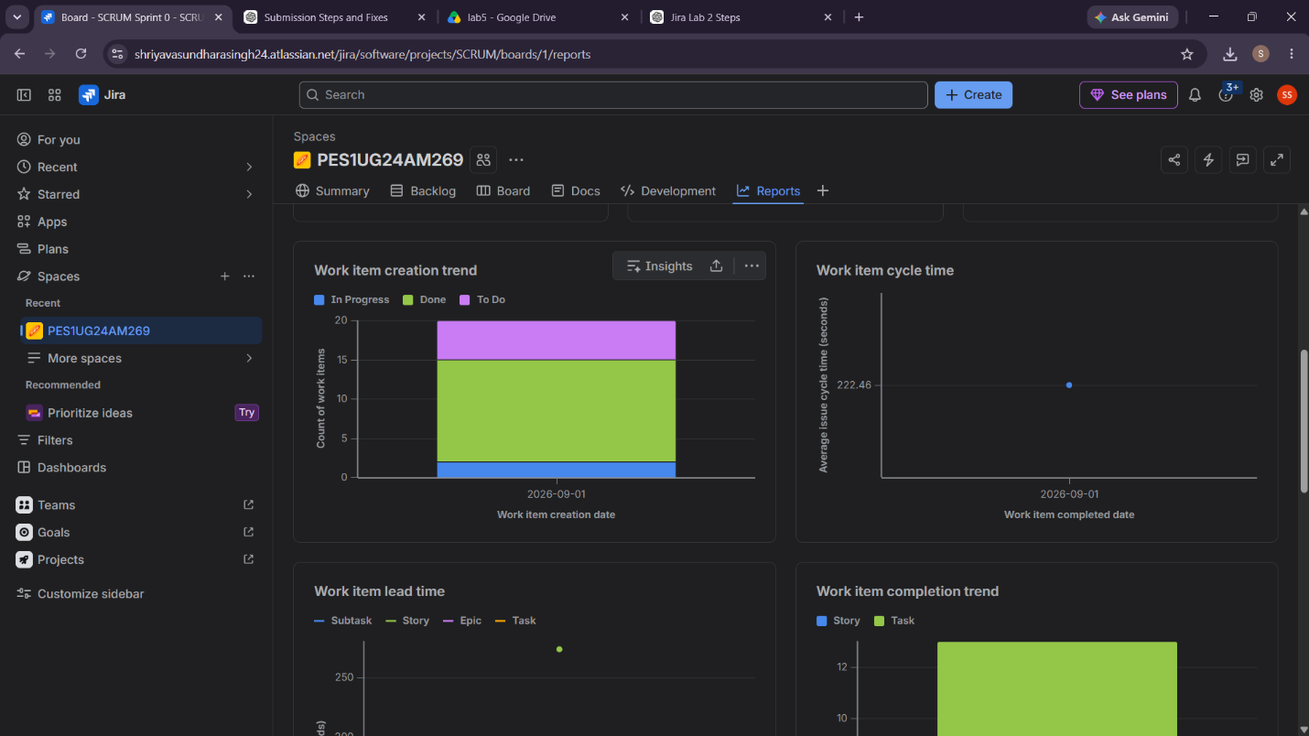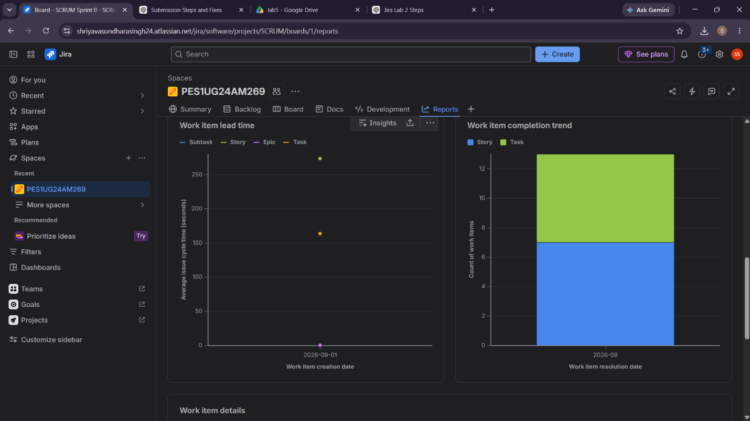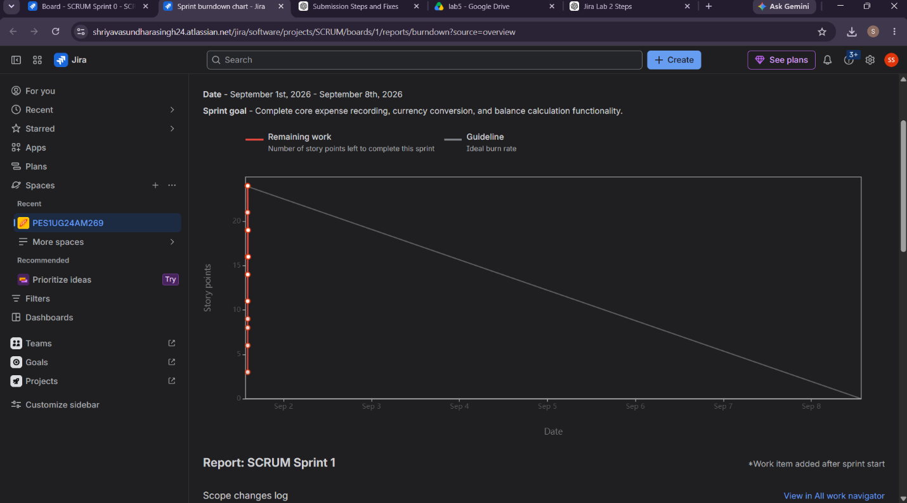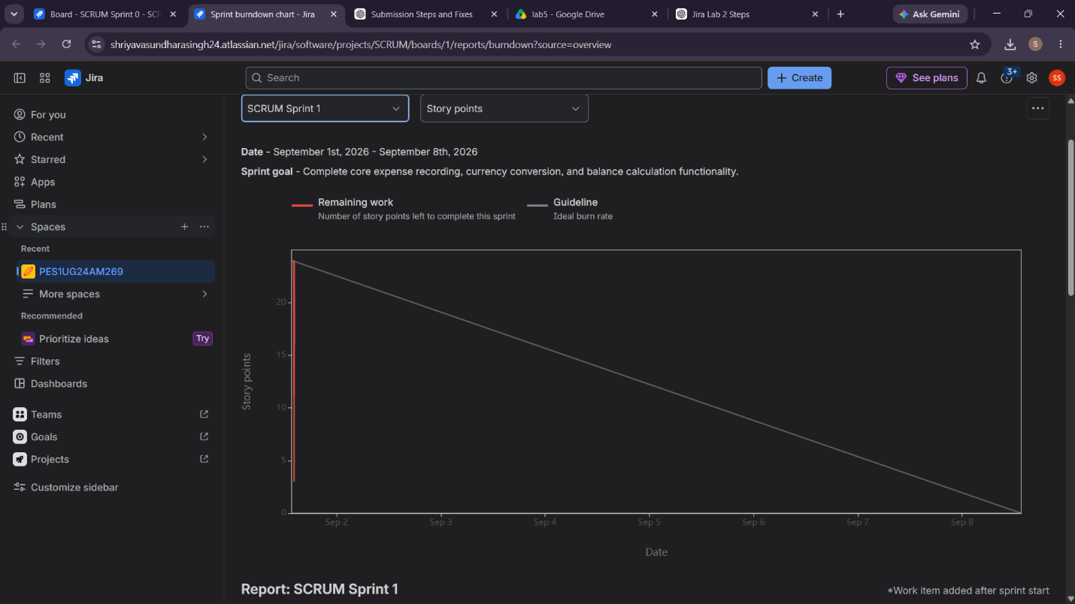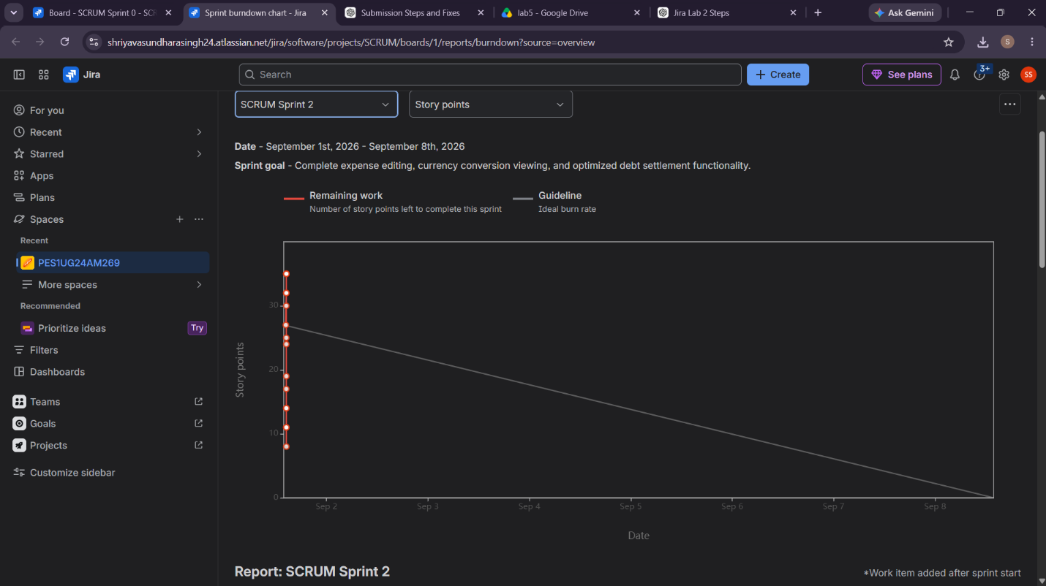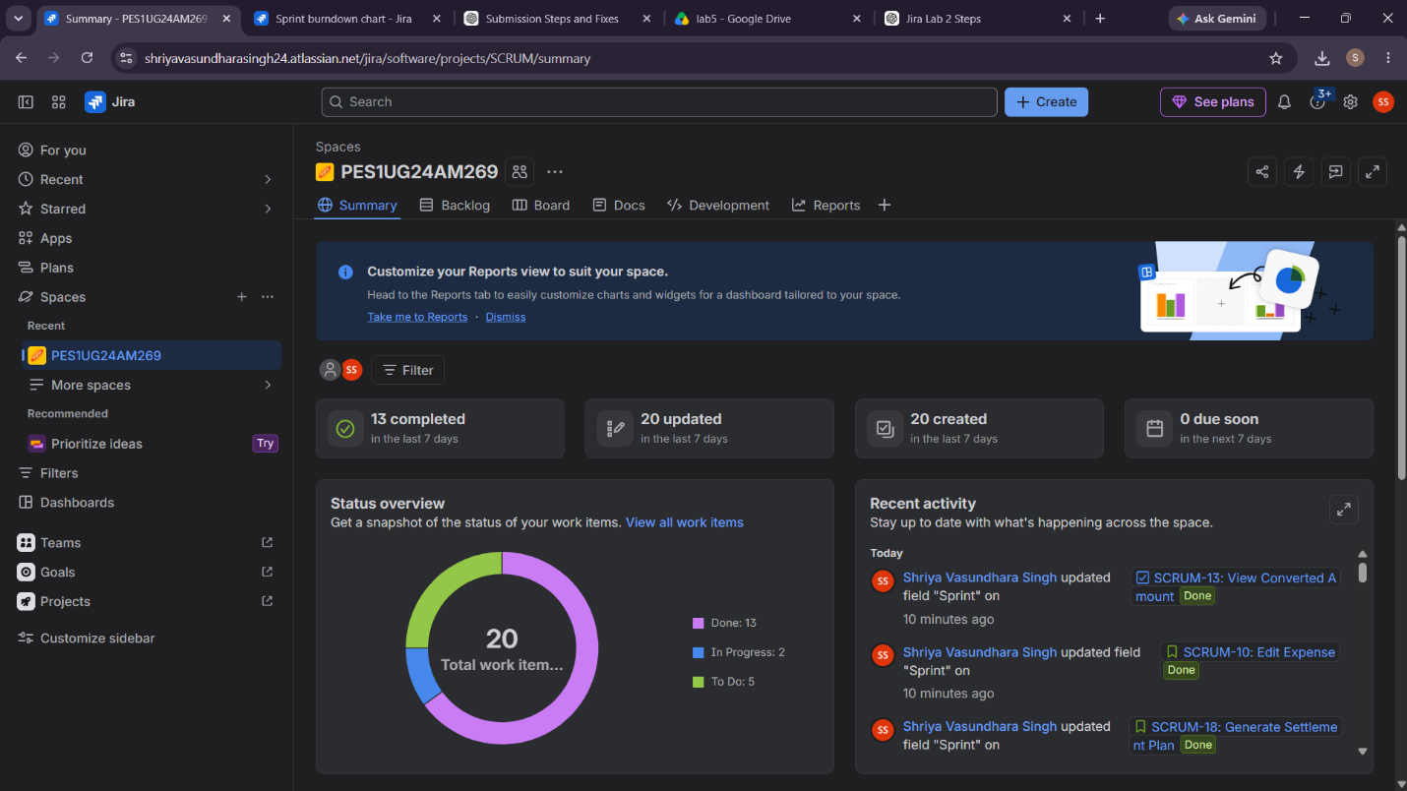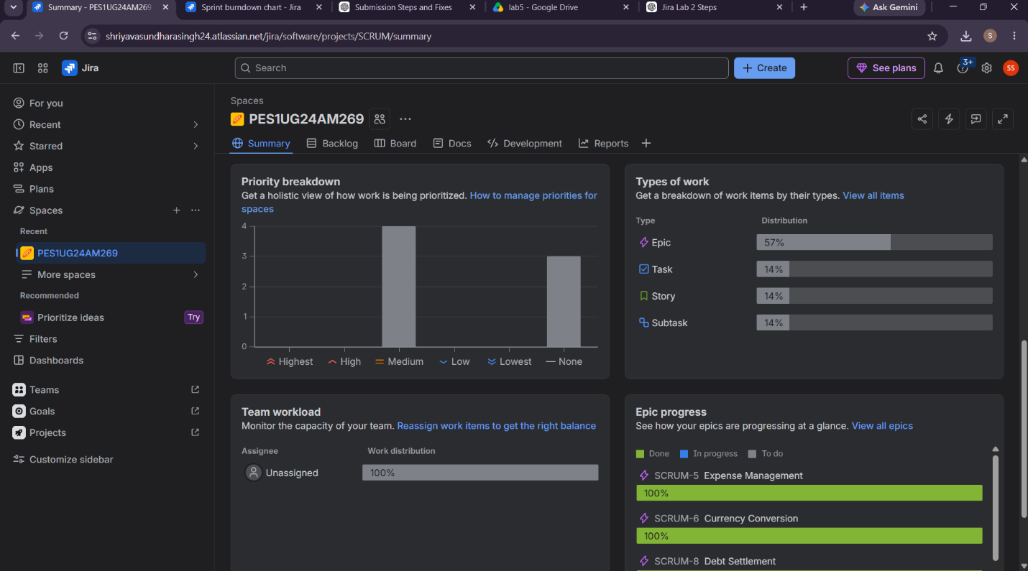

ANSWER TO REFLECTION QUESTIONS:
1. Did your estimations reflect the actual effort?
Answer:
Yes, the Story Point estimates reasonably reflected the relative effort, complexity, and uncertainty of the User Stories. Simple features such as viewing balances were assigned fewer points, while more complex functionality such as generating a settlement plan received higher points. Overall, the estimates helped us divide the workload effectively between the two sprints.
2. Was your backlog well-prioritized?
Answer:
Yes. The backlog was prioritized according to business value and user needs. Core features such as recording expenses, currency conversion, and balance calculation were given higher priority because they are fundamental to the Group Travel Expense Simplification Engine. Less critical functionality was scheduled for later in the development process.
The lab specifically requires prioritizing backlog items according to user impact using High, Medium, and Low priorities.
3. How did your simulated sprint align with your plan?
Answer:
The simulated sprints aligned well with the planned backlog. The User Stories were divided across two sprints, and the work was progressed through the Jira workflow from To Do → In Progress → Done. This allowed us to simulate how a Scrum team tracks and completes planned work during a sprint.
The lab specifically requires creating Sprint 1, selecting backlog items, and progressing them through these workflow stages.
4. What insights did the Burndown Chart give about your team’s capacity?
Answer:
The Burndown Chart provided a visual representation of the remaining work as the sprint progressed. It helped us understand whether the planned workload was achievable within the sprint duration and whether work was being completed at an appropriate rate. It also showed how completing User Stories reduced the remaining Story Points. A sudden change in the burndown could indicate estimation or task-breakdown issues, while consistently finishing early or late could indicate that the team was under- or over-committing.
Final short conclusion
Conclusion: Jira helped us convert the Lab 1 requirements into Epics and User Stories, prioritize and estimate the backlog, plan two Scrum sprints, track progress, and analyze sprint performance using the Burndown Chart. The exercise demonstrated how Agile planning and Jira can be used to manage a software project systematically.

