**WEEK-4 SPRING-REST-HANDSON-2**

**SUPERSET ID : 6393674**

**Hello World RESTful Web Service**

**SOLUTION:**

**SpringLearnApplication.java**

**package** com.cognizant.spring_learn;

**import** org.springframework.boot.SpringApplication;

**import** org.springframework.boot.autoconfigure.SpringBootApplication;

@SpringBootApplication

**public** **class** SpringLearnApplication {

**public** **static** **void** main(String[] args) {

SpringApplication.*run*(SpringLearnApplication.**class**, args);

}

}

**HelloController.java**

**package** com.cognizant.spring_learn.controller;

**import** org.slf4j.Logger;

**import** org.slf4j.LoggerFactory;

**import** org.springframework.web.bind.annotation.GetMapping;

**import** org.springframework.web.bind.annotation.RestController;

@RestController

**public** **class** HelloController {

**private** **static** **final** Logger ***LOGGER*** = LoggerFactory.*getLogger*(HelloController.**class**);

@GetMapping("/hello")

**public** String sayHello() {

***LOGGER***.info("START: sayHello()");

String message = "Hello World!!";

***LOGGER***.info("END: sayHello()");

**return** message;

}

}

**Application.properties.xml**

server.port=8087

spring.application.name=spring-learn

**pom.xml**

<?xml version="1.0" encoding="UTF-8"?>

<project xmlns="http://maven.apache.org/POM/4.0.0" xmlns:xsi="http://www.w3.org/2001/XMLSchema-instance"

xsi:schemaLocation="http://maven.apache.org/POM/4.0.0 https://maven.apache.org/xsd/maven-4.0.0.xsd">

<modelVersion>4.0.0</modelVersion>

<parent>

<groupId>org.springframework.boot</groupId>

<artifactId>spring-boot-starter-parent</artifactId>

<version>3.5.3</version>

<relativePath/> <!-- lookup parent from repository -->

</parent>

<groupId>com.cognizant</groupId>

<artifactId>spring-learn</artifactId>

<version>0.0.1-SNAPSHOT</version>

<name>spring-learn</name>

<description>Spring Web Demo</description>

<url/>

<licenses>

<license/>

</licenses>

<developers>

<developer/>

</developers>

<scm>

<connection/>

<developerConnection/>

<tag/>

<url/>

</scm>

<properties>

<java.version>17</java.version>

</properties>

<dependencies>

<dependency>

<groupId>org.springframework.boot</groupId>

<artifactId>spring-boot-starter-web</artifactId>

</dependency>

<dependency>

<groupId>org.springframework.boot</groupId>

<artifactId>spring-boot-devtools</artifactId>

<scope>runtime</scope>

<optional>true</optional>

</dependency>

<dependency>

<groupId>org.springframework.boot</groupId>

<artifactId>spring-boot-starter-test</artifactId>

<scope>test</scope>

</dependency>

</dependencies>

<build>

<plugins>

<plugin>

<groupId>org.springframework.boot</groupId>

<artifactId>spring-boot-maven-plugin</artifactId>

</plugin>

</plugins>

</build>

</project>

**OUTPUT**

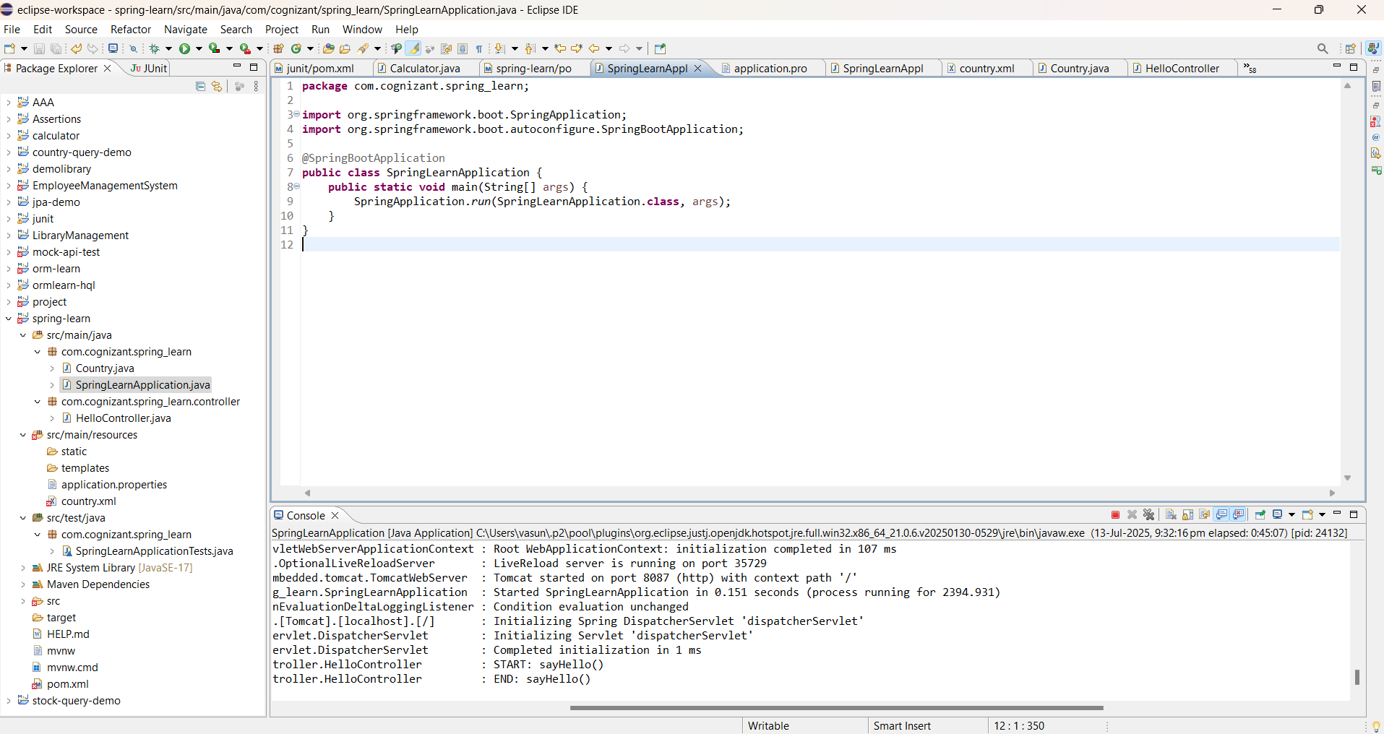

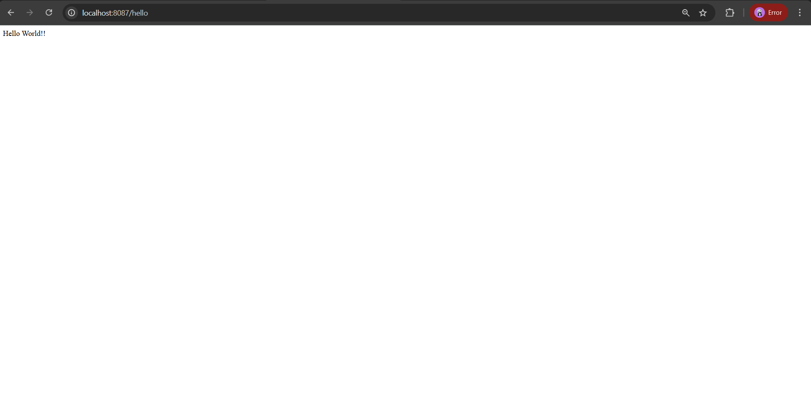

**REST - Country Web Service** 

**SOLUTION:**

**SpringLearnApplication.java**

**package** com.cognizant.spring_learn;

**import** org.springframework.boot.SpringApplication;

**import** org.springframework.boot.autoconfigure.SpringBootApplication;

@SpringBootApplication

**public** **class** SpringLearnApplication {

**public** **static** **void** main(String[] args) {

SpringApplication.*run*(SpringLearnApplication.**class**, args);

}

}

**Country.java**

**package** com.cognizant.spring_learn;

**public** **class** Country {

**private** String code;

**private** String name;

// Getters and Setters

**public** String getCode() {

**return** code;

}

**public** **void** setCode(String code) {

**this**.code = code;

}

**public** String getName() {

**return** name;

}

**public** **void** setName(String name) {

**this**.name = name;

}

}

**CountryController.java**

**package** com.cognizant.spring_learn.controller;

**import** com.cognizant.spring_learn.Country;

**import** org.slf4j.Logger;

**import** org.slf4j.LoggerFactory;

**import** org.springframework.context.ApplicationContext;

**import** org.springframework.context.support.ClassPathXmlApplicationContext;

**import** org.springframework.web.bind.annotation.RequestMapping;

**import** org.springframework.web.bind.annotation.RestController;

@RestController

**public** **class** CountryController {

**private** **static** **final** Logger ***LOGGER*** = LoggerFactory.*getLogger*(CountryController.**class**);

@RequestMapping("/country")

**public** Country getCountryIndia() {

***LOGGER***.info("START getCountryIndia()");

ApplicationContext context = **new** ClassPathXmlApplicationContext("country.xml");

Country country = (Country) context.getBean("country");

***LOGGER***.info("END getCountryIndia()");

**return** country;

}

}

**Country.xml**

<?xml version="1.0" encoding="UTF-8"?>

<beans xmlns="http://www.springframework.org/schema/beans"

xmlns:xsi="http://www.w3.org/2001/XMLSchema-instance"

xsi:schemaLocation="http://www.springframework.org/schema/beans

http://www.springframework.org/schema/beans/spring-beans.xsd">

<bean id="country" class="com.cognizant.spring_learn.Country">

<property name="code" value="IN"/>

<property name="name" value="India"/>

</bean>

</beans>

**OUTPUT**

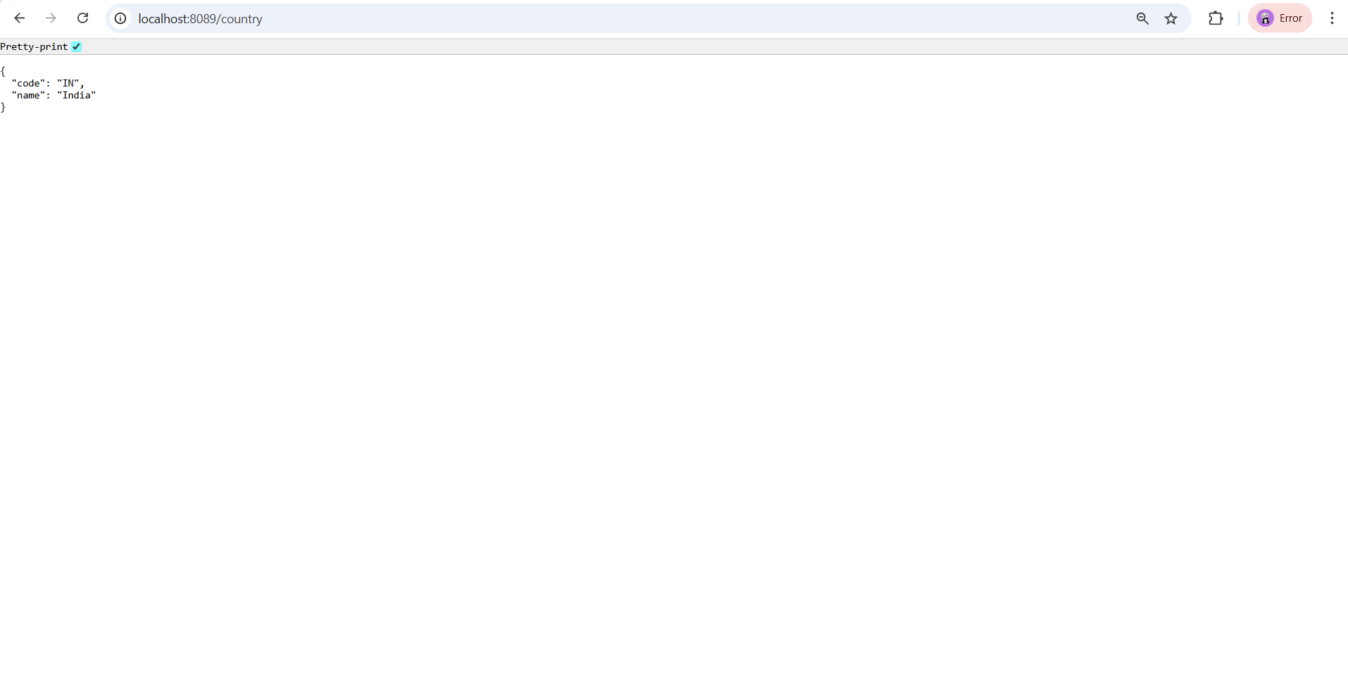

**REST - Get country based on country code**

**SOLUTION:**

**SpringLearnApplication.java**

**package** com.cognizant.spring_learn;

**import** org.springframework.boot.SpringApplication;

**import** org.springframework.boot.autoconfigure.SpringBootApplication;

@SpringBootApplication

**public** **class** SpringLearnApplication {

**public** **static** **void** main(String[] args) {

SpringApplication.*run*(SpringLearnApplication.**class**, args);

}

}

**Country.java**

**package** com.cognizant.spring_learn;

**public** **class** Country {

**private** String code;

**private** String name;

// Getters and Setters

**public** String getCode() {

**return** code;

}

**public** **void** setCode(String code) {

**this**.code = code;

}

**public** String getName() {

**return** name;

}

**public** **void** setName(String name) {

**this**.name = name;

}

}

**CountryController.java**

**package** com.cognizant.spring_learn.controller;

**import** com.cognizant.spring_learn.Country;

**import** org.slf4j.Logger;

**import** org.slf4j.LoggerFactory;

**import** org.springframework.context.ApplicationContext;

**import** org.springframework.context.support.ClassPathXmlApplicationContext;

**import** org.springframework.web.bind.annotation.RequestMapping;

**import** org.springframework.web.bind.annotation.RestController;

@RestController

**public** **class** CountryController {

**private** **static** **final** Logger ***LOGGER*** = LoggerFactory.*getLogger*(CountryController.**class**);

@RequestMapping("/country")

**public** Country getCountryIndia() {

***LOGGER***.info("START getCountryIndia()");

ApplicationContext context = **new** ClassPathXmlApplicationContext("country.xml");

Country country = (Country) context.getBean("country");

***LOGGER***.info("END getCountryIndia()");

**return** country;

}

}

**CountryService.java**

package com.cognizant.spring_learn.service;

import com.cognizant.spring_learn.model.Country;

import org.springframework.beans.factory.annotation.Value;

import org.springframework.core.io.Resource;

import org.springframework.stereotype.Service;

import org.springframework.beans.factory.xml.XmlBeanFactory;

import org.springframework.core.io.ClassPathResource;

import org.springframework.context.support.ClassPathXmlApplicationContext;

import java.util.List;

@Service

public class CountryService {

public Country getCountry(String code) throws Exception {

ClassPathXmlApplicationContext context = new ClassPathXmlApplicationContext("country.xml");

List<Country> countryList = (List<Country>) context.getBean("countryList");

return countryList.stream()

.filter(c -> c.getCode().equalsIgnoreCase(code))

.findFirst()

.orElseThrow(() -> new Exception("Country Not Found"));

}

}

**Country.xml**

<?xml version="1.0" encoding="UTF-8"?>

<beans xmlns="http://www.springframework.org/schema/beans"

xmlns:xsi="http://www.w3.org/2001/XMLSchema-instance"

xsi:schemaLocation="http://www.springframework.org/schema/beans

http://www.springframework.org/schema/beans/spring-beans.xsd">

<bean id="country" class="com.cognizant.spring_learn.Country">

<property name="code" value="IN"/>

<property name="name" value="India"/>

</bean>

</beans>

**OUTPUT**



