**WEEK-8-GIT-HOL-5**

**SUPERSET ID 6393674**

**Objectives**

**• Explain how to clean up and push back to remote Git**

To clean up and push to remote Git:

1. Use git status to check for uncommitted changes.
2. Stage changes using git add . and commit with git commit -m "message".
3. Push the committed changes using git push origin branch_name.
4. This syncs local changes to the remote repository.

Please follow the instructions to complete the hands-on. Each instruction expects a command for the Git Bash.

1.Verify if master is in clean state.

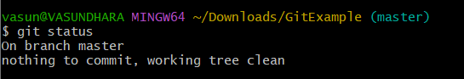

2.List out all the available branches.

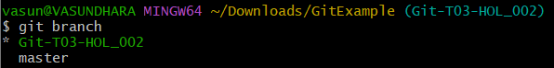

3.Pull the remote git repository to the master

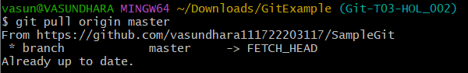

4.Push the changes, which are pending from **“Git-T03-HOL_002”** to the remote repository

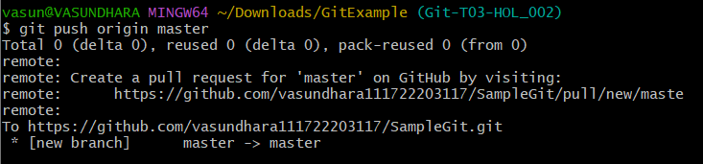

5.Observe if the changes are reflected in the remote repository.

