Name: | Vasundhara Singh
UID no.: | 2021700062
Experiment No. | 1B
Class: | SE CSE(DS)
Batch: | D-4
Date of Experiment: | 06/02/2023

AIM: | Experiment on finding the running time of an algorithm.
PROBLEM STATEMENT: | For this experiment, you need to implement Insertion and Selection sort methods. Compare these algorithms based on time and space complexity. Generate 1,00,000 integer numbers using C/C++ Rand function and save them in a text file. Both the sorting algorithms uses these 1,00,000 integer numbers as input as follows. Each sorting algorithm sorts a block of 100 integers numbers with array indexes numbers A[0..99], A[0..199], A[0..299],..., A[0..99999]. You need to use a function to find the time required for 100, 200, 300.... 100000 integer numbers. Finally, compare the two algorithms by plotting the time required to sort 100000 integers using MS Excel. The x-axis of 2-D plot represents the block no. of 1000 blocks. The y-axis of 2-D plot represents the running time to sort 1000 blocks of 100,200,300,...,100000 integer numbers.
THEORY: | Insertion sort is a simple sorting algorithm in which the array is virtually split into a sorted and an unsorted part. Values from the unsorted part are picked and placed at the correct position in the sorted part. To sort an array of size N in ascending order:  - Iterate from arr[1] to arr[N] over the array.  - Compare the current element (key) to its predecessor.  - If the key element is smaller than its predecessor, compare it to the elements before. Move the greater elements one position up to make space for the swapped element.  Selection sort is a simple and efficient sorting algorithm that works by repeatedly selecting the smallest (or largest) element from the unsorted portion of the list and moving it to the sorted portion of the list. The algorithm repeatedly selects the smallest (or largest) element from the unsorted portion of the list and swaps it with the first element of the unsorted portion. This process is repeated for the remaining unsorted portion of the list until the entire list is sorted. Follow the below steps to solve the problem:  - Initialize minimum value(min_idx) to location 0.  - Traverse the array to find the minimum element in the array.  - While traversing if any element smaller than min_idx is found then swap both the values.  - Then, increment min_idx to point to the next element.  - Repeat until the array is sorted.
PROGRAM: | #include <stdio.h>  #include <stdlib.h>  #include <time.h>  void rand_int()  {  int num1, num2;  long num;  FILE *ptr;  ptr = fopen("int.txt", "w");  srand( time(0));  for (long i = 0; i < 100000; i++)  {  num1 = rand();  num2 = rand();  num = num1 * 10 + num2;  fprintf(ptr,"%ld\n",num);  }  fclose(ptr);  }  void in_sort(int arr[], int n)  {  int i, key, j;  for (i = 1; i < n; i++)  {  key = arr[i];  j = i - 1;  while (j >= 0 && arr[j] > key)  {  arr[j + 1] = arr[j];  j = j - 1;  }  arr[j + 1] = key;  }  }  void sel_sort(long * A, long n)  {  for(int i = 0; i<n; i++)  {  int min = A[i];  int pos = i;  int temp;  for(int j = i; j<n; j++)  {  if(A[j]<min)  {  min = A[j];  pos = j;  }  }  temp = A[i];  A[i] = min;  A[pos] = temp;  }  }  int main()  {  rand_int();  FILE * ptr_int, * ptr_time;  ptr_time = fopen("times.csv", "w");  if(!ptr_time)  return 0;  fprintf(ptr_time, "Cases, Selection, Insertion\n");  for(long int i = 100; i<=100000; i+=100)  {  ptr_int = fopen("int.txt", "r");  long int A[i], B[i];  clock_t start1, end1, start2, end2;  if(i % 1000 == 0)  {  printf("i = %ld.\n", i);  }  for(long int j = 0; j<i; j++)  {  fscanf(ptr_int, "%d\n", &A[j]);  B[j] = A[j];  }  start1 = clock();  sel_sort(A, i);  end1 = clock();  start2 = clock();  in_sort(B, i);  end2 = clock();  double t1 = (double) (end1 - start1) / CLOCKS_PER_SEC;  double t2 = (double) (end2 - start2) / CLOCKS_PER_SEC;  fprintf(ptr_time, "%ld, %f, %f\n", i, t1, t2);  fclose(ptr_int);  }  fclose(ptr_time);  return 0;  }
GRAPH: | 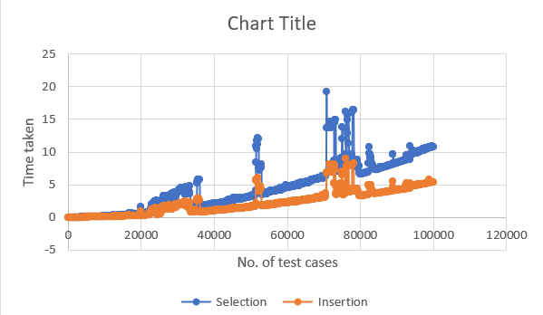
OBSERVATION: | Worst case scenario among the given test cases occurs at the case containing around 72000 integers, marked by a sudden spike in both graphs.  Time complexity of selection sort is O(n²) as it uses two nested loops, outer for loop to select an element from the array one by one and inner for loop to compare it with every other element of the unsorted sub-array to find the min element.  Time complexity of insertion sort is O(n²) as it also uses two nested loops, the outer for loop to select an element from the array as key and inner while loop to shift the other unsorted elements to make space for the key.
CONCLUSION: | Time and Space Complexity of Insertion and Selection Sort is  investigated.

