Name: | Vasundhara Singh
UID no.: | 2021700062
Experiment No. | 1A
Class: | SE CSE(DS)
Batch: | D-4
Date of Experiment: | 23/01/2023

AIM: | To implement the various functions e.g. linear, non-linear, quadratic, exponential etc.
PROBLEM STATEMENT: | Implement the following functions in C language:  - n  - n³  - log₂n  - log_{e}n  - log₂(log₂n)  - log_{e}(log_{e}n)  - (log₂n)²  - 2 ^{log}₂^{n}  - √ log₂n  - (log₂n) ^{log}₂^{n}  Plot line graphs of all these functions using values of f(n) where ‘n’ varies from 0 to 100 with an increment of 10.  Also implement the function n! and plot its line graph using values of n varying from 0 to 20 with an increment of 2.
PROGRAM: | #include <stdio.h>  #include <math.h>  float f2(int n)  {  return pow(n,3);  }  float f3(int n)  {  return log2(n);  }  float f4(int n)  {  return log(n);  }  float f5(int n)  {  return log2(log2(n));  }  float f6(int n)  {  return log(log(n));  }  float f7(int n)  {  return log2(n)*log2(n);  }  float f8(int n)  {  return pow(2, log2(n));  }  float f9(int n)  {  return sqrt(log2(n));  }  float f10(int n)  {  return pow(log2(n), log2(n));  }  long long fact(int n)  {  if(n==0 || n==1)  return 1;  else  return n*fact(n-1);  }  void main()  {  int i=0;  printf("\nn\t|n^3\t\t|log2(n)\t|ln(n)\t|log2(log2(n))\t|ln(ln(n))\t|(log2(n))^2\t|2^(log2(n))\t|sqrt(log2(n))\t|(log2(n))^(log2(n))\n");  //printf("\t|\t\t|\t\t|\t|\t\t|\t\t|\t\t|\t\t|\t\t|\t|\n");  printf("---------------------------------------------------------------------------------------------------------------------------------------------------");  for(i=0; i<=100; i+=10)  {  printf("\n%d\t",i);  printf("|%7.0f\t", f2(i));  printf("|%0.2f\t\t", f3(i));  printf("|%0.2f\t", f4(i));  printf("|%0.2f\t\t", f5(i));  printf("|%0.2f\t\t", f6(i));  printf("|%0.2f\t\t", f7(i));  printf("|%0.0f\t\t", f8(i));  printf("|%0.2f\t\t", f9(i));  printf("|%0.2f", f10(i));  }  printf("\n\nn\t|n!");  for(i=0; i<=20; i+=2)  {  printf("\n%d\t",i);  printf("|%lld", fact(i));  }  }
OUTPUT: | 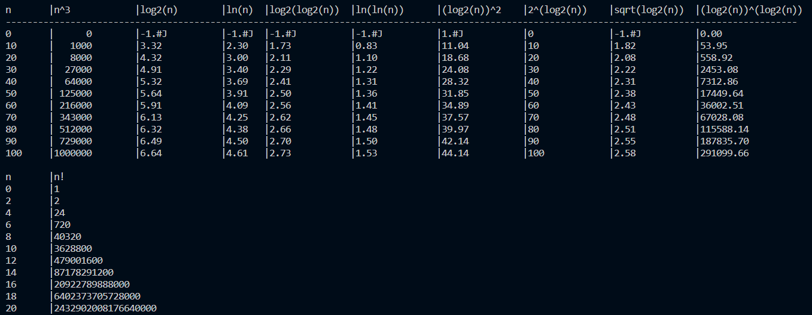
GRAPH: | 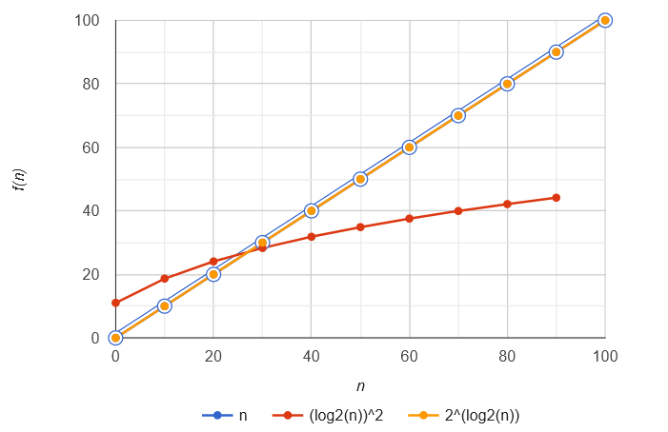  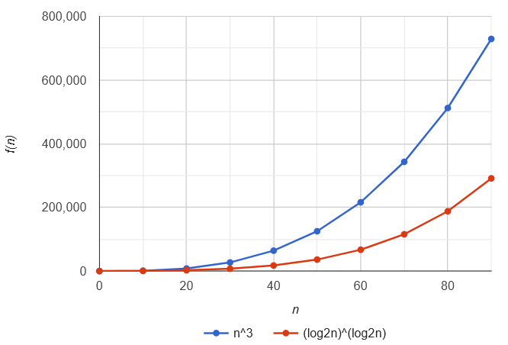  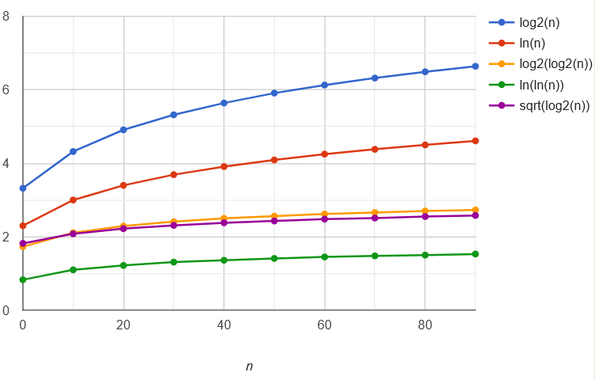  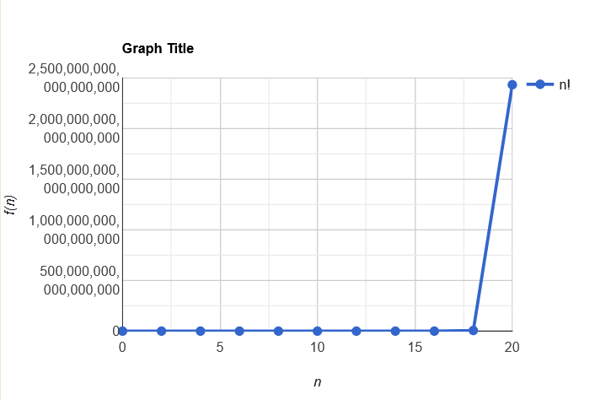
CONCLUSION: | We are able to implement and graph linear, non-linear, logarithmic and exponential functions.  Some functions involving log(n) are not defined for n=0, which is displayed as a random value.  The values for factorial function increase very steeply.  Functions having a term raised to the power ‘n’ take more time to execute.  Time of execution of all functions increases as value of n increases.

