When Windows Grows, Microsoft Benefits

Microsoft took a bold step into the digital sector at that time, since technology was rapidly evolving. Bill Gates and Paul Allen created Microsoft in 1975. Microsoft is a multinational corporation that manufactures computer software, personal computers, and related services. The name "Windows" came from the interactive boxes that users used to traverse the machine's apps. MSDOS was Microsoft's first operating system, which bridged the gap between software and hardware. It essentially gives a set of typable commands for controlling the machine. With the introduction of the mouse, which performs movement rather than keyboard shortcuts, they released Windows 1.0, which was an extension of MS-DOS. Meanwhile, Microsoft began introducing its most well-known office applications, such as Word and Excel. On Windows 2 and 3 editions, there were soon icons and keyboard shortcuts, allowing users to improve their usability. The technical landscape for enterprises had transformed by the time Microsoft's fifth operating system, Windows 95, was set to be released. The majority of businesses have adopted technology, but the internet was going to revolutionize everything.

The Internet is a fundamental binder that connects all machines on the world. They created email and faxes as a result of system connectivity, which allows information to be sent from one system to another via the internet. During those days, it was fashionable to communicate in this manner. However, businesses were confronted with a slew of challenges as a result of the abrupt transition. Almost every organization was connected to the internet within a few years, and the majority of them were running Windows 95. After a thirteen-year wait, Microsoft eventually released Windows 7 in 2009. Touch, speech, and handwriting recognition are among the new features, as is support for virtual hard discs and other file formats, as well as better speed. Eventually, the internet provided an opportunity for Microsoft to develop Windows 10 by adding Task View, support for fingerprint and facial recognition login, and additional security features.

People began to switch from personal computers to portable devices as a result of this. It established the foundations for cloud computing, which is one of the most popular pay-as-you-go storage options for consumers with limited storage space. The loss of the iconic Start button and the inability to boot to the desktop were major flaws in Windows Vista and Windows 8. Still, Windows devotes 13 to 14 percent of its income to its research and development division, which is tasked with coming up with fresh ideas. On June 24, 2021, Microsoft officially announced the launch of Windows 11, which includes exciting new features such as Chromebooks and Android apps. Even though individuals still buy Chromebooks, they have an 83 percent market share for PCs. The popular phrase "When Windows Grows, Microsoft Benefits" is a good fit.

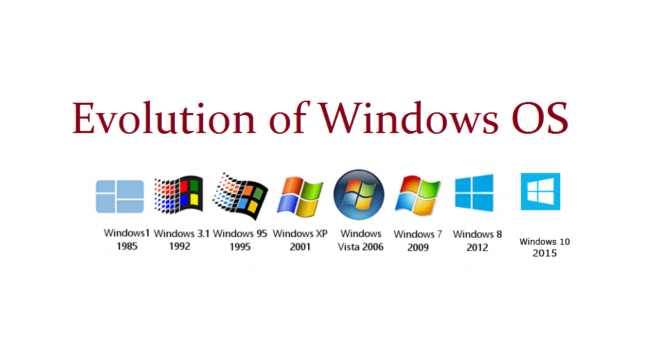

Web Is Humanity Connected by Technology

The World Wide Web, sometimes known as the web, is an information space that contains hyperlinked documents and other resources that are identifiable by their URIs. It uses Internet protocols like as TCP/IP and HTTP to implement both client and server applications. With the availability of e applications and the Internet of Things, we have reached a point where we can connect with the internet in new and improved ways. With each generation, new tools and strategies for improved usability and performance were introduced. They are the Web 1.0, Web 2.0, and Web 3.0 kinds, which have evolved dramatically alongside the internet. Initially, web development resembles the creation of intranet and internet web pages and websites. People created web applications as a part of their business sources as time passed. They develop programmes that allow clients all around the world to access them, as well as growing world-class businesses. Web 1.0 provides a restricted user experience and e-commerce "store front" site. It doesn't stop with 1.0; Web 2.0 ushered in a new era of social networking with the development of social apps like Facebook. It was more interactive and richer. Some believe it's the backbone of many websites, allowing for easy content updates, editing, uploading, and downloading. People create and share knowledge with one another through social networking.

Then there's Web 3.0, which revolutionized everyone's perception of the internet by introducing the concept of a user experience that included a full software application that could run online. Semantic web, RSS feeds, and data sharing are among the features. The web that we see today is the result of the continual work of an open community of web designers who aid in the development of cutting-edge technologies. CSS3, WebGL, HTML 5, Java, React JS, Angular JS, PHP, and more technologies are now being used in web development. These technologies also guarantee that the website or web app is compatible with all major web browsers. Web applications can be created in a variety of ways, including frontend and backend. Since the early 2000s, the web has grown in popularity as a platform for developing websites utilizing common web development technologies such as HTML, CSS, and JavaScript. To get a website or web application up and running at the time, the developer had to follow simply three steps. One must write and save code, then test it to see whether it is working properly before deploying it.

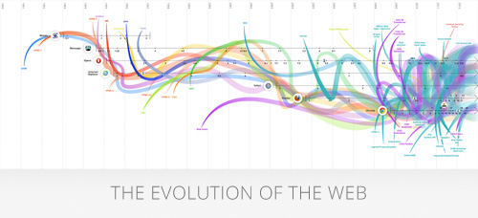

Netscape, one of the most well-known and widely used browsers in the world, was released. The public now has easy access to the internet. In 1994, graphical elements such as animated GIF images, text formatting, and tables were added. The World Wide Web Consortium (W3C) was established in order to provide a single standard for web development. The use of tables to format the HTML structure became popular. In 1995, JavaScript was also introduced. CSS1 was created to add more colors and fonts to the web, but prior to that, all codes were written in inline HTML. Flash 5, JavaScript, CSS3, SVG, WordPress, and Sass were the following years. CSS grid layout has gained the attention of web developers because it provides a layout that can be used for content alignment, mostly to conserve space, Flexbox, and other complicated effects. Responsive design, which was introduced in 2010, allows programmes to adjust to their environment, whether they are used on a mobile device or a desktop computer. Websites now attempt to create a streamlined user experience and suit the demands of visitors, rather than filling up your screen with extraneous information. Web design has evolved in so many ways, both subtle and obvious, that the changes highlighted here are just the tip of the iceberg. Although it may be difficult to conceive, the Web of the future will most likely be unrecognizable from what most people are used to today.

**CLOUD–THIRD WAVE OF DIGITAL REVOLUTION**

Cloud computing has evolved from an inventive concept to a disruptive endeavor through time. Cloud computing is a thriving sector today, with firms and academics pushing the frontiers of what is possible and providing new and improved solutions to essential problems. The delivery of various services over the Internet is known as cloud computing. These resources include data storage, servers, databases, networking, and software, among other tools and applications. Cloud-based storage allows you to save files to a remote database rather than maintaining them on a proprietary hard drive or local storage device. As long as an electronic device has internet access, it has access to the data as well as the software programmes needed to run it. For a variety of reasons, including cost savings, greater productivity, speed and efficiency, performance, and security, cloud computing is a popular choice among individuals and corporations.

On-Demand Self-Service, Broad Network Access, Resource Pooling, Rapid Elasticity, and Measured Service are the five essential characteristics. The following are the three service models: Platform-as-a-Service (PaaS) is a business model that allows consumers to consume and manage software that is provided by the provider. Infrastructure-as-a-Service (IaaS) — Users are in charge of everything from the operating system to the network infrastructure. Software-as-a-Service (SaaS) is a business model that allows customers to access software that is hosted on the provider's servers.

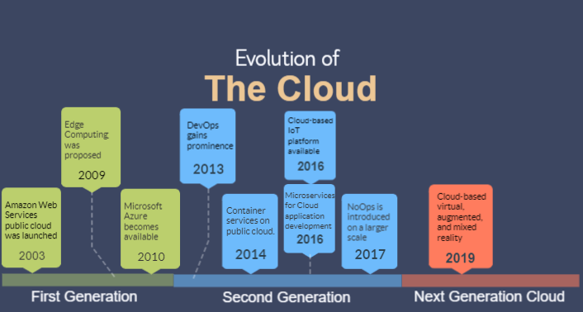

In 2000 Amazon, a popular online retailer, pioneered the current Cloud Computing industry. There are many myths about how Amazon Web Services (AWS) came to be, one of which is that it began as a way for Amazon to rent out spare computing capacity after the holiday shopping season. When Amazon Web Services (AWS) first began in 2002, it only offered a few services and capabilities, focusing primarily on assisting partners with integrating with their e-commerce platform. Amazon released a beta version of Amazon Simple Queue Solution (SQS), an online queueing service for developers, in 2004. AWS later offered numerous more services in 2006, including Amazon Simple Storage Service (S3) and Amazon Elastic Compute Cloud, an IaaS offering (in beta) (EC2). At the time, EC2 and S3 were released with a unique pricing mechanism dubbed On-Demand, which allowed users to only pay for the capacity they used. Many of the services we use now were introduced by AWS in 2009. Amazon CloudWatch, Amazon Virtual Private Cloud (vpn), Amazon Relational Database Service (RDS), and Auto scaling are just a few of the notable features.

IBM, a firm with a lengthy history in virtualization and cloud dating back to the 1950s, said in 2007 that it planned to develop enterprise clouds and deliver new services on top of them. IBM produced various cloud software and hardware solutions (such as IBM Cloudburst in 2009), but IBM Smart Cloud was the company's first cloud computing service. Google! emerged as a new cloud contender in 2008. Google App Engine, the company's first public PaaS solution, was launched. With Google App Engine, Google took a similar approach to AWS, focusing on the creation and hosting of web apps on Google's infrastructure. In 2009, Alibaba Group, a Chinese e-commerce giant, launched a new cloud service. Alibaba Cloud was established in 2009, and its first data Centre launched the following year. Between 2015 and 2017, the number of enterprises using software-as-a-service (SaaS) services doubled as a result of this adoption. In addition, a slew of new businesses has entered the market. In 2017, 55 new SaaS startups were formed in India alone. Infrastructure-as-a-service (IaaS) has, nevertheless, seen the most increase. Five companies dominated the IaaS industry in 2018: Google, Amazon, Microsoft, Alibaba, and IBM. The industry's value reflects this: revenues are expected to approach $623 billion by 2025, up from roughly $12 billion in 2010.