Section B Team20

Names | Hsin-Yu Hung | QiAng Wang | Vasundhara Penmetsa | Wenqi Fan | Xinyi Shen
NetID | hh292 | qw122 | vp144 | wf63 | xs121
Question1:
This heatmap visualization we provided shows how the levels of Property Damage coverage options are distributed across different combinations of "Car Age" and "Car Value." It allows us to observe patterns and relationships in the data with the correlation to ,D, levels of Property Damage coverage.
For example the combinations of car with the youngest age and highest value tend to have higher coverage of damage and older cars with relatively low value has low damage coverage, which has been shown with color blue.
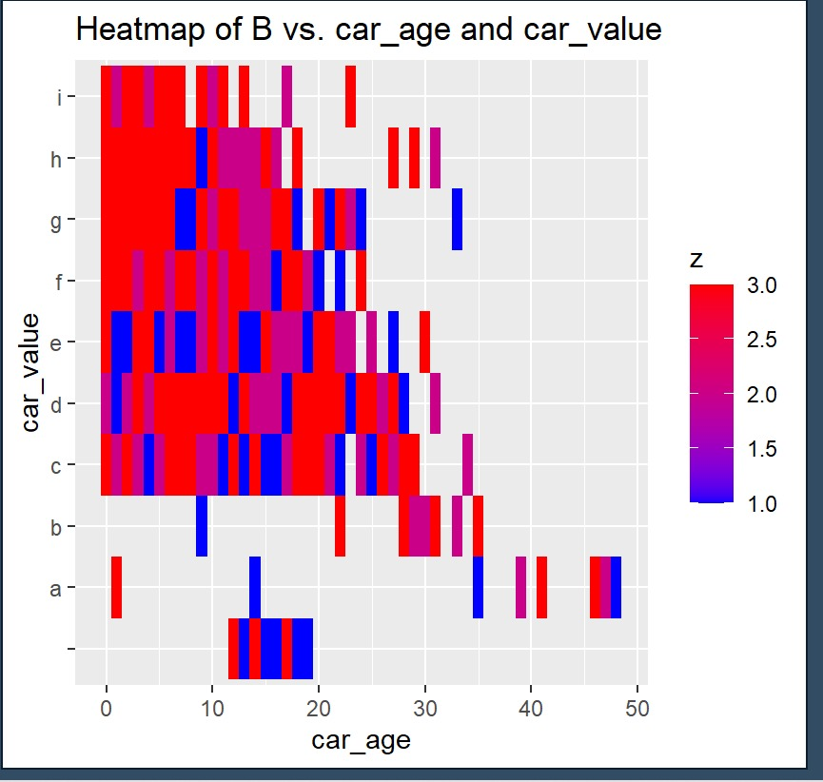
Question 2:
 | Car Age | Car Value
Summary | Coefficient (Estimate): -0.95609  As car age increases, the insurance quote decreases by approximately $0.956, holding all other variables constant. | Coefficient (Estimate for car_value c): -44.80932  Cars with under value (c) would on average receive a quote that is $44.809
Business Perspective | Older cars tend to have lower insurance quote. This is because they have lower replacement cost compared to newer models. Also they usually tend to lack modern features and maybe outdated which could mean higher maintenance costs and repair costs. Also, likely not safe to use after a certain point- more accidents are likely to take place. | Cars in the value category 'c' receive a significantly lower quote compared to the base category. This suggests that these cars might be perceived as less risky to insure compared to the base category. Cars in category 'c' are less likely to be stolen, have fewer accidents, and have lower repair costs. category 'c' represents cars that are neither too old nor too new which means there is a balance of safety features and replacement costs.
Recommendation | Offer special insurance packages for older cars and competitive based pricing. | Allstate could create segmented marketing campaigns or specialized insurance packages based on car value categories.

Question 3:
Goal: To maximize expected immediate revenue from a customer given the observed characteristics
Mathematical model:
- Customer classifications: Accept our offer (Accept) OR Reject our offer (Reject)
- Factor notations:
  - 1) P_Quote: The price of our quotation offered to a customer
  - 2) Cost: Expected costs associated with the company
- E[Revenue|Accept] = P(Accept) * (P_Quote - Cost)
- E[Revenue|Reject] = (1 - P(Accept)) * (- Cost)
- E[Revenue] = E[Revenue|Accept] + E[Revenue|Reject]
= P(Accept) * (P_Quote - Cost) - (1 - P(Accept)) * (Cost)
- If we assume there is no expected Cost associated with each quotation,
then E[Revenue] = P(Accept) * (P_Quote)
Decomposition strategy:
- According to our mathematical model of the expected revenue, there are two core factors that we need to strategize on: the rate of accepting our offer & price of our offer.
- In order to better decompose the current situation, two assumptions are made:
  - 1) There is no difference between the service offered by us and ALLSTATE, and incremental value between two brands equals 0.
  - 2) The customer always accepts the offer with a lower quotation price.
- Based on these two assumptions, there are two cores tasks: 1) Build a prediction model indicating ALLSTATE’s quotation price, 2) Conduct price optimization to set a optimal price to maximize revenue
Core tasks 1: Prediction model of ALLSTATE’s quotation
- Data mining methods: linear regression
- Based on historical data offered in this case, a prediction model of ALLSTATE’s quotation could be established. This model can firstly allow us to determine the probability of ALLSTATE’s offer at different price points. Since we previously assumed that the customer will accept the offer from the firm with a lower price, we can calculate your expected revenue based on this graph.
- For example, if we offer a quotation of 600, our P(Accept) equals the forecasted probability that ALLSTATE offers a quote greater than 600, which can be determined based on the prediction model. Along with P_Quote = 600, E[Revenue] can be indicated.
Core task 2: Price optimization
- Data mining methods: quantile regression
- Based on historical data offered in this case, we can conduct a quantile regression to see the distribution of ALLSTATE’s quotes with previous customers. By trying different tau values, we could indicate a price point that (1- tau value) portion of the quotations have a higher price. For example, if we offer the expected at a tau value of 0.2, ALLSTATE will offer a higher price than us for 80% of time. This regression can reduce the effort of finding the optimal price for each customer based on the previous linear regression model and makes the calculator of expected revenue easier since P(Accept) is fixed.
Question4:
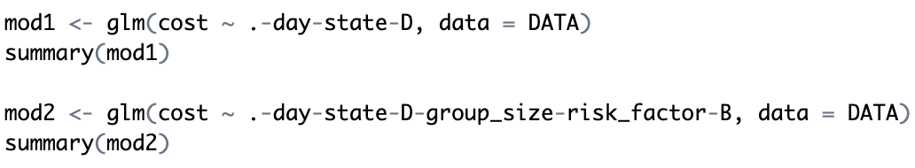
Our core task is basically the same as Question 3 and the data mining method we use is linear regression. First we run the linear regression model with “cost” as the predicted variable and others as predictive variables. After checking the p-value of each variable, we decide to eliminate “day”, “state” and “D” because their p-values are greater than 0.05. Then we build another model without these three variables and delete another three variables “group_size”, “risk_factor” and “B” as their p-values are greater than 0.05. Then we get our final model with almost all variables significant.

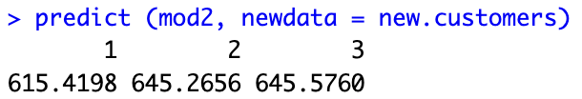
Then we use our final model to predict each customer’s predicted revenue. If our predicted revenue is the lowest, we can offer it as is. For customer 1, the value is $615.4198, so we should provide a quote lower than $615.4198. For customer 2, the value is $645.2656, so we should provide a quote lower than $645.2656. For customer 3, the value is $645.5760, so we should provide a quote lower than $645.5760.

Question5
Since there is an extra assumption compared to question 3 that the customer may choose neither our offer nor the competitor ALLSTATE's offer, the customer may consider the lowest priced offer. So the process changes from:
comparing prices -> accepting/rejecting the offer to
comparing prices -> considering the offer -> accepting/rejecting the offer.
Goal: To maximize expected immediate revenue from a customer given the observed characteristics
Mathematical model:
- Customer classifications: Consider and Accept our offer (Accept) OR Consider and Reject our offer (Consider) OR Reject our offer (Reject)
- Factor notations:
  - 1) P_Quote: The price of our quotation offered to a customer
  - 2) Cost: Expected costs associated with the company
  - 3) 𝑝: Our estimate of the probability of accept after considering
- E[Revenue|Accept] = 𝑝 * P(Accept) * (P_Quote - Cost)
- E[Revenue|Consider] = (1-𝑝)* P(Accept) * (- Cost)
- E[Revenue|Reject] = (1-𝑝)* (1 - P(Accept)* (- Cost)
- E[Revenue] = E[Revenue|Accept] + E[Revenue|Reject] + E[Revenue|Reject]
- If we assume there is no expected Cost associated with each quotation,
then E[Revenue] = 𝑝 *P(Accept) * (P_Quote)

Decomposition strategy:
- According to our mathematical model of the expected revenue, there are three core factors that we need to strategize on: the rate of the client is willing to accept the offer after consideration & the rate of accepting our offer & price of our offer.
- In order to better decompose the current situation, two assumptions are made:
  - 1) There is no difference between the service offered by us and other companies, and incremental value between two brands equals 0.
  - 2) The customer always accepts the offer with a lower quotation price
Based on these two assumptions, there are three cores tasks:
1) Build a prediction model indicating ALLSTATE’s quotation price,
2) Conduct price optimization to set a optimal price to maximize revenue
3) Build a classification according to the acceptance rate after customer consideration based on available historical information
（The first two are just like #3, and the following focuses on the third one)

Core task 3:
- Data mining methods: Classification
- Based on historical data offered in this case, we can build a classification. we predict the acceptance rate (0 or 1) hoping to match the Actual. Based on the estimated acceptance rate, to decide whether it should target on the above, i.e., to decide whether to carry out the reduction of the price. If 𝑝 is our estimate of the probability of accept, then a customer E[Revenue] = 𝑝*P(Accept) * (P_Quote)

