CHAPTER – 1

INTRODUCTION

1. **Introduction**

* 1. Need for the new system:-

In almost all business organizations a daily status report (DSR) is maintained for every employee to keep a record of the tasks assigned and the work done by the employee in the direction of task accomplishment.

The DSR is maintained in order to keep the officials informed about the division of work among the employees and to evaluate the efficiency of the person. It also helps in making decisions on the amount of work to be assigned to an employee by measuring his potential.

A DSR has the following fields:

• Date- the date on which the DSR was filled

• Tasks assigned-the tasks assigned to the person on this particular date.

• Status-status of the task (in progress/hung/completed)

• Time spent- the time spent towards performing each task.

• Remarks- any special experience or comment about the task for future reference.

The prime purpose is to enable the maintenance of the Daily Status Reports (DSR) of the employees of the company in a systematic and logical manner.

* 1. Detailed Problem Definition

The definition of our problem lies in maintaining the Daily status report (DSR) by excel sheets and maintaining the Daily status reports(DSR’s) in the way this program does

* No specific access right policies,
* No storage provision for the archived data,
* The system was not adaptable to the client-server technology,
* There was no arrangement for the superiors to make any recordable comment on the DSR of a subordinate,
* The efficiency of any employee in any specific area was not measurable,
* The system didn’t support functional integration with other systems handling various business functions.

*Pro-DSR system*

With the advent of latest technology if we do not update our system then our business result in losses gradually with time. The Pro-DSR systems contains the tools of latest trend i.e. computers, printers, fax, internet etc. The systems with this technology are very fast, accurate, user-friendly and reliable.

* Specific access right policies,
* Storage provision for the archived data,
* The system is adaptable to the client-server technology,
* There is an arrangement for the superiors to make any recordable comment on the DSR of a subordinate,
* The efficiency of any employee in any specific area is clearly and efficiently measurable,
* The system supports functional integration with other systems handling various business functions.
  1. Presently Available Systems for the same

Maintaining Daily Status Report (DSR’s) by excel system is a very tedious job, its properties are as follows:-

• No specific access right policies,

• No storage provision for the archived data,

• The system was not adaptable to the client-server technology,

• There was no arrangement for the superiors to make any recordable comment on the DSR of a subordinate,

• The efficiency of any employee in any specific area was not measurable,

• The system didn’t support functional integration with other systems handling various business functions.

* 1. Modules of the system

The different modules for this particular system were:-

* Module for Login and Logoff.
* Module for Reports.
* Module for Visit.
* Module for Administrator.
* Module for User.
  1. Future Prospects

Previously, the DSRs were maintained in excel sheets and there were,

* No specific access right policies,
* No storage provision for the archived data,
* The system was not adaptable to the client-server technology,
* There was no arrangement for the superiors to make any recordable comment on the DSR of a subordinate,
* The efficiency of any employee in any specific area was not measurable,
* The system didn’t support functional integration with other systems handling various business functions.

The product to be developed can be deployed at any business organization where the DSRs of the employees are maintained and a general functional hierarchy is followed. The product can be integrated with different applications deployed to automate other business functions.

A few factors that direct us to develop a new system are given below:-

* Faster system
* Accuracy
* Reliability
* Informative
* Easier addition, deletion and modification of records.

Other than these simple things the actual need of the project is already told earlier that handling Daily status reports (DSR’s) with this project named Pro-DSR is much more easier, efficient, systematic, logical and this have much more facilities available into this.

CHAPTER – 2

**LITERATURE SURVEY**

1. **Literature survey**

In almost all business organizations a daily status report (DSR) is maintained for every employee to keep a record of the tasks assigned and the work done by the employee in the direction of task accomplishment.

The DSR is maintained in order to keep the officials informed about the division of work among the employees and to evaluate the efficiency of the person. It also helps in making decisions on the amount of work to be assigned to an employee by measuring his potential.

A DSR has the following fields:

* Date- the date on which the DSR was filled
* Tasks assigned-the tasks assigned to the person on this particular date.
* Status-status of the task (in progress/hung/completed)
* Time spent- the time spent towards performing each task.
* Remarks- any special experience or comment about the task for future reference.

The prime purpose is to enable the maintenanceof the Daily Status Reports (DSR) of the employees of the company in a systematic and logical manner. Previously, the DSRs were maintained in excel sheets and there were,

* No specific access right policies,
* No storage provision for the archived data,
* The system was not adaptable to the client-server technology,
* There was no arrangement for the superiors to make any recordable comment on the DSR of a subordinate,
* The efficiency of any employee in any specific area was not measurable,
* The system didn’t support functional integration with other systems handling various business functions.

The product to be developed can be deployed at any business organization where the DSRs of the employees are maintained and a general functional hierarchy is followed. The product can be integrated with different applications deployed to automate other business functions.

CHAPTER – 3

ANALYSIS

1. **Analysis**
   1. Detailed Requirement

Prodsr will have the following classes of users-

Administrator: The administrator will assign the visiting rights to the monitors on the DSRs of the team members. He will also be responsible for managing the whole system by managing the entry of new users, exit of some user, changing the password etc.

Member: The members of any team working on any particular task should be able to make entries in their respective DSRs.The whole project can be divided in the following five modules:

User Management: This module entails the functions of adding new users, editing the profile of existing users and deleting the users. The users can be any one among the three type of profiles viz. administrator, monitor and team member. The user login rules are specified [further](a3PRD.doc#ur) in this document.

Password Management: The passwords of the users must conform to the specified standards (mentioned [further](a3PRD.doc#pr) in this document).

Authorization Management: It is concerned with the granting and revoking of authorization for the monitors over the team members. The person who is authorized to visit the DSR of any other person is termed as a monitor.

DSR Management: The functions to be taken care of in this module are adding the status report, visiting the DSR and saving the DSR.

Report Management: Only the administrator is allowed to extract a report on the DSRs of the employees. The report will be in a format specified by the administrator. The administrator will be provided with options to select the format of the report to be generated. This report can then be saved for any purpose as applicable.

As much as possible the look and feel of the user interface of the product shall be designed to be consistent for all classes of the above users. However there may be minor differences in the UI for each class of users as will be noted in the specifications below.

* 1. Functional Requirement

To grant authorization:-

|  |  |  |  |  |  |  |
| --- | --- | --- | --- | --- | --- | --- |
| **Field- name** | **Field-Type** | **Required** | **Max Length** | **Error Handling** | **Default** | **Comments** |
| Member Name | String | Yes | 50 | Please select a member name | Member-List | 1. Names of all the employees except the admin . |

|  |  |  |  |  |  |  |
| --- | --- | --- | --- | --- | --- | --- |
| **Field- name** | **FieldType** | **Required** | **Max-Length** | **Error Handling** | **Default** | **Comments** |
| Employee Name | String | Yes | 50 | 1.Please enter employee name  2. Only alphabets and spaces are allowed in the employee name | Blank | 1. Employee name length must be between 3 and 50 |
| User Id | String | Yes | 30 | 1.Please enter a user id  2. The user id can not have special characters except dot(.), @ and underscore(_)  3. The userid is not correct! Please enter a valid user id! It must be like | Blank | 1. Length of the User id must be between 3 and 30. |
| Password | String | Yes | 10 | 1.Please enter a password  2. Spaces are not allowed in the password | Blank | 1. Password length must be between 3 and 10. |
| Department | String | Yes | NA | 1. Please select a department | Please Select |  |
| Profile | String | Yes | NA | 1. Please select a profile for the new entrant | Please Select |  |

To create user:-

To edit user profile:-

|  |  |  |  |  |  |  |
| --- | --- | --- | --- | --- | --- | --- |
| **Field- name** | **Field-Type** | **Required** | **Max-Length** | **Error Handling** | **Default** | **Comments** |
| Employee Name | string | Yes | 50 | Please select an employee | Please Select | Names of all the employees will be displayed except the administrator |
| Profile | String | Yes | NA | Please select a profile | Please Select | .One of the three profiles admin, monitor and member is to be selected. |

To delete user:-

|  |  |  |  |  |  |  |
| --- | --- | --- | --- | --- | --- | --- |
| **Field- name** | **Field-Type** | **Required** | **Max-Length** | **Error Handling** | **Default** | **Comments** |
| Employee Name | string | Yes | 50 | Are you sure you want to delete this name | First name | 1. Names of all the employees except admin are displayed, out of which one name is to be selected for deletion.  2. On submit the user is asked to confirm the deletion. |
|  |  |  |  |  |  |  |

For Reports:-

|  |  |  |  |  |  |  |
| --- | --- | --- | --- | --- | --- | --- |
| **Field- name** | **Field-Type** | **Required** | **Max-Length** | **Error Handling** | **Default** | **Comments** |
| Department | string | Yes | NA | Please select department name | Blank | 1. All the departments are displayed in a drop down list |
| Employee Name | string | Yes | 50 | Please select a member | Member-List | 1. This field gets populated by the names of the employees who belong to the department selected in the previous field |
| From Date | string | Yes | NA | please specify date range | Blank | 1. The selected date is displayed in yyyy-mm-dd format |
| To | string | Yes | NA | please specify date range | Blank | 1.The starting date must be before the ending date |

To visit DSR:-

|  |  |  |  |  |  |  |
| --- | --- | --- | --- | --- | --- | --- |
| **Field- name** | **Field-Type** | **Required** | **Max-Length** | **Error Handling** | **Default** | **Comments** |
| Name | String | Yes | 50 | Please select the name | Please Select | 1. Names of only those employees will appear here whose DSR exists in the database. |
| From Date | String | Yes | NA | The period must be specified | Blank | 1. If the from date is greater than the current date an error message (no records found) is displayed. |
| To | String | Yes | NA | The period must be specified | Blank | 1. The starting date must be before the ending date |

To change password:-

|  |  |  |  |  |  |  |
| --- | --- | --- | --- | --- | --- | --- |
| **Field- name** | **Field-Type** | **Required** | **Max-Length** | **Error Handling** | **Default** | **Comments** |
| Old Password | String | Yes | 10 | 1.Please enter old password  2. Please enter a valid old password (if the length is not between 3 and 10). | Please Select | 1. The old password will be checked only for its validity here and not for its existence. |
| New Password | String | Yes | 10 | 1. Please enter new password  2. Spaces are not allowed in the password | Blank | 1. New Password must be between 3 and 10 characters. |
| Confirm Password | String | Yes | 10 | 1. Please enter confirm password  2. New password and confirm password doesn't match! Try again | Blank | 1. It must match with the new password. |

To fill DSR:-

|  |  |  |  |  |  |  |
| --- | --- | --- | --- | --- | --- | --- |
| **Field- name** | **Field-Type** | **Required** | **Max-Length** | **Error Handling** | **Default** | **Comments** |
| Date | string | Yes | NA | 1.Please select a date  2. The date must be less than or equal to the current date | Blank |  |
| Task Assigned | string | Yes | 500 | Please enter the assigned task | Blank |  |
| Status | string | Yes | NA | Please select a status | Please Select |  |
| Time Spent | string | Yes | 4 | 1.Please enter the time spent  2. Please enter a valid time duration | Blank | 1.The time spent in a day can’t be more than of 4 characters . |

* 1. System Specification

HARDWARE :

* .CPU : PENTIUM III
* PROCESSOR SPEED : 1.2 GHz
* TOTAL RAM : 64 MB
* HARD DISK SPACE : 4 GB
* OPERATING SYSTEM : WINDOWS
* OPEARTING SYSTEM, JAVA VIRTUAL MACHINE

SOFTWARE :

* Java development kit: jdk1.6.0 ,
* Database: ORACLE 10g,
* SERVER :BEA WEBLOGIC 8.0
* Best viewed in Internet Explorer 8.x, 9.x on windows Works fine in Mozilla Firefox 3.6.0.x or later version.

CHAPTER – 4

DESIGN

1. **Design**
   1. Detailed Requirements:

Prodsr will have the following classes of users-

Member: The members of any team working on any particular task should be able to make entries in their respective DSRs.

Administrator: The administrator will assign the visiting rights to the monitors on the DSRs of the team members. He will also be responsible for managing the whole system by managing the entry of new users, exit of some user, changing the password etc.

The whole project can be divided in the following five modules:

Employee Management: This module entails the functions of adding new users, editing the profile of existing users and deleting the users. The users can be any one among the three type of profiles viz. administrator, monitor and team member. The user login rules are specified [further](a3PRD.doc#ur) in this document.

Password Management: The passwords of the users must conform to the specified standards (mentioned [further](a3PRD.doc#pr) in this document).

Authorization Management: It is concerned with the granting and revoking of authorization for the monitors over the team members. The person who is authorized to visit the DSR of any other person is termed as a monitor.

DSR Management: The functions to be taken care of in this module are adding the status report, visiting the DSR and saving the DSR.

Report Management: Only the administrator is allowed to extract a report on the DSRs of the employees. The report will be in a format specified by the administrator. The administrator will be provided with options to select the format of the report to be generated. This report can then be saved for any purpose as applicable.

As much as possible the look and feel of the user interface of the product shall be designed to be consistent for all classes of the above users. However there may be minor differences in the UI for each class of users as will be noted in the specifications below.

ProDSR Use Case Scenarios:

* + 1. Utilities:

1. User Login Rules:

As mentioned before, the product would have various interfaces based on the user types. All the interfaces will be similar but may be slightly different from on class of users to another. The Login id would be the user’s email address, and the password would follow industry best practices. Note, that the Login id and password would be the only two types of entries required. In other words there would be no Member ID or anything similar.

Based on User Type configured in the system, the system will decide which interface to present to the user after login. Note that this implies that by design for better usability and simplicity of UI, one LoginId will be able to access only one type of interface, since User Type can only have a single value.

The validations for the username and the user id are as follows:

1. The user id must have the suffix a3logics.com.

2. The user id can not contain spaces.

3. The user id must be unique.

4. The username and user id can not have special characters.

5. The username or user id can not be left blank.

6. The user id must start with an alphabet.

7. The length of the username must be between 3 and 50 characters.

8. The length of the user id must be between 3 and 30 characters.

1. Password Rules:

Please follow these norms for password management:

1. Password must be at least 3 characters and maximum 10 characters long.

2. May contain special characters, such as “_”, “#”, “&” etc.

3. Must not contain spaces.

4. Must not be left blank.

* 1. **Data Flow Diagram**

A “**Data Flow Diagram”** is graphical representation that depicts the information flow and the transforms that are applied as data moves from input to output.

It can be used to represent software at any level of abstraction. In fact, DFD’s may be portioned into levels that represent increasing information flow and functional detail. Therefore, it provides mechanics for functional modeling as well as information flow modeling.

DFD’s are defined in levels with every level decreasing the level of abstraction, as well as defining the functional organs of the system.

SYMBOLS OF DFD-

1. Bubble: A circle is used to depict a process. Both inputs and outputs to a process are data flows.

2. Arrow: Data flows are represented by a line with an arrow.

**DATA FLOW**

3. Rectangle: Rectangles are used to represent the entities that are outside the system.

**EXTERNAL ENTITY**

4. Parallel Lines: Parallel lines are used to depict data stores. Process may store or receive data from data stores.

**DATA STORES**

5.Output Symbol:

The output symbol is used when a hard copy is produced and the user of the copies cannot be clearly specified or there are several users of the output.

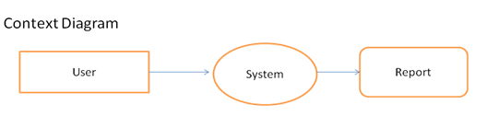

**0’ level DFD :**

ADMIN

STATUS

REPORT

login

(order book)

EMPLOYEE

information

DEPT. Information

STATUS

REPORT

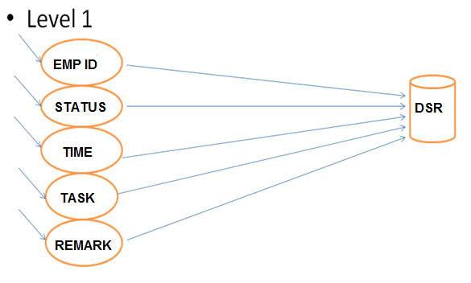

CHAPTER – 5

SYSTEM MODELING

1. **System Modeling**
   1. UML DIAGRAMS**:**

UML is not simply a notation for drawing diagrams, but a complete language for capturing knowledge about a subject and expressing knowledge regarding the subject for the purpose of communication.

Applies to modeling and system. Modeling involves a focus on understanding a subject and capturing and being able to communication. Applies to a multitude of different types of systems, domains and methods or processes.

Purpose of these variety models:-

* + Analysis
  + Specification
  + Design
  + Visualize and understand the problem and the working of a system
    1. **UML DIAGRAM FOR THE ADMINISTRATOR**

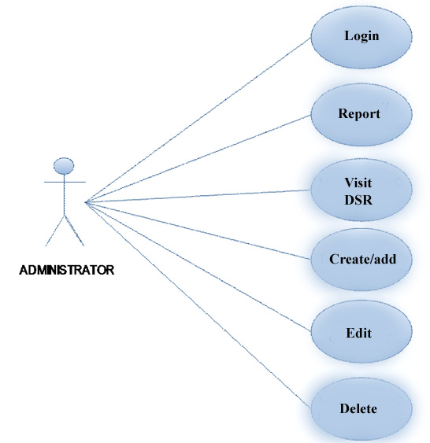

Fig 5.1 : Use Case Diagram for Administrator

* 1. **Database design**

The database to be created in MySQL must be named as “dsrdb”.

This database consists of fore tables

1. dept:

|  |  |  |  |  |  |  |  |
| --- | --- | --- | --- | --- | --- | --- | --- |
| Field | Type | Collation | Null | Key | Default | Extra | Privileges |
| department | varchar(100) | latin1_swedish_ci | No | PRI |  |  | select, insert, update,  references |

Names of the departments must be entered directly in this table viz.,

Business Analysis

DB Administration

HR

Java

Php

QA

System Analysis

Web Methods

More values for the department field can be entered later on.

2. dsr:

|  |  |  |  |  |  |  |  |
| --- | --- | --- | --- | --- | --- | --- | --- |
| Field | Type | Collation | Null | Key | Default | Extra | Privileges |
| Empname | varchar(50) | latin1_swedish_ci | YES |  | (NULL) |  | select, insert,  update,  references |
| emp_id | varchar(30) | latin1_swedish_ci | NO |  |  |  | ’’ |
| Tdate | Date | (NULL) | NO | PRI |  |  | ’’ |
| task_assigned | varchar(500) | latin1_swedish_ci | NO | PRI |  |  | ’’ |
| Status | varchar(15) | latin1_swedish_ci | YES |  | (NULL) |  | ’’ |
| time_spent | int(3) | (NULL) | YES |  | (NULL) |  | ’’ |
| Remarks | varchar(500) | latin1_swedish_ci | YES |  | (NULL) |  | ’’ |

3. status:

|  |  |  |  |  |  |  |  |
| --- | --- | --- | --- | --- | --- | --- | --- |
| Field | Type | Collation | Null | Key | Default | Extra | Privileges |
| status | varchar(10) | latin1_swedish_ci | No | PRI |  |  | select, insert, update,  references |

Following data must be inserted in this table beforehand

Completed

Halted

InProcess

NotStarted

More options for the status field can be entered later on.

4. emp:

|  |  |  |  |  |  |  |  |
| --- | --- | --- | --- | --- | --- | --- | --- |
| Field | Type | Collation | Null | Key | Default | Extra | Privileges |
| emp_id | varchar(30) | latin1_swedish_ci | NO |  |  |  | select, insert,  update,  references |
| Empname | varchar(30) | latin1_swedish_ci | YES | PRI | (NULL) |  |  |
| Emppass | varchar(10) | latin1_swedish_ci | NO | MUL |  |  |  |
| Profile | varchar(10) | latin1_swedish_ci | NO |  |  |  |  |
| Projects | varchar(300) | latin1_swedish_ci | YES |  | (NULL) |  |  |
| Department | varchar(200) | latin1_swedish_ci | YES |  | (NULL) |  |  |

Administrator must be created as a user in this table beforehand to enable him to manage all the proceedings.

Emp_id = admin

Empname = Administrator

Emppass = admin

Profile = admin

Projects = null

Department = null

CHAPTER – 6

**TESTING AND SYSTEM SECURITY**

1. **Testing and System Security**
   1. **Introduction**

Here the System testing involved is the most widely used testing process consisting of five stages as shown in the figure. In general, the sequence of testing activities is component testing, integration testing, and then user testing. However, as defects are discovered at any one stage, they require program modifications to correct them and this may require other stages in the testing process to be repeated.

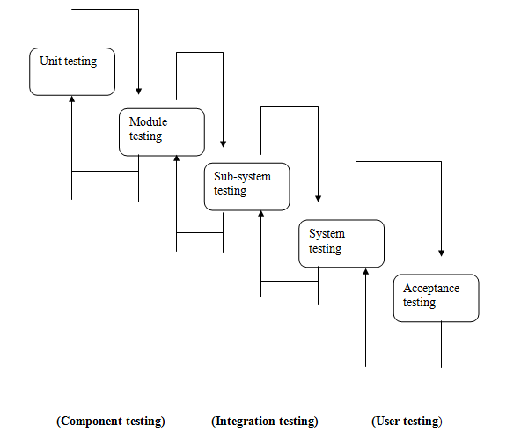

Testing is the process of detecting errors. Testing performs a very critical role for quality assurance and for ensuring the reliability of the software. The results of testing are used later on during maintenance also.

Testing is vital to the success of the system. System testing makes a logical assumption that if the parts of the system are correct, the goal will be successfully achieved. In adequate testing or non-testing leads to errors that may not appear until months or even years later (Remember the New York three day power failure due to a misplaced ‘Break’ statement).

**LEVELS OF TESTING**

In order to uncover the errors present in different phases, we have the concept of levels of testing. The basic levels of testing are

Client Needs Acceptance Testing

Requirements System Testing

Design Integration Testing

Code

Unit Testing

Software Configuration

Test Results

**Error**

Error Rate Data

Expected Results

Test Configuration

Predicated Reliability

Correction

**INFORMATION FLOW OF DATA FOR TESTING**

* 1. **QUALITY ASSURANCE**

The key factor to the success in software quality program is its implementation. While definition of process can be evolving phenomenon, implementation of processes makes the difference between success & failure.

A quality product can be defined as:

* One that is fit for use.
* One that is produced as per the predefined standards.

So, Software Quality Assurance is the process of ensuring that the product confirms to its standards.

QUALITY MANAGEMENT SYSTEM

A Quality Management System (QMS) is instituted by an organization to manage & maintain quality procedures in its day-to-day functioning. It is a conglomerate of people who have the required authority, responsibility and procedures for performing various activities. The QMS of an organization is guided by quality policy & quality procedures supported by various documents-Forms/Formats to maintain records & work instructions to provide guidelines for doing a particular piece of work.

* 1. **IMPLEMENTATION**

System implementation is the stage when the user has thoroughly tested the system and approves all the features provided by the system. The various tests are performed and the system is approved only after all the requirements are met and the user is satisfied.

The new system may be totally new, replacing an existing manual or automated system, or it may be a major modification to an existing system. In either case, proper implementation is essential to provide a reliable system to meet organizational requirements. Successful implementation may not guarantee improvement in the organization using the new system (that is a design question), but improper will prevent it.

Implementation is the process of having systems personnel check out and put new equipment into use, train users, install the new application and construct any files of data needed to use it. This phase is less creative than system design. Depending on the size of the organization that will be involved in using the application and the risk involved in its use, systems developers may choose to test the operation in only one area of the firm with only one or two persons. Sometimes, they will run both old and new system in parallel way to com-pare the results. In still other situations, system developers stop using the old system one day and start using the new one the next.

* 1. **MAINTENANCE**

Maintenance or enhancement can be classified as: -

**Corrective :** Corrective maintenance means repairing processing or performance failures or making changes because of previously uncorrected problems or false assumptions.

**Adaptive :**  Adaptive maintenance means changing the program function

**Perfective :** Perfective maintenance means enhancing the performance or modifying the program(s) to respond to the user’s additional or changing needs.

Maintenance is actually the implementation of the post implementation review plan. As important as it is, many programmers and analysts are reluctant to perform or identify themselves with the maintenance effort. There are psychological, personality and professional reasons for this. In any case, a first class effort must be made to ensure that software changes are made properly and in time to keep the system in tune with user specifications. Maintenance is costly. One way to reduce maintenance costs is through maintenance management and software modification audits.

CONCLUSION

At last we conclude that finally after our dedicated efforts and with the help of our ever helping project guide we have successfully created the project what we have aimed for which is having these features and is built because of the fact that:-

In almost all business organizations a daily status report (DSR) is maintained for every employee to keep a record of the tasks assigned and the work done by the employee in the direction of task accomplishment.

The DSR is maintained in order to keep the officials informed about the division of work among the employees and to evaluate the efficiency of the person. It also helps in making decisions on the amount of work to be assigned to an employee by measuring his potential.

And the features added in our project are:-

* The DSRs can be maintained in a central database
* Access rights should be assigned in a hierarchical manner.
* There are provisions for storage and maintenance of archived data.
* The efficiency of an employee can be measured by using the DSR.
* The employees can be assigned work based on their strength or weaknesses in certain areas.

BIBLIOGRAPHY

## Web Resources:

[1] “SUN”, [***http://www.sun.com***](http://www.sun.com)

[2] ***“***CORESERVLETS***”,*** [***http://www.coreservlets.com***](http://www.coreservlets.com)

[3] “W3SCHOOLS”, [***http://www.w3schools.com***](http://www.w3schools.com)

APPENDIX

* 1. **Appendix**

PURPOSE:-

In almost all business organizations a daily status report (DSR) is maintained for every employee to keep a record of the tasks assigned and the work done by the employee in the direction of task accomplishment.

The DSR is maintained in order to keep the officials informed about the division of work among the employees and to evaluate the efficiency of the person. It also helps in making decisions on the amount of work to be assigned to an employee by measuring his potential.

SCOPE OF THE PRODUCT:-

Previously, the DSRs were maintained in excel sheets and there were,

* No specific access right policies,
* No storage provision for the archived data,
* The system was not adaptable to the client-server technology,
* There was no arrangement for the superiors to make any recordable comment on the DSR of a subordinate,
* The efficiency of any employee in any specific area was not measurable,
* The system didn’t support functional integration with other systems handling various business functions.

The product to be developed can be deployed at any business organization where the DSRs of the employees are maintained and a general functional hierarchy is followed. The product can be integrated with different applications deployed to automate other business functions.

SCOPE OF THIS DOCUMENT:-

This document will describe the requirements for the prodsr. There will be detailed product requirements specified for the initial scope of the product, however, as applicable, enough details will be provided on what is needed beyond Phase 1, so that product design can encompass both present and future functionalities. Furthermore, the product design conceived in this document is intended to encompass as much of the currently required and future functionality as possible, without having to do fundamental changes in the product.

NEED:-

A few factors that direct us to develop a new system are given below:-

* Faster system
* Accuracy
* Reliability
* Informative
* Easier addition, deletion and modification of records.

Other than these simple things the actual need of the project is already told earlier that handling Daily status reports (DSR’s) with this project named Pro-DSR is much more easier, efficient, systematic, logical and this have much more facilities available into this.

* 1. Appendix

Screenshots:

Admin Page:

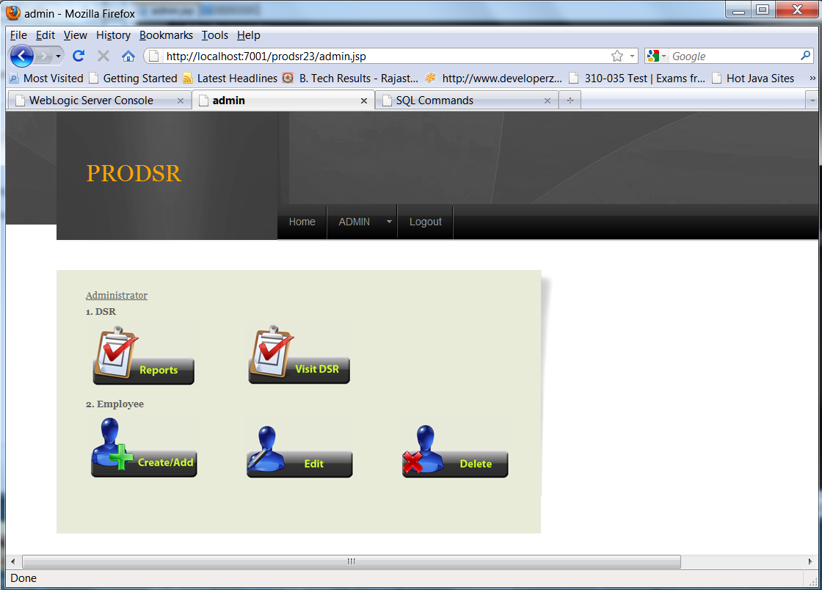

Employee account creation:

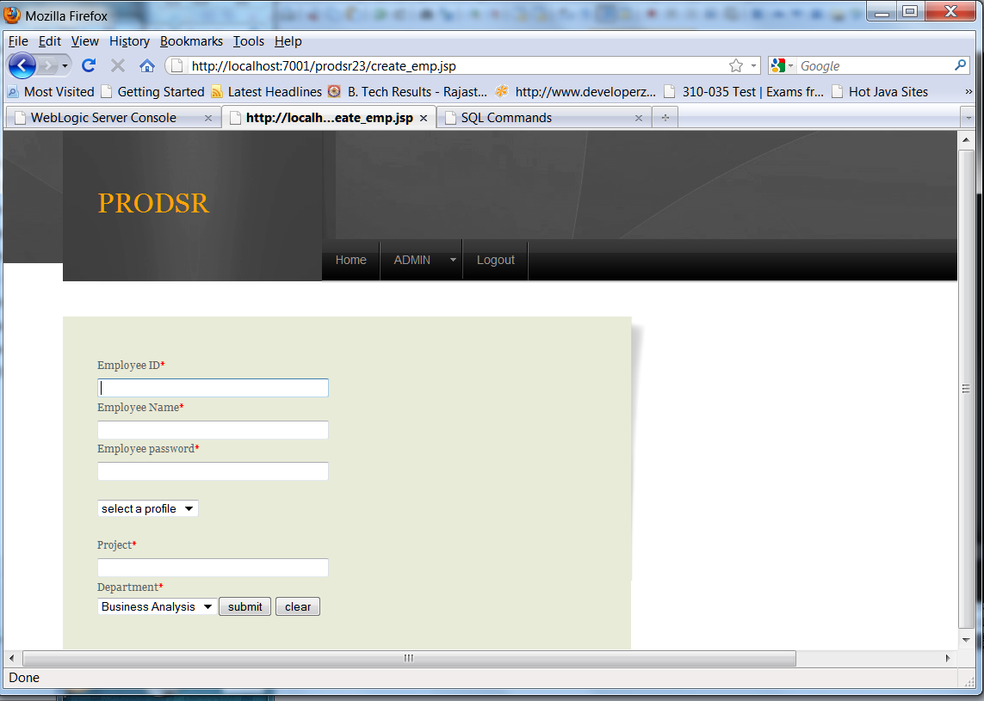

Dsr-Report:

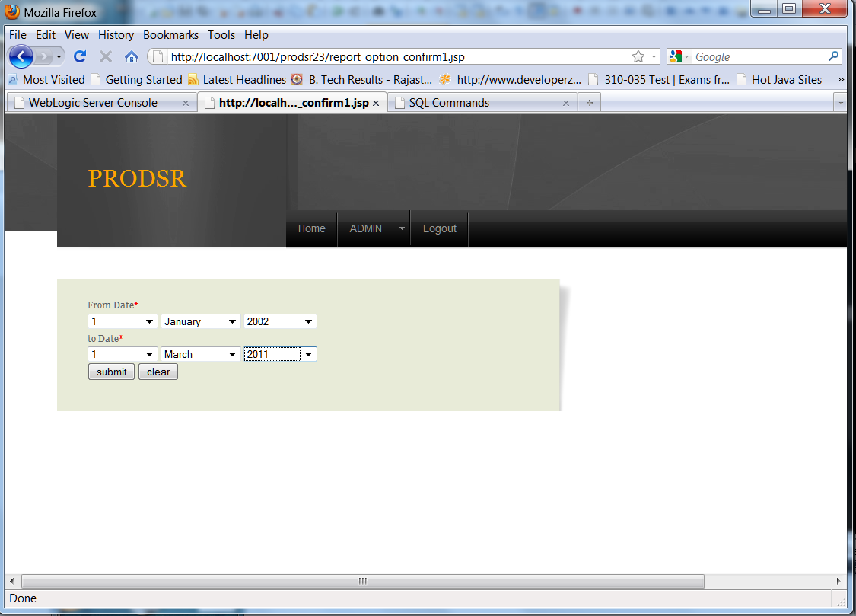

Dsr-Visit:

