

SAVEETHA SCHOOL OF ENGINEERING
SAVEETHA INSTITUTE OF MEDICAL AND TECHNICAL SCIENCES
DEPARTMENT OF COMPUTER SCIENCE AND ENGINEERING

COURSE NAME: Theory of Computation COURSE CODE: CSA1153

COURSE OUTCOME COVERED
CO1: Apply mathematical foundations such as formal proofs, induction, and basic concepts of automata theory to solve computational problems. (BL:3)

Assessment Tool Weightage: 20%

QUESTIONS: 5 Total Marks:50
Duration : 1 Hour
Simulation

Code of Conduct:
I K.Vasudeva Reddy(192411256) (Name / Reg No) certify that this submission is my original work and that I have adhered to the guidelines specified for this assessment.
I understand that any violation of academic integrity rules will result in disciplinary action.

Signature of the student:
Criteria | Weightage | Q1 (10) | Q2 (10) | Q3 (10) | Q4 (10) | Q5 (10) | Total Marks (50)
Conceptual Understanding | 30 | 3 | 3 | 3 | 3 | 3 | 15
Accuracy of Answer | 25 | 2.5 | 2.5 | 2.5 | 2.5 | 2.5 | 12.5
Application of Knowledge | 20 | 2 | 2 | 2 | 2 | 2 | 10
Completeness of Response | 15 | 1.5 | 1.5 | 1.5 | 1.5 | 1.5 | 7.5
Clarity & Presentation | 10 | 1 | 1 | 1 | 1 | 1 | 5
Total per Question | 10 Marks | /10 | /10 | /10 | /10 | /10 | / 50
QUESTIONS:

- Design a Non-Deterministic Finite Automaton (NBA) for an Automatic Door System based on sensor inputs. An automatic door system can be modeled using an NBA to represent different states and transitions. The system consists of four states: Closed, Opening, Open, and Closing. The input symbols are P (Person detected) and N (No person detected). Initially, the door is in the Closed state. When a person is detected (P), the system may non-deterministically transition from Closed to Opening. Once opened, the system moves to the Open state. If no person is detected (N), the door transitions to Closing and eventually returns to the Closed state. Non-determinism occurs when the system may remain in the Open state even if a person is detected or may start closing if no detection occurs.

SIMULATION:

Steps for Simulation:
Step1: Add four states:
- q0 → Closed (Initial State)
- q1 → Opening
- q2 → Open
- q3 → Closing

Step2: Define the alphabet
P, N
where:
- P = Person detected
- N = No person detected
Step3: Add the transitions
From | Input | To
q0 | P | q1
q0 | N | q0
q1 | P | q2
q1 | N | q2
q2 | P | q2
q2 | N | q2
q2 | N | q3
q3 | P | q1
q3 | N | q0

Test Case 1

Input String: P
Description:
The automaton starts from the Closed (q0) state. When a person is detected (P), the door begins to open by transitioning to the Opening (q1) state.
State Transition:
q0 ──P──► q1
Result:
The system successfully moves from the Closed state to the Opening state, indicating that the door starts opening when a person is detected.
Output Screenshot:
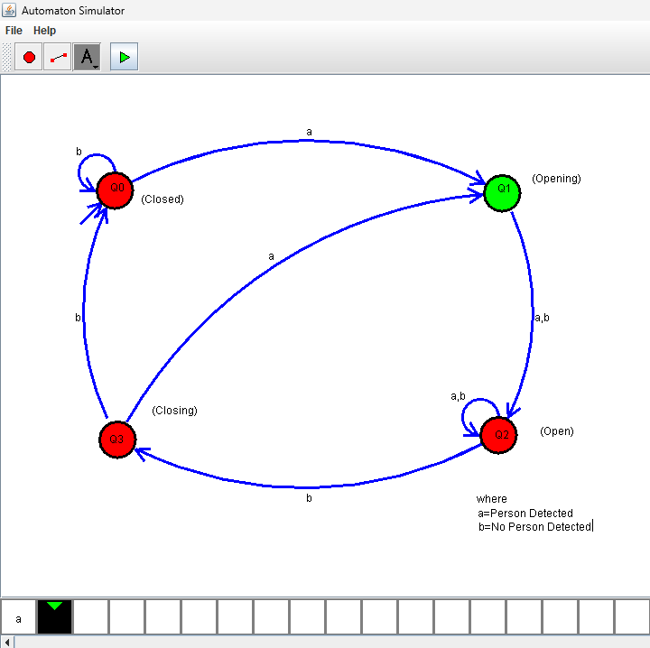

Test Case 2

Input String: PP
Description:
The first P moves the automaton from Closed (q0) to Opening (q1). The second P completes the opening process, moving the automaton to the Open (q2) state.
State Transition:
q0 ──P──► q1 ──P──► q2
Result:
The door reaches the Open state after receiving two consecutive person detection inputs.
Output Screenshot:
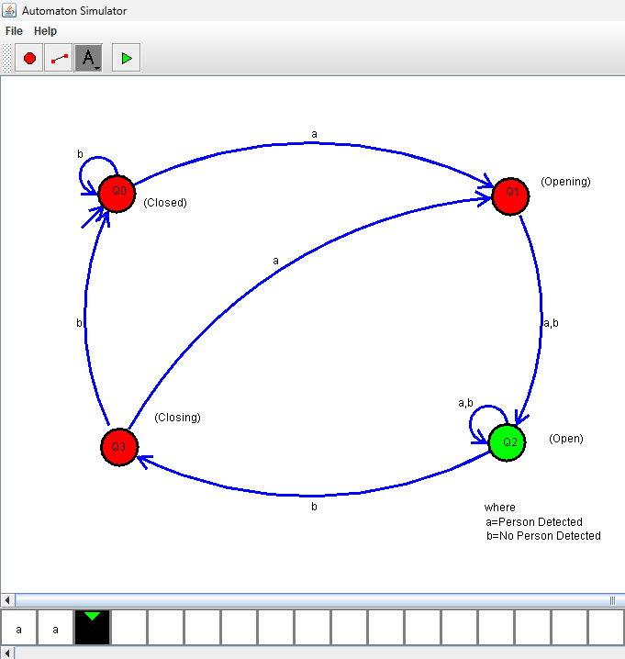

Test Case 3

Input String: PN
Description:
The first P moves the automaton to the Opening (q1) state. The next input N completes the opening process, allowing the automaton to reach the Open (q2) state.
State Transition:
q0 ──P──► q1 ──N──► q2
Result:
The system reaches the Open state even though no person is detected during the second input.
Output Screenshot:
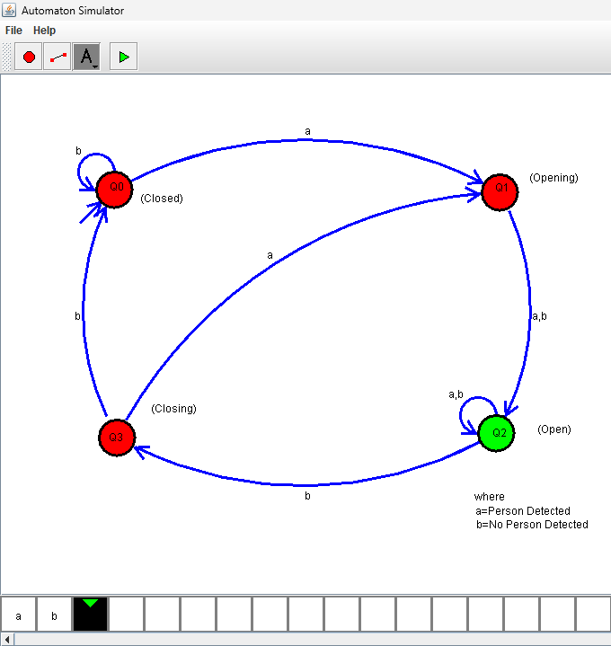

Test Case 4

Input String: PNN
Description:
After reaching the Open (q2) state, another N input introduces non-determinism. The automaton may either remain in the Open state or move to the Closing (q3) state.
State Transitions:
Path 1:
q0 ──P──► q1 ──N──► q2 ──N──► q2

Path 2:
q0 ──P──► q1 ──N──► q2 ──N──► q3
Result:
The automaton produces two possible computation paths, demonstrating the non-deterministic behavior of the automatic door system.
Output Screenshot:
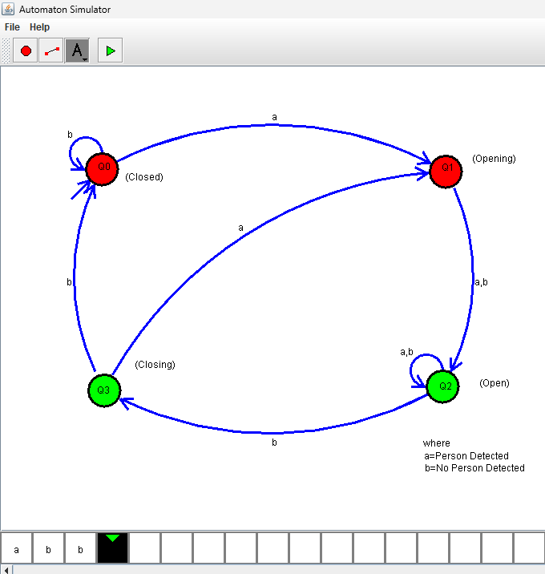

Test Case 5

Input String: PNNN
Description:
After reaching the Open (q2) state, the automaton has two possible paths due to non-determinism. One path remains in the Open state, while the other transitions to Closing (q3) and finally returns to the Closed (q0) state.
State Transitions:
Path 1:
q0 ──P──► q1 ──N──► q2 ──N──► q2 ──N──► q2

Path 2:
q0 ──P──► q1 ──N──► q2 ──N──► q3 ──N──► q0
Result:
The automaton demonstrates multiple possible outcomes for the same input string, confirming that it is a Non-Deterministic Finite Automaton (NFA).
Output Screenshot:
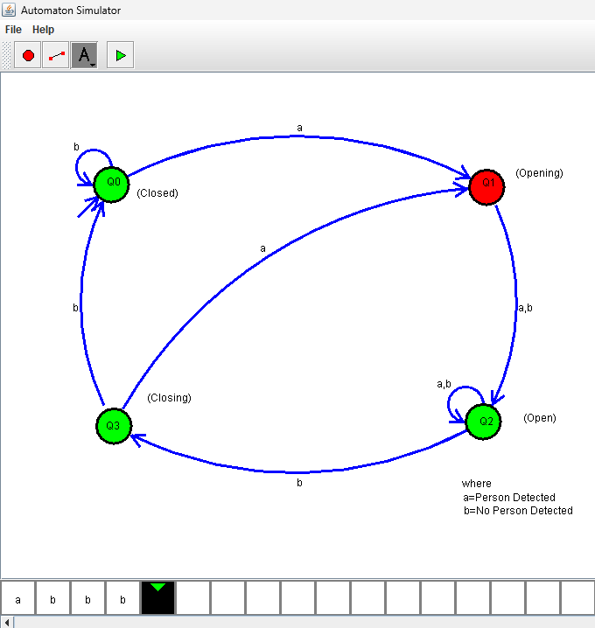

- Design a finite automaton to model a traffic light control system at a road intersection. The automaton should represent different states corresponding to the traffic lights, such as Red, Green, and Yellow. Define the transitions between these states based on a timer or control signals, ensuring that the sequence follows the standard order (Red → Green → Yellow → Red). Include considerations for timing constraints, such as how long each light remains active, and describe how the automaton handles continuous cycling of signals. Additionally, explain how this model can be extended to handle pedestrian crossing signals or emergency vehicle overrides, ensuring safe and efficient traffic flow.

SIMULATION:

Step 1: Add States
- q0 – Red (Initial State)
- q1 – Green
- q2 – Yellow
(Optional: Mark q0 as Final State.)

Step 2: Define the Alphabet
“T”
where
- T = Timer Expired

Step 3: Add the Transitions
From | Input | To
q0 | T | q1
q1 | T | q2
q2 | T | q0

Test Case 1

Input String: T

Description
The automaton starts from the Red (q0) state. When the timer expires (T), the traffic light changes from Red to Green.

State Transition
q0 →T→ q1

Result
The system successfully changes the signal from the Red state to the Green state.

Output Screenshot
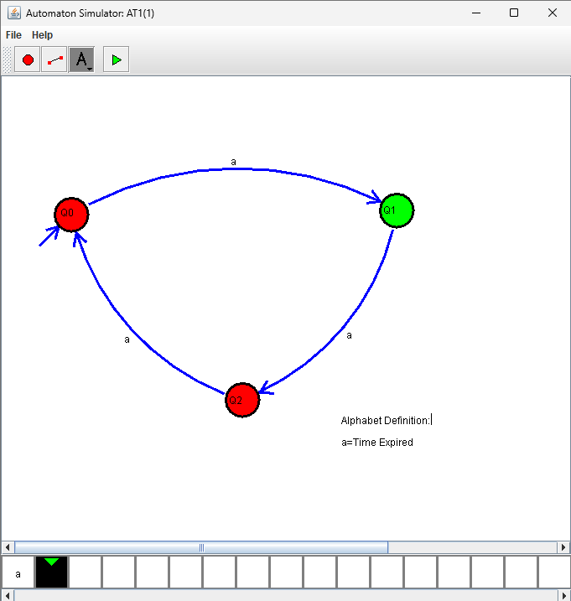

Test Case 2

Input String: TT

Description
The first timer signal changes the traffic light from Red to Green. The second timer signal changes it from Green to Yellow.

State Transition
q0 →T→ q1 →T→ q2

Result
The traffic signal reaches the Yellow state after two timer signals.

Output Screenshot
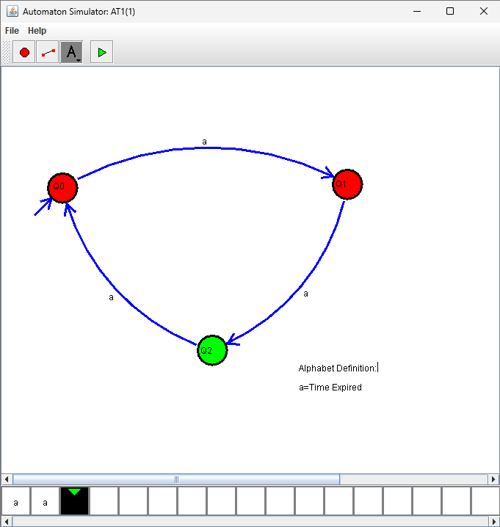

Test Case 3

Input String: TTT

Description
The automaton completes one complete traffic light cycle. The signal changes from Red to Green, then Yellow, and finally returns to the Red state.

State Transition
q0 →T→ q1 →T→ q2 →T→ q0

Result
The traffic light successfully completes one full cycle and returns to the Red state.

Output Screenshot
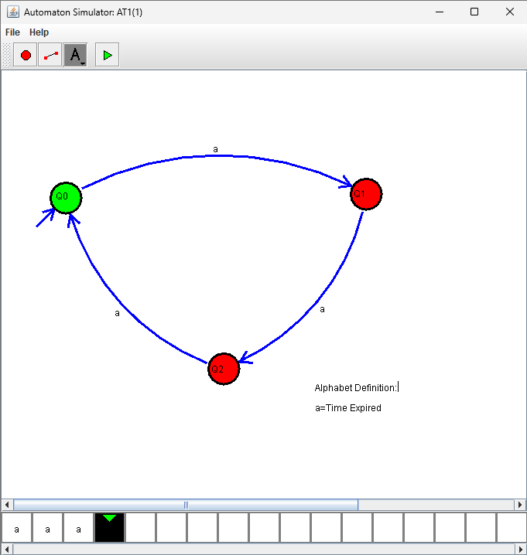

Test Case 4

Input String: TTTT

Description
After completing one cycle, another timer signal changes the traffic light from Red to Green, beginning a new cycle.

State Transition
q0 →T→ q1 →T→ q2 →T→ q0 →T→ q1

Result
The automaton starts another traffic signal cycle and reaches the Green state.

Output Screenshot
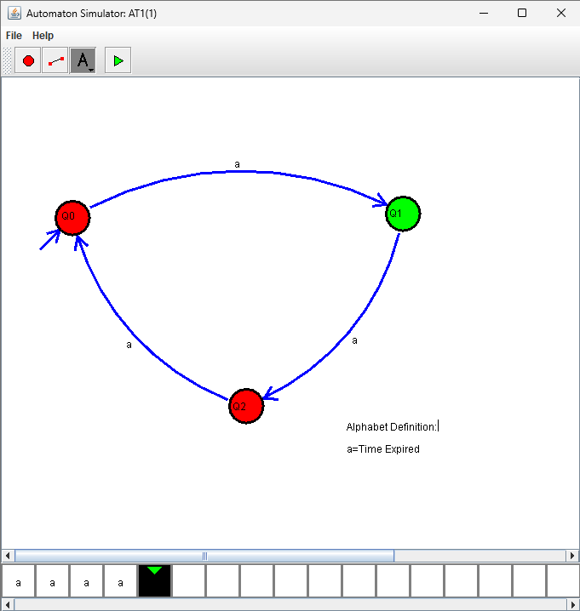

Test Case 5

Input String: TTTTTT

Description
The automaton completes two complete traffic light cycles. The traffic signal continuously follows the sequence Red → Green → Yellow → Red.

State Transition
q0 →T→ q1 →T→ q2 →T→ q0 →T→ q1 →T→ q2 →T→ q0

Result
The traffic light continuously cycles through all three states without interruption.

Output Screenshot
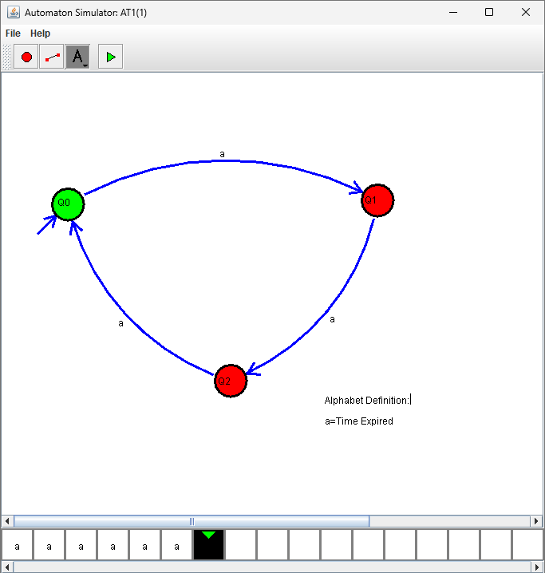
Q3) Design a Deterministic Finite Automaton (DFA) using a simulator to accept all strings ending with "ab" over the alphabet {a, b}. Test the string W = aaabab.

SIMULATION

Step 1: Add States
- q0 – Initial State
- q1 – Last symbol is a
- q2 – String ends with ab (Final State)
Mark:
- q0 as Start State
- q2 as Final State

Step 2: Define the Alphabet
a
b
where
- a = Input symbol a
- b = Input symbol b

Step 3: Add the Transitions
From | Input | To
q0 | a | q1
q0 | b | q0
q1 | a | q1
q1 | b | q2
q2 | a | q1
q2 | b | q0

Test Case 1

Input String: ab

Description
The automaton starts at q0. Reading a moves to q1, and reading b moves to q2, which is the accepting state.

State Transition
q0 →a→ q1 →b→ q2

Result
The string ab is Accepted because it ends with ab.

Output Screenshot
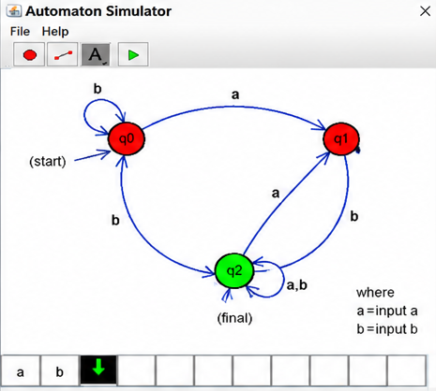

Test Case 2

Input String: aab

Description
The automaton processes two a's before reading b, eventually reaching the accepting state q2.

State Transition
q0 →a→ q1 →a→ q1 →b→ q2

Result
The string aab is Accepted.

Output Screenshot
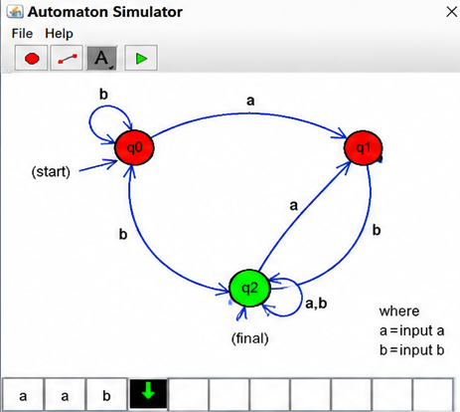

Test Case 3

Input String: aaabab

Description
The automaton processes each symbol and finishes in the accepting state q2, since the string ends with ab.

State Transition
q0 →a→ q1
→a→ q1
→a→ q1
→b→ q2
→a→ q1
→b→ q2

Result
The given string W = aaabab is Accepted because it ends with ab.

Output Screenshot

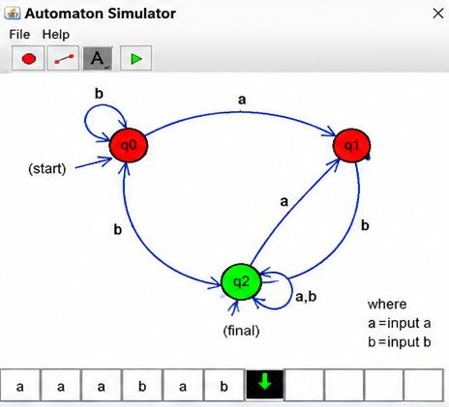

Conclusion
The DFA successfully accepts all strings over the alphabet {a, b} that end with "ab". The given input string W = aaabab is accepted because its last two characters are "ab". The simulation in AutoSim verifies the correctness of the DFA.

Design a Deterministic Finite Automaton (DFA) using a simulator to accept only the input strings "c", "bc", and "bcaaa" over the alphabet {a, b, c}. Any other input string should be rejected by moving to a dead state. Implement the DFA in AutoSim and verify its correctness using suitable test cases.

SIMULATION

Step 1: Add States
- q0 – Start State
- q1 – After reading b
- q2 – Accepts c and bc
- q3 – After reading bca
- q4 – After reading bcaa
- q5 – Accepts bcaaa
- qd – Dead State

Accepting States
- q2
- q5

Step 2: Define the Alphabet
a
b
c
where
- a = Input symbol a
- b = Input symbol b
- c = Input symbol c

Step 3: Add the Transitions
From | Input | To
q0 | a | qd
q0 | b | q1
q0 | c | q2
q1 | a | qd
q1 | b | qd
q1 | c | q2
q2 | a | q3
q2 | b | qd
q2 | c | qd
q3 | a | q4
q3 | b | qd
q3 | c | qd
q4 | a | q5
q4 | b | qd
q4 | c | qd
q5 | a | qd
q5 | b | qd
q5 | c | qd
qd | a | qd
qd | b | qd
qd | c | qd

Take only 3 test cases
Sure! Since only the accepted strings are required to verify the DFA, you can use these 3 test cases.

Test Case 1

Input String: c

Description
The automaton starts from the initial state q0. On reading the input symbol c, it directly transitions to the accepting state q2.

State Transition
q0 → c → q2

Result
The input string "c" is Accepted because it matches one of the specified valid strings.

Output Screenshot
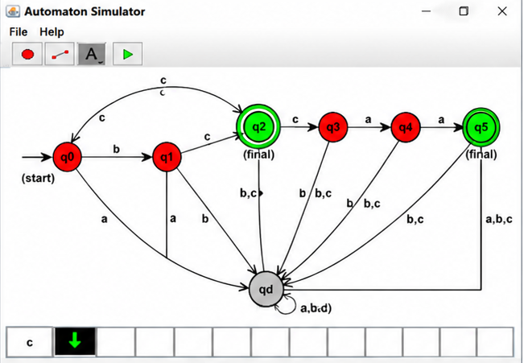

Test Case 2

Input String: bc

Description
The automaton reads b and moves from q0 to q1. It then reads c and reaches the accepting state q2.

State Transition
q0 → b → q1 → c → q2

Result
The input string "bc" is Accepted because it exactly matches one of the required strings.

Output Screenshot
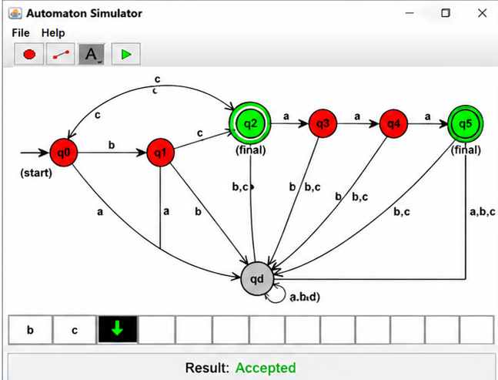

Test Case 3

Input String: bcaaa

Description
The automaton processes the sequence b → c → a → a → a through the intermediate states and finally reaches the accepting state q5.

State Transition
q0 → b → q1
→ c → q2
→ a → q3
→ a → q4
→ a → q5

Result
The input string "bcaaa" is Accepted because it exactly matches the specified valid string.

Output Screenshot
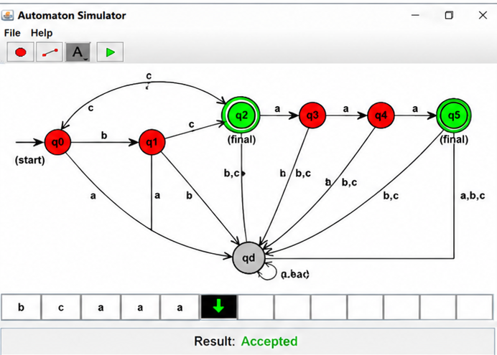

Conclusion
The designed Deterministic Finite Automaton (DFA) successfully accepts only the strings "c", "bc", and "bcaaa" over the alphabet {a, b, c}. Any deviation from these exact patterns causes the automaton to transition to the dead state, ensuring that no invalid strings are accepted. The AutoSim implementation verifies the correctness of the DFA through the above test cases.

Q5) Design a Deterministic Finite Automaton (DFA) using a simulator to accept all strings over the alphabet {a, b} that begin with either "a" or "b". The automaton should start in an initial state and immediately transition to an accepting state upon reading the first input symbol. After the first symbol is processed, the DFA should remain in the accepting state regardless of the subsequent sequence of "a" and "b". Include a dead state to handle invalid or empty inputs if required by the simulator. Verify the DFA using AutoSim.

SIMULATION

Step 1: Add States
- q0 – Start State
- q1 – Accepting State
- qd – Dead State (Optional for AutoSim)
Mark:
- q0 as Start State
- q1 as Final (Accepting) State

Step 2: Define the Alphabet
a
b
where
- a = Input symbol a
- b = Input symbol b

Step 3: Add the Transitions
From | Input | To
q0 | a | q1
q0 | b | q1
q1 | a | q1
q1 | b | q1
qd | a | qd
qd | b | qd

Test Case 1

Input String: a

Description
The automaton starts from q0. Reading the first symbol a moves it to the accepting state q1.

State Transition
q0 → a → q1

Result
The input string "a" is Accepted because it begins with a.

Output Screenshot
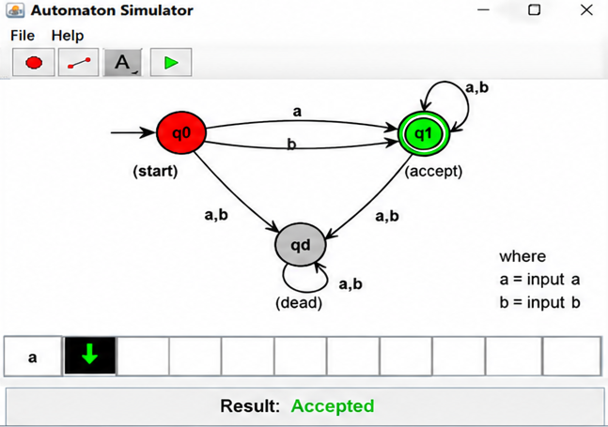

Test Case 2

Input String: b

Description
The automaton starts from q0. Reading the first symbol b moves it directly to the accepting state q1.

State Transition
q0 → b → q1

Result
The input string "b" is Accepted because it begins with b.

Output Screenshot

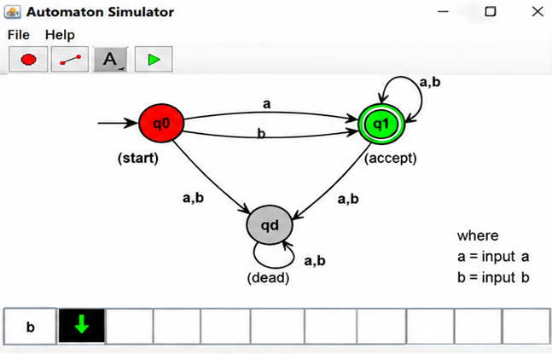

Conclusion
The designed Deterministic Finite Automaton (DFA) correctly accepts all strings over the alphabet {a, b} that begin with either a or b. After reading the first valid symbol, the automaton transitions to the accepting state and remains there regardless of the remaining input. The AutoSim simulation verifies that all valid strings are accepted as expected.

