

SAVEETHA SCHOOL OF ENGINEERING
SAVEETHA INSTITUTE OF MEDICAL AND TECHNICAL SCIENCES
DEPARTMENT OF COMPUTER SCIENCE AND ENGINEERING

COURSE NAME: Theory of Computation COURSE CODE: CSA1153

COURSE OUTCOME COVERED
CO2: Design Finite Automata DFA, NFA, ε-NFA and demonstrate their equivalence for recognizing regular languages. (BL:3)

Assessment Tool Weightage: 10%

QUESTIONS: 5 Total Marks:50
Duration : 1 Hour
Application Based Question

Code of Conduct:
I K.Vasudeva Reddy(192411256) (Name / Reg No) certify that this submission is my original work and that I have adhered to the guidelines specified for this assessment.
I understand that any violation of academic integrity rules will result in disciplinary action.

Signature of the student:

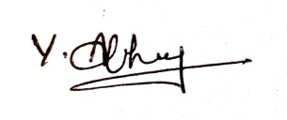

RUBRICS FOR CALCULATION

Criteria | Weightage | Q1 (10) | Q2 (10) | Q3 (10) | Q4 (10) | Q5 (10) | Total Marks (50)
Conceptual Understanding | 30 | 3 | 3 | 3 | 3 | 3 | 15
Accuracy of Answer | 25 | 2.5 | 2.5 | 2.5 | 2.5 | 2.5 | 12.5
Application of Knowledge | 20 | 2 | 2 | 2 | 2 | 2 | 10
Completeness of Response | 15 | 1.5 | 1.5 | 1.5 | 1.5 | 1.5 | 7.5
Clarity & Presentation | 10 | 1 | 1 | 1 | 1 | 1 | 5
Total per Question | 10 Marks | /10 | /10 | /10 | /10 | /10 | / 50

.Q1. Design a Deterministic Finite Automaton (DFA) over the alphabet Σ = {0,1} to validate passwords that end with the pattern "01". Further, minimize the DFA and analyse how the optimized design improves system efficiency in real-world hardware implementations.

Aim
To design a Deterministic Finite Automaton (DFA) over the alphabet Σ = {0,1} that accepts all binary strings ending with "01", minimize the DFA, and analyze its practical applications in digital hardware systems.

Step 1: DFA Design

Alphabet
[
\Sigma={0,1}
]

States
- q0 – Initial State
- q1 – Last symbol read is 0
- q2 – String ends with 01 (Accepting State)

Start State
[
q_0
]

Accepting State
[
F={q_2}
]

Transition Table
Present State | Input 0 | Input 1
→ q0 | q1 | q0
q1 | q1 | q2
*q2 | q1 | q0

State Diagram
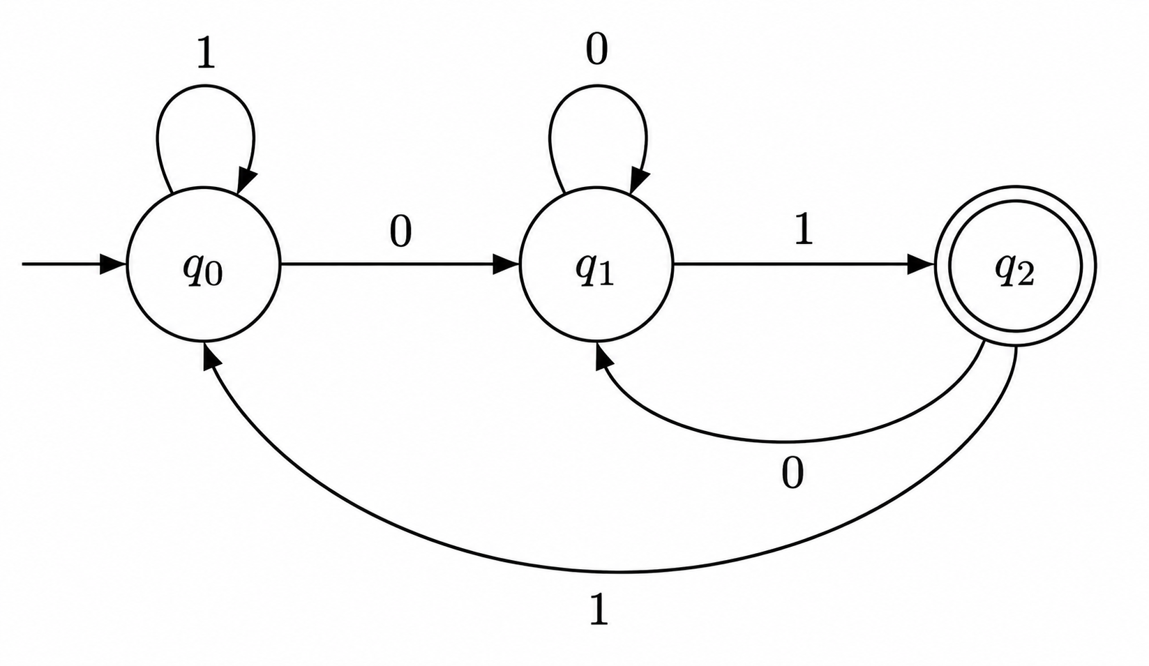

Working
- The DFA starts in q0.
- Reading 0 moves to q1.
- Reading 1 after 0 moves to q2, indicating that the string ends with 01.
- If more symbols are read, the DFA updates its state accordingly.
- A string is accepted only if the final state is q2.

Examples
Input String | Final State | Result
01 | q2 | Accepted
101 | q2 | Accepted
1101 | q2 | Accepted
1001 | q2 | Accepted
111 | q0 | Rejected
100 | q1 | Rejected

DFA Minimization
The designed DFA contains three states:
- q0
- q1
- q2
Each state represents a unique condition:
- q0: No useful suffix detected.
- q1: Last symbol is 0.
- q2: String ends with 01.
Since all three states have distinct behaviors and cannot be merged, the DFA is already minimal.

Minimized DFA
The minimized DFA is identical to the original DFA.
Number of states before minimization = 3
Number of states after minimization = 3

Hardware Implementation Analysis
The minimized DFA improves hardware performance in embedded systems such as ATM machines, authentication modules, and digital security devices in the following ways:
- Requires only three states, reducing hardware complexity.
- Uses fewer flip-flops and logic gates in FPGA or ASIC implementations.
- Reduces memory required for storing transition tables.
- Provides faster password validation with lower processing delay.
- Consumes less electrical power, making it suitable for battery-powered embedded devices.
- Improves reliability because fewer states reduce the possibility of implementation errors.
- Simplifies digital circuit design and maintenance.

Applications
The DFA can be used in:
- Password authentication systems
- ATM PIN validation
- Smart card authentication
- Embedded security controllers
- Digital access control systems
- IoT authentication modules

Conclusion
A Deterministic Finite Automaton (DFA) was successfully designed to accept all binary strings ending with the pattern "01" over the alphabet Σ = {0,1}. The DFA is already minimal with three states, ensuring efficient operation. Its optimized design reduces hardware complexity, memory usage, and power consumption while providing fast and reliable password validation in real-world embedded systems.

Q2. In web applications, validating user input is essential to ensure correctness, security, and performance. Design a regular expression to validate the specific input pattern "aaaabb" over the alphabet Σ = {a, b}. Further, analyze how regular languages and regular expressions are used to efficiently validate user inputs in real-world web applications.

Aim
To design a Regular Expression (RE) that accepts only the string "aaaabb" over the alphabet Σ = {a, b} and analyze the role of regular languages and regular expressions in user input validation.

Alphabet
[
\Sigma = {a, b}
]

Regular Expression
The regular expression for accepting only the string "aaaabb" is:
^aaaabb$
where:
- ^ → Beginning of the string
- aaaabb → Exact input pattern
- $ → End of the string
This regular expression accepts only one valid string, namely "aaaabb".

Accepted String
Input | Result
aaaabb | Accepted

Rejected Strings
Input | Reason
aaabb | Missing one 'a'
aaaab | Missing one 'b'
aaaabbb | Extra 'b'
baaaabb | Starts with 'b'
aaaaba | Ends incorrectly
aaaa | Incomplete pattern

Working
The regular expression checks whether the input string exactly matches "aaaabb".
- If the input starts with "aaaa" followed by "bb", it is accepted.
- Any missing, additional, or misplaced character causes the string to be rejected.

Applications of Regular Languages and Regular Expressions
Regular languages and regular expressions are widely used in modern web applications for efficient input validation.

Common Applications
- User login validation
- Password validation
- Email address verification
- Phone number validation
- ZIP/Postal code validation
- Form field validation
- Search functionality
- URL validation

Advantages
- Fast pattern matching
- Reduces invalid user inputs
- Improves application security
- Prevents malicious data entry
- Enhances system performance
- Easy to implement in programming languages such as Java, Python, JavaScript, and PHP

Real-World Analysis
In modern web applications, regular expressions are integrated into both client-side and server-side validation.
- Correctness: Ensures that users enter data in the required format.
- Security: Helps block invalid or potentially harmful input before processing.
- Performance: Validates input quickly using efficient pattern matching, reducing unnecessary processing.
- User Experience: Provides immediate feedback, reducing form submission errors and improving usability.

Conclusion
A regular expression ^aaaabb$ was designed to accept only the input string "aaaabb" over the alphabet Σ = {a, b}. Regular languages and regular expressions provide an efficient mechanism for validating user inputs in web applications, improving correctness, security, performance, and the overall user experience.

Q3. In modern computing systems such as intrusion detection systems, compilers, and real-time monitoring tools, pattern recognition plays a critical role. Demonstrate how the regular expression (a^b^) can be converted into an equivalent Finite Automaton (FA). Further, explain why regular expressions and finite automata are equivalent models and how they are effectively used in real-time detection systems.

Aim
To convert the regular expression (a^b^) into an equivalent Finite Automaton (FA) and explain the equivalence of regular expressions and finite automata along with their applications in real-time detection systems.

Regular Expression
[
a^b^
]

Meaning
- (a^*) → Zero or more occurrences of a
- (b^*) → Zero or more occurrences of b
The language consists of all strings having any number of a's followed by any number of b's.

Examples of Accepted Strings
- ε (empty string)
- a
- aa
- aaa
- b
- bb
- abb
- aaabbb
- aab

Rejected Strings
- ba
- baba
- aba
- baa
- abab

Equivalent Finite Automaton (FA)

States
- q0 – Start State (Accepting)
- q1 – Reading b's (Accepting)
- qd – Dead State

Alphabet
[
\Sigma={a,b}
]

Transition Table
Present State | Input a | Input b
→ *q0 | q0 | q1
*q1 | qd | q1
qd | qd | qd

State Diagram
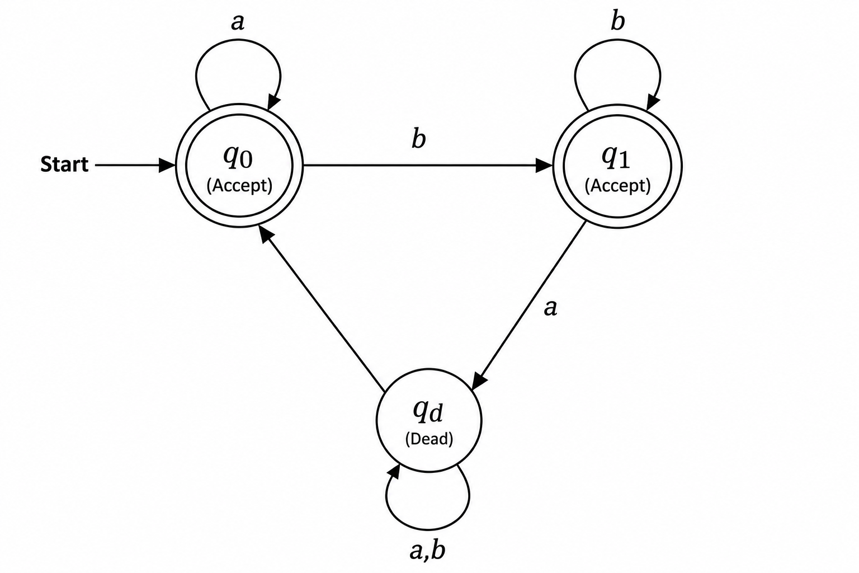
Where:
- q0 = Start and Accepting State
- q1 = Accepting State
- qd = Dead State

Working of the Automaton
- The automaton starts at q0.
- It remains in q0 while reading any number of a's.
- On reading the first b, it moves to q1.
- It remains in q1 while reading additional b's.
- If an a appears after entering q1, the automaton moves to the dead state qd and rejects the string.

Why Regular Expressions and Finite Automata are Equivalent
Regular expressions and finite automata are considered equivalent because:
- Both describe the same class of languages called Regular Languages.
- Every regular expression can be converted into an equivalent finite automaton.
- Every finite automaton can be represented by an equivalent regular expression.
- Both accept exactly the same set of strings.
- They differ only in representation, not in computational power.

Applications in Real-Time Detection Systems
Regular expressions and finite automata are widely used in:
- Intrusion Detection Systems (IDS): Detect suspicious network traffic by matching attack signatures.
- Compiler Design: Perform lexical analysis by recognizing tokens and keywords.
- Real-Time Monitoring Tools: Identify event patterns in logs and system activities.
- Spam Filtering: Detect unwanted email patterns.
- Web Input Validation: Validate user inputs such as email addresses, passwords, and phone numbers.
- Search Engines: Perform efficient text and pattern matching.

Advantages
- Fast pattern recognition
- Efficient implementation in hardware and software
- Low memory requirements
- Deterministic processing with predictable performance
- Suitable for real-time applications
- Easy conversion between regular expressions and finite automata

Conclusion
The regular expression (a^b^) was successfully converted into an equivalent finite automaton. The automaton accepts all strings consisting of zero or more a's followed by zero or more b's while rejecting any string where an a appears after a b. Regular expressions and finite automata are equivalent computational models because they recognize the same class of regular languages. Their efficiency in pattern matching makes them indispensable in compilers, intrusion detection systems, and other real-time monitoring applications.

Q4. In compiler design, not all patterns can be recognized using finite automata. Using the Pumping Lemma, demonstrate why the language (L={a^n b^n \mid n \ge 0}) cannot be recognized by any finite automaton. Further, analyse the implications of this limitation in the design of modern compilers.

Aim
To prove using the Pumping Lemma that the language
[
L={a^n b^n \mid n\ge0}
]
is not a regular language, and explain its significance in compiler design.

Language Definition
[
L={a^n b^n \mid n\ge0}
]
This language contains strings having an equal number of a's followed by an equal number of b's.

Examples
String | Result
ε | Accepted
ab | Accepted
aabb | Accepted
aaabbb | Accepted
aaaabbbb | Accepted

Not in the Language
String | Reason
abb | Unequal number of a's and b's
aaabb | Unequal number of b's
aabbb | Unequal number of a's
abab | Incorrect order
ba | Begins with b

Pumping Lemma
The Pumping Lemma states:
If a language is regular, then there exists a pumping length p such that every string w with length |w| ≥ p can be written as
[
w = xyz
]
such that
- (|xy| \le p)
- (|y| > 0)
- (xy^iz \in L) for every (i \ge 0)

Proof Using Pumping Lemma
Assume that
[
L={a^n b^n}
]
is regular.
Let the pumping length be p.
Choose the string
[
w=a^p b^p
]
Clearly,
[
|w|=2p\ge p
]
According to the Pumping Lemma,
[
w=xyz
]
where
[
|xy|\le p
]
Since the first p symbols are all a, both x and y consist only of a's.
Let
[
y=a^k,\quad k>0
]
Now pump y twice ((i=2)).
The new string becomes
[
xy^2z=a^{p+k}b^p
]
Now,
- Number of a's = (p+k)
- Number of b's = (p)
Since
[
p+k\neq p
]
the string is not of the form
[
a^n b^n
]
Hence,
[
xy^2z\notin L
]
This contradicts the Pumping Lemma.
Therefore,
[
\boxed{L={a^n b^n}\text{ is NOT a Regular Language.}}
]

Why Finite Automata Cannot Recognize (a^n b^n)
Finite Automata have limited memory.
They cannot:
- Count the number of a's
- Remember how many a's have been seen
- Compare that count with the number of b's
Hence, they cannot recognize languages that require counting and matching.

Implications in Compiler Design
The limitation of finite automata has important implications in compiler design:
- Lexical Analysis: Finite automata are used to recognize tokens such as keywords, identifiers, operators, and numbers because these follow regular patterns.
- Syntax Analysis: Programming language constructs like balanced parentheses, nested blocks, and matching begin–end or {} require counting and nesting, which finite automata cannot perform.
- Use of Pushdown Automata: Compilers use pushdown automata (PDA) and parsers with a stack to recognize context-free languages and handle nested structures.
- Improved Error Detection: Stack-based parsing enables accurate detection of syntax errors involving missing or unmatched symbols.
- Efficient Compilation: Separating lexical analysis (finite automata) from syntax analysis (pushdown automata) results in efficient and modular compiler design.

Applications
The Pumping Lemma is used in:
- Formal language theory
- Compiler construction
- Automata theory
- Complexity analysis
- Proving non-regular languages
- Designing parsers for programming languages

Conclusion
Using the Pumping Lemma, it is proved that the language
L={a^{n}b^{n} | n>=0}
is not regular because pumping changes the number of a's without changing the number of b's, violating the language definition. This limitation shows that finite automata cannot recognize languages requiring counting or matching. Therefore, modern compilers use finite automata for lexical analysis and pushdown automata for syntax analysis, enabling them to process programming languages effectively.

Q5. Modern systems such as intrusion detection, spam filtering, and input validation often require combining multiple pattern-matching rules. Explain how the closure properties of regular languages enable the combination of multiple detection rules. Further, justify why the resulting language after applying these operations remains regular, ensuring efficient implementation using finite automata.

Aim
To explain the closure properties of regular languages, demonstrate how they are used to combine multiple pattern-matching rules, and justify why the resulting language remains regular for efficient implementation using finite automata.

Introduction
Regular languages are a class of formal languages that can be recognized by Finite Automata (FA). One of their most important characteristics is that they are closed under several operations, meaning that applying these operations to regular languages always produces another regular language.
This property allows multiple pattern-matching rules to be combined efficiently in modern computing systems.

Closure Properties of Regular Languages
A regular language remains regular after applying the following operations:
- Union ( ∪ )
- Concatenation ( · )
- Kleene Star ( * )
- Intersection ( ∩ )
- Complement
- Difference ( − )
- Reversal

Combining Multiple Detection Rules
Suppose two detection rules are represented by regular languages:
- L₁ = Strings containing the keyword "virus"
- L₂ = Strings containing the keyword "malware"
Using the Union operation:
[
L = L_1 \cup L_2
]
The resulting language accepts strings matching either rule.
Similarly,
Using Intersection:
[
L = L_1 \cap L_2
]
Only strings satisfying both rules are accepted.
Using Concatenation:
[
L = L_1L_2
]
The system accepts strings where the pattern of L₁ is followed by the pattern of L₂.
Using Kleene Star:
[
L = L_1^*
]
The pattern in L₁ can occur zero or more times.

Why the Resulting Language Remains Regular
Regular languages are closed under all the above operations.
Therefore,
- If L₁ and L₂ are regular,
- Then L₁ ∪ L₂ is regular.
- L₁ ∩ L₂ is regular.
- L₁L₂ is regular.
- L₁* is regular.
- Complement and Difference also produce regular languages.
Since the resulting language is still regular, it can always be recognized by a Finite Automaton (FA).

Applications in Modern Systems
Closure properties are widely used in:
- Intrusion Detection Systems (IDS): Combine multiple attack signatures into a single detection engine.
- Spam Filtering: Detect emails matching different spam patterns.
- Input Validation: Validate usernames, passwords, email addresses, and phone numbers using combined regular expressions.
- Compiler Design: Recognize multiple tokens such as identifiers, keywords, operators, and constants.
- Search Engines: Match multiple search patterns efficiently.
- Network Security: Detect malicious traffic using combined signature rules.

Advantages
- Efficient pattern matching
- Simple combination of multiple rules
- Fast implementation using finite automata
- Reduced computational complexity
- Scalable for large rule sets
- High reliability in real-time systems

Justification
Since closure operations preserve regularity, the combined language can always be implemented using a Deterministic Finite Automaton (DFA) or a Non-Deterministic Finite Automaton (NFA). This ensures:
- Efficient execution with predictable performance
- Low memory requirements
- Fast processing of large volumes of input
- Suitability for real-time applications such as intrusion detection, spam filtering, and web input validation

Conclusion
The closure properties of regular languages enable multiple pattern-matching rules to be combined using operations such as union, concatenation, intersection, Kleene star, complement, and difference. Since regular languages remain regular after these operations, the resulting language can still be recognized efficiently by finite automata. This property makes regular languages highly suitable for implementing real-time pattern-matching systems in applications such as intrusion detection, spam filtering, compiler design, and user input validation.

