

SAVEETHA SCHOOL OF ENGINEERING
SAVEETHA INSTITUTE OF MEDICAL AND TECHNICAL SCIENCES
DEPARTMENT OF COMPUTER SCIENCE AND ENGINEERING

COURSE NAME: Theory of Computation COURSE CODE: CSA1153

COURSE OUTCOME COVERED
CO2: Design Finite Automata DFA, NFA, ε-NFA and demonstrate their equivalence for recognizing regular languages. (BL:3)

AssessmentTool Weightage: 40%

QUESTIONS: 5 Total Marks:50
Duration : 1 Hour
Design Task

Code of Conduct:
I K.Vsaudeva Reddy(192411256) (Name / Reg No) certify that this submission is my original work and that I have adhered to the guidelines specified for this assessment.
I understand that any violation of academic integrity rules will result in disciplinary action.

Signature of the student:

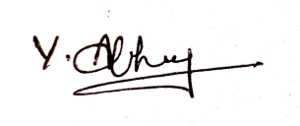

RUBRICS FOR CALCULATION

Criteria | Weightage | Q1 (10) | Q2 (10) | Q3 (10) | Q4 (10) | Q5 (10) | Total Marks (50)
Conceptual Understanding | 30 | 3 | 3 | 3 | 3 | 3 | 15
Accuracy of Answer | 25 | 2.5 | 2.5 | 2.5 | 2.5 | 2.5 | 12.5
Application of Knowledge | 20 | 2 | 2 | 2 | 2 | 2 | 10
Completeness of Response | 15 | 1.5 | 1.5 | 1.5 | 1.5 | 1.5 | 7.5
Clarity & Presentation | 10 | 1 | 1 | 1 | 1 | 1 | 5
Total per Question | 10 Marks | /10 | /10 | /10 | /10 | /10 | / 50

Questions:
1.Design the regular expression for the language represented by the given automata
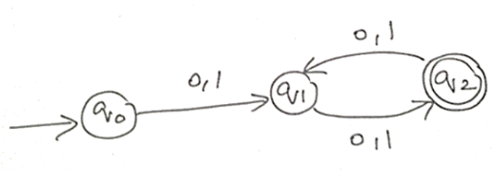

Design the Regular Expression for the language represented by the given automaton.
Answer:

Step 1: Analyze the Automaton
From the given automaton:
- q0 → Start State
- q2 → Final (Accepting) State
Transitions:
- q0 → q1 on 0 or 1
- q1 → q2 on 0 or 1
- q2 → q1 on 0 or 1

Step 2: Language Description
The automaton:
- Requires at least two symbols to reach the accepting state.
- After reaching q2, every additional input symbol moves between q1 and q2.
- Therefore, the automaton accepts all binary strings of even length (length ≥ 2).

Examples Accepted
- 00
- 01
- 10
- 11
- 0011
- 1010
- 111100
- 010101

Examples Rejected
- ε
- 0
- 1
- 000
- 101
- 11111

Step 3: Regular Expression
Since every pair of symbols is accepted,
Each pair can be
00
01
10
11
Hence the Regular Expression is
((0+1)(0+1))+((0+1)(0+1))^+((0+1)(0+1))+
or equivalently,
((0|1)(0|1))+
If your faculty uses + for union, write:
((0+1)(0+1))+

Explanation
- (0+1) means either 0 or 1.
- (0+1)(0+1) represents any two binary symbols.
- The outer + means one or more repetitions of these pairs.
Thus, the expression accepts every binary string having even length.

Final Answer

Regular Expression
((0+1)(0+1))⁺

Conclusion
The automaton accepts all binary strings having even length over the alphabet Σ = {0,1}. Therefore, the required regular expression is:
((0+1)(0+1))⁺

2.Consider the following grammar
S-&gt;aSc|T|U|e
T-&gt; bTc|e
U-&gt;aUb|e
A} What is the language defined by the grammar?
B)Give the derivation tree for the word aaabbc
C)A Grammar is Ambiguous if there exists two distinct derivations for a word. Is the above
grammar ambiguous? Justify.
Answer:
A} What is the language defined by the grammar?

Derivation of each non-terminal

1. S→aScS
This rule adds one a at the beginning and one c at the end.
Examples:
- ac
- aacc
- aaaccc
- ...

2. T→bTc∣εT
This generates equal numbers of b's followed by c's.
Examples:
- ε
- bc
- bbcc
- bbbccc
- ...
Language:
L(T)={ b^{n}c^{n}∣n≥0 }

3. U→aUb∣ε
This generates equal numbers of a's followed by b's.
Examples:
- ε
- ab
- aabb
- aaabbb
- ...
Language:
L(U)={ a^{n}b^{n}∣n≥0 }

Overall Language
Since
S→aSc∣T∣U∣ε,
the grammar generates:
- Equal numbers of a's and b's
- Equal numbers of b's and c's
- Strings with matching numbers of a's and c's wrapped around strings generated by T, U, or ε
Hence, the language is
L={ a^{i}xc^{i}∣i≥0, x∈{ a^{n}b^{n}, b^{n}c^{n}, ε } }

Simple Explanation
The grammar generates strings with balanced numbers of symbols. Specifically, it can generate:
- Equal numbers of a's followed by b's (anbn)(a^n b^n)(anbn)
- Equal numbers of b's followed by c's (bncn)(b^n c^n)(bncn)
- Strings enclosed by matching a's and c's, producing balanced combinations of a, b, and c.

Examples of strings generated
- ε
- ab
- aabb
- aaabbb
- bc
- bbcc
- bbbccc
- ac
- aacc
- aaaccc
- aabcc
- aaabbccc
B) Give the derivation tree for the word aaabbc
Given Grammar
S → aSc∣T∣U∣ε
T → bTc∣ε
U → aUb∣ε ​

Leftmost Derivation
S ⇒aSc
⇒aUc
⇒aaUbc
⇒aaaUbbc
⇒aaabbc
Derivation Tree​
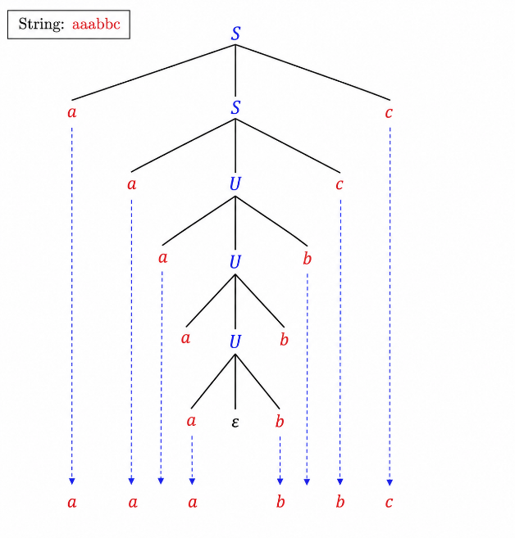
C)A Grammar is Ambiguous if there exists two distinct derivations for a word. Is the above
grammar ambiguous? Justify.​
The given grammar is ambiguous.

Justification
A grammar is said to be ambiguous if there exists at least one string that can be generated by two or more different leftmost derivations or two different parse (derivation) trees.
In this grammar, the empty string (ε) can be derived in more than one way:

Derivation 1

S⇒ε

Derivation 2
S⇒T⇒ε

Derivation 3
S⇒U⇒ε
Thus, the same string ε has three different derivations, which satisfies the definition of ambiguity.

Conclusion
Since the string ε can be derived through multiple distinct derivations, the grammar is ambiguous.

3. Design a non deterministic finite automata with ε-transitions to represent the language denoted
by the regular expression
00*1+11*0

Aim
To design an ε-NFA for the regular expression:
00*1 + 11*0
using ε-transitions.

Step 1: Understanding the Regular Expression
The expression consists of two parts joined by union (+):

Expression 1
00*1
This accepts strings such as
- 01
- 001
- 0001
- 00001
- …
(i.e., one or more 0's followed by one 1)

Expression 2
11^*0
This accepts strings such as
- 10
- 110
- 1110
- 11110
- …
(i.e., one or more 1's followed by one 0)

Step 2: ε-NFA Design

States
- q0 → Start State
- q1, q2 → Branch for 00*1
- q3, q4 → Branch for 11*0
- q5 → Final State

Alphabet
∑={0,1}

Start State
q_0

Final State
F={q_5}

Step 3: Transition Table
Current State | Input | Next State
→q0 | ε | q1
→q0 | ε | q3
q1 | 0 | q2
q2 | 0 | q2
q2 | 1 | q5
q3 | 1 | q4
q4 | 1 | q4
q4 | 0 | q5

Step 4: Working

Branch 1
q0 --ε--> q1 --0--> q2 --0(loop)--> q2 --1--> q5
Accepts
01
001
0001
00001
...

Branch 2
q0 --ε--> q3 --1--> q4 --1(loop)--> q4 --0--> q5
Accepts
10
110
1110
11110
...

Step 5: Accepted Strings
String | Accepted
01 | ✓
001 | ✓
0001 | ✓
10 | ✓
110 | ✓
1110 | ✓

Rejected Strings
String | Reason
00 | No ending 1
11 | No ending 0
101 | Doesn't match
010 | Doesn't match
1001 | Doesn't match

Applications
This ε-NFA can be used in:
- Compiler lexical analysis
- Pattern matching
- Text processing
- Intrusion detection systems
- Network packet filtering
- Input validation

Conclusion
The ε-NFA successfully recognizes the language represented by
00^*1+11^*0
using ε-transitions to split into two independent branches. One branch accepts strings with one or more 0's followed by one 1, while the other accepts one or more 1's followed by one 0.
ε-NFA state diagram:
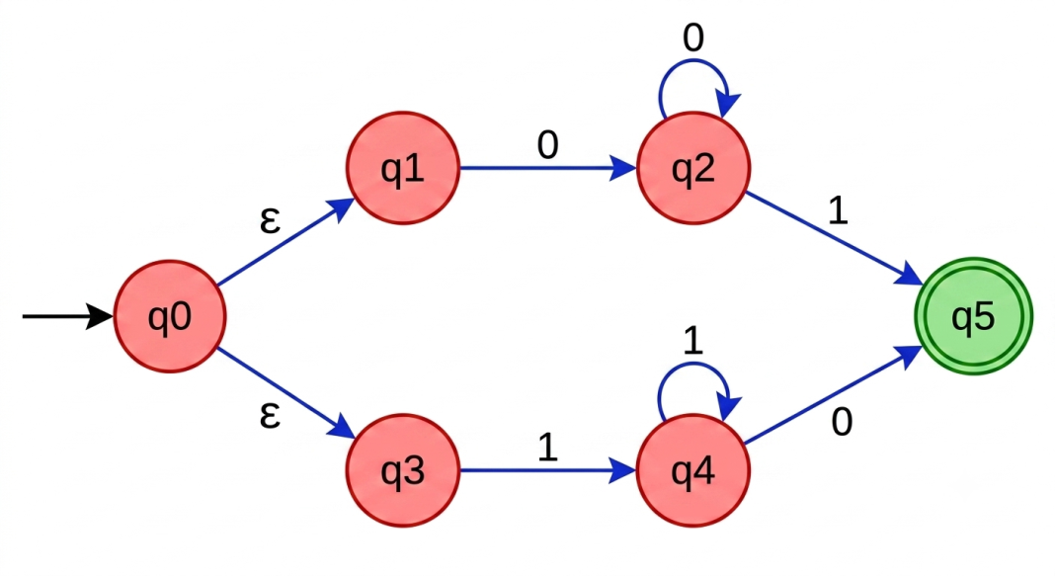

4. I)Show that if L1 and L2 are regular then (L1+l2) also regular
ii)Is the language { a^p| p is prime} regular? Justify
Answer:

(i)Show that if (L_1) and (L_2) are regular, then ((L_1 + L_2)) is also regular.

Proof
Assume that:
- (L_1) is a regular language.
- (L_2) is also a regular language.
Since both languages are regular, there exist finite automata:
- (M_1) accepts (L_1).
- (M_2) accepts (L_2).
The operation + denotes the union of two languages.
L=L1​+L2​=L1​∪L2​
A new automaton can be constructed that accepts all strings accepted by either (M_1) or (M_2). This can be done by:
- Constructing an ε-NFA with a new start state having ε-transitions to the start states of (M_1) and (M_2), or
- Constructing an equivalent DFA.
Since finite automata recognize regular languages, the resulting language is also regular.

Conclusion
Regular languages are closed under union. Therefore,
L1+L2=L1∪L2 is regular.

ii) Is the L={a^{p}∣p is prime} regular? Justify your answer.

Answer
The language
L={a^{p}∣p is prime}is not regular.

Justification (Using the Pumping Lemma)
Assume that (L) is regular.
Then, by the Pumping Lemma, there exists a pumping length (m).
Choose the string
w=a^{p}
where (p) is a prime number and (p\ge m).
According to the Pumping Lemma,
w=xyz
such that:
- |xy|≤ m
- |y|>0
Let
y=a^{k}, k>0
Now pump (y) with (i=p+1).
The resulting string has length
p+pk=p(1+k)
Since (1+k>1), the length is composite, not prime.
Therefore,
xyz^{p+1} ɆL
This contradicts the Pumping Lemma.
Hence, our assumption is false.

Conclusion
{L={a^{p}| p is prime}is NOT a regular language.

Final Answer

4(i)
Since regular languages are closed under union, if (L_1) and (L_2) are regular, then
L_1+L_2= L_1 U L_2
is also regular because it can be accepted by a finite automaton.

4(ii)
The language
L={a^{p} | p is prime}
is not regular. Using the Pumping Lemma, pumping a valid string changes its length from a prime number to a composite number, which violates the language definition. Therefore, the language cannot be recognized by any finite automaton.

5. Design minimized automata, Consider the DFA given below. Find the states that are equivalent and construct a minimum state automata equivalent to the given automata. Draw the minimized automata, write its transition table and mark initial and final states
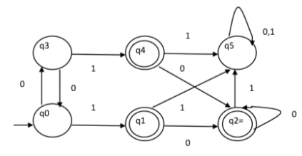
Answer:
Let's minimize the given DFA step by step.

Step 1: Identify States
From the diagram:
- States: q0, q1, q2, q3, q4, q5
- Initial State: q0
- Final States: q1, q2, q4 (double circles)

Step 2: Transition Table
State | 0 | 1
→q0 | q3 | q1
q3 | q0 | q4
*q4 | q2 | q5
*q1 | q2 | q5
*q2 | q2 | q5
q5 | q5 | q5
(* denotes final state)

Step 3: Find Equivalent States

Final States
- q1
- q2
- q4
Compare their transitions:
State | 0 | 1
q1 | q2 | q5
q2 | q2 | q5
q4 | q2 | q5
All three have identical transitions.
Therefore,
q1≡q2≡q4​
These three states are equivalent.

Non-final States
Compare q0, q3 and q5.
- q5 is a trap state.
- q0 and q3 have different transitions:
q0:
- 0 → q3
- 1 → Final state
q3:
- 0 → q0
- 1 → Final state
They transition to each other on input 0, so they are not equivalent.
Hence
q0,q3,q5
remain separate.

Step 4: Minimized States
Merge
q1=q2=q4=A
The minimized DFA has four states:
- q0
- q3
- A = {q1,q2,q4}
- q5

Step 5: Minimized Transition Table
Present State | 0 | 1
→q0 | q3 | A
q3 | q0 | A
*A | A | q5
q5 | q5 | q5

Initial State
q0

Final State
A={q1,q2,q4}

Equivalent States
q1≡q2≡q4

Minimized DFA
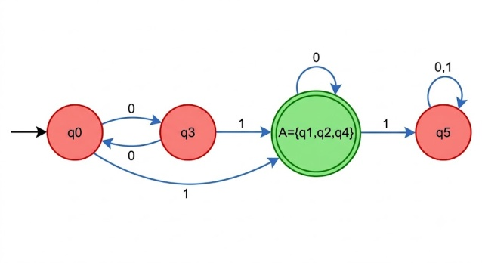
Where:
- q0 = Initial state
- A = Merged accepting state {q1, q2, q4}
- q5 = Dead state
- q3 = Intermediate state

Final Answer
- Equivalent States: 𝑞1≡𝑞2≡𝑞4
- Initial State: (q0)
- Final State: A={q1,q2,q4}
- Number of states before minimization: 6
- Number of states after minimization: 4
This is the minimized DFA corresponding to the given automaton.

