SeekerPay
The native SKR payments app for Solana Seeker
QR · NFC · Bluetooth · Offline · Multi-Pay · Split Bills · .SKR Directory · Chat
Merchant-ready · Seeker-native · Open-source SDK
Solana Mobile Builder Grant Application · March 2026 · Vasu Thammaiah
Applicant | Vasu Thammaiah

Email | vasu.thammaiah@gmail.com

Category | Payments · Developer Tooling · Merchant App · Seeker-Native

Payment Currency | 100% SKR

Grant Track | Builder Grant

Consumer App | Closed-source · Exclusively on Solana Seeker dApp Store

SDK | Open-source · MIT licence · pub.dev + GitHub

Demo | https://bitcoinvision.ai/web/spay/

Status | Feature-complete · Verified on real Seeker hardware with real on-chain SKR

OPEN SOURCE: All 7 SDK packages are MIT-licensed and published to pub.dev + GitHub. The consumer app is closed-source and exclusively on the Solana dApp Store. The app is the living proof that every SDK package works end-to-end in production.

1. Executive Summary
SeekerPay is a merchant-ready, feature-complete SKR payment app running on real Seeker hardware. Any shop, restaurant, market stall, or event can accept SKR via QR code scan, NFC terminal tap, or Bluetooth proximity — all signed by Seed Vault. Groups split bills with on-chain tracking. Payments can be initiated offline and broadcast when connectivity returns.

The consumer app ships exclusively on the Solana dApp Store — closed-source. The full payment stack is extracted into seven open-source Flutter packages under MIT licence, published to pub.dev, giving every Flutter developer on Seeker production-ready SKR payment infrastructure.

NFC tap-to-pay and Bluetooth P2P payments are believed to be a first on the Solana dApp Store. No existing listing offers contactless SKR payments. SeekerPay brings the payment UX of Apple Pay — natively to Seeker, exclusively in SKR.

2. Nine Features — Verified on Seeker Hardware
All features are implemented and verified on a physical Solana Seeker device with real confirmed on-chain SKR transactions. Demo available at https://bitcoinvision.ai/web/spay/

MERCHANT-READY: Cafés display a QR code — customer scans and pays. Market stalls tap NFC devices. Food trucks collect payments offline and sync later. SeekerPay handles every merchant payment scenario in SKR.

2.1 QR Pay & Receive — shareable amount-specific codes
Merchants generate a branded SEEKERPAY QR for a specific SKR amount. The SHARE CODE button shares the QR image via WhatsApp, Telegram, or any messaging app — recipient taps, SeekerPay opens with amount pre-filled. Verified working via WhatsApp in real device testing.
- Solana Pay URL — amount + recipient embedded in QR
- SHARE CODE — native Android share sheet, WhatsApp, Telegram, email
- CameraX-based scanner — fast and reliable in all lighting conditions
- Merchant use: display on counter or share via message before customer arrives

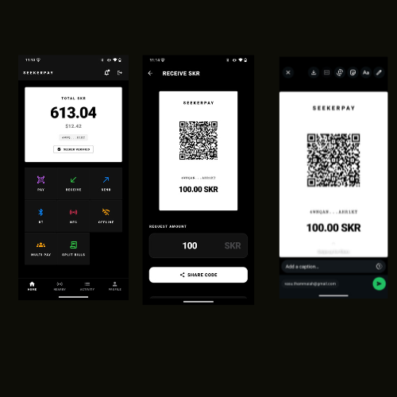
Caption

2.2 NFC Tap-to-Pay — believed first on Solana dApp Store
NEARBY PAY → NFC tab shows a TAP TO PAY screen with pulsing ring animation. Receiver enters RECEIVE mode. Payer taps back of Seeker to recipient device — payment preview appears — one Seed Vault fingerprint confirmation completes the transaction.
- Android NfcAdapter — native, not a WebView workaround
- Device-to-device payment URL transfer — no internet needed for the tap
- Works between any two NFC-enabled Android devices
- Believed to be the first NFC SKR payment on the Solana dApp Store

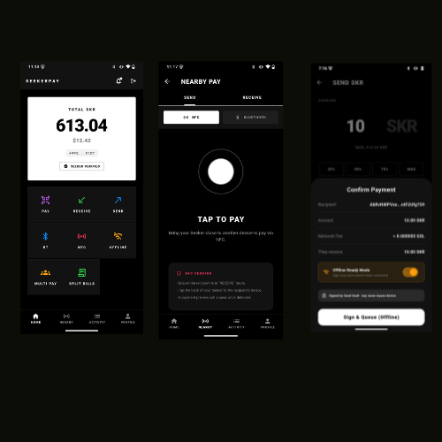
Caption

2.3 Bluetooth Nearby Pay — P2P without QR, NFC, or internet
NEARBY PAY → BLUETOOTH. Receiver enters RECEIVE mode — device broadcasts BLUETOOTH ADVERTISING with the SKR amount. Sender sees SCANNING FOR DEVICES — selects, reviews, Seed Vault confirms. Pure device-to-device, no server or relay. Tested: 12 SKR Bluetooth advertising confirmed working on real Seeker.
- Android Nearby Connections API — BLE discovery within metres
- Receiver broadcasts amount: e.g. "Requesting 12.00 SKR" visible on sender device
- Works at crowded events and venues where QR is impractical
- Believed to be the first Bluetooth P2P SKR payment on the Solana dApp Store

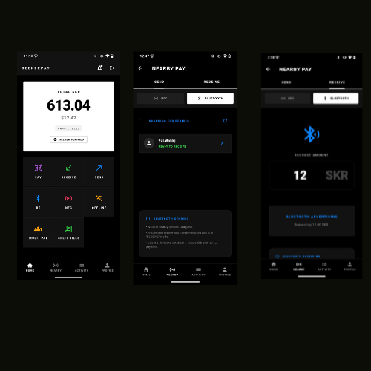
Caption

2.4 Offline Payments — Seed Vault signs without internet
OFFLINE-READY MODE: Seed Vault signs locally without internet. Signed payload stored on device. When connectivity returns, app sends a push notification reminding user of pending payment. User re-signs with a fresh blockhash (Solana blockhashes expire ~90 seconds) — SYNC ALL NOW broadcasts all queued transactions.
- Seed Vault signs locally — private key never leaves device
- Push notification when internet returns: reminder for pending sync
- Re-sign flow: one tap for fresh blockhash — SYNC ALL NOW completes broadcast
- EXPIRED state shown for old blockhashes — clear UX for re-sign
- Critical for markets, rural areas, and venues with poor connectivity

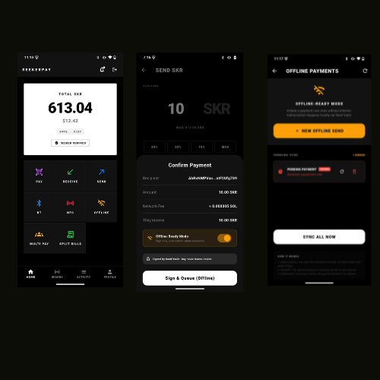
Caption

2.5 Multi Pay — one confirmation, multiple recipients
Multi Pay sends SKR to multiple wallet addresses in a single Solana transaction. One Seed Vault confirmation distributes SKR to all recipients simultaneously. This is distinct from Split Bills — Multi Pay is outbound sending to many recipients at once, not group bill collection.
- Multiple wallet addresses paid in one atomic Solana transaction
- One Seed Vault confirmation — not N separate payments
- Use cases: batch payouts, settling multiple debts simultaneously

2.6 Split Bills — divide and track group payments on-chain
Split Bills divides a total amount among N participants. Each person pays their individual share. On-chain tracking via getSignaturesForAddress shows real-time status per person — Pending or Paid. The organiser is notified when all shares are complete. Integrates with NFC tap-to-settle.
- Enter total + number of people — per-person amount calculated automatically
- On-chain tracking — each payment confirmed via Solana RPC per participant
- Real-time status dashboard: who has paid, who is pending
- NFC tap-to-settle: organiser taps pending participant to receive their share

2.7 Seeker Verified Identity
SEEKER VERIFIED badge on the home dashboard when the connected wallet holds a Seeker Genesis Token. Visible on Home and Profile screens. Trust signal for NFC and Bluetooth payments — users confirm they are paying a verified Seeker device owner before Seed Vault signs.

3. Two Deliverables

4. SDK — 7 Flutter Packages

5. Context & Traction
Bitcoin Vision AI — proof the team ships
Bitcoin Vision AI is an AI crypto insights app by the same developer. Bitcoin Vision AI Pro uses Mobile Wallet Adapter for SKR-based subscription payments — the identical MWA implementation that powers SeekerPay. This is not a new team learning the Solana Mobile Stack.

6. Deliverables & Milestones
Grant amount is at Solana Mobile discretion. Percentages below apply to whatever amount is approved.

4 Sample Apps published to GitHub
- Sample 1 — QR Merchant Checkout: shop displays QR, customer scans and pays SKR
- Sample 2 — NFC Terminal: merchant device in RECEIVE mode, customer taps to pay
- Sample 3 — Bluetooth P2P: two devices pay without QR, NFC, or internet
- Sample 4 — Split Bill: group dining with on-chain per-person tracking and tap-to-settle

7. Merchant Use Cases

8. Grant Criteria Alignment

9. Team
Vasu Thammaiah — Founder & Developer
- 15+ years software engineering — Java/J2EE, Liferay portal, Android, Flutter specialist
- Built Bitcoin Vision AI solo: 4 live app stores, 2,300+ users
- MWA + Seed Vault proven in production via Bitcoin Vision AI Pro
- SeekerPay verified on physical Seeker device — real SKR, real confirmed on-chain transactions
- Contact: vasu.thammaiah@gmail.com

This is a working product by a developer who ships. The Activity screen shows real confirmed on-chain SKR transactions. The grant funds open-source release and ecosystem distribution of a completed product.

10. Summary
SeekerPay gives Seeker users and merchants the payment app the ecosystem has been missing. QR, NFC tap, Bluetooth proximity, offline Seed Vault signing, multi-wallet send, and on-chain split bills — all exclusive to SKR, all native to Seeker hardware.

The open-source SDK scales this across every Flutter developer on Seeker — seven packages, MIT licensed, free forever.

The app is built. Transactions are real. The grant funds open-source release of a completed product.

SeekerPay · Vasu Thammaiah · vasu.thammaiah@gmail.com · Solana Mobile Builder Grant · March 2026
2.8 .SKR Domain Directory — browse, resolve, and chat
The .SKR DIRECTORY screen provides a paginated, searchable list of all registered .skr domains on-chain. Users find any domain, resolve it to a verified wallet address, and initiate a payment directly from the directory — no copy-pasting of addresses. Domain resolution uses the AllDomains (ANS) protocol with SQLite local caching for instant re-lookups. Seeker Genesis Token verification is shown alongside each domain entry.
.skr domain resolution — COMPLETE. AllDomains ANS protocol + Bonfida SNS, fully shipped in seekerpay_domains v1.0.2
Paginated directory — browse all registered .skr domains with search and filter
One-tap pay — select any domain entry → payment screen pre-fills recipient
Seeker Verified badge shown per domain — Genesis Token holders identified on-chain
Local SQLite cache — instant re-resolution, zero redundant RPC calls
2.9 .SKR Chat — message any domain holder directly in-app
The CONVERSATIONS tab within .SKR DIRECTORY lets users message any .skr domain holder directly — no phone number or email required. Messages are tied to domain identity, not raw wallet addresses. Chat history is persisted locally and grouped by domain. Users can initiate payment requests inline from a conversation, making .SKR Chat the first domain-native messaging layer on Seeker.
Message any .skr domain — identity-based chat, not address-based
Conversation history grouped by domain — persisted locally
Inline payment request — tap to send SKR directly from a chat thread
First domain-native messaging on Solana Seeker
SeekerPay Consumer App  CLOSED SOURCE  Exclusively on Solana Seeker dApp Store. All 7 features built and verified on real Seeker hardware with real SKR. Source code proprietary. The reference proof that every SDK package works. | SeekerPay SDK — 7 Flutter Packages  OPEN SOURCE — MIT LICENCE  Published to pub.dev and GitHub. Any Flutter developer on Seeker gets production-ready SKR payments in one dependency. Free forever. This is the primary grant deliverable.
Package | Description
seekerpay_core | Foundational Solana RPC, MWA + Seed Vault integration, payment services, wallet state.
seekerpay_qr | Solana Pay-compatible QR generation + CameraX scanner. Shareable amount-specific QR codes.
seekerpay_nfc | NFC NDEF tap-to-pay via Android NfcAdapter. Write and read Solana Pay payment URLs.
seekerpay_bluetooth | BLE P2P payment discovery via Android Nearby Connections. No internet required.
seekerpay_split | Split bill management — divide total, track each person on-chain, tap-to-settle.
seekerpay_domains | SNS .sol and Seeker .skr domain resolution — COMPLETE & published v1.0.2. AllDomains ANS protocol, Bonfida SNS, SQLite caching, paginated .SKR directory, Seeker Genesis Token verification, inline payment from directory.
seekerpay_ui | Matrix-inspired dark theme, payment animations, drop-in Compose UI components.
✅ seekerpay_domains v1.0.2 — .skr domain resolution is COMPLETE and live on pub.dev. All 7 SDK packages are now published at v1.0.2. The .SKR Directory and Chat features are fully implemented and verified on physical Seeker hardware.
// Any Flutter app on Seeker — SKR payment in 5 lines
dependencies:
seekerpay_core: ^1.0.2 # MWA + Seed Vault + SKR
seekerpay_nfc: ^1.0.2 # NFC tap-to-pay
final receipt = await SeekerPay.pay(
recipient: 'merchant.skr',
amountSkr: 49.99,
); // MWA + Seed Vault + RPC confirm — all inside SDK
Live on | Solana dApp Store · iOS App Store · Google Play · Amazon Appstore
Users | 2,300+ registered users across all platforms
MWA in production | Bitcoin Vision AI Pro uses MWA for SKR subscriptions — same codebase as SeekerPay
Developer | Vasu Thammaiah — built and shipped solo across all four stores
The hard part — MWA + Seed Vault in Flutter — is proven in production. SeekerPay is verified on real Seeker hardware with real confirmed on-chain SKR transactions visible in the Activity screen. The grant funds open-source release, not research.
Phase | Allocation | Deliverables | Timeline
Implemented | 60% of grant | Consumer app on Solana dApp Store — all 9 features verified on real Seeker hardware. All 7 SDK packages on pub.dev v1.0.2 (MIT): seekerpay_core + seekerpay_qr + seekerpay_nfc + seekerpay_bluetooth + seekerpay_split + seekerpay_ui + seekerpay_domains (.skr resolution, directory, and chat — COMPLETE). GitHub source with README and full API docs. | ✅ Delivered
New Features & Enhancements | 25% of grant | Merchant Dashboard — payment analytics, daily/weekly SKR volume charts, export CSV. Push Payment Requests — request SKR from any .skr domain via in-app notification. Transaction Memos — attach labels/notes to payments, searchable in Activity. Enhanced .SKR Chat — read receipts, payment-request messages, group threads. 5 sample apps published to GitHub: QR Checkout, NFC Terminal, Bluetooth P2P, Split Bill, .SKR Directory integration. Full API docs on GitHub Pages. | 4–6 weeks post-grant
Maintenance | 15% of grant | 12 months — Flutter/SDK version compatibility, GitHub Issues triage, monthly pub.dev download reports, community support for SDK integrators, Solana protocol updates (MWA, Seed Vault API changes). | 12 months
✅ All 7 SDK packages are complete and live on pub.dev v1.0.2 — including seekerpay_domains with full .skr resolution, directory, and chat. The 60% Implemented milestone is fully delivered. New Features & Enhancements (25%) begin immediately upon grant approval.
Merchant Type | How SeekerPay Is Used
Café / Restaurant | QR on counter or NFC terminal tap. Customer pays under 3 seconds. Confirmed instantly in Activity screen.
Market Stall / Street Vendor | Share QR via WhatsApp before customer arrives. Or Bluetooth — no NFC needed. Offline signing works with poor signal.
Events / Festivals | NFC tap or Bluetooth proximity. Split entry fees. Offline works in crowded venues with poor connectivity.
Freelancers | Send amount-specific QR via email or message. Client pays from any Seeker device. Confirmed on-chain.
Group Dining | SPLIT BILLS divides total — each person pays their share. NFC tap-to-settle. Organiser notified when all paid.
Criterion | Evidence
Mobile-First / Seeker-Native | Native Flutter. NFC (NfcAdapter), Bluetooth (Nearby Connections), CameraX QR, MWA, Seed Vault — all native Android APIs. Verified on physical Seeker device with real SKR.
Solana Mobile Stack | MWA + Seed Vault for all signing — proven in Bitcoin Vision AI Pro. Profile screen shows Seed Vault Protected status.
First-on-dApp-Store | NFC tap-to-pay and Bluetooth P2P payments believed to be first on Solana dApp Store. No existing listing offers contactless SKR payments.
SKR-Only | SKR is exclusive across all 9 payment flows. No SOL fallback. No fiat. Pure SKR utility.
Open-Source SDK | 7 packages MIT licence — all live on pub.dev v1.0.2 + GitHub. seekerpay_domains .skr resolution COMPLETE. .SKR Directory and Chat shipped. Flutter SDK for the full Seeker developer ecosystem.
Team Execution | Bitcoin Vision AI: 4 live stores, 2,300+ users, MWA in production. SeekerPay on real Seeker hardware with confirmed on-chain SKR transactions.

