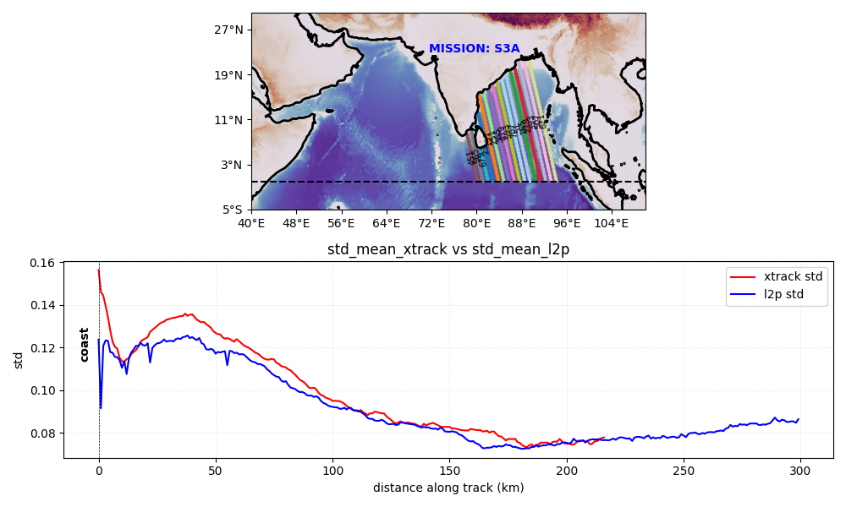
Fig1: Standard deviation of SLA of the tracks meeting the east coast of India for the satellite mission S3A compared between Xtrack along track products and AVISO l2p tracks.

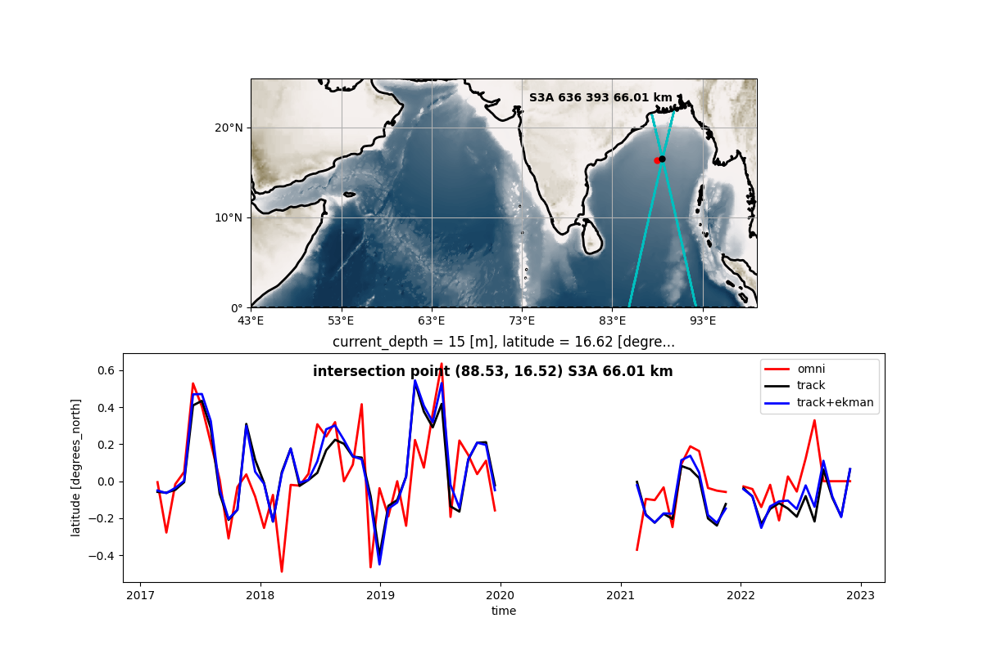
Fig2

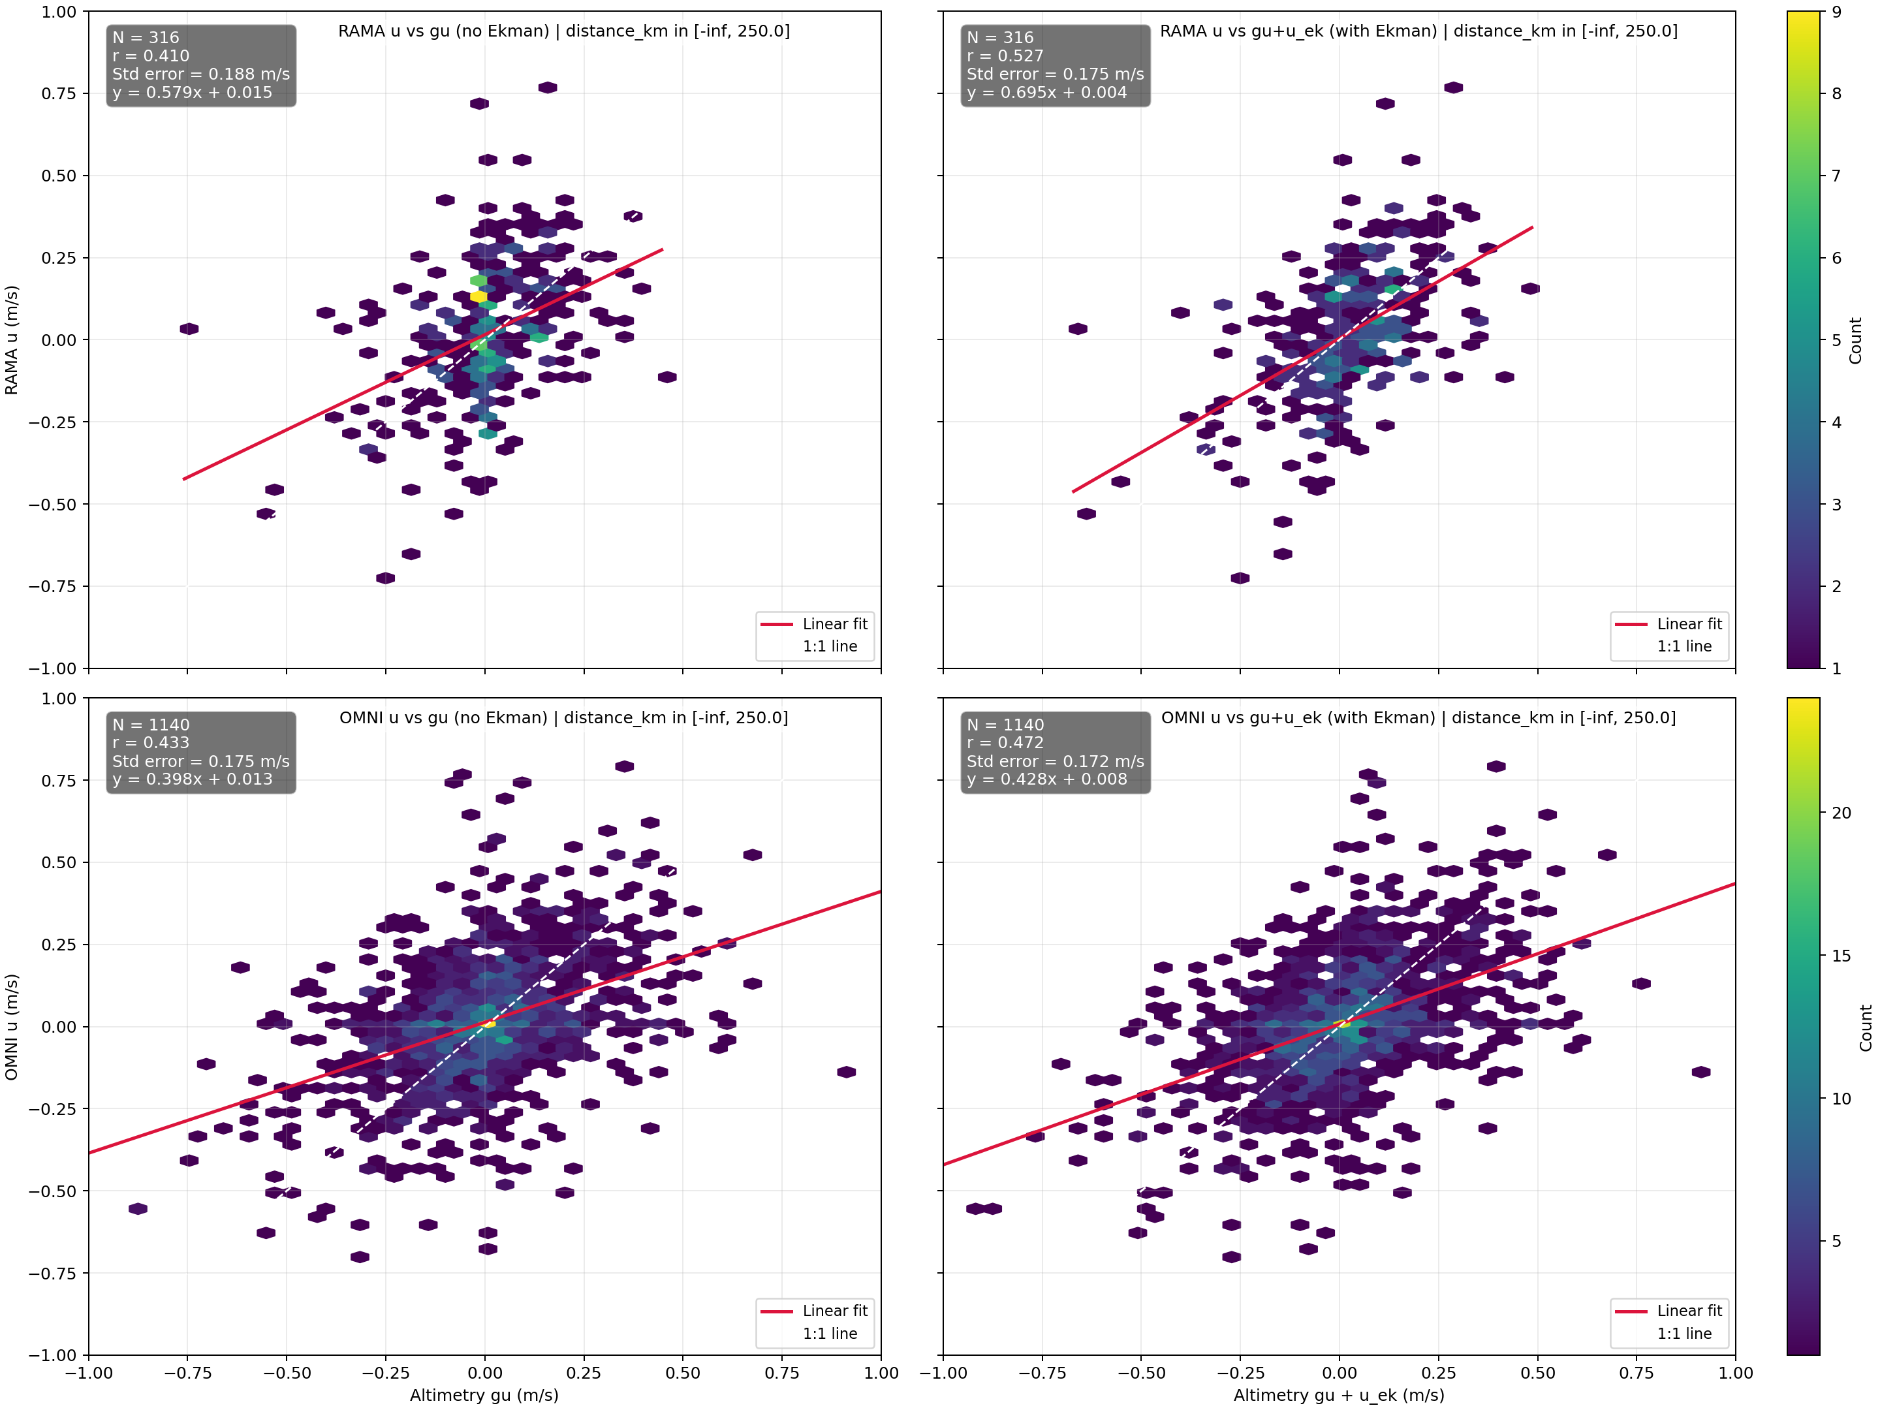
Fig3

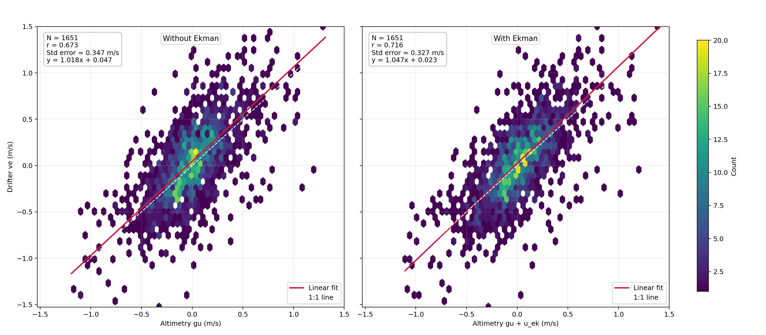
Fig4

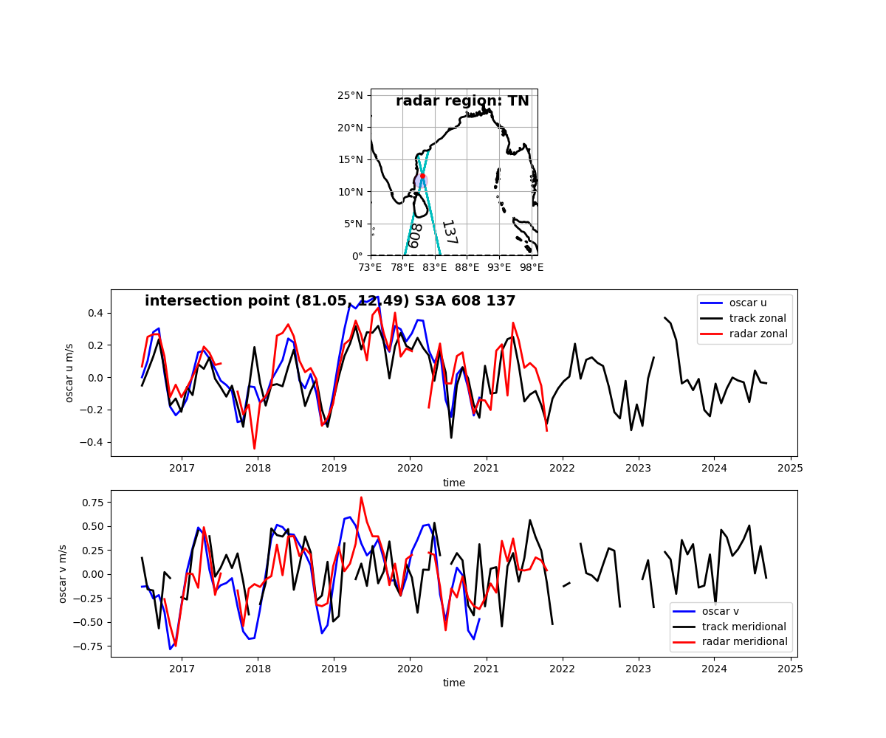
Fig5

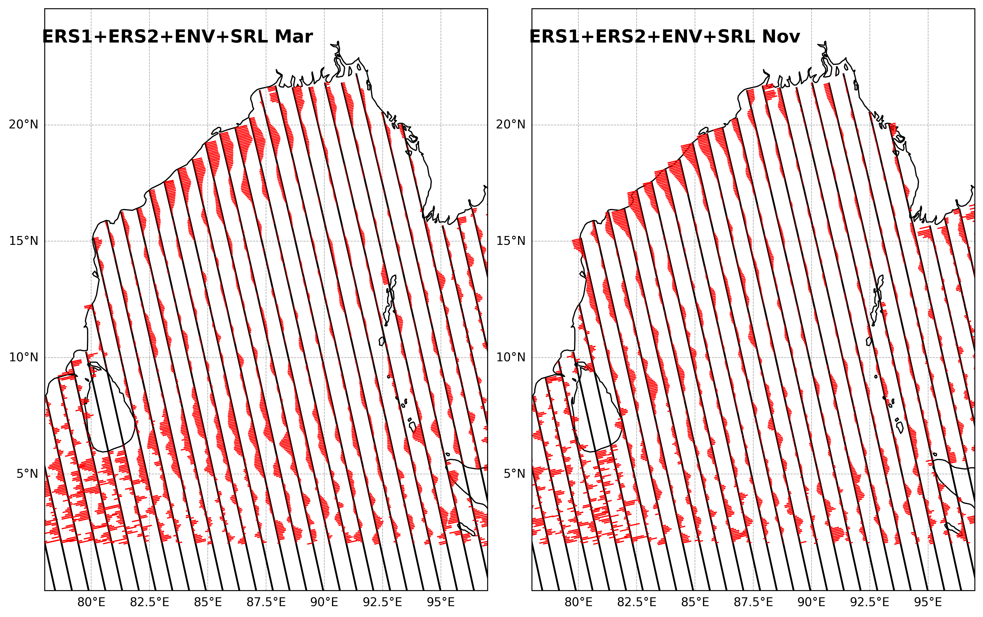
Fig6: Climatology of cross-track geostrophic currents for the months Mar (left) and Nov (right)
derived from the satellite mission ERS1+ERS2+ENV+SRL. Only descending tracks are shown
since cross track direction in this case makes small angle to the slope of the local coast which means
that cross track geostrophic velocity is approximately along shelf.

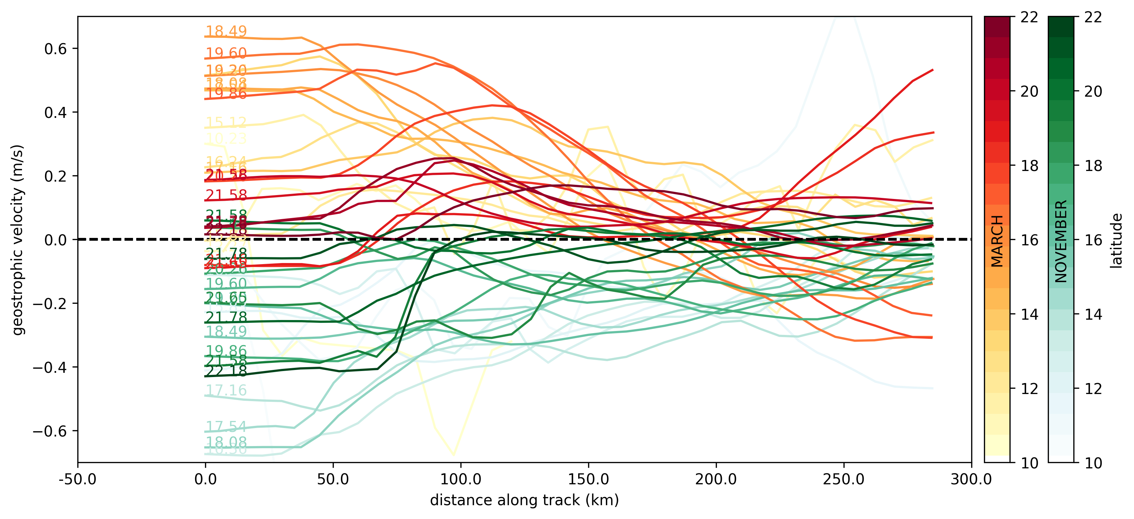
Fig7: Climatological mean cross-track velocities across the width of EICC for the months March
and November at different latitudes.

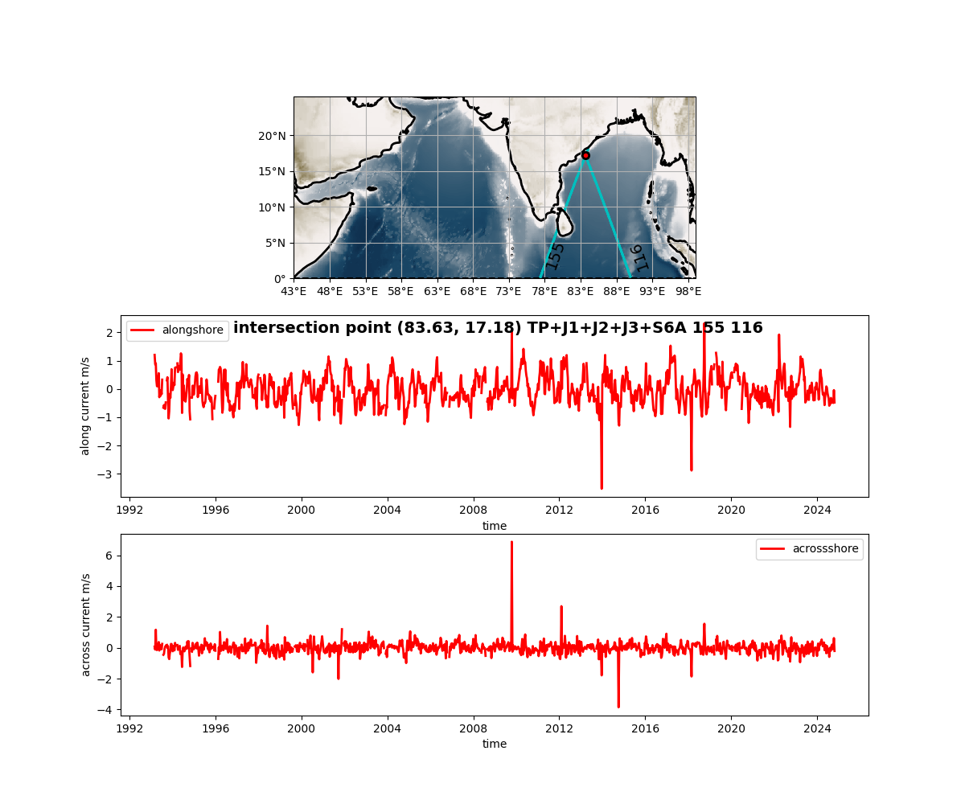
Fig8: Thirty year timeseries of along shore and across shore current components at the
intersection of two satellite tracks (155, 116) at point along the east coast of India.

