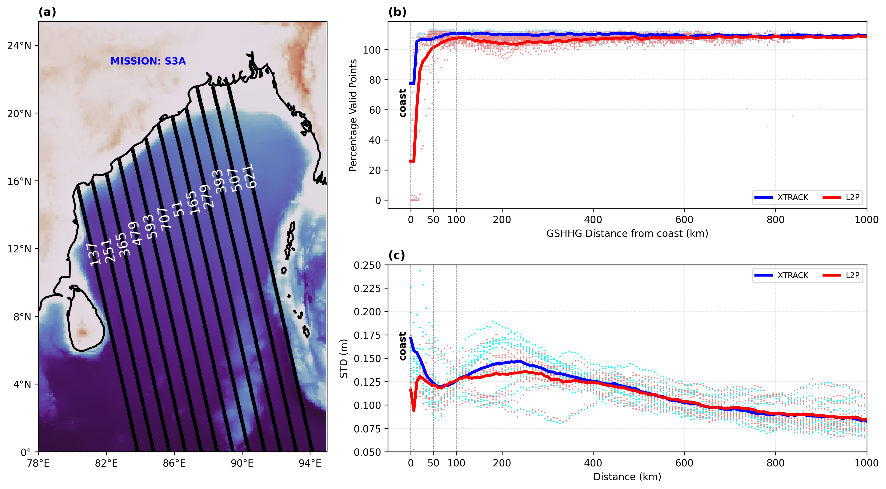
Fig1: Comparison of Sentinel-3A (S3A) sea level anomaly (SLA) data between X-TRACK and along-track Level-2+ (L2P) products for common ground tracks that are meeting the east coast of India. (a) Selected common S3A tracks plotted (black) over ETOPO5 bathymetry, with track numbers annotated in white. (b) Percentage of valid SLA observations available along-track plotted against GSHHG coastline distance, showing X-TRACK (blue) and L2P (red) individual track values (dots) and multi-track means (solid lines). The dashed vertical line in (b) and (c) marks the coastline. (c) Temporal standard deviation of SLA as a function of distance from coast for individual tracks (dots) and their multi-track mean (solid lines) from X-TRACK (blue) and L2P (red) products.

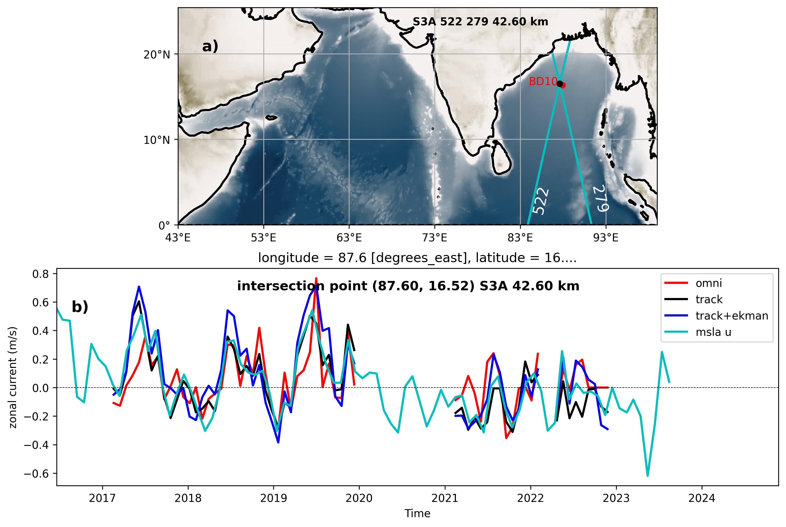
Fig2: b) Time series of geostrophic zonal component (black) derived at an intersection point (of track numbers 522 and 279 of S3A satellite mission) which is close to an OMNI buoy (BD10) overlied with buoy's zonal current(red). Timeseries of gu corrected with ekman u component(blue) and AVISO msla_uv at the intersection point(cyan) also added. a) Shows the intersection point(black) of the tracks and the close by bouy(red). It is rougly half a degree away from the intersection point.

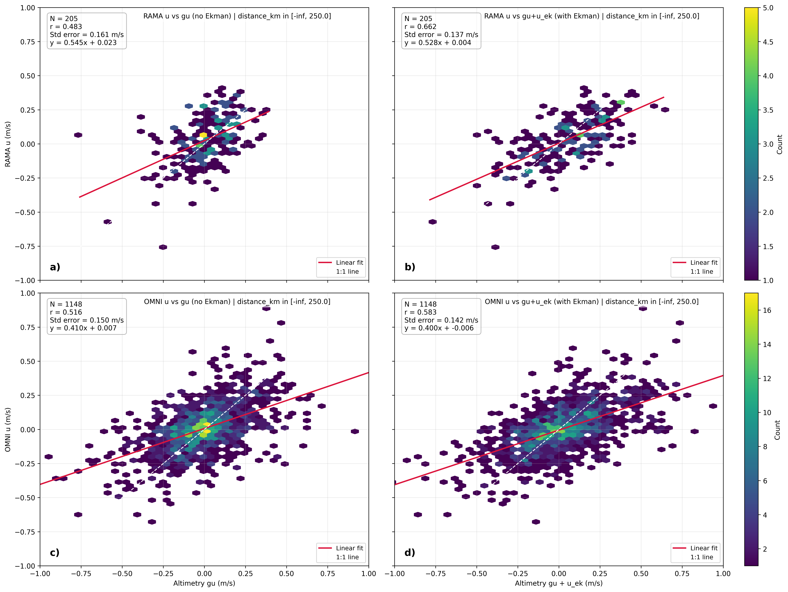
Fig3: a) Scatter plot of rama buoys' zonal currents(y-axis) versus altimetry derived zonal currents(x-axis) at nearby intersection points. b) Shows scatter plot with altimetry derived currents corrected with ekman zonal currents. c) and d) show scatter plots of OMNI currents with and without Ekman correction against altimetry zonal currents. The colorbar shows density of points in the scatter plot in terms of count. A redline passing through the points indicates linear fit and white dashed line represents perfect fit as a reference. The number of points, correlations and standard errors are show in boxes in the upper left corner.

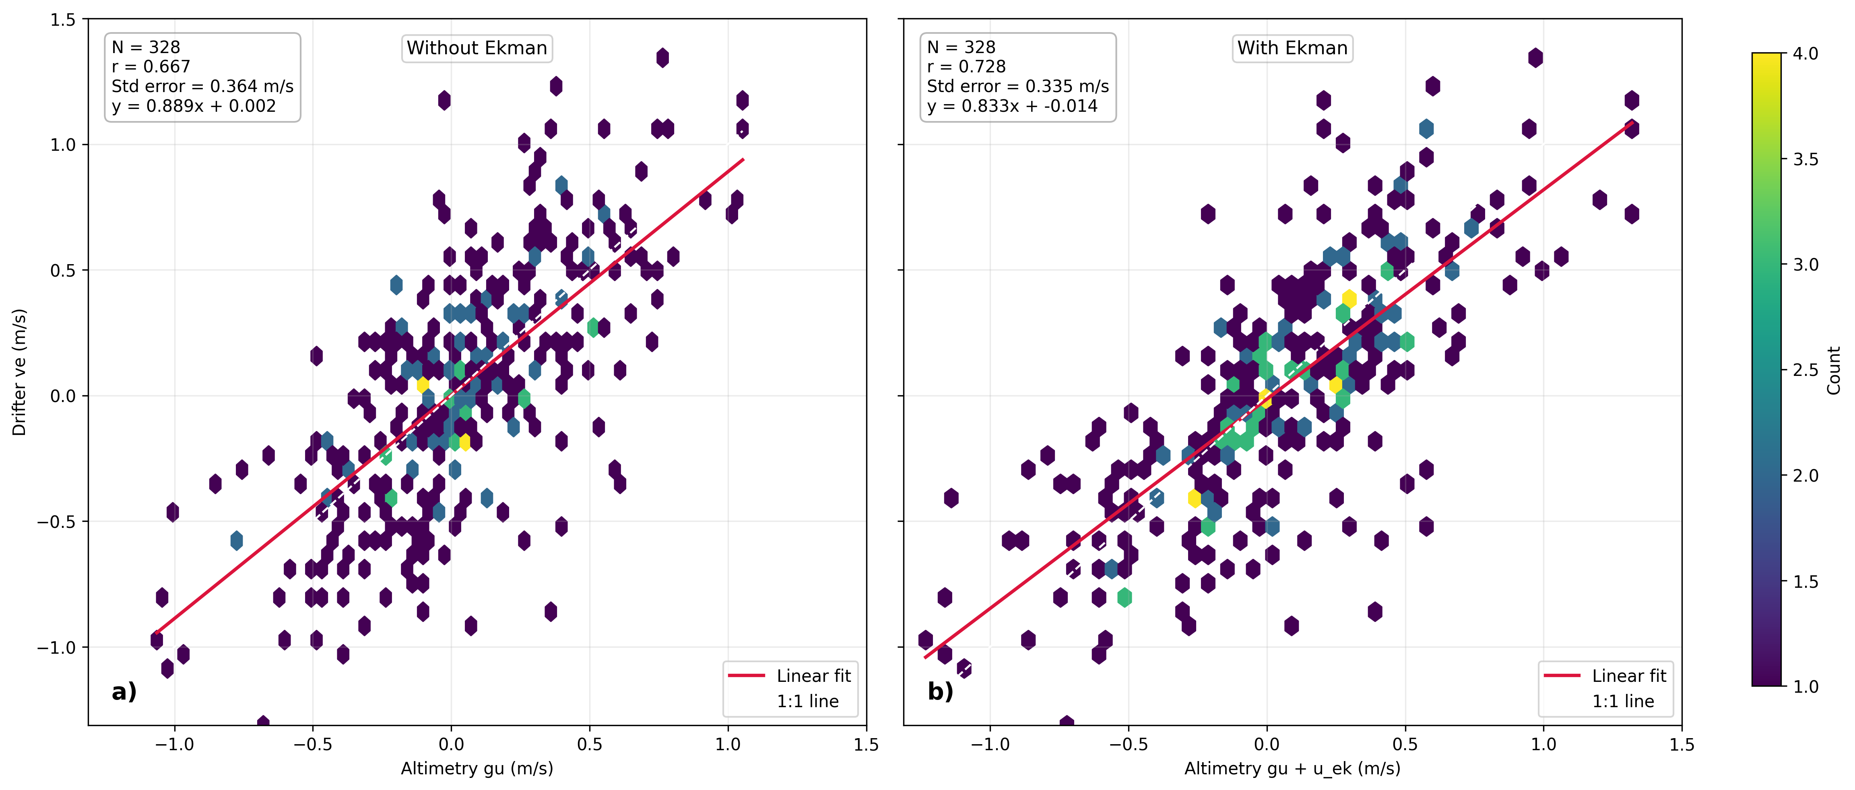
Fig4: a) Scatter plot of drifters' zonal velocities versus altimetry derived velocities within 100km inshore of the coast for the satellite mission TP+J1+J2+J3+S6A. b) shows scatter plot with altimetry derived velocities corrected with ekman zonal velocities. The colorbar shows density of points in the scatter plot in terms of count. A redline passing through the points indicates linear fit and white dashed line represents perfect fit as a reference. The number of points, correlations and standard errors are shown in boxes in the upper left corner.

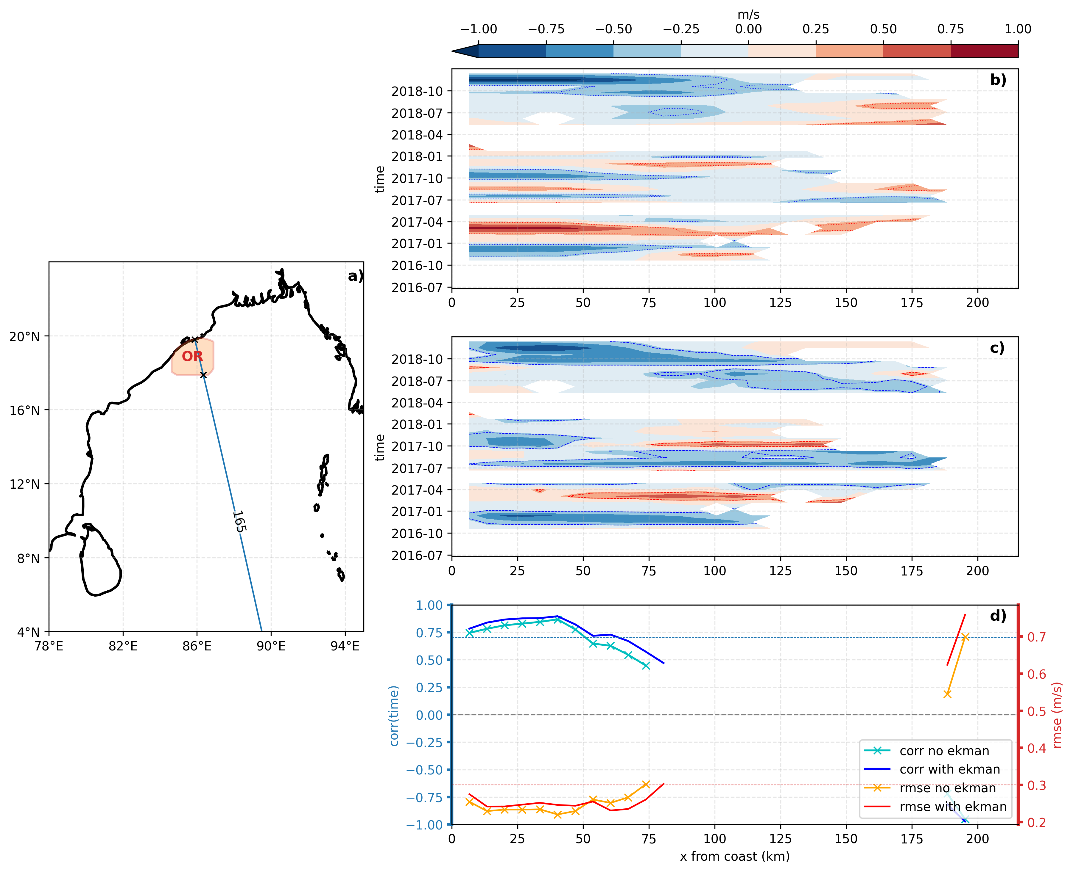
Fig5: Comparison of along-track cross-track velocity structure for the selected OR radar–altimeter intersection (track 165, S3A). (a) Map of the Bay of Bengal showing the selected Odisha radar region (OR) as polygon (shaded), satellite track segment, and intersection limits, with distance x measured from coast. (b) Time–distance section of geostrophic current plus Ekman component, (gc+uk). (c) Time–distance section of radar-derived velocity(rotated to cross track direction). (d) Skill metrics versus offshore distance: correlation (left axis; blue) and RMSE (right axis; red), each shown for cases without Ekman correction and with Ekman correction (legend). Only statistically significant correlations ((p<0.05)) are retained.

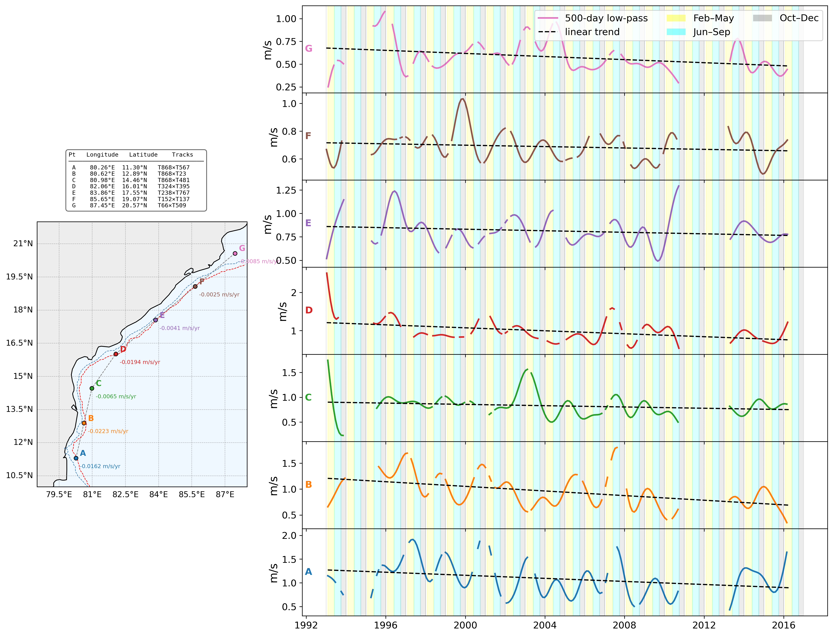
Fig6: Long-term variability and linear trends of Ekman corrected geostrophic current speed at seven crossover points of the East India Coastal Current (EICC) derived from ERS-1/2, Envisat, and SARAL/AltiKa altimetry. (Left) Locations of the seven crossover points (A–G, south to north) along the eastern boundary of the Bay of Bengal (10°–22°N, 78°–88°E). Each point is colour-coded by its label; the annotated value is the linear trend in m s⁻¹ yr⁻¹ (greyed out where the trend is not significant at the 95% confidence level, p ≥ 0.05). Isobaths of 200m(skyblue) and 1000m(red) are added. (Right) 500-day low-pass filtered current speed (coloured line) and its linear trend fit (black dashed line) at each point. Background shading indicates the spring inter-monsoon (February–May, yellow), summer monsoon (June–September, cyan), and post-monsoon/early winter (October–December, grey) seasons. Point coordinates and contributing ground-track pairs are: A (80.26°E, 11.30°N; T868×T567), B (80.62°E, 12.89°N; T868×T23), C (80.98°E, 14.46°N; T868×T481), D (82.06°E, 16.01°N; T324×T395), E (83.86°E, 17.55°N; T238×T767), F (85.65°E, 19.07°N; T152×T137), and G (87.45°E, 20.57°N; T66×T509).

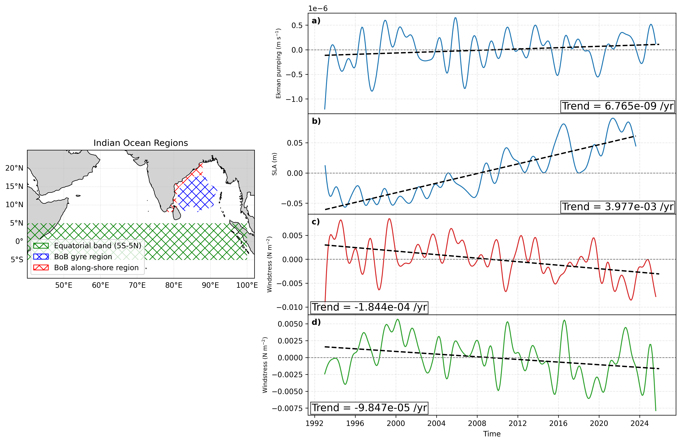
Fig7: Regional context and low-pass filtered variability of Bay of Bengal and equatorial Indian Ocean forcing/response. Left panel shows the analysis masks over the Indian Ocean: equatorial band (5°S-5°N, green hatch), Bay of Bengal gyre region (blue hatch), and Bay of Bengal along-shore region (red hatch). Right panels (a-d) show monthly area-averaged time series after applying a 500-day low-pass filter, with linear trend lines (black dashed): (a) Ekman pumping over the Bay of Bengal gyre mask, (b) sea-level anomaly over the Bay of Bengal gyre mask, (c) windstress magnitude over the Bay of Bengal along-shore mask, and (d) windstress magnitude over the equatorial band. Spatial means are cosine-latitude weighted, and Bay of Bengal masks are interpolated to each dataset grid before averaging.

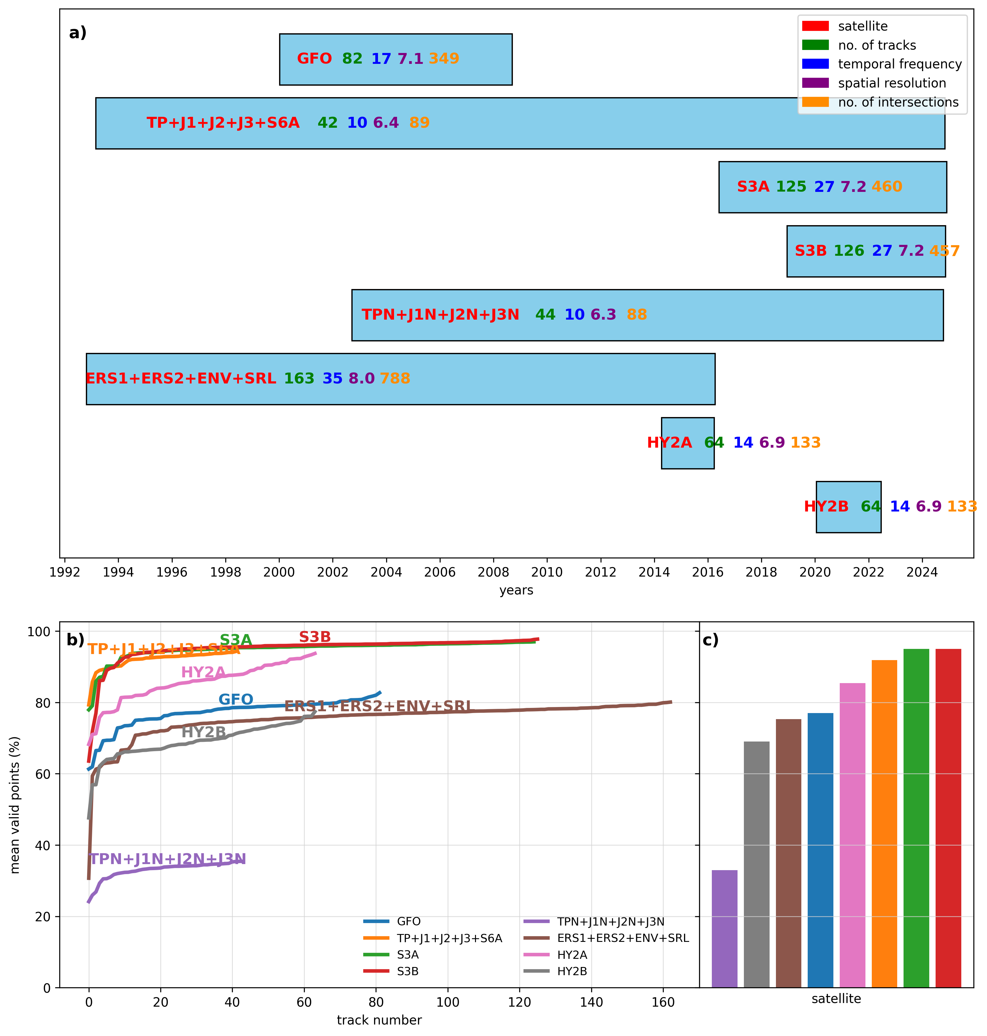
Sup Fig1: Composite overview of mission coverage and data validity across altimeter satellites. (a) Mission timelines showing each satellite’s observation period, annotated with number of tracks, temporal sampling frequency, and spatial sampling resolution. (b) Track-wise mean valid-point percentage for each satellite, with colored curves indicating within-mission variability. (c) Satellite-level mean of valid-point percentage, summarizing overall data-validity performance across missions. Panel colors are consistent between (b) and (c).

