# Purpose

This document provides the guidelines for releasing a software product. Refer to the Release Software Product procedure for the steps involved in releasing a software product. The software release procedure is followed for both integration (system-level) testing and user acceptance testing. Hence, the software is released prior to integration testing. It results in more number of releases, compared to releasing the software after integration testing, but provides better and standardized testing process.

# Scope

It is applicable to all users who develop software for the Electronics Department.

# Definitions

See *W1201 Software Development Roles and Responsibilities* for the acronyms used.

# Release ID

Each released version of a software is identified by a unique identifier, called Release ID (RID). The RID must be easily discernible from the installation; this is useful for reporting defects. For GUI-based executables, it must be available at Help -> About. For command-line software, it must be available through an option (-v). For libraries, it could be part of the file name. The RID must be in the following format: **M.N.I Q#**

* M is the Major number. It indicates major changes, new features, and incompatibility (backward or forward)
* N is the Minor number. It indicates small changes, bug-fixes, minor enhancements. Minor releases should be backward compatible.
* I is the optional Micro number. It indicates very small changes and bug-fixes only. It should be backward and forward compatible.
* Q is an optional qualifier. It can be ‘b’ for beta releases, ‘p’ for patches. '#' is the sequence number for the qualifier. Beta releases cannot have patches. All beta releases lead to the production release of the corresponding M.N.I release.

# Production Release

Our deployment policy is to have only one production release for a software at a given time. When a new production version is released, the old one is removed from all installations, and it is replaced with the new release. The following is the recommended way for achieving this with a version control system:

* Regular development work is done using the trunk
* Each production release results in a branch
* Defects in the production version must be fixed on the corresponding branch
* Other enhancements are continued on the trunk
* Before releasing a new production version, the last production's branch is merged on to the trunk

This is illustrated in the diagram below. The first release is 1.0 b0. It is not a production release; it is for system-level testing (quality control). The second release, 1.0 b1, is again for system-level testing. The first production release is 1.0; it results in the first branch in the source code tree. Enhancements continue to be made to the current source code, toward 2.0 b0 release. In the meantime, if a defect is reported on the the production version (1.0), it is fixed on the branch. This may involve checking out the code from the branch, repairing the defect, and then committing the source back to the branch. Once the bug is fixed, release 1.1 b0 is put out for testing. Once the testing is complete, a new production version, 1.1, is released.

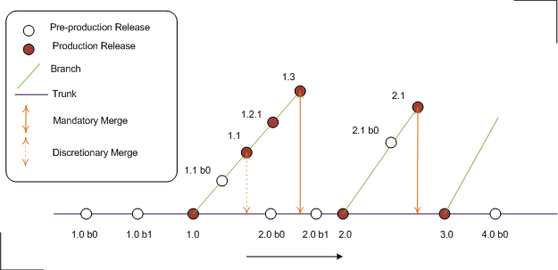

The source code of release 1.1 may or may not be merged with the current enhancements; this is left to the discretion of the development team. However, the next production version, 2.0, must include all the changes from the branch for release 1.x. There can be exceptions to this rule, for example, if version 2.0 has a very different architecture from version 1.x then the sources need not be merged. If there are changes to previous production version (1.x), while the next one is being tested (2.0 b0), those changes still must be incorporated into the next release, possibly by having another test release (2.0 b1).

# References

* 1. *M01 NSCL Electronics Department ISMS Manual*, NSCL Document Server, Electronics Folder
  2. *P501 Information Security Policy,* NSCL Document Server, Electronics Folder
  3. *P1201 Information Systems Acquisition, Development, and Maintenance Policy*, NSCL Document Server, Electronics Folder
  4. *W1201 Software Development Roles and Responsibilities*, NSCL Document Server, Electronics Folder

# Revision History

|  |  |  |
| --- | --- | --- |
| Revision  Level | Date | Revision Changes |
|  |  |  |

# Reviews

|  |  |
| --- | --- |
| Reviewer | Review Date |
| Information Security Working Group |  |

**Approved**

**Department Head:** ________________________________

**Approval Date: ________________ Effective Date: ________________**