# Purpose

The purpose of this procedure is to define the roles and responsibilities in a software development team. It defines the roles of the various team members or groups. The mapping between roles and people is not one-to-one. Depending on the size of the project, a person can be responsible for more than one role, or a role may be assigned to more than one person.

# Scope

It is applicable to all teams that develop software for the Electronics Department.

# Definitions

In this document, information security related terms have been marked in *underlined* *italics*. For their definitions, refer to the standard *EE-ISMS-S001 Terms and Definitions*.

# Entry Criteria

N/A

# Inputs

N/A

# Procedure

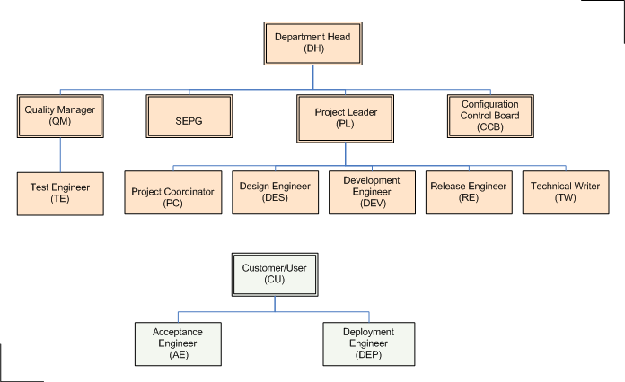

|  |  |  |
| --- | --- | --- |
| **Role** | **Acronym** | **Description** |
| Acceptance Engineer | AE | AE is responsible for performing system-level tests in customer's environment/premises (User Acceptance Testing). |
| Configuration (or Change) Control Board | CCB | CCB responsible for reviewing and approving changes to the project. It is generally a group consisting of one or more stakeholders. |
| Customer | CU | The entity that desires the software, commissions its development, and will use the it. It can be a person, a group, an unit, or an organization; it may be internal or external to the EE department. |
| Department Head | DH | DH leads a functional unit within NSCL. In PMBOK terminology, it is the Functional Manager. |
| Deployment Engineer | DEP | DEP is responsible for installing and configuring the software in customer's environment (production or test). |
| Design Engineer | DES | DES is responsible for both architectural and low-level design activities. |
| Development Engineer | DEV | DEV is responsible for coding and unit-testing. |
| Quality Manager | QM | QM is responsible for overseeing the quality assurance and quality control functions for the project. |
| Project Coordinator | PC | PC role is responsible for the management activities of the project. PC assists the Project Leader with all the project management related activities. PC role generally does not include technical or engineering activities. |
| Project Leader | PL | PL is responsible for the engineering and technical activities of the project. PL has the ultimate responsibility and authority for the project. PL, with help from PC, develops the project's plan, execute the project, monitor and control its progress, and delegate responsibilities to other people in the project team. For small and medium-sized projects, one person may perform both PL and PC roles. |
| Project Manager | PM | It is a combination of PC and PL roles (PM = PL + PC). |
| Technical Manager | TM | Synonym for Project Leader. |
| Release Engineer | RE | RE is responsible for building, packaging, and releasing the software, and associated management activities. |
| Software Engineering Process Group | SEPG | SEPG is responsible for managing the processes, including process definitions, improvements, and training. |
| Sponsor |  | Sponsor champions the project throughout the organization by promoting its benefits, and provides the necessary financial resources. Sponsor is involved in development of the project's initial scope and charter, and in the authorization of changes. In most cases, this role will be taken up by the Department Head. |
| Technical Writer | TW | TW is responsible for writing the technical documents -User Manuals, Installation Manuals, Help Files etc- using the appropriate medium. |
| Test Engineer | TE | TE's responsibilities include developing test cases, and performing integration tests. |
| User |  | Same as Customer. |

# Exceptions

N/A.

# References

* 1. *M01 NSCL Electronics Department ISMS Manual*, NSCL Document Server, Electronics Folder
  2. *P501 Information Security Policy,* NSCL Document Server, Electronics Folder
  3. *P1201 Information Systems Acquisition, Development, and Maintenance Policy*, NSCL Document Server, Electronics Folder

# Revision History

|  |  |  |
| --- | --- | --- |
| Revision  Level | Date | Revision Changes |
|  |  |  |

# Reviews

|  |  |
| --- | --- |
| Reviewer | Review Date |
| Information Security Working Group |  |

**Approved**

**Department Head:** ________________________________

**Approval Date: ________________ Effective Date: ________________**