# Purpose

The purpose of this procedure is to manage projects such that they meet the quality, cost, and time objectives, and increase the likelihood of success of future projects.

# Scope

It is applicable to all users of the Electronics Department.

# Definitions

In this document, information security related terms have been marked in *underlined* *italics*. For their definitions, refer to the standard *EE-ISMS-S001 Terms and Definitions*.

For software development related roles and their acronyms, refer to *W1201 Software Development Roles and Responsibilities*.

# Entry Criteria

A Request of Work (RFW) has been received, by the responsible person(s) at the Electronics Department.

# Inputs

* The RFW. The RFW may not be very formal but must be a written artifact preferably in electronic format. It could be a document, a Work Order, a form, or an email; a verbal request does not qualify as a RFW.

# Procedure

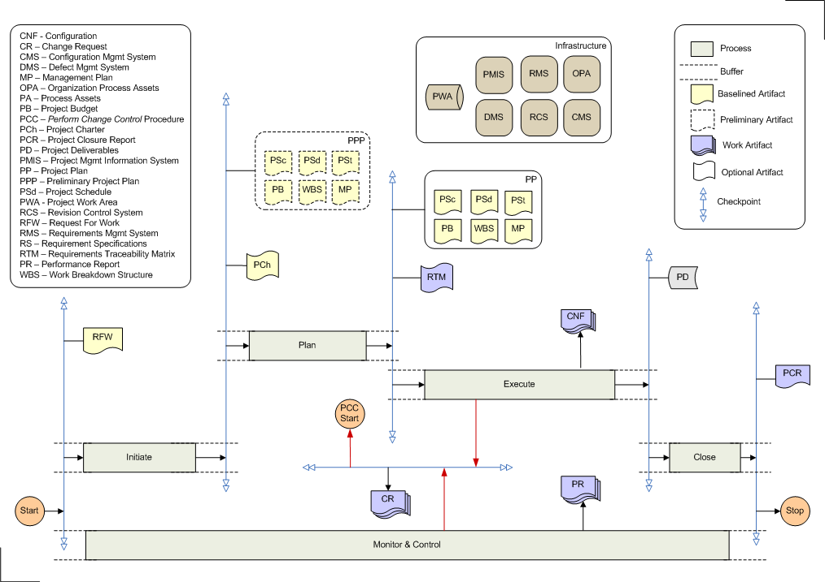

|  |  |  |
| --- | --- | --- |
| **Step** | **Role** | **Action** |
| 1 | DH,PL,PC | **Initiate Project.** Define the preliminary scope, strategy, WBS, schedule, and budget for the project. If required, develop preliminary management plans for human resources, quality, risks, procurements, and communications. The goal is to come up with the estimates so that decisions can be made about the feasibility of the project. The resulting documents from this step are the Preliminary Project Plan and the Project Charter (optional). |
| 2 | PL,PC | **Plan for Project.** Refine the scope, strategy, WBS, schedule, budget, and management plans developed in the previous step. These refinements result in the Project Plan. The requirements are optionally tracked using the Requirements Traceability Matrix (RTM). RTM may not be used for smaller projects. RTM tracks the owner, design, test, and implementation of a requirement. |
| 3 | Project Team | **Execute Project.** (For software projects) Elicit detailed requirements; architect design, code, integrate, test, and release the software solution. For each release, create the configuration that includes:   * requirement specifications * design documentation * test plans * information on development environment (compilers, platform, IDE, build scripts etc) * information on operating environment (platform, configuration files etc) * the released package (executables, installation manual, user manual etc)   Any major changes to scope result in Change Requests, and have to be processed through the Change Control Procedure. |
| 4 | PL,PC | **Close Project.** Formally complete the project by finalizing all its activities. Review that the project objectives are met. Develop the Project Closure Report by documenting lessons learned, customer feedback, and project performance. |
| 5 | PL,PC | **Monitor and Control Project.** Periodically check the progress of the project, ascertain its performance, evaluate risks, inform stakeholders, and take corrective actions. This step starts any time after the start of the project and goes on till almost the end.    Any changes to scope, cost, or schedule result in Change Requests, and are processed by the Change Control Procedure. |

# Outputs

* Project Deliverables. For a software project this includes everything that is needed to make the software solution work. It includes but is not limited to:
  + The Executables
  + Installation Manual
  + User Manual
* Project Artifacts:
  + Preliminary Project Plan
  + Project Charter (optional)
  + Project Plan
  + Requirements Traceability Matrix (optional)
  + Performance Reports
  + Product Configurations
  + Change Requests
  + Project Closure Report

# Exit Criteria

The Work Order is closed.

# Exceptions

All exceptions must be approved by the Electronics Department Head.

# References

* 1. *M01 NSCL Electronics Department ISMS Manual*, NSCL Document Server, Electronics Folder
  2. *P501 Information Security Policy,* NSCL Document Server, Electronics Folder
  3. *P1201 Information Systems Acquisition, Development, and Maintenance Policy*, NSCL Document Server, Electronics Folder
  4. *W1201 Software Development Roles and Responsibilities*, NSCL Document Server, Electronics Folder

# Revision History

|  |  |  |
| --- | --- | --- |
| Revision  Level | Date | Revision Changes |
|  |  |  |

# Reviews

|  |  |
| --- | --- |
| Reviewer | Review Date |
| Information Security Working Group |  |

**Approved**

**Department Head:** ________________________________

**Approval Date: ________________ Effective Date: ________________**