# Purpose

To define the preliminary scope, strategy, WBS, schedule, and budget for the project, and if required, to develop preliminary management plans for human resources, quality, risks, procurements, and communications. The goal is to come up with the estimates so that decisions can be made about the feasibility of the project.

# Scope

It is applicable to all users of the Electronics Department.

# Definitions

In this document, information security related terms have been marked in *underlined* *italics*. For their definitions, refer to the standard *EE-ISMS-S001 Terms and Definitions*.

For software development related roles and acronyms, refer to *W1201 Software Development Roles and Responsibilities*.

# Entry Criteria

A Request for Work (RFW) has been received.

# Inputs

* The RFW. The RFW may not be very formal but must be a written artifact preferably in electronic format. It could be a document, a form, or an email; a verbal request does not qualify as a RFW. Sometimes a Work Order is the initiation point for a project; in such cases the Work Order itself is the RFW.

# Procedure

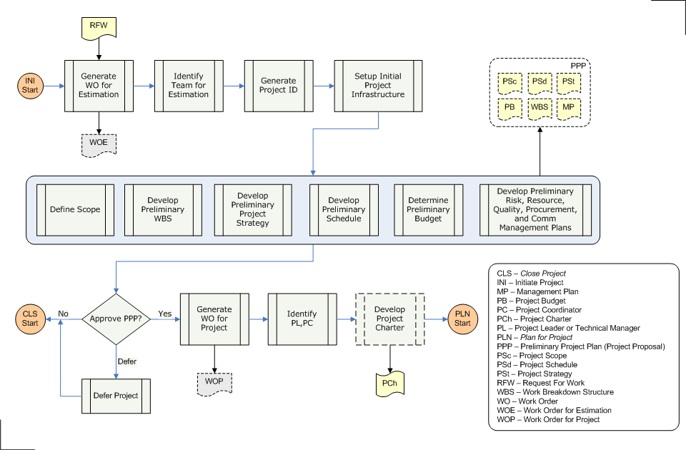

|  |  |  |
| --- | --- | --- |
| **Step** | **Role** | **Action** |
| 1 | Customer | Generate a Work Order, unless the RFW itself was a Work Order. The effort for estimation activities must be posted against this Work Order. |
| 2 | DH | Identify the team that will perform the roles of PL, PC in estimating the cost and schedule for the project. This team may be different from the team that will actually execute the project. |
| 3 | PC | Generate a Project ID (PJID). The PJID will be used to refer to the project throughout its life cycle. Follow the Naming Standard for the new PJID. |
| 4 | PC | Create the initial infrastructure required for the project. This includes the file-system area, version control system module, project management system entry etc. Create only those portions that are needed for estimation, the rest can be created in subsequent procedures. |
| 5 | PL,PC | Perform the steps 5.1 through 5.6 iteratively. For the first iteration, steps 5.1 through 5.5 are performed in a sequence, and after that they are performed in parallel. While executing these activities, fill-in the relevant portions of the Preliminary Project Plan (PPP) document. There are two goals to this exercise: to come up with the estimates, and to develop the PPP. The activities at this stage are preliminary in nature; detailed planning is performed in the Plan Project procedure. |
| 5.1 | PL,PC | Define Scope |
| 5.2 | PL,PC | Develop Preliminary WBS |
| 5.3 | PL,PC | Develop Preliminary Project Strategy |
| 5.4 | PL,PC | Develop Preliminary Schedule |
| 5.5 | PL,PC | Determine Preliminary Budget |
| 5.6 | PL,PC | Develop Preliminary human resource, quality, risk, communication, and procurement plans. Plan for risks and include contingencies in the plan. Refer to Risk-based Contingency Methodology document. |
| 6 | PL,PC | Inform the Sponsor that PPP is complete (recall that Sponsor is generally the Department Head). |
| 7 | Sponsor | Based on PPP, lab's goals, available resources, and various other factors, approve, reject, or defer the project. |
| 8.1 | Customer, Sponsor, PL, PC | If the project is approved, generate the Work Order for the project. This process is described in the 'Preliminary Project Plan Approval' document. |
| 8.2 | PL,PC | If the project is rejected, follow the relevant activities from the Close Project procedure. |
| 8.3 | PL,PC | If the project is deferred, add the project to the Deferred Project List, and then follow the relevant activities from the Close Project procedure. |
| 9 | Sponsor | Identify the team that will perform the roles of PL and PC in executing the project. If it is different from the current team, release the current team. |
| 10 | PL,PC | (optional) Develop Project Charter and get it approved by the Sponsor. |

# Outputs

* The Work Order for estimation (WOE)
* The Work Order for the project (WOP)
* The Preliminary Project Plan (PPP)
* (optional) The Project Charter (PC)

# Exit Criteria

Work Order for the project has been generated, or the project has been terminated.

# Exceptions

All exceptions must be approved by the Electronics Department Head.

# References

* 1. *M01 NSCL Electronics Department ISMS Manual*, NSCL Document Server, Electronics Folder
  2. *P501 Information Security Policy,* NSCL Document Server, Electronics Folder
  3. *P1201 Information Systems Acquisition, Development, and Maintenance Policy*, NSCL Document Server, Electronics Folder
  4. *W1201 Software Development Roles and Responsibilities*, NSCL Document Server, Electronics Folder

# Revision History

|  |  |  |
| --- | --- | --- |
| Revision  Level | Date | Revision Changes |
|  |  |  |

# Reviews

|  |  |
| --- | --- |
| Reviewer | Review Date |
| Information Security Working Group |  |

**Approved**

**Department Head:** ________________________________

**Approval Date: ________________ Effective Date: ________________**