# Purpose

The purpose of this procedure is to plan for the project by refining the scope, WBS, schedule, budget, and management plans.

# Scope

It is applicable to all users of the Electronics Department.

# Definitions

In this document, information security related terms have been marked in *underlined* *italics*. For their definitions, refer to the standard *EE-ISMS-S001 Terms and Definitions*.

For software development related roles and acronyms, refer to *W1201 Software Development Roles and Responsibilities*.

# Entry Criteria

The project Work Order has been generated.

# Inputs

* The Preliminary Project Plan (PPP)
* (optional) The Project Charter.

# Procedure

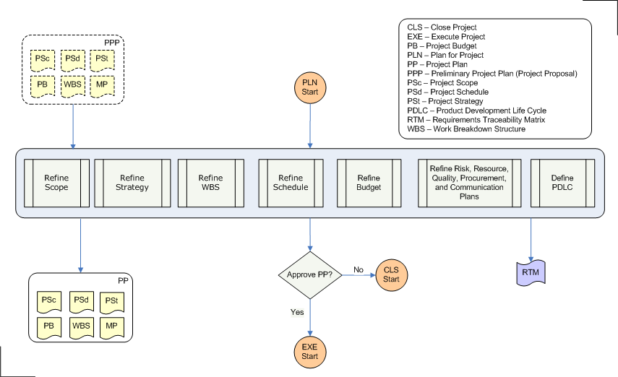

|  |  |  |
| --- | --- | --- |
| **Step** | **Role** | **Action** |
| 1 | PL,PC | Perform Steps 1.1 through 1.7 iteratively. While performing these steps, write the relevant (sub) documents that form the project plan (you may start with PPP, and refine it to result in PP). |
| 1.1 | PL,PC | Refine Scope |
| 1.2 | PL,PC | Refine WBS |
| 1.3 | PL,PC | Refine Project Strategy |
| 1.4 | PL,PC | Refine Schedule |
| 1.5 | PL,PC | Refine Budget |
| 1.6 | PL,PC | Refine Preliminary human resource, quality, risk, communication, and procurement plans. |
| 1.7 | PL,PC | Define the Product Development Life Cycle (PDLC). Describe how the deliverables of this project will be developed. The development life cycle depends on various parameters: criticality, requirements clarity, effort, customer participation etc. This activity may not be essential for some projects but is crucial for software-related projects. |
| 2 | PL,PC | Submit the PP for Sponsor's approval (Sponsor is the person financing the project). |
| 3 | Sponsor | Based on PP, lab's goals, available resources, and various other factors and analyses, approve, or reject the project. |
| 3.1 | PL,PC | If the PP is approved, proceed to Execute Project procedure. Otherwise, perform the relevant activities from Close Project procedure. |

# Outputs

* The Project Plan

# Exit Criteria

The Project Plan has been approved.

# Exceptions

All exceptions must be approved by the Electronics Department Head.

# References

* 1. *M01 NSCL Electronics Department ISMS Manual*, NSCL Document Server, Electronics Folder
  2. *P501 Information Security Policy,* NSCL Document Server, Electronics Folder
  3. *P1201 Information Systems Acquisition, Development, and Maintenance Policy*, NSCL Document Server, Electronics Folder
  4. *W1201 Software Development Roles and Responsibilities*, NSCL Document Server, Electronics Folder

# Revision History

|  |  |  |
| --- | --- | --- |
| Revision  Level | Date | Revision Changes |
|  |  |  |

# Reviews

|  |  |
| --- | --- |
| Reviewer | Review Date |
| Information Security Working Group |  |

**Approved**

**Department Head:** ________________________________

**Approval Date: ________________ Effective Date: ________________**