# Purpose

The purpose of this procedure is to develop the solution by executing the project.

# Scope

It is applicable to all users of the Electronics Department.

# Definitions

In this document, information security related terms have been marked in *underlined* *italics*. For their definitions, refer to the standard *EE-ISMS-S001 Terms and Definitions*.

For software development related roles and acronyms, refer to *W1201 Software Development Roles and Responsibilities*.

# Entry Criteria

The Project Plan has been approved..

# Inputs

* The Project Plan.

# Procedure

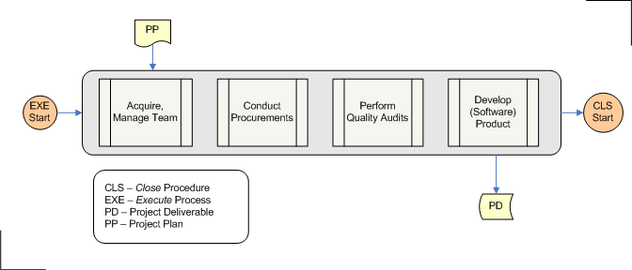

|  |  |  |
| --- | --- | --- |
| **Step** | **Role** | **Action** |
| 1 | PL,PC | Execute the following steps, 1.1 thru 1.4. Based on the project, you may execute them in a sequence or in parallel. You may need to execute some of them multiple times during the project life cycle, whereas some of them can be optional. |
| 1.1 | PL,PC | Acquire and manage resources. The loading and releasing of resources is outlined in the Project Plan. Acquire and release the resources as per the plan. |
| 1.2 | PL,PC | Conduct procurements. Evaluate the bids, and select the vendors, according to the Procurement Plan which is part of the Project Plan. |
| 1.3 | QM,PL,PC | Perform Quality Audits. Conduct quality audits periodically, and check if the processes are being adhered too. This step enforces compliance with the prescribed processes (Quality Assurance). Inspection and testing of the deliverables (Quality Control) is done as part of the Monitor and Control procedure. |
| 1.4 | Project Team | Develop product. Construct the product or execute the service (if product is a service). Analyze, design, build, release, deploy, and test the product. Verify the project deliverables with the Customer. Perform configuration management. This process for a software product is described in the Develop Software Product procedure. |

# Outputs

* The Product Package

# Exit Criteria

The Project Deliverables has been approved by the Customer.

# Exceptions

All exceptions must be approved by the Electronics Department Head.

# References

* 1. *M01 NSCL Electronics Department ISMS Manual*, NSCL Document Server, Electronics Folder
  2. *P501 Information Security Policy,* NSCL Document Server, Electronics Folder
  3. *P1201 Information Systems Acquisition, Development, and Maintenance Policy*, NSCL Document Server, Electronics Folder
  4. *W1201 Software Development Roles and Responsibilities*, NSCL Document Server, Electronics Folder

# Revision History

|  |  |  |
| --- | --- | --- |
| Revision  Level | Date | Revision Changes |
|  |  |  |

# Reviews

|  |  |
| --- | --- |
| Reviewer | Review Date |
| Information Security Working Group |  |

**Approved**

**Department Head:** ________________________________

**Approval Date: ________________ Effective Date: ________________**