# Purpose

The purpose of this procedure is to monitor the progress of the project, report it to the stakeholders, and take corrective actions if required..

# Scope

It is applicable to all users of the Electronics Department.

# Definitions

In this document, information security related terms have been marked in *underlined* *italics*. For their definitions, refer to the standard *EE-ISMS-S001 Terms and Definitions*.

For software development related roles and acronyms, refer to *W1201 Software Development Roles and Responsibilities*.

# Entry Criteria

The project has been initiated. The starting point is flexible; the procedure can start any time after the project has started but it has to start by the time Execute Project procedure commences.

# Inputs

* The Project Plan.

# Procedure

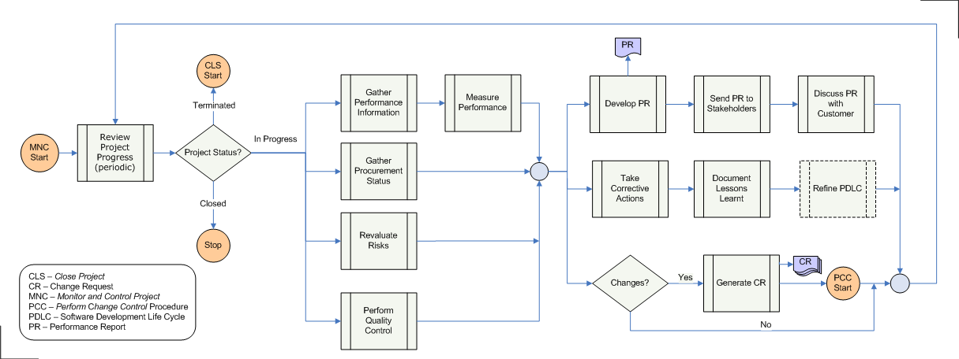

|  |  |  |
| --- | --- | --- |
| **Step** | **Role** | **Action** |
| 1 | PC | Periodically execute the following steps. |
| 2 | PC | Review project's progress. |
| 2 | PC | If the project is complete then stop. If the project is terminated, without completion, initiate the Close Project procedure. |
| 3.1 | PC | Collect performance data, and measure the project's performance. Use the Earned Value Management (EVM) methodology for performance measurement. |
| 3.2 | PC | If any part of the work was performed by a supplier, review the status of the work. The periodicity of the supplier review may be different from that of the current (Monitor and Control) procedure. |
| 3.3 | PC | Reevaluate the risks identified (in Project Plan). check the risk factors have changed. |
| 3.4 | QM | Perform quality control. Measure and analyze the deliverables against the quality metrics. Check if the results are within the control limits. |
| 4.1 | PC | Develop the Performance Report based on the output from previous steps. Distribute PR to the stakeholders, and discuss it with the Customer. |
| 4.2 | PL,PC | Depending on the results from previous steps, take corrective actions. |
| 4.3 | PL,PC | Document the lessons learned. The lessons will eventually become part of the Project Closure Report. |
| 4.2 | PL,PC | Refine the Product Development Life Cycle (PDLC) parameters. |
| 4.3 | PL,PC | Does the project require a change, in its scope, schedule, budget, or any other aspect? If so, create a Change Request, and follow the Change Control procedure. |

# Outputs

* Project Performance Report
* Change Requests

# Exit Criteria

Project has been closed; either it is complete or terminated. The end point is flexible; the procedure may stop before the project has closed but it cannot end before the Execute Project procedure has finished.

# Exceptions

All exceptions must be approved by the Electronics Department Head.

# References

* 1. *M01 NSCL Electronics Department ISMS Manual*, NSCL Document Server, Electronics Folder
  2. *P501 Information Security Policy,* NSCL Document Server, Electronics Folder
  3. *P1201 Information Systems Acquisition, Development, and Maintenance Policy*, NSCL Document Server, Electronics Folder
  4. *W1201 Software Development Roles and Responsibilities*, NSCL Document Server, Electronics Folder

# Revision History

|  |  |  |
| --- | --- | --- |
| Revision  Level | Date | Revision Changes |
|  |  |  |

# Reviews

|  |  |
| --- | --- |
| Reviewer | Review Date |
| Information Security Working Group |  |

**Approved**

**Department Head:** ________________________________

**Approval Date: ________________ Effective Date: ________________**