# Purpose

The purpose of this procedure is to review all change requests, analyze their impact, and approve/disapprove them.

# Scope

It is applicable to all users of the Electronics Department.

# Definitions

In this document, information security related terms have been marked in *underlined* *italics*. For their definitions, refer to the standard *EE-ISMS-S001 Terms and Definitions*.

For software development related roles and acronyms, refer to *W1201 Software Development Roles and Responsibilities*.

# Entry Criteria

One or more Change Requests (CR) have been received.

# Inputs

* Change Request

# Procedure

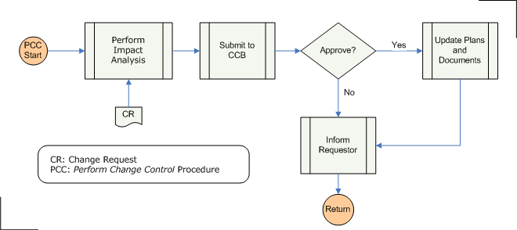

|  |  |  |
| --- | --- | --- |
| **Step** | **Role** | **Action** |
| 1 | PC | Analyze the impact of the change to the project, in terms of cost and schedule. |
| 2 | PC | Submit the CR with the Impact Analysis to the Change Control Board (CCB) for approval. |
| 3 | CCB | Based on cost and benefits, either approve or disapprove the change. |
| 4 | PC | If approved, re-evaluate scope, schedule, budget, and strategy; update the Project Plan. |
| 5 | PC | Inform the requester (of the CR) of the decision. |

# Outputs

* Impact Analysis
* CCB decision
* Updated project documents (Project Plan etc)

# Exit Criteria

The CR has been approved or disapproved.

# Exceptions

All exceptions must be approved by the Electronics Department Head.

# References

* 1. *M01 NSCL Electronics Department ISMS Manual*, NSCL Document Server, Electronics Folder
  2. *P501 Information Security Policy,* NSCL Document Server, Electronics Folder
  3. *P1201 Information Systems Acquisition, Development, and Maintenance Policy*, NSCL Document Server, Electronics Folder
  4. *W1201 Software Development Roles and Responsibilities*, NSCL Document Server, Electronics Folder

# Revision History

|  |  |  |
| --- | --- | --- |
| Revision  Level | Date | Revision Changes |
|  |  |  |

# Reviews

|  |  |
| --- | --- |
| Reviewer | Review Date |
| Information Security Working Group |  |

**Approved**

**Department Head:** ________________________________

**Approval Date: ________________ Effective Date: ________________**