# Purpose

The purpose of this procedure is to construct the software solution. It is based on both predictive and adaptive Software Development Life Cycle (SDLC) models. It uses a dynamic SDLC model, where the process can be adaptive at the beginning and morph into a predictive one by the later stages of the development.

# Scope

It is applicable to all users who develop software for the Electronics Department.

# Definitions

In this document, information security related terms have been marked in *underlined* *italics*. For their definitions, refer to the standard *EE-ISMS-S001 Terms and Definitions*.

For software development related roles and acronyms, refer to *W1201 Software Development Roles and Responsibilities.*

# Entry Criteria

The Project Plan has been approved.

# Inputs

The project plan.

# Procedure

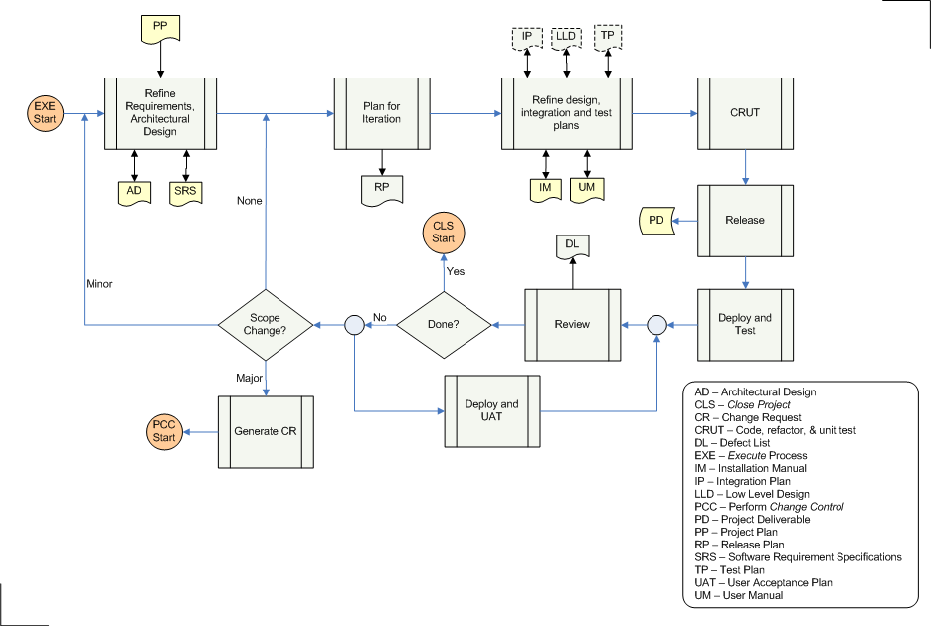

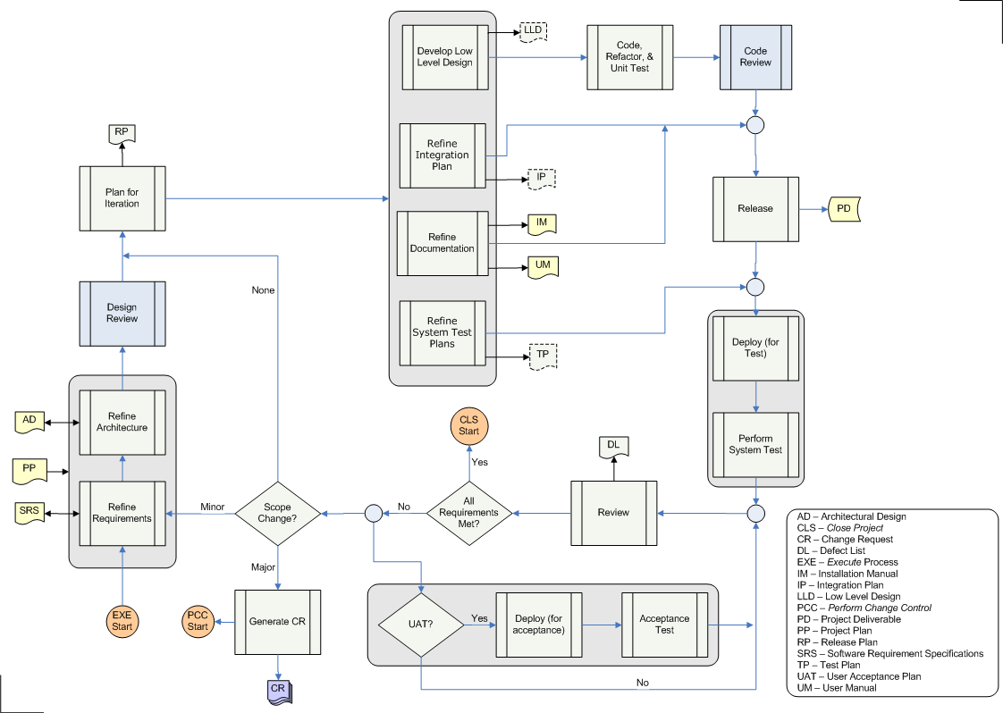

|  |  |  |
| --- | --- | --- |
| **Step** | **Role** | **Action** |
| 1 | PL,PC | Starting with the project scope (from the Project Plan), develop and refine the project requirements in detail. This results in the Software Requirement Specifications (SRS). |
| 2 | PL,DES | Using the project strategy described in the Project plan and SRS, develop and refine the high-level design for the software. The output from this activity is the Architecture Design (AD). |
| 3 | PL,PC,DES,DEV | Review the architecture design with peers from this and other projects. This step need not be done in every iteration. |
| 4 | PL,DES,PC | Plan for the next iteration. The output of this activity is the Release Plan (RP) which includes the following:   * Release ID * The software requirements that will be fulfilled in this iteration * The release schedule * The team * The team meeting schedule * Will User Acceptance Test (UAT) be performed? |
| 5 | PL | Execute the following steps (Steps 5.x), in parallel: |
| 5.1 | DES,DEV | Develop or refine the detailed design, resulting in the Low Level Design (optional). |
| 5.2 | DES,RE | Refine the integration steps. Output of this activity is the Integration Plan (optional). |
| 5.3 | DOC | Develop or refine the documentation. The Installation and User Manuals are mandatory. Any other documentation is optional, and is based on the project scope. |
| 5.4 | DES,QM,TE,RE | Develop or refine the system-level testing strategy. The output of this activity is the system-level Test Plan (optional). |
| 6 | DEV | Based on LLD, code, refactor, and test programs. |
| 7 | PL,PC,QM,DEV,DES | Review the programs with peers. Check for standards, quality, and design compliance. |
| 8 | RE | Wait for the Integration Plan and Documentation. Integrate, build, and release the package. This is further detailed in the Release Product process. The output from this activity is the deliverable for the current iteration. |
| 9 | TE | Wait for the system-level Test Plan, if needed. Use the Installation Manual to deploy the software solution in the test environment. |
| 10 | TE | Test the software according to the system-level Test Plan, SRS, and User Manual. |
| 11 | PL,PC | Review the results from the system test. The output from this activity is the Defect List (DL). |
| 12 | PL,PC,Customer | Is the project done? This could be based on any of the following conditions:   * All the requirements have been met and verified with the Customer * The project's goal was to meet as many requirements as possible in a given period, and the time has run out * The project was to deliver as many requirements as possible for the given budget, and the finances have run out * The project is terminated |
| 13 | PL | Does this release require UAT? If so, then send the PD to the Customer. UAT can proceed in parallel with the rest of the process. |
| 13.1 | AE | Deploy the software solution in Customer's environment, either test or production. |
| 13.2 | AE | Test the software for correctness and completeness. Defects are gathered and reported to the PL/PC; they will get fixed in the next iteration. |
| 14 | PC | Are there any changes in the scope?   * If none, then plan for the next iteration (Step 4) * If the changes are minor, then refine the requirements (Step 1) * If the changes are major, Generate a Change Request (CR), and perform Change Control process   The differentiation between major and minor changes must be agreed upon by PL, PC, and the Customer. What constitutes a major or a minor change is described in the Project Plan (Change Control). |

# Outputs

* The Project Deliverables that include the executables, installation manual, user manual, configuration files etc. The deliverables are specified in the Project Plan

# Exit Criteria

The Project Deliverables have been approved by the Customer.

# Exceptions

All exceptions must be approved by the Electronics Department Head.

# References

* 1. *M01 NSCL Electronics Department ISMS Manual*, NSCL Document Server, Electronics Folder
  2. *P501 Information Security Policy,* NSCL Document Server, Electronics Folder
  3. *P1201 Information Systems Acquisition, Development, and Maintenance Policy*, NSCL Document Server, Electronics Folder
  4. *W1201 Software Development Roles and Responsibilities*, NSCL Document Server, Electronics Folder

# Revision History

|  |  |  |
| --- | --- | --- |
| Revision  Level | Date | Revision Changes |
|  |  |  |

# Reviews

|  |  |
| --- | --- |
| Reviewer | Review Date |
| Information Security Working Group |  |

**Approved**

**Department Head:** ________________________________

**Approval Date: ________________ Effective Date: ________________**