# Purpose

The purpose of this procedure is to integrate, build, package, and then release the software product.

# Scope

It is applicable to all users who develop software for the Electronics Department.

# Definitions

In this document, information security related terms have been marked in *underlined* *italics*. For their definitions, refer to the standard *EE-ISMS-S001 Terms and Definitions*.

For software development related roles and acronyms, refer to *W1201 Software Development Roles and Responsibilities*.

# Entry Criteria

The release components (source code, documents etc) have been completed.

# Inputs

* Source Code
* Documents: Installation Manual, User Manual etc
* Release Identifier.

# Procedure

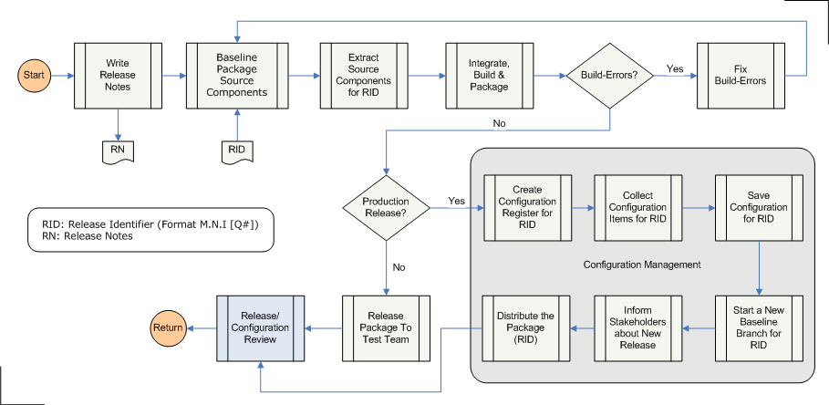

|  |  |  |
| --- | --- | --- |
| **Step** | **Role** | **Action** |
| 1 | RE | Write the Release Notes. It should include the following:   * Release ID (RID) * System Requirements * Supported platforms/environments * Changes from last release * Known defects |
| 2 | RE | Baseline all the objects needed to make the software solution. This includes the source code, documents including the Release Notes, configuration files etc. Identify the baseline with the Release ID (RID).  If using a version control system, like CVS, this simply involves tagging the entire module with a tag that is based on the RID. |
| 3 | RE | Extract all the baselined source components which are identified by the RID.  If using a version control system, like CVS, this simply involves exporting the entire module using the RID-based tag. |
| 4 | RE | * Integrate the source components in the desired structure * Build the executables and deliverables from the source components * Package the deliverables. This is generally done using Zip, tar, MSI, InstallShield, APT, RPM etc. |
| 5 | RE | If there were any errors in the previous step, fix the errors, and repeat the process from Step 1. If using a version control system, like CVS, it may be necessary to remove the tag used in Step 2. |
| 6 | RE | A release can be a production release that gets sent to the Customer, or a test release for system-level testing or User Acceptance Testing (UAT). If it is a production release follow Steps 7.x, otherwise inform the appropriate test team of the new release. |
| 7.1 | PC | Create the Configuration Register for this release. It includes the following:   * Release ID * The platform details: hardware, Operating System version, DBMS version etc * Development environment details: compiler versions, libraries and their versions etc |
| 7.2 | PC | Collect the configuration items for this release. The configuration items are described in the project plan, and generally include:   * The RFW * The Project Charter * The Project Plan * The Project Deliverables * The internal documents: SRS, Architecture Design, Low Level Design, Test Plans etc * All approved Change Requests |
| 7.3 | PC | Save and archive the configuration collected in the previous step. |
| 7.4 | PC | Initiate a development branch on the baseline for this release. If using a version control system, like CVS, it is accomplished by creating a branch in the source tree for this release. |
| 7.5 | PC | Inform the stakeholders of the new production release. |
| 7.6 | PC | Distribute the package for this release (created in Step 4). |
| 8 | QM,PC | Review the release and configuration processes. This includes:   * Making sure that the configuration includes all configuration items * Package contains Installation Manual, Release Notes etc * Branching is done properly |

# Outputs

* The Product Package
* The Configuration (for Production Releases only)

# Exit Criteria

The Product Package has been released.

# Exceptions

All exceptions must be approved by the Electronics Department Head.

# References

* 1. *M01 NSCL Electronics Department ISMS Manual*, NSCL Document Server, Electronics Folder
  2. *P501 Information Security Policy,* NSCL Document Server, Electronics Folder
  3. *P1201 Information Systems Acquisition, Development, and Maintenance Policy*, NSCL Document Server, Electronics Folder
  4. *W1201 Software Development Roles and Responsibilities*, NSCL Document Server, Electronics Folder

# Revision History

|  |  |  |
| --- | --- | --- |
| Revision  Level | Date | Revision Changes |
|  |  |  |

# Reviews

|  |  |
| --- | --- |
| Reviewer | Review Date |
| Information Security Working Group |  |

**Approved**

**Department Head:** ________________________________

**Approval Date: ________________ Effective Date: ________________**