|  |  |  |
| --- | --- | --- |
|  |  |  |

Proteus: Calibration – User Manual

Version 0.5

|  |  |
| --- | --- |
|  |  |
|  |  |
|  |  |
|  |  |

Revision History

|  |  |  |  |
| --- | --- | --- | --- |
| Version | Date | Author | Description |
| 0.5 | 6/16/2015 | VV | Initial |
|  |  |  |  |
|  |  |  |  |
|  |  |  |  |
|  |  |  |  |

Table of Contents

1 Introduction 5

1.1 Purpose 5

1.2 Definitions, Acronyms, and Abbreviations 5

1.3 Overview 5

2 Work Flows 5

2.1 Manage Model 6

2.2 Manage Device 6

2.3 Manage Calibration Record 7

2.4 Browse 7

3 PCT in Depth 8

List of Figures and Tables

**No table of figures entries found.**

Table 1 Definition, Acronyms, and Abbreviations 5

# Introduction

Proteus: Calibration System (PCT) is a software system to manage calibration for devices at NSCL/FRIB. It provides the following features:

* Device Management: Information about devices or equipment that needs to calibrated. This includes model, serial number, location, and custodian.
* Model Management: Information about device models. This includes manufacturer, manual, and calibration cycle.
* Calibration Record Management: Calibration records for a device
* Reminders: Users are notified, via email, of upcoming and past due calibrations.

## Purpose

Purpose of this document is to describe the operation of PCT.

## Definitions, Acronyms, and Abbreviations

Table Definition, Acronyms, and Abbreviations

|  |  |
| --- | --- |
| Item | Description |
| Device | An entity that needs to be calibrated. |
| Equipment | Synonym for *device.* We are slowly replacing the term *equipment* with *device* to in conformance with FRIB nomenclature. |
| FRIB | Facility for Rare Isotope Beam. |
| Model | A type of *device*. There can be several devices of the same model. |
| NSCL | National Superconducting Cyclotron Lab. |
| PCT | Proteus: Calibration System. |
| PCT URL | The URL of PCT, https://controls.frib.msu.edu/calib/ |
| Standard | A device that is used for calibrating other devices. |

## Overview

The *Work Flows* section describes the common work-flows that you will use. The *PCT in Depth* section goes into details of PCT.

# Work Flows

The following major work-flows are supported by PCT:

* Manage Model: How to create, edit, and delete a device model
* Manage Device: How to create, edit, and delete a device
* Manage Calibration Record: How to create and delete a calibration record for a device
* Browse: Browse devices and their Calibrations

## Manage Model

1. Open the PCT URL in a browser
2. Login to the system by clicking on the Login button
3. 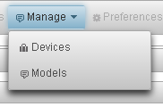Refresh the page
4. Click on menu item Manage -> Models. This will display the Manage Models Page.
5. 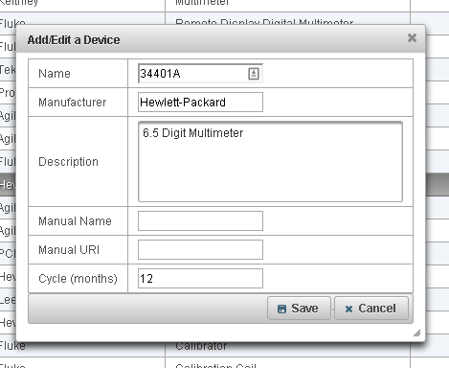To add a model, click on ‘Add’ button at the bottom. This will display a window to add or edit a model.
   1. Enter the Name, Manufacturer, Description, and calibration cycle in months. If the model has an online manual, you can enter its name and URL.
   2. Once done, click on Save.
6. To edit a model, select the model by clicking on it. You can filter the models through the filter fields on the header. Once selected, click on ‘Edit’ button at the bottom.
   1. Modify the Name, Manufacturer, Description, Manual, or calibration cycle.
   2. Once done, click on Save.
7. To delete a model, select the model by clicking on it. You can filter the models through the filter fields on the header. Once selected, click on ‘Delete button at the bottom. You will be asked for confirmation. You cannot delete a model that has devices associated with it.

## Manage Device

1. Open the PCT URL in a browser
2. Login to the system by clicking on the Login button
3. Refresh the page
4. Click on menu item Manage -> Devices. This will display the *Manage Devices* page.
5. To add a device, click on ‘Add’ button at the bottom. This will display a window to add or edit a device.
   1. 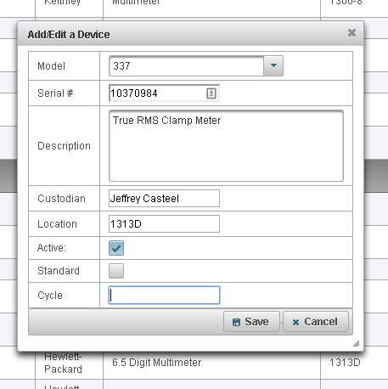Enter the Model, Serial Number, Description, Custodian, and Location. Check the box to indicate if the device is active or has been retired. Indicate if the device is a calibration standard. By default, the calibration cycle of the model is used for a device. However, you can override the calibration cycle by entering it in the ‘Cycle’ field.
   2. Once done, click on Save.
6. To edit a device, select the device by clicking on it. You can filter the devices through the filter fields on the header. Once selected, click on ‘Edit’ button at the bottom.
   1. Enter the Model, Serial Number, Description, Custodian, and Location. Check the box to indicate if the device is active or has been retired. Indicate if the device is a calibration standard. By default, the calibration cycle of the model is used for a device. However, you can override the calibration cycle by entering it in the ‘Cycle’ field.
   2. Once done, click on Save.
7. To delete a device, select the device by clicking on it. You can filter the devices through the filter fields on the header. Once selected, click on ‘Delete’ button at the bottom. You will be asked for confirmation. You cannot delete a device that has associated calibration records.

## Manage Calibration Record

1. Open the PCT URL in a browser
2. 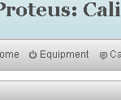Login to the system by clicking on the Login button
3. Refresh the page
4. Click on menu item *Equipment*.
5. Find the device for which calibration records have to be added or deleted. You may use the filtering fields in the header or browse the pages.
6. Click on the calibration icon in the left most column. This will display all the calibration records associated with the device.
7. To add a device, click on ‘Add’ button at the bottom. This will display a page to add a calibration record.
   1. 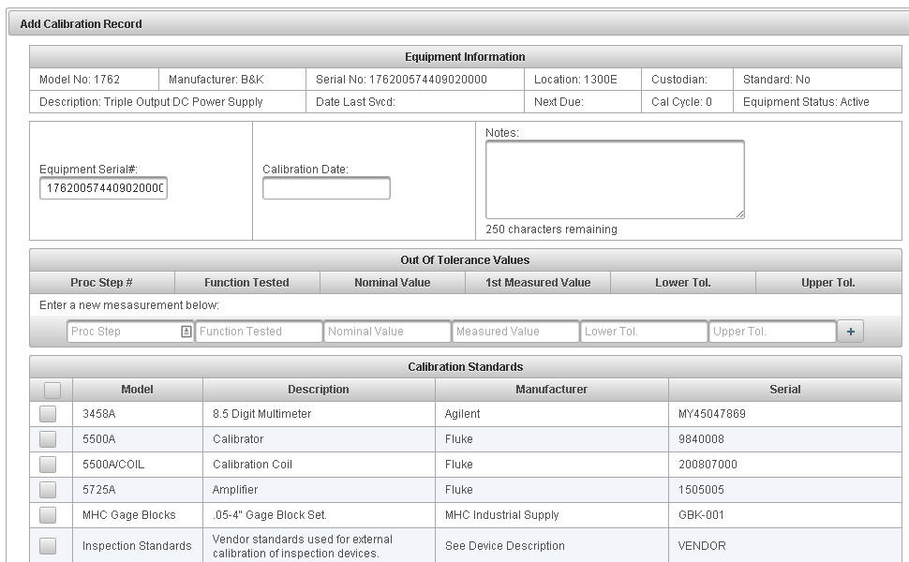Enter the Calibration Date and Notes. Add ‘Out of Tolerance values’, if any. Choose the standards used for calibration from the list at the bottom of the page.
   2. Once done, click on Save.
8. To delete a calibration record, click on the Delete icon next to it.

## Browse

1. Open the PCT URL in a browser
2. You can browse calibration records in two ways: *Equipment* Menu or *Calibrations* Menu. Click on the *Equipment* menu.
3. Use the filtering fields in the header or browse the pages to locate the desired device.
4. Click on the calibration icon in the left most column. This will display all the calibration records associated with the device.
5. 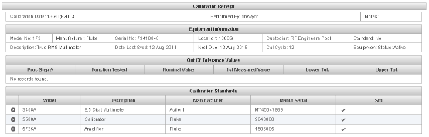Click on ‘View’ icon next to the calibration. This will display the calibration record.
6. To browse all calibration records for all devices, click on *Calibrations* menu. Click on View icon to display the corresponding calibration record.

# PCT in Depth

This section is still under development.