 | Facility for Rare Isotope Beams  U.S. Department of Energy Office of Science | Michigan State University  East Lansing, MI 48824-1321 • Ph: (517) 355-9672 • Fax: (517) 353-5967  www.frib.msu.edu

Hour Log – Schema Design
Version 1.0.0

 | Name | Signature | Date
Prepared By | Vasu Vuppala
Reviewed By
Approved By
Revision History

Version | Date | Author | Description
V1.0.0 | 3/3/15 | Vasu V | Initial

Table of Contents
1 Introduction 6
1.1 Purpose 6
1.2 Scope 6
1.3 Definitions, Acronyms, and Abbreviations 6
1.4 References 7
1.5 Overview 7
2 Conceptual Model 7
2.1 Concepts 8
2.1.1 Configuration 8
2.1.2 Components 9
2.1.3 Component Types 10
2.1.4 Example 10
2.1.5 Inventory 10
2.1.6 Component Information 11
2.1.7 Signals 12
2.1.8 Security 12
2.2 Entities 12
2.3 Relationships 13
3 Logical Model 15
3.1 Component Representation 15
3.2 Schema 16
3.2.1 Abstract Logical-Components 17
3.2.2 Attributes and Properties 17
3.2.3 Design Parameters, Measurements 17
3.3 Component Relationships 17
4 Physical Model 18
4.1 Data Types 18
4.2 Generic Values 18
4.3 Relationships 18
4.4 Table Descriptions 19
4.5 Attributes and Properties 25
4.6 Challenges 25
4.6.1 Modeling Assemblies/Compositions 25
4.6.2 Real vs Virtual 25
Appendix A – Notation 27

List of Figures and Tables
Figure 1 FRIB Systems 8
Figure 2 FRIB LINAC Segment 1 9
Figure 3 Component Type, Logical Component, and Physical Component 11
Figure 4 Logical Model 16
Figure 5 Tables-Relationships 19
Figure 6 Notation Example 27

Table 1 Definition, Acronyms, and Abbreviations 6
Table 2 Entities 12

Introduction
.

Purpose
The objective of this document is to describe the schema of the database associated with the Configuration Module.

Scope

Definitions, Acronyms, and Abbreviations

Table 1 Definition, Acronyms, and Abbreviations
Item | Description
EPICS | Experimental Physics and Industrial Control System
ERD | Entity-Relationship Diagram
FRIB | Facility for Rare Isotope Beam
ACDB | FRIB Controls Global Database
ACDM | Accelerator Controls Database Model
ACDS | Accelerator Controls Data Services
IOC | Input/Output Controller
IRMIS | Integrated Relational Model of Installed Systems
PV | Process Variable. Identifier for a data item in EPICS.
RDBMS | Relational Database Management System
UML | Unified Modeling Language

References
- Facility for Rare Isotope Beam, “FRIB Parameters”, FRIB Portal, https://portal.frib.msu.edu, 2011
- Facility for Rare Isotope Beam , “FRIB Naming Convention”, FRIB Portal, https://portal.frib.msu.edu, 2011
- Facility for Rare Isotope Beam , “FRIB Expanded Lattice”, FRIB Portal, https://portal.frib.msu.edu, 2011
- Facility for Rare Isotope Beam , “FRIB Data Requirements”, FRIB Portal, https://portal.frib.msu.edu, 2011
- NSCL, “Control System Information Architecture”, NSCL, 2011
- Don Dohan, IRMIS Design Document, 7/7/2011
- Integrated Relational Model of Installed Systems, IRMIS, http://irmis.sourceforge.net
- Spallation Neutron Source, “SNS Global Database Schema”, http://snsapp1.sns.ornl.gov/SNS_Data_Model/index.htm, 2011
- DISCS Handbook, http://

Overview

Conceptual Model
This section describes the various concepts that are useful in modeling an accelerator facility as an information system.

Concepts

Configuration
An accelerator facility’s configuration defines its layout: the various systems, sub-systems, devices, and relationships amongst them. For example, FRIB’s configuration is broken into segments such as Front End, LINAC Segment 1, Folding Segment 1, LINAC Segment 2 and Folding Segment 2, as shown in Figure 1. Each segment is further divided into sub-segments, and then into devices, as shown in Figure 2.
Figure 1 FRIB Systems
Figure 2 FRIB LINAC Segment 1

Components
A component is any entity the accelerator facility’s configuration: magnet, power supply, cavity, rack, room, controller etc. Components can be looked at in different ways, and have different kinds of information associated with them: design data, measurements, test data, alignment information, physical characteristics etc. For our modeling concerns, we define two kinds of components:
- Physical-Component: This represents physical entities; things that exist in the real world. A physical-component has identifiers that can identify it, and has attributes that can be measured and calibrated. For example, the cavity with part number T30802-MDE-0008 that was manufactured by Jefferson Lab is a physical-component. A physical-component has attributes such as measurements, traveler data, manufacturer etc.
- Logical-Component: It represents the entities that exist on the blueprint or configuration of the Accelerator facility. A small part of FRIB’s configuration is shown in Figure 2; the various elements in the figure are Logical-Components. For example, elements with FRIB-identifiers LS1_CA01:CAV1_D1093 and LS1_CA01:CAV2_D1101 are Logical-Components, at positions 1093 and 1101 respectively on LINAC Segment #1. Logical-Components are not limited to the entities on the blueprint of the accelerator configuration; see the Section Abstract Logical-Components for details.

Component Types
Components, both physical and logical, are classified into types. A Component Type represents a generic component and its design. For example, there can be several horizontal electrostatic dipoles with the same characteristics i.e. they are interchangeable; in such case the common characteristics are denoted by a Component Type, ‘Horizontal Electrostatic Dipole Type I’. A Component Type is a conceptual entity; Physical Components are its manifestation in the real world, and Logical Components are the manifestations on the blueprint. Component types have a hierarchy. For example, QM1 is a quadrupole which is a magnet.

Example
These concepts are illustrated in Figure 3. Cavity-A is a Component-Type; it has attributes such as design parameters, CAD drawings etc. The cavities LS1_CA01:CAV1_D1093 and LS1_CA01:CAV2_D1101 are Logical-Components on FRIB’s LINAC Segment #1 at positions 1093 and 1101 respectively. They have attributes such as distance from the source, optical properties etc. However, they share the design parameters and CAD drawings of the Component Type, Cavity-A. At the bottom of the figure, the cavity with serial number T30802-MDE-0008, which is manufactured by Jefferson Labs, is a Physical-Component. It also shares its design attributes with the Component Type Cavity-A. It can be installed at either position 1093 or 1101 of the LINAC segment #1. Let us say it is installed at position 1101; it now represents the Logical-Component LS1_CA01:CAV2_D1101. But at a later date, it can be moved and installed at position 1093 to represent the Logical-Component LS1_CA01:CAV1_D1093.

Inventory
Physical-Components form the inventory. Physical-components that are not installed (i.e. not linked to a Logical-Component) are the spares.
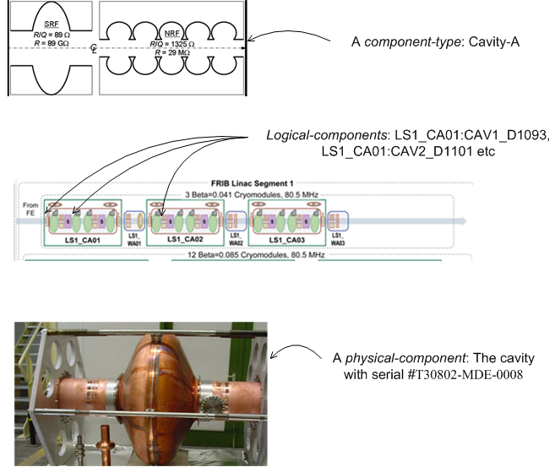
Figure 3 Component Type, Logical Component, and Physical Component

Component Information
A large amount of information is associated with components:
- Design Parameters: The data used for designing the component
- Measurements: After their fabrication, components are tested and measured to verify their conformance with the design. The measured attributes are different for different device types. The measured data is very different for different measurement methodologies applied on the same device. The raw measurement data associated with a device is processed to derived the measured property of the device. The derived data is also in different formats, but is generally in the form of a polynomial.
- Alignment: Components on the beamline must be aligned, as per their design, on a three dimensional coordinate system. Once a component is installed on the beamline, it is aligned to a specific coordinate system. Components are periodically realigned to correct for minor changes in their alignment. At a high-level, only a limited number of attributes, related to alignment, need to be stored: the global X, Y, Z coordinates. The raw data associated used to derive this information

Signals

Security
The entire facility is divided into areas. Each area has an Area Manager who is responsible for its operation. Only the area manager is allowed to modify the configuration data associated with the corresponding area.

Entities
Table 2 Entities
Name | Definition | Examples
Area | A group of Logical-Components. | Vacuum, Cryogenics, Experimental System
Area Manager | Person responsible for an area.
Calibration | Comparison of measurements of a physical device with those of a standard device
Component | An entity in the accelerator facility. It could be device such as magnet, or a non-physical entity such as LINAC segment. | Cavity. Cryomodule. Power supply, Magnet, Rack, Room.
Component Type | A type of component. See next section for further explanation. | Horizontal electrostatic quadrupole. BPM.
Component Relationship | A binary relationship between Logical Components. | Magnet M1 is powered by power supply PS1.
Configuration | The layout of the accelerator facility. Logical Components + Relationships among them. See next section for further explanation.
Design Parameter | Property associated with a Component Type | Effective Length, CAD Drawing
Logical Component | An entity on the blueprint of the accelerator facility. It is placeholder for a Physical Component. See next section for further explanation.
Lattice | A sequence of Beamline Elements (Logical Components in the beamline) with their settings.
Layout | Physical arrangement of the Logical Components. A set of Segments.
Measurement | A property associated with a Physical Component. | Magnetic Field
Physical Component | A real-world physical entity of an accelerator facility. It is eventually installed at a Logical Component. See next section for further explanation. | Magnet with serial number xxx.
Property | An attribute associated with a Component Type, Logical Component, or Physical Component. | Effect Length, Bending Angle, CAD Drawing, Field Image
Segment | An ordered set of Logical Components | Beamlines, Front Ends
Signal | A controls input/output associated with a Logical Component.

Relationships
A Logical-Component is implemented from a Component-Type i.e. it borrows its design elements from the Component-Type. Similarly, a physical-component is manufactured based a Component-Type. During installation process, a Physical-Component becomes the physical representation of a Logical-Component
Which of the three kinds of the components described above should be used for the relationships that exist among and with components? Most of such relationships are represented using the Logical-Components and not the physical-components. The model, lattice, control system, configuration layout, housing, power and control groups, security, etc are all represented using Logical-Components. They are independent of the actual physical-component. However, information such as measurements, calibrations, maintenance, travelers are related to physical components, and hence are linked to physical-components.
- A Logical-Component is associated with one and only one Component-Type
- A Physical-Component is associated with one and only one Component-Type
- A Logical-Component is associated with zero or one Physical-Component
- A Component-Type has zero or more Properties. A Property may be associated with zero or more Component-Types.
- A Component-Type may have a more generic Component-Type associated with it (as its super type).
- A Logical-Component has zero or more Properties. A Property may be associated with zero or more Logical-Components.
- A Physical-Component has zero or more Properties. A Property may be associated with zero or more Physical-Components.
- A Logical-Component can have zero or more alignment records.
- Two Logical-Components may be associated each other through one or more Relationship. Example: Power supply PS1 powers the magnet QM1.
- A Physical-Component may be composed of one or more other Physical-Components.
- A Physical-Component may be calibrated by one or more of other Physical-Components (standards). A Physical-Component (standard) may calibrate zero or more other Physical-Components.

Logical Model

Component Representation
There are two ways to model components:
- A class or entity type per Component-Type. There will be several entity types: Magnet, Cavity, Power Supply, Segment etc. Each entity type will be mapped to its physical representation (tables in Relational Model).
- An object (or entity instance) per Component-Type. There will be three entity types: one each for Logical-Components, Physical-Components, and Component-Types.
The problem with the first approach is that it will result in too many entity types and they keep on growing, which will require changes to the schema. The second approach solves this problem by having a single entity type for all Logical (Physical) components. But how to represent the different attributes of the various real-world component with one entity type? It is inefficient and sometimes impossible to associate all the attributes with one entity type. A solution to this is to have the attributes as Properties (Key-Value pairs). Based on the component type, an entity instance will have different properties associated with it. With this approach, associating entities (JOIN operation in RDB) based on attribute-values will be inefficient, and may lead to performance degradation. After analyzing the pros and cons of the two approaches, we have chosen the second method.
Figure 4 Logical Model

Schema
Figure 4 shows the logical model of the database. A Logical-Component is based on exactly one Component-Type. Similarly, a Physical-Component is also based on exactly one Component-Type. However, there can be many Logical-Components and Physical-Components that are implemented based on a single Component-Type. A Physical-Component is associated (during installation) at the most with one Logical-Component; it is not associated with any when it is a spare. Similarly, a Logical-Component is related to at the most one Physical-Component; it may not be related to any. When a Physical-Component is installed and gets linked to a Logical-Component, both the Physical-Component and Logical-Component must be based on the same Component-Type.
Logical-Component, Physical-Component, and Component-Type have Properties. Logical-Component has zero or more Signals.

Abstract Logical-Components
The concept of Logical-Components can be extended to represent other entities in a configuration that may not be on the facility’s blueprint. Examples of such Logical-Components are:
- Group of Physical-Components such as a segments or beamlines
- High-level virtual physics devices that are implemented in software
- Beam modes
Such Logical-Components that do not have a physical manifestation (i.e. they are not linked to any Physical-Component) are marked as ‘Abstract’.

Attributes and Properties
Attributes of the Logical-Components, Physical-Components, and Component-Types keep changing. This is more so during development and commissioning of the machine, but continues into operations. Also, different accelerator facilitates would have their own attributes. Changing the database schema often results in a large effort to modify the related services and/or applications. So only the core attributes are kept in the schema, and the rest are stored as properties (key-value pairs).

Design Parameters, Measurements
Measurements are dependent on the Component-Type, measurement methodology, vendor etc. Similarly design parameters are specific to the design team and Component-Type. Such data cannot be modeled by a fixed schema. Hence they are modeled as properties (key-value pairs).

Component Relationships
Two Logical-Components can be associated with each other through various relationships. Relationships are also generalized, the same way as Logical-Components are. We do not identify or represent specific relationships in the logical model. They are represented by Component-Relationship entity. The relationships are assumed to be binary.
A Physical-Component may be composed of other Physical-Components. This relationship is represented by a one-to-many association (UML Composition).
Note that the assembly relationship among components (say a cryomodule and its cavities and solenoids) is duplicated at both at as-designed (among Logical-Components) and as-built (among Physical-Components) layers. During installation (uninstallation), the Logical and Physical Components have to be associated (disassociated) accordingly.

Physical Model
Relational Model is used for this module. Figure 5 shows the tables and relationships in the model. The tables are described in the next section. The SQL schema definition is available online at .

Data Types
As explained in the previous section, attributes are represented by key-value pairs. A side-effect of this choice is that attributes cannot be associated with specific DBMS data types. Because attributes are represented with key-values pairs, all the values have to be of the same type. It is possible to have a fixed number of data types associated with each property but it is not efficient or workable. So it was decided to have attribute values as generic type that can accommodate large values. MySQL provides two such data types: BLOB and TEXT (with their ‘larger’ versions). Currently, TEXT is used but it may be changed in the future.

Generic Values

Relationships
The relationships among Logical-Components are implemented through two tables: component_relation and component_pair. The ‘component_relation’ table stores information about the relationships: their IDs, names etc. The ‘component_pair’ table links two Logical-Components with a relationship. It has three (foreign-key) fields; two containing Logical-Component primary keys, and one containing relationship primary key (from component_relation).
The hierarchical composition relationship among Physical-Components is implemented by a field in the Physical-Component that points to the primary key of the parent Physical-Component.
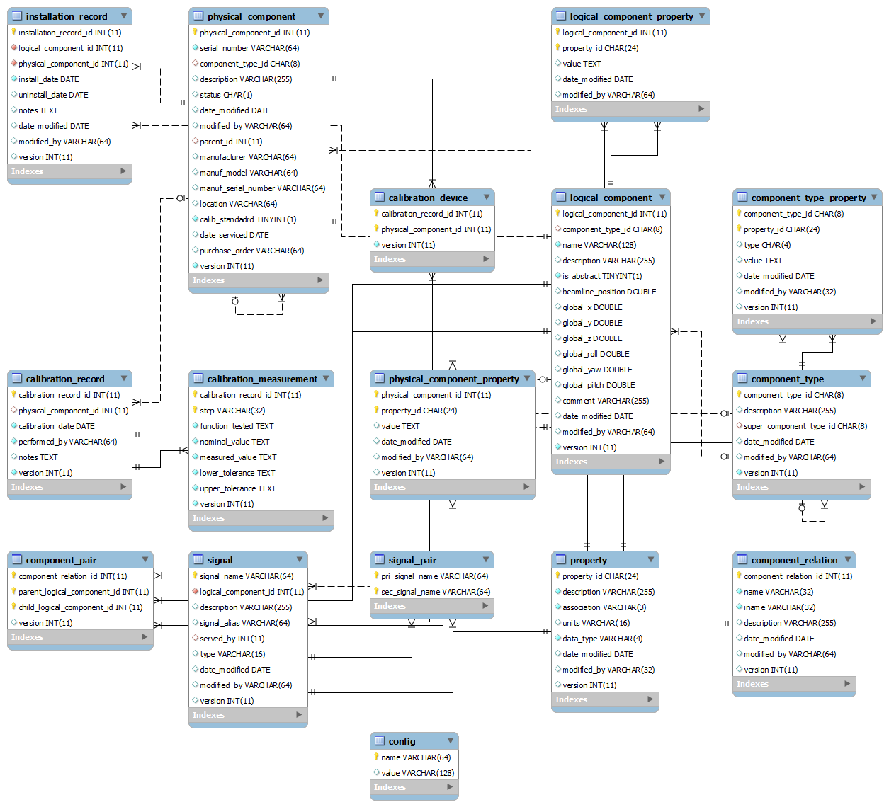
Figure 5 Tables-Relationships

Table Descriptions
Most of the tables have a column named ‘version’ which is used for optimistic concurrency control.
Table Name | calibration_device
Description | Each row is a device used in a calibration
Attribute | Description
calibration_record_id | The calibration record
physical_component_id | The standard used

Table Name | calibration_measurement
Description | Each row is a measurement made in a calibration
Attribute | Description
calibration_record_id | The calibration record
step | The step identifier
function_tested | The tested function in the step
nominal_value | The nominal value
measured_value | The measured value
lower_tolerance | Lower bound on tolerance
upper_tolerance | Upper bound on tolerance

Table Name | calibration_record
Description | Each row represents a calibration
Attribute | Description
calibration_record_id | Unique identifier for the calibration
physical_component_id | Physical component being calibrated
calibration_date | Date of calibration
performed_by | Person who performed the calibration
notes | Comments

Table Name | component_pair
Description | Each row represents a pair of Logical-Components that are related through a relationship (as defined in component_relation).
Attribute | Description
component_relation_id | The relationship
parent_logical_component_id | The parent Logical-Component
child_logical_component_id | The child Logical-Component

Table Name | component_relation
Description | Each row represents a binary relationship (among Logical Components).
Attribute | Description
component_relation_id | Unique identifier
name | Name of the relationship. Example: contains, powers, controls etc
iname | Name of the inverse relationship. Example: contained-in, powered-by, controlled-by etc
description | Description
date_modified | Date the row was last modified
modified_by | Name of the person who last modified the row

Table Name | component_type
Description | Each row represents a Component-Type.
Attribute | Description
component_type_id | Unique identifier
description | Description
super_component_type_id | Super type (more general type)
date_modified | Date the row was last modified
modified_by | Name of the person who last modified the row

Table Name | component_type_property
Description | Each row represents the value of a property of a Component-Type.
Attribute | Description
component_type_id` | The Component-Type
property_id | The property
value | Value of the property
date_modified | Date the row was last modified
modified_by | Name of the person who last modified the row

Table Name | config
Description | Each row represents a key-value pair. They can be used for initialization or configuration of this module. Examples: (‘schema_version’, ‘1.0’), (‘default_relationship’, ‘contains’).
Attribute | Description
name | Name of the key
value | Value of the key

Table Name | installation_record
Description | Each row represents an installation record. It links a Physical-Component to a Logical-Component.
Attribute | Description
installation_record_id | Unique identifier
logical_component_id | The Logical-Component
physical_component_id | The Physical-Component that got installed.
install_date | Date of installation
uninstall_date | Date of un-installation
notes | Installation notes
date_modified | Date the row was last modified
modified_by | Name of the person who last modified the row

Table Name | logical_component
Description | Each row represents a Logical-Component.
Attribute | Description
logical_component_id | Unique identifier
component_type_id | Component-Type associated with this Logical-Component
name | Name of the Logical-Component.
description | Description
is_abstract | True, if the Logical-Component does not have physical representation (cannot be associated with a Physical-Component).
beamline_position | Position on the beamline
global_x, global_y, global_z | As-designed global coordinates (alignment)
global_roll, global_yaw, global_pitch | As-designed global coordinates (alignment)
comment | Comments
date_modified | Date the row was last modified
modified_by | Name of the person who last modified the row

Table Name | logical_component_property
Description | Each row represents the value of a Logical-Component’s property.
Attribute | Description
logical_component_id | The Logical-Component
property_id | The property
value | The value of the property
date_modified | Date the row was last modified
modified_by | Name of the person who last modified the row

Table Name | physical_component
Description | Each row represents a Physical-Component
Attribute | Description
physical_component_id | Unique identifier
serial_number | Serial number of the Physical-Component
component_type_id | The associated Component-Type
description | Description
status | f - in fabrication  t - under testing  p – under repair  r - ready (in use)  s - spare
parent_id | Parent physical component (in an assembly)
manufacturer | Manufacturer
manuf_model | Manufacturer model
manuf_serial_number | Manufacturer serial number
Location | Location, if component is not installed
calib_standadrd | Is this a standard (calibration)?
date_serviced | Last date of service
Purchase_order | Purchase Order information
date_modified | Date the row was last modified
modified_by | Name of the person who last modified the row

Table Name | physical_component_property
Description | Each row represents the value of a Logical-Component’s property.
Attribute | Description
physical_component_id | The Physical-Component
property_id | The property
value | The value of the property
date_modified | Date the row was last modified
modified_by | Name of the person who last modified the row

Table Name | property
Description | Each row represents a property. It can be related to a Component-Type, Logical-Component, or Physical-Component
Attribute | Description
property_id | Unique identifier
description | Description
association | T - The property is only for Component Types. For example, CAD drawing.  L - The property is only for Logical Component  P - The property is only for Physical Component  PT - The property is for both Physical Component and Component Type  LP - The property is for both Logical and Physical Components
units | Units of measurement
data_type | Normative data type
date_modified | Date the row was last modified
modified_by | Name of the person who last modified the row

Table Name | signal
Description | Each row represents a control signal associated with a Logical-Component
Attribute | Description
signal_name | Unique identifier
logical_component_id | Th Logical-Component
description | Description
Signal_alias | Another name for the signal
served_by | The IOC that services it
type | Signal type
date_modified | Date the row was last modified
modified_by | Name of the person who last modified the row

Table Name | signal_pair
Description | Each row represents a pair of related signals. The primary signal controls the secodary signal.
Attribute | Description
pri_signal_name | Primary signal
sec_signal_name | Secondary signal

Attributes and Properties
Attributes of the classes defined in ACDM keep changing. This is more so during development and commissioning of the machine, but continues into operations. Also, different labs would want to have their own attributes (assuming that we share our effort with other labs). Changing the database schema often can result in large efforts to incorporate the changes into the services and/or applications. So it appears that it will be better to have only the core attributes in the schema, and have the rest of the attributes as properties (key-value pairs). This has drawbacks. It will be cumbersome to query across tables using properties (say, joining tables using a property value).

Challenges

Modeling Assemblies/Compositions

Real vs Virtual
The data in ACDB will be useless if it does not accurately represent the real-world Accelerator facility. At the same time, generally it is not possible to keep the real machine and the virtual one in sync. For example, the operator needs a power supply but there are none in the inventory. So the operator uses a power-supply that is being used for another component but does not change the configuration in ACDB. There are several ways to ensure the synchronization between the virtual and real worlds:
- Develop procedures to streamline structural changes to the machine
- Develop an application to check for the integrity of the data in ACDB
- Find ways to automatically update the configuration in ACDB if there is change in real-world configuration
- Develop very intuitive and easy-to-use tools for modifications to ACDB

Appendix A – Notation

Figure 6 Notation Example
- E2[1..m] - E3[0..n] means:
  - An instance of E2 can be related to 0 or more instances of E3
  - An instance of E3 can be related to 1 or more instances of E2
- E2[1..1] - E3[0..n] means:
  - An instance of E2 can be related to 0 or more instances of E3
  - An instance of E3 can be related to exactly one instance of E2
- E2[3..6] - E3[2..5] means:
  - An instance of E2 can be related to 2 to 5 instances of E3
  - An instance of E3 can be related to 3 to 6 instances of E2

It is not an exact duplicate because not all physical components in the assembly need be associated with a logical component. We need not have logical representations of all physical components.

