Hour Log: Data Migration Guide

FRIB-WBS-SUB-000000-RXXX

Issued 9 January 2013

Prepared by Reviewed by



Reviewed by Approved by



Concurred Concurred



# Table of Contents

Table of Contents 1

Revision History 1

Authorizing Document 1

Authorized Documents 1

Authorized Committees and Boards 1

1 Introduction 2

2 Data Mapping 2

2.1 Scope 4

3 Definitions and References 4

3.1 .Acronyms and Definitions 4

4 References 4

Appendix – A 5

# Revision History

|  |  |  |
| --- | --- | --- |
| Revision | Issued | Changes |
|  | Click here to enter date | Click here to enter revision(s) |

# Authorizing Document

A FRIB document **Error! Reference source not found.** (*if applicable; see section [**Error! Reference source not found.**]).

# Authorized Documents

None.

# Authorized Committees and Boards

None.

# Introduction

This document describes migration of data from Current Hour Log (CHL) to the New Hour Log (NHL).

# Data Mapping

Current Hour Log gets its data from various lab-wide databases. NHL has a different schema and uses other external systems, such as Olog, for storing its data. Table 1 lists the tables used by Current Hour Log, and the destination for the migration for their data. Only a portion of the data from a CHL table may be migrated to its destination, or data in a table may be split across multiple destinations. Table 2 shows this at a more granular level.

Table 1 Table Descriptions

|  |  |  |
| --- | --- | --- |
| Current Hour Log Table  (Schema.Table) | Description | Destination |
| HourLog.logDetails | Log entries | Olog and NHL |
| HourLog.logChanges | Changes to log entries | Olog and NHL |
| HourLog.notes | Actual text of the log entry. logDetails.notesID has points to this table. | Olog |
| HourLog.changedNotes | Actual text of changes to a log entry. logChanges.notesID points to the entry here. | Olog |
| HourLog.docs | Attachments to a log entry: Trouble Report and Images. Has the log entry ID. ‘docID’ column is either TR number or id of the image in contribImages. | Image into Olog. TR number into NHL. |
| Staff.Employees | All employees, old and current. | Olog author.  All info into NHL. |
| Staff.Person | Current employees | NHL |
| HourLog.userInfo | Abbreviated names of users who are permitted to write to Hour Log. | NHL |
| HourLog.summaries | Facility status codes and description (EXR, UOF etc) | NHL |
| HourLog.people | Operations staff members | NHL |
| HourLog.peopleShift | Shift information | NHL |
| HourLog.breakdownCategories | Breakdown categories | NHL |
| HourLog.breakdowns | Breakdown events | NHL |
| HourLog.beams | Beams (element, energy, charge etc) | NHL |
| HourLog.beamSystems | Beam Systems (K500, K1200 etc) | NHL |
| HourLog.elements | Physics elements | NHL |
| HourLog.smsTelco | SMS Provider | NHL |
| ApprovedExperiments.Experiments | Experiments | Cache in NHL through new interface |
| Training.* | Training information | New interface |
| UsersDb.* | User authorization | NHL |
| imageContrib.images | Images attached to log entries | Olog |

Table 2 Data Mapping

|  |  |  |  |
| --- | --- | --- | --- |
| Current Hour Log | | Description | Destination |
| Table Name | Column Name |
| HourLog.logDetails | ocrDateTime | Log entry creation time | Olog |
| HourLog.logDetails | UserID | Log entry author. UserID is a number. Actually login-id is stored in Staff.Persons but cannot get it for old employees. | Olog. Store UserID instead of Login-ID |
| HourLog.logDetails | NoteID | Pointer to the text of the log entry. |  |
| HourLog.notes | Id,notes | Actual text of the log entry | Olog |
| HourLog.logChanges | ocrDateTime | Log change time | Olog |
| HourLog.logChanges | UserID | Author of the log change | Olog. Store numerical id. |
| HourLog.logChanges | NoteID | Pointer to text of log change |  |
| HourLog.changedNotes | Id, notes | Actual text of log change | Olog |
| HourLog.docs | logId, docId, type | Pointer to attachments of a log entry (Type = IMG only). |  |
| imageContrib.images | Id,status,image,imageType | Actual image stored as blob. Status must be ‘accepted’. | Olog (image and image type) |
|  |  |  |  |
|  |  |  |  |
|  |  |  |  |
|  |  |  |  |
|  |  |  |  |
|  |  |  |  |
|  |  |  |  |
|  |  |  |  |
|  |  |  |  |

## Log Entries

* Each row in logDetails table is a ‘Log Detail’. Each row in logChanges table is a ‘Log Change.
* Copy all notes to log_entry table. Use the occurrence date and reporting date from logDetails table.
* Copy all Note Changes to log_entry table. Add a base number to all Note Change IDs.
* For each Log Entry

# Definitions and References

## .Acronyms and Definitions

|  |  |
| --- | --- |
| **Acronym** | **Description** |
| ASD | Accelerator System Division |
| CHL | Current Hour Log |
| CM | Cryomodule |
| EPICS | Experimental Physics and Industrial Control System |
| ESD | Experiment System Division |
| FAT | Field Acceptance Test |
| FPS | Fast Protection System |
| FRIB | Facility for Rare Isotope Beams |
| GUI | Graphical User Interface |
| GTS | Global Timing System |
| HLA | High Level Applications |
| HMI | Human Machine Interface |
| I/O | Input / Output |
| IOC | EPICS Input/Output Controller. |
| IPMI | Intelligent Platform Management Interface |
| MPS | Machine Protection System |
| NA or n/a | Not Applicable |
| NHL | New Hour Log |
| PLC | Programmable Logic Controller |
| PPS | Personnel Protection System |
| PV | Process Variable |
| RDB | Relational Database |
| RDBMS | Relational Database Management System |
| RPS | Run Permit System |
| SBC | Single Board Computer |
| TCP/IP | Transmission Control Protocol/Internet Protocol |

# References

1. Hour Log Software Requirement Specifications
2. Hour Log Architectural Design

# Appendix – A

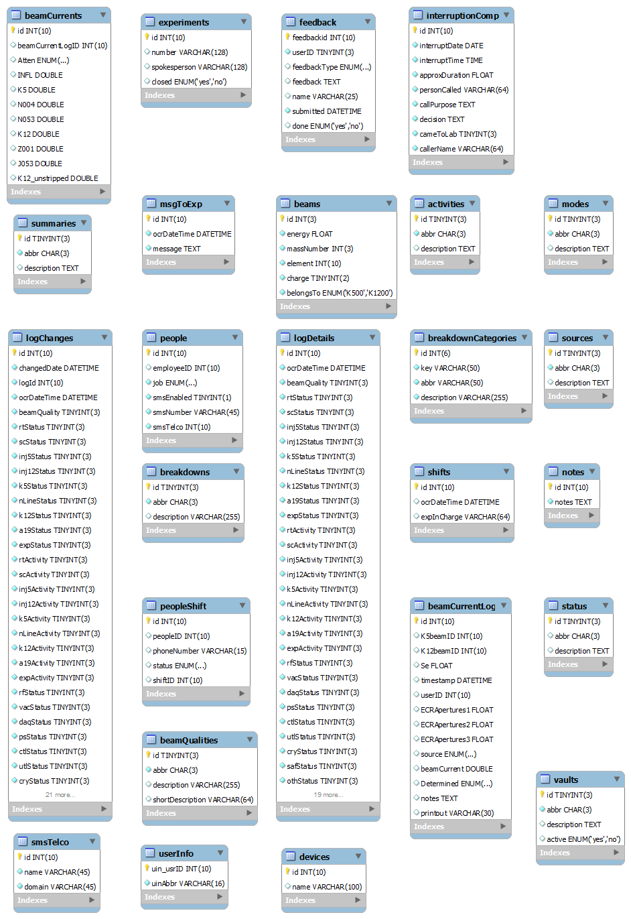

Figure 1 HourLog Schema

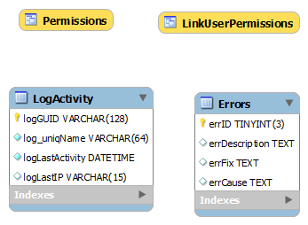

Figure 2 UserDB Schema

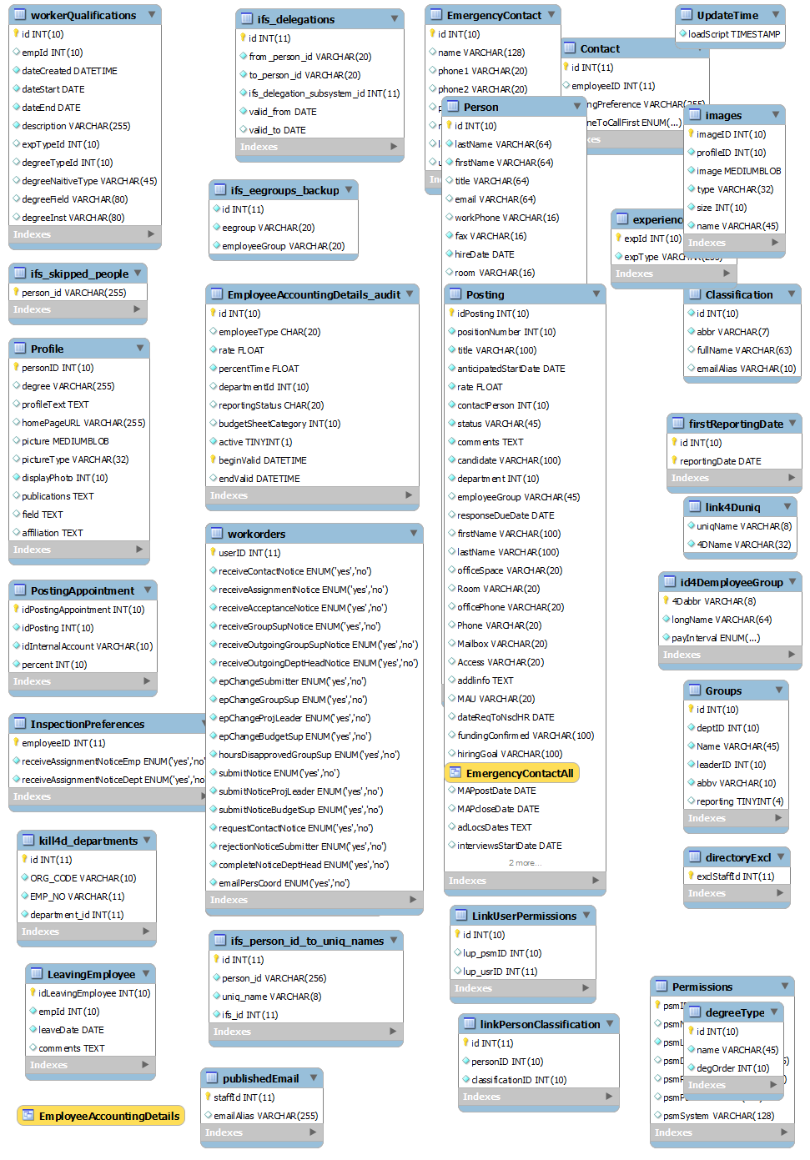

Figure 3 Staff Schema

Table 3 Approved Experiments Schema

