|  |  |  |
| --- | --- | --- |
| nscl.PNG | National Superconducting Cyclotron Laboratory | MSU-Wordmark-PMS-567.eps |

Hour Log – Approved Experiments Interface Specifications

|  |  |
| --- | --- |
|  |  |
| Project Name | Hour Log |
| Project Code |  |
| Account |  |
| Department |  |
| Project Leader |  |
| Project Coordinator |  |

|  |  |  |  |
| --- | --- | --- | --- |
|  | Name | Signature | Date |
| Prepared By |  |  |  |
| Reviewed By |  |  |  |
| Approved By |  |  |  |

Revision History

|  |  |  |  |
| --- | --- | --- | --- |
| Version | Date | Author | Description |
|  |  |  |  |
|  |  |  |  |
|  |  |  |  |
|  |  |  |  |
|  |  |  |  |
|  |  |  |  |

Table of Contents

1 Introduction 4

1.1 Purpose 4

1.2 Scope 4

1.3 Definition, Acronyms, and Abbreviations 4

1.4 References 4

1.5 Overview 4

2 Overall Description 4

2.1 Product Perspective 4

2.1.1 System Interfaces 5

2.1.2 User Interfaces 5

2.1.3 Hardware Interfaces 5

2.1.4 Software Interfaces 5

2.1.5 Communications Interfaces 5

2.1.6 Memory Constraints 5

2.1.7 Operations 5

2.1.8 Site-adaptation Requirements 5

2.2 Product Functions 5

2.3 User Characteristics 5

2.4 General Constraints 5

2.5 Assumptions and Dependencies 5

3 Specific Requirements 5

3.1 External Interfaces 5

3.2 Functions 6

3.3 Performance Requirements 6

3.4 Design Constraints 6

3.5 Software System Attributes 6

3.6 Other Requirements 6

Appendix A: Use Cases 7

List of Figures and Tables

Table 1 Glossary 4

# Introduction

Hour Log application is used by the Operations Department at National Superconducting Cyclotron Laboratory (NSCL) to manage activity log, facility status, system breakdowns, shift change, and to generate reports for funding agencies. A new version of Hour Log is being implemented to enhance functionality, improve maintainability, and to allow extensibility. The new version will interface with several external systems: Approved Experiments, Trouble Reports, Logbook, and Configuration Database.

## Purpose

The purpose of this document is to capture requirements for Hour Log’s interface to Approved Experiments. It is intended for the following audience:

* Members of the Computer Department that will implement the interface to Approved Experiments; they need to make sure that the requirements are accurate and feasible.
* Members of the Controls and Computing Department; they need to make sure that the requirements are accurate and complete.

## Scope

The new version of Hour Log, referred to simply as Hour Log from now on, needs read-only access to all the approved experiments.

## Definition, Acronyms, and Abbreviations

Table 1 Glossary

|  |  |
| --- | --- |
| Item | Description |
|  |  |
|  |  |
|  |  |
|  |  |
|  |  |
|  |  |
|  |  |
|  |  |

## References

## Overview

# Overall Description

## Product Perspective

Hour Log tracks facility status and system breakdowns against scheduled experiments. This information is used to measure a facility’s performance and quality objectives, which is reported to the funding agencies and management. Hour Log does not manage the experiments; it is done by the Approved Experiments system. Hour Log interfaces with Approved Experiments to get to the list of approved experiments for the current and past years.

### System Interfaces

Hour Log shall interface with Approved Experiments using a RESTful interface.

### User Interfaces

None

### Hardware Interfaces

None

### Software Interfaces

See Section 2.1.1

### Communications Interfaces

See Section 2.1.1

### Memory Constraints

None

### Operations

None

### Site-adaptation Requirements

None.

## Product Functions

The desired interface shall provide a list of approved experiments.

## User Characteristics

The users of the interface are familiar with REST architectural style.

## General Constraints

## Assumptions and Dependencies

# Specific Requirements

This section contains all the software requirements with sufficient detail so as to enable designers to design a system that meets the requirements.

## External Interfaces

None.

## Functions

|  |  |  |  |
| --- | --- | --- | --- |
| ID | Description | By | Comments |
| AEI-F01 | The interface shall provide a list of all approved experiments with at least the following details for each experiment:   * Experiment Number * Experiment Title * Experiment Description * Approved Date * PAC Number * Hours Approved * Completion Date * Spokesperson * A1900 Contact | Vuppala V |  |
| AEI-F02 | It shall be possible to filter the experiments on:   * Experiment number * Approved Date range * Completed/not-completed (optional) | Vuppala V |  |
| AEI-F03 | It should provide a list of experiments that have been modified since a given timestamp. | Vuppala V |  |
|  |  |  |  |

## Performance Requirements

## Design Constraints

|  |  |  |  |
| --- | --- | --- | --- |
| ID | Description | By | Comments |
| AEI-D01 | The interface shall be RESTful | Vuppala V |  |
| AEI-D02 | The Experiment Number must not change. It shall remain unique and always identify the same experiment. | Vuppala V |  |
| AEI-D03 | The representation of the returned data shall be in JSON or XML. The schema shall be clearly specified. | Vuppala V |  |
|  |  |  |  |

## Software System Attributes

## Other Requirements

The methods (GET, POST, PUT etc) and RESTful URL format are left to the designers’ discretion.

1. Use Cases

UC-01: List of Experiments

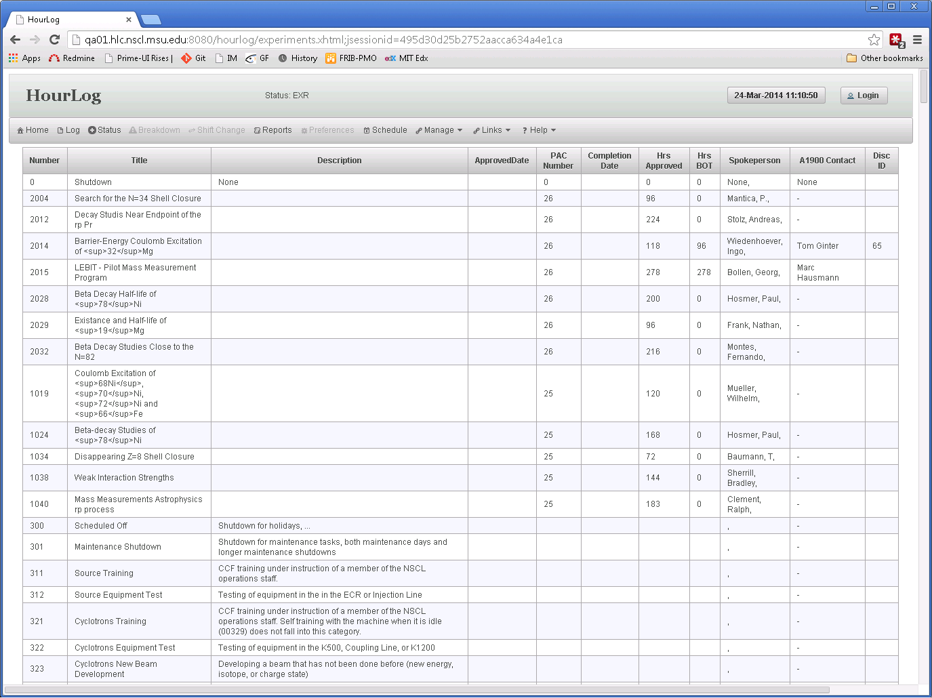

UC-02: Facility Status Linked to an Experiment

