New Hour Log: Architecture Manual

FRIB-WBS-SUB-000000-RXXX

Issued 9 January 2013

Prepared by Reviewed by



Reviewed by Approved by



Concurred Concurred



# Table of Contents

Table of Contents 1

Revision History 1

Authorizing Document 1

Authorized Documents 1

Authorized Committees and Boards 1

1 Introduction 2

2 System Scope and Overview 2

2.1 Current System 2

2.2 Scope 7

2.3 Existing Functionality 8

3 Definitions and References 9

3.1 .Acronyms and Definitions 9

4 General System Description 9

4.1 Functional Requirements 9

5 System Capabilities, Conditions & Constraints 9

6 References 9

Appendix – A 10

# Revision History

|  |  |  |
| --- | --- | --- |
| Revision | Issued | Changes |
|  | Click here to enter date | Click here to enter revision(s) |

# Authorizing Document

A FRIB document [1] (*if applicable; see section [**Error! Reference source not found.**]).

# Authorized Documents

None.

# Authorized Committees and Boards

None.

# Introduction

NSCL’s Operations Department wants to develop a new system, New Hour Log (NHL), to manage logbook entries, facility status, shift data, and interface with external systems such as Trouble Reports, Approved Experiments, and Olog. NHL will be used to generate reports for funding agencies and the quality management system.

Purpose

Purpose of this document is to describe NHL’s high-level design.

# Requirements

## Scope

The new system will be limited to the functionality of existing Hour Log.. Other systems, such as Interruption Compensation

# Architecture

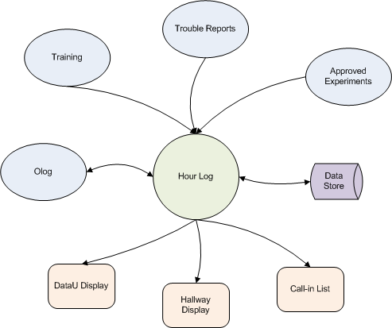

# Data Model

Entities

|  |  |  |
| --- | --- | --- |
| Name | Definition | Examples |
| API Client | Any application or system that uses Hour Log’s API | DataU Display, Hallway Display |
| Operation (Auth) | An operation that can be performed on a resource (auth) |  |
| Permission (Auth) | An operation that can be performed by a role on a resource. |  |
| Resource (Auth) | An entity that must be protected from unauthorized access. |  |
| Role (Auth) | A set of authorizations. A user having a role has the corresponding authorizations. |  |
| Beam | A bunch of charged and energized particles |  |
| Beam System | A system that accelerates or modifies a beam | K500, K1200,A1900 |
| Breakdown Category | A class of devices or a system that can break down and interrupt the running experiment. | Controls (CTL), DAQ, RF, Vacuum |
| Control Signal |  |  |
| Element | An entry from the Periodic Table | H, He, Pb |
| Experiment | A |  |
| External Service | A service that Hour Log depends upon | Olog, Trouble Reports |
| Facility |  | CCF, ReA |
| Mode |  |  |
| (Operations) Role |  |  |
| Shift |  |  |
| Shift Status |  |  |
| Source | The source of ions for an experiment |  |
| Summary | A summarized status of a facility’s status | EXR, EXN, UOF |
| User | A user of Hour Log |  |
| Vault | The destination of a beam for an experiment | S2, ATTPC |
|  |  |  |
|  |  |  |
|  |  |  |

Shift



Security



Beam



Breakdowns



Events



# Definitions and References

## .Acronyms and Definitions

|  |  |
| --- | --- |
| **Acronym** | **Description** |
| ASD | Accelerator System Division |
| CM | Cryomodule |
| EPICS | Experimental Physics and Industrial Control System |
| ESD | Experiment System Division |
| FAT | Field Acceptance Test |
| FPS | Fast Protection System |
| FRIB | Facility for Rare Isotope Beams |
| GUI | Graphical User Interface |
| GTS | Global Timing System |
| HLA | High Level Applications |
| HMI | Human Machine Interface |
| I/O | Input / Output |
| IOC | EPICS Input/Output Controller. |
| IPMI | Intelligent Platform Management Interface |
| MPS | Machine Protection System |
| NA or n/a | Not Applicable |
| PLC | Programmable Logic Controller |
| PPS | Personnel Protection System |
| PV | Process Variable |
| RDB | Relational Database |
| RDBMS | Relational Database Management System |
| RPS | Run Permit System |
| SBC | Single Board Computer |
| TCP/IP | Transmission Control Protocol/Internet Protocol |

# General System Description

## Functional Requirements

# Appendix



# References

1. A FRIB document (FRIB-TXXXXX-AD-000XXX)
2. FRIB Configuration Management Plan (FRIB-T10201-PL-000044)
3. FRIB Document Control Procedure (FRIB-T10502-PR-000001)
4. FRIB Document Numbering Procedure (FRIB-T10502-PR-000002)
5. FRIB WBS Graphic (FRIB-Z00000-BL-000004)
6. FRIB WBS Dictionary (FRIB-Z00000-BL-000003)
7. Acronym List (FRIB-T10501-AD-000068)

# Appendix – A

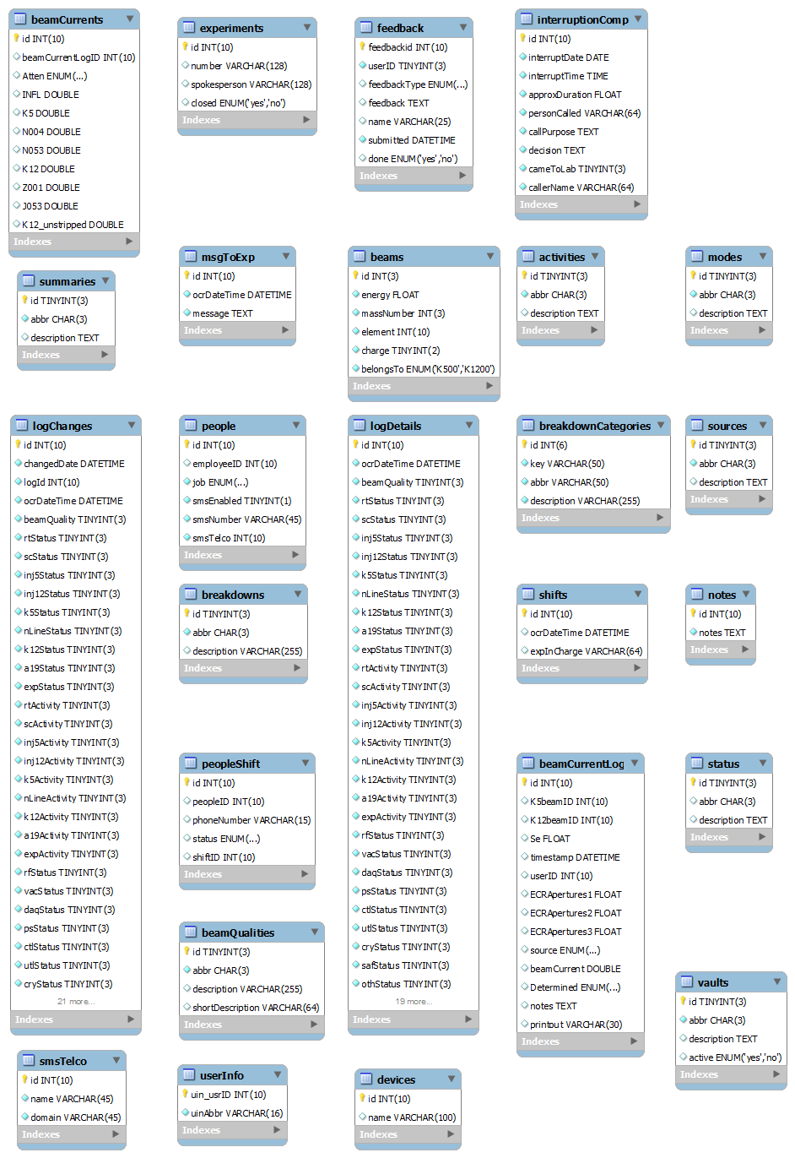

Figure HourLog Schema

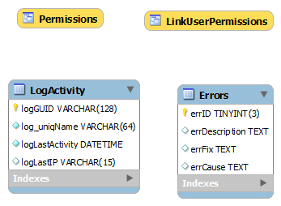

Figure UserDB Schema

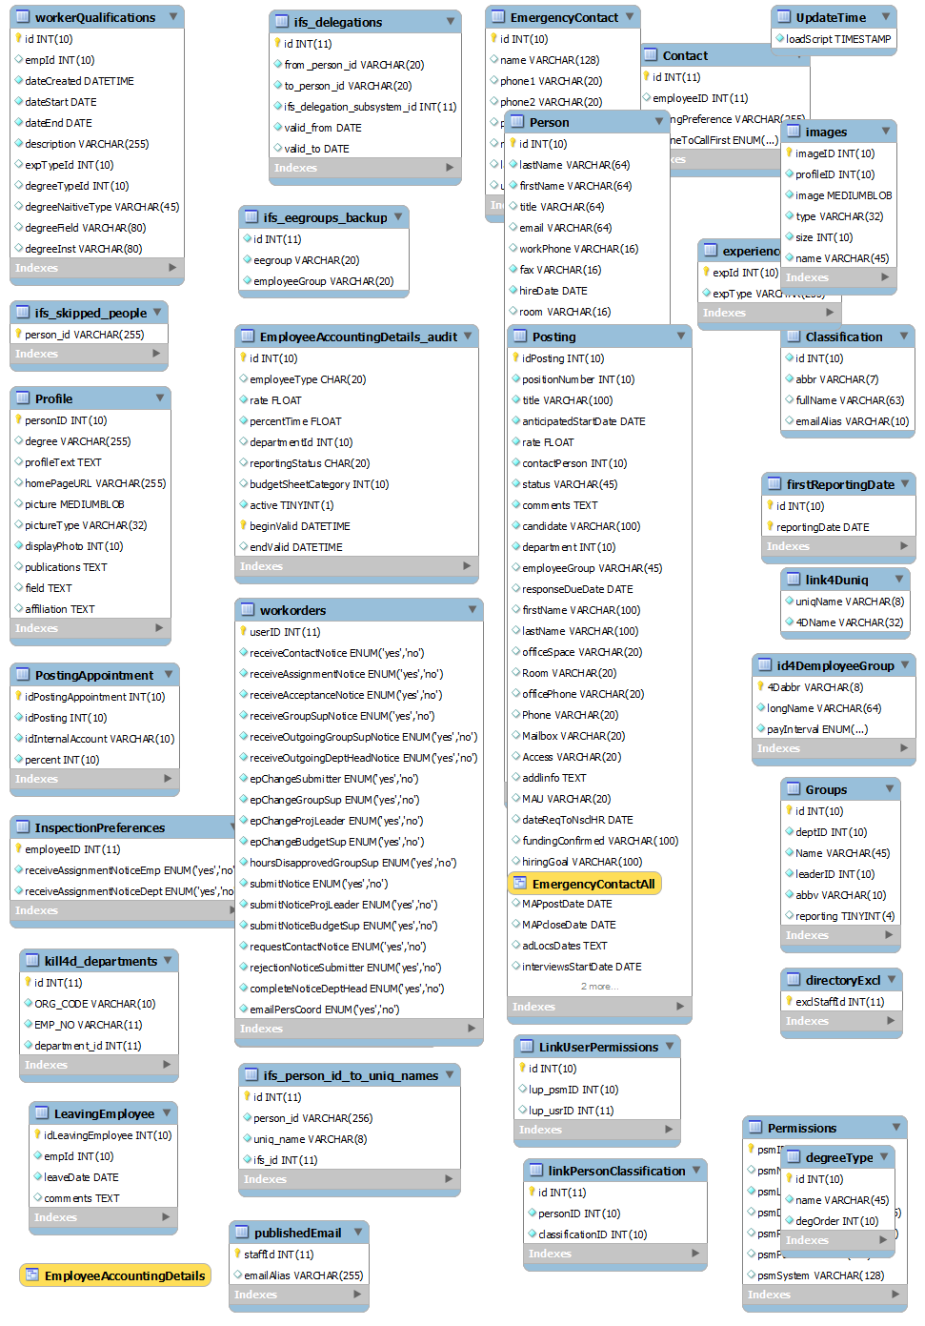

Figure Staff Schema

Table Approved Experiments Schema

