New Hour Log: Software Requirement Specifications

FRIB-WBS-SUB-000000-RXXX

Issued 9 January 2013

Prepared by Reviewed by



Reviewed by Approved by



Concurred Concurred



# Table of Contents

Table of Contents 1

Revision History 1

Authorizing Document 1

Authorized Documents 1

Authorized Committees and Boards 1

1 Introduction 2

2 System Scope and Overview 2

2.1 Current System 2

2.2 Scope 7

2.3 Existing Functionality 8

3 Definitions and References 9

3.1 .Acronyms and Definitions 9

4 General System Description 9

4.1 Functional Requirements 9

5 System Capabilities, Conditions & Constraints 9

6 References 9

Appendix – A 10

# Revision History

|  |  |  |
| --- | --- | --- |
| Revision | Issued | Changes |
|  | Click here to enter date | Click here to enter revision(s) |

# Authorizing Document

A FRIB document [1] (*if applicable; see section [**Error! Reference source not found.**]).

# Authorized Documents

None.

# Authorized Committees and Boards

None.

# Introduction

NSCL’s Operations Department uses Hour Log Application for operational activities:

* To record logbook entries
* Facility status: primary beam tuning, experiment is running, scheduled off, unscheduled off etc
* System breakdown status
* Shift information
* Reports for funding agencies and quality management system

Due to several factors –architecture, technologies, lack of documentation– it has become difficult to sustain and improve the application. Hour Log is critical to the current operation of NSCL beamlines, and must meet ReA and FRIB’s operational requirements in the near future. Hence, it is desirable to re-engineer the application.

Purpose

This document provides high-level requirements for the new system. It is intended for:

* NSCL Operations Department: To make sure that the requirements are complete
* Controls Group: To make sure that the requirements are feasible and are adequate for system design

# Requirements

## Scope

New Hour Log (NHL) will:

* Include the functionality of old or current Hour Log (CHL)
* Allow for multiple facilities (CCF and ReA)
* Interface with several external services through APIs
* Provide APIs for other systems to interface with it

# Specific Requirements

High-level requirements for NHL are listed in the following table.

|  |  |  |  |
| --- | --- | --- | --- |
| ID | Name | Description | Requestor |
| NHL-001 | Authorization | Only authorized users must have access restricted information. . | CHL |
| NHL -002 | User Administration | Privileged users must be able to manage authorizations. | CHL |
| NHL -003 | Activity Log | Users must be able to log operational activities. They must be able to attach documents and Trouble Reports with each entry. | CHL, Stolz A |
| NHL -004 | Reports | Users must generate the following reports:   * Operations Hour Log Report * Breakdown Report * Experiment Report * Beam Reports | CHL |
| NHL -005 | Facility Status | Users must be able to manage a facility’s status. | CHL |
| NHL -006 | Breakdown status | Users must be able to manage breakdown status for various breakdown categories. | CHL |
| NHL -007 | Shift Information | NHL must allow users to manage shift staff information. | CHL |
| NHL-008 | Interfaces | NHL must provide programmatic interfaces to its data | Stolz A |
| NHL-009 | Multiple Facilities | NHL must manage multiple facilities. | Stolz A |
| NHL-010 | Multiple Logbooks | NHL must manage multiple logbooks | Stolz A |
| NHL-011 | External Interfaces | NHL must interface with Trouble Reports, Training, and Approved Experiment systems using APIs instead of directly accessing their databases as done currently. | Stolz A |
| NHL-012 | Olog Interface | NHL must store the logbook entries and attachments in the Olog system. | Stolz A |
| NHL-013 | Search | NHL must allow users to search for log entries (stored in Olog) | Stolz A |
| NHL-014 | DataU Display | DataU Display application must be modified to interface with Hour Log through Hour Log API | Stolz A |
| NHL-015 | Hallway Display | NHL must provide API for Hallway Display to access its data | Stolz A |
| NHL-016 | Notifications | NHL must send notifications, to subscribers, when a facility goes to UOF | CHL |
| NHL-017 | Data Migration | Data from the old Hour Log must be migrated to the new one | Stolz A |
| NHL-018 | Documentation | NHL must have the following documents: Architecture Manual, API Manual, Installation Manual, User Manual | Stolz A |

# Definitions and References

## .Acronyms and Definitions

|  |  |
| --- | --- |
| **Acronym** | **Description** |
| API | Application Programming Interface |
| CCF | Couple Cyclotron Facility |
| CHL | Current Hour Log (old Hour Log) |
|  |  |
|  |  |
|  |  |
|  |  |
| FRIB | Facility for Rare Isotope Beams |
| GUI | Graphical User Interface |
|  |  |
| NHL | New Hour Log |
| Olog | Olog Logbook Service |
| ReA | Re-Accelerator Facility |
| UOF | Unscheduled Off |
|  |  |
|  |  |
|  |  |
|  |  |
|  |  |
|  |  |
|  |  |
|  |  |
|  |  |
|  |  |
|  |  |
|  |  |

# General System Description

## Functional Requirements

# System Capabilities, Conditions & Constraints

# References

1. A FRIB document (FRIB-TXXXXX-AD-000XXX)

# Appendix – A

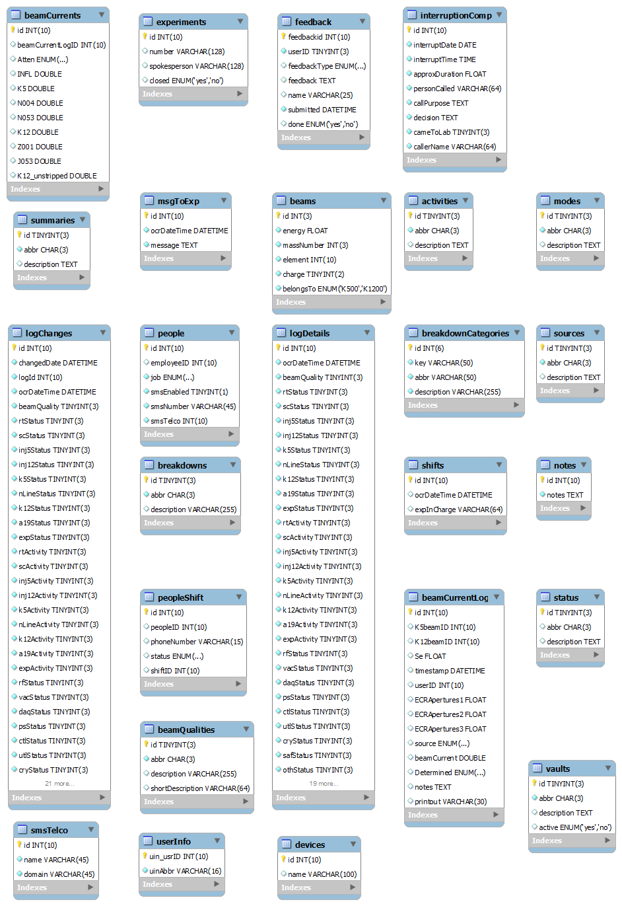

Figure HourLog Schema

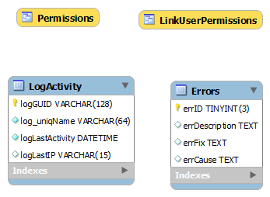

Figure UserDB Schema

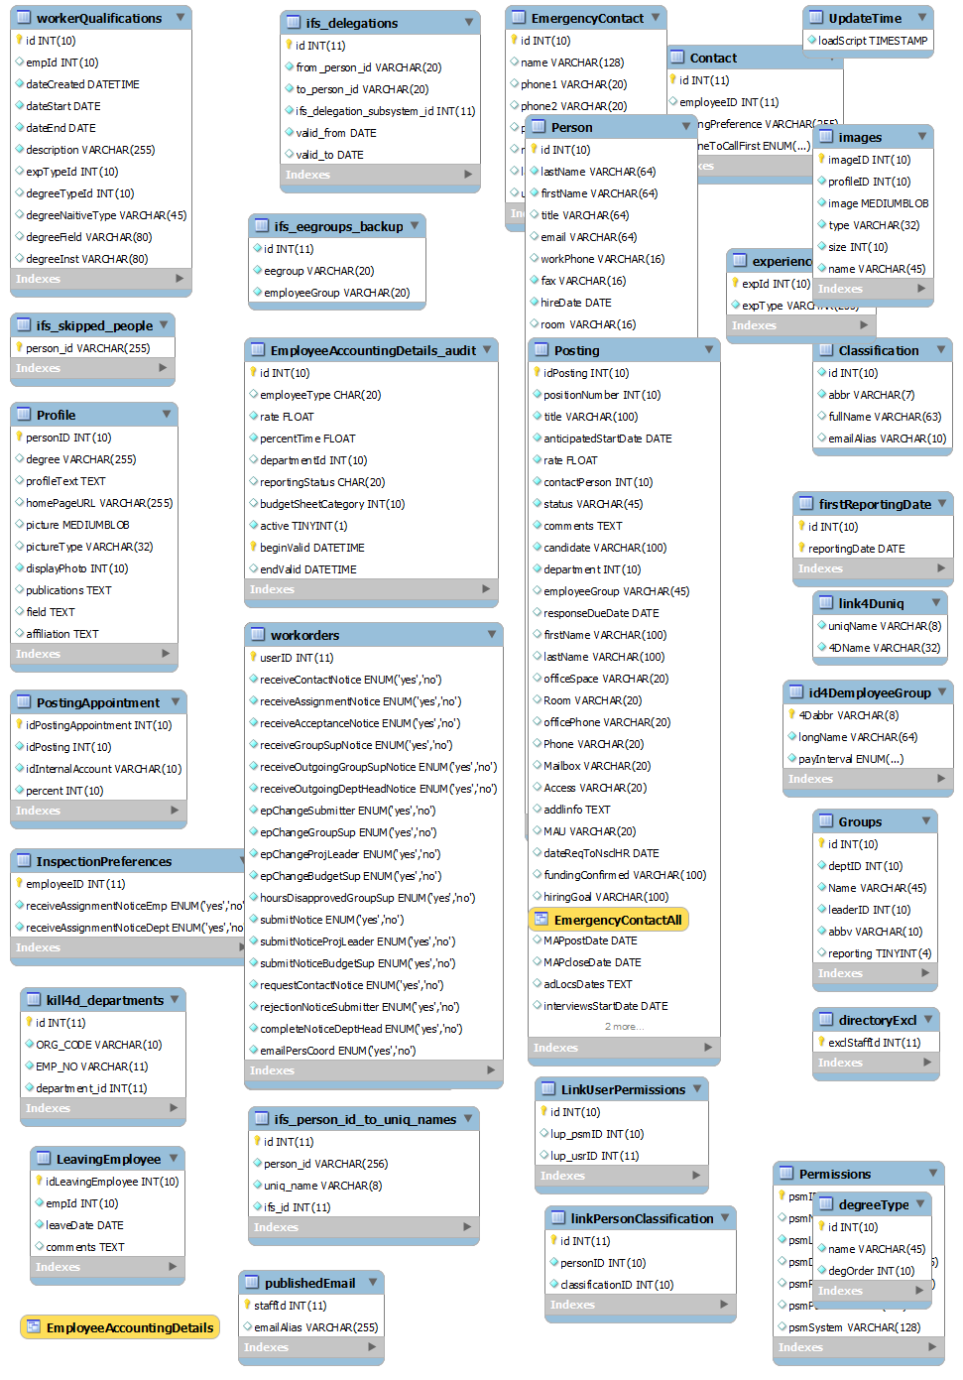

Figure Staff Schema

Table Approved Experiments Schema

