|  |  |  |
| --- | --- | --- |
| nscl.PNG | National Superconducting Cyclotron Laboratory | MSU-Wordmark-PMS-567.eps |

Hour Log – TR and Training Interface Specifications

|  |  |
| --- | --- |
|  |  |
| Project Name | Hour Log |
| Project Code |  |
| Account |  |
| Department |  |
| Project Leader |  |
| Project Coordinator |  |

|  |  |  |  |
| --- | --- | --- | --- |
|  | Name | Signature | Date |
| Prepared By | Vuppala V |  | 12-May-2014 |
| Reviewed By |  |  |  |
| Approved By |  |  |  |

Revision History

|  |  |  |  |
| --- | --- | --- | --- |
| Version | Date | Author | Description |
| 1.0 | 12-May-204 | Vuppala | Initial |
| 1.1 | 11-Aug-2014 | Liu, Vuppala | Added TR-F05, updated TG-F01 |
|  |  |  |  |
|  |  |  |  |
|  |  |  |  |
|  |  |  |  |

Table of Contents

1 Introduction 4

1.1 Purpose 4

1.2 Scope 4

1.3 Definition, Acronyms, and Abbreviations 4

1.4 References 5

1.5 Overview 5

2 Overall Description 5

2.1 Product Perspective 5

2.1.1 System Interfaces 5

2.1.2 User Interfaces 5

2.1.3 Hardware Interfaces 5

2.1.4 Software Interfaces 5

2.1.5 Communications Interfaces 5

2.1.6 Memory Constraints 5

2.1.7 Operations 5

2.1.8 Site-adaptation Requirements 5

2.2 Product Functions 5

2.3 User Characteristics 6

2.4 General Constraints 6

2.5 Assumptions and Dependencies 6

3 Specific Requirements 6

3.1 External Interfaces 6

3.2 Functions 6

3.3 Performance Requirements 7

3.4 Design Constraints 7

3.5 Software System Attributes 7

3.6 Other Requirements 7

Appendix A: Use Cases 8

List of Figures and Tables

Table 1 Glossary 4

# Introduction

Hour Log application is used by the Operations Department at National Superconducting Cyclotron Laboratory (NSCL) to manage activity log, facility status, system breakdowns, shift change, and to generate reports for funding agencies. A new version of Hour Log is being implemented to enhance functionality, improve maintainability, and to allow extensibility. The new version will interface with several external systems: Approved Experiments, Trouble Reports, Training, Logbook, and Configuration databases.

## Purpose

The purpose of this document is to capture requirements for the Trouble Report and Training Systems that enable Hour Log to interface with them. It is intended for the following audience:

* Members of the Business IT Department that will implement the interfaces; they need to make sure that the requirements are feasible.
* Members of the Controls and Computing Department; they need to make sure that the requirements are accurate and complete for interfacing with Hour Log.
* Members of the Operations Department; they need to make sure that the requirements are accurate and complete as business requirements.

## Scope

The Trouble Report system will provide an interface, referred to as the TR Interface, which will allow NHL (or any other system) to programmatically:

* Access information in trouble reports
* Create and modify trouble reports. This is desirable but not mandatory

The Training system will provide an interface, referred to as the TG Interface, which will allow NHL (or any other system) to programmatically:

* Access training information of an employee

## Definition, Acronyms, and Abbreviations

Table 1 Glossary

|  |  |
| --- | --- |
| Item | Description |
| API | Application Programming Interface |
| NSCL | National Superconducting Cyclotron Lab |
| TG | Training System |
| TR | Trouble Report System |
|  |  |
|  |  |
|  |  |
|  |  |
|  |  |

## References

## Overview

# Overall Description

## Product Perspective

NHL manages log entries and on-shift staff for the various facilities in the lab. It allows users to link trouble reports, from TR system, into log entries. It prohibits personnel without proper training to be assigned as operator-in-charge. To provide these functionalities, NHL needs to access information in TR and TG systems programmatically.

### System Interfaces

TR and TG systems will provide APIs for accessing their information.

### User Interfaces

None

### Hardware Interfaces

None

### Software Interfaces

See Section 2.1.1

### Communications Interfaces

See Section 2.1.1

### Memory Constraints

None

### Operations

None

### Site-adaptation Requirements

None.

## Product Functions

The TR Interface shall provide a list of trouble reports based on given criteria. It should also enable users to create and modify trouble reports.

The TG Interface shall provide the trainings undertake by a given employee.

## User Characteristics

The users of these interfaces are familiar with various interfacing technologies.

## General Constraints

## Assumptions and Dependencies

# Specific Requirements

This section contains all the software requirements with sufficient detail so as to enable designers to design a system that meets the requirements.

## External Interfaces

None.

## Functions

|  |  |  |  |
| --- | --- | --- | --- |
| ID | Description | By | Comments |
| TR-F01 | The TR interface shall provide a list of Trouble Reports with at least the following details for each TR:   * TR Number * Date * System * Reporter * Problem Description | Vuppala V |  |
| TR-F02 | The TR interface to list of TRs shall allow filters on:   * Range of TR Numbers * Reporter * System * Search on Problem Description | Vuppala V |  |
| TR-F03 | It shall provide a URL to a TR, in the TR System, so that it is possible to access the TR page through a browser. It shall be possible to bookmark the URL. | Vuppala V |  |
| TR-F04 | The TR interface should allow authorized users to create a new TR. | Vuppala V | Not essential for this phase. Will be discussed during the next phase. |
| TR-F05 | The TR Interface shall provide a list of Trouble Reports that were created or modified at and after a given timestamp (date + time). The number of desired trouble reports shall be specified by a parameter (‘size’). If size is not specified all trouble reports matching the criteria must be returned. If no timestamp is specified, the oldest date in the system must be assumed. | Liu D, Vuppala V | If both timestamp and size are not specified, all trouble reports in the system must be returned. |
| TR-F06 | The TR Interface shall provide an interface to check the status of the TR System. The interface must indicate if the system is working properly or if it is down (for maintenance etc). | Liu D, Vuppala V | Connection time-outs will be used to check if the TR Service itself is down. |
| TG-F01 | The TG interface shall provide all the trainings undertaken by a given user. | Vuppala V | Details will be discussed once the new Training system is initiated. |
| TG-F02 | The TG Interface shall provide an interface to check the status of the Training System. The interface must indicate if the system is working properly or if it is down (for maintenance etc). | Liu D, Vuppala V |  |

## Performance Requirements

## Design Constraints

|  |  |  |  |
| --- | --- | --- | --- |
| ID | Description | By | Comments |
| TRT-D01 | The interface shall be RESTful | Vuppala V |  |
| TR-D02 | The TR Number must not change. It shall remain unique and always identify the same trouble report. | Vuppala V |  |
| TRT-D03 | The representation of the returned data, from TR and TG interfaces, shall be in JSON or XML. The schema shall be clearly specified in the documentation. | Vuppala V |  |
| TRT-D04 | The TR and TG Interfaces shall be documented with examples of their use. | Vuppala V |  |
|  |  |  |  |

## Software System Attributes

## Other Requirements

1. Use Cases

UC-01: List of TRs

1. User opts to add TRs (+TR), NHL displays a list of Trouble Reports from the TR System using TR Interface.

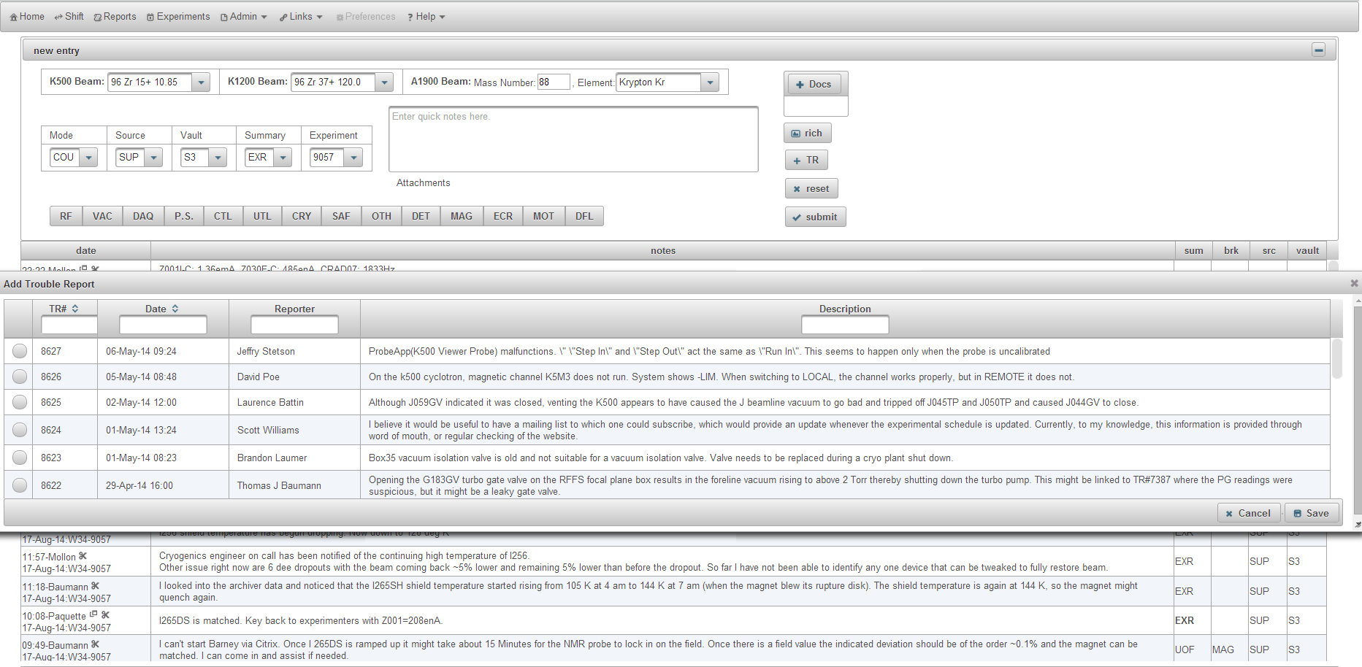

UC-02: Training

1. When an operator starts a new shift, NHL displays a list of operators. Only operators with appropriate training are allowed to be Operator-In-Charge.

