|  |  |  |
| --- | --- | --- |
| nscl.PNG | National Superconducting Cyclotron Laboratory | msu.png |

Project Plan

[Baseline 08-June-2010]

|  |  |
| --- | --- |
|  |  |
| Project Name | LINAC Emittance Measurement Application |
| Project Code | LEMA |
| Account | 2961-004-EE-002 |
| Department | EE |
| Project Leader | Robert Gaul III |
| Project Coordinator | Vasu Vuppala |

|  |  |  |  |
| --- | --- | --- | --- |
|  | Name | Signature | Date |
| Prepared By | Robert Gaul III |  |  |
| Reviewed By | Vasu Vuppala |  |  |
| Approved By | John Vincent |  |  |

Revision History

|  |  |  |  |
| --- | --- | --- | --- |
| Version | Date | Author | Description |
| 1.0 | 6/3/10 | Vuppala, Gaul | Initial PP |
| 1.1 | 6/4/10 | Gaul | Approval form, budget, responsibilities |
| 1.2 | 6/7/10 | Vuppala | Added Schedule and Milestones (appendix) |
| 1.3 | 6/8/10 | Vuppala | Updated the old schedule image (appendix A). updated the date on the PP approval form |

|  |  |
| --- | --- |
| **Project Plan Approval Form** | |
| **Approval Procedure*:***   1. Project Coordinator (PC) sends the Project Plan (PP) to Department Head (DH) for approval. 2. DH approves the PP by signing this form or acknowledging it via written communication such as email 3. PC sends the PP to the Customer 4. Customer approves the PP by signing this form or acknowledging it via written communication such as email | |
| ***Project***: LINAC Emittance Measurement App (LEMA) | ***Customer***: Oliver Kester |
| *Project Leader (PL)*: Robert Gaul III | *Project Coordinator (PC):* Vasu Vuppala |
| ***Project Description***:  ReA3 is a new radioactive beam re-accelerator being commissioned for the Coupled Cyclotron Facility (CCF) and will be used in the Facility for Rare Isotope Beams (FRIB). The ion beam emittance in the transverse direction will need to be evaluated at different points during the beam’s travels. This project will collect data from slits and beam current monitors using EPICS, analyze the data, and graphically display the results to visualize monitor beam emittances. | |
| ***Estimates****:* See LEMA Project Schedule and Budget for Details   |  |  | | --- | --- | | *Effort*: 456 Person Hours | *Cost*: USD 31,920.00 (See Section 5) | | *Start Date*: 6/1/10 | *End Date*: 8/30/10 (See Section 4) | | |
| ***Project Team****:*  Robert Gaul III  Vasu Vuppala | |
| ***Comments***: | |
| *Approvals*:   |  |  | | --- | --- | | Department Head: | Date: | | Customer: | Date: | | |

Table of Contents

1 Project Overview 7

1.1 Introduction 7

1.2 Business Need 7

1.3 Value Engineering 7

2 Project Scope 7

2.1 Scope Statement 8

2.1.1 Scope Description 8

2.1.2 Product Acceptance Criteria 8

2.1.3 Project Deliverables 8

2.1.4 Project Exclusions (Out of Scope) 8

2.1.5 Project Constraints 8

2.1.6 Project Assumptions 8

2.2 Milestones 8

2.3 Work Breakdown Structure 9

2.3.1 WBS Dictionary 9

3 Project Strategy 10

3.1 Technical Strategy 10

3.2 Critical Success Factors 10

3.3 Project Life Cycle 10

3.4 Product Life Cycle 10

4 Project Schedule 11

4.1 Project Milestones 11

5 Project Budget 11

5.1 Budget 11

6 Human Resource Management 11

6.1 Organization 11

6.2 Roles and Responsibilities 12

6.2.1 Responsibility Assignment Matrix 12

6.3 Resource Loading and Release Plan 13

7 Quality Management 13

7.1 Quality Metrics 13

8 Risk Management 13

8.1 Risk Breakdown Structure 13

8.1.1 Risk Register 13

8.2 Environment, Safety, and Health (ESH) 13

9 Communications Management 13

9.1 Stakeholder Register 13

9.2 Communications Plan 14

9.3 Issue Escalation and Resolution 14

9.3.1 Internal 14

9.3.2 External 14

10 Procurement Management 14

10.1 Procurement Items 14

10.2 Procurement Process 15

10.3 Make or Buy Analysis 15

10.4 Vendor Evaluation 15

11 Configuration Management 15

11.1 Configuration Items 15

11.2 Change Control 15

11.3 Change Classification (Major vs Minor) 15

12 References 15

13 Glossary 15

14 Appendix A – Project Schedule 17

15 Appendix B – Milestones 18

List of Figures and Tables

Figure 1 Work Breakdown Structure 9

Table 1 WBS Dictionary 9

Table 2 Project Budget 11

Table 3 RACI Matrix 12

# Project Overview

## Introduction

National Superconducting Cyclotron Laboratory (NSCL) is a world leader in rare isotope research and nuclear science education. NSCL scientists and researchers conduct advanced research in fundamental nuclear science, nuclear astrophysics, and accelerator physics. To facilitate the research, NSCL operates multiple particle accelerators. The control system at NSCL enables operators to control the various devices in the lab: ion sources, cyclotrons, beam lines, experimental devices, and auxiliary equipment. It is based on the Experimental Physics and Industrial Control Systems (EPICS) standard. EPICS is a distributed soft real-time control system for large scientific experiments.

ReA3 is a new radioactive beam re-accelerator being commissioned for the Coupled Cyclotron Facility (CCF) and will be used in the Facility for Rare Isotope Beams (FRIB). The ion beam emittance in the transverse direction will need to be evaluated at different points during the beam’s travels. This project will collect data from slits and beam current monitors using EPICS, analyze the data, and graphically display the results to visualize monitor beam emittances.

## Business Need

This project calls for the development of the LINAC Emittance Measurement Application (LEMA). This application is essential for the commissioning and operation of ReA3’s LINAC. Development in C++ using Qt will allow portability, graphing capabilities, and easier communication with the hardware.

## Value Engineering

Value Engineering (VE) strives to increase the value of a product by analyzing its functions, evaluating the alternatives, and maximizing the ratio of function over cost. The function of this project is to enable the measurement of the beam emittance. There are several ways to achieve this: MATLAB, Qt/C++, and Java. The chosen approach, Qt with C++, has several advantages over the alternatives:

* Portability
* Performance
* Standards-based
* Robust
* Cost

The Project Leader will be responsible for VE activities throughout the project.

# Project Scope

The scope and WBS for the project are outlined in this document. The scope will be refined and the requirements will be detailed iteratively during the execution phase of the project. The scope will be verified against the deliverables during the conclusion of the execution phase. The scope will be controlled as per the Change Control process (Section 11.2).

## Scope Statement

### Scope Description

This project will develop an application to the measure the ion beam emittance in the transverse direction. It must implement the following features:

* Slit initializations
* Data collection from the hardware (slits and Faraday cup)
* Mathematical analysis of the collected data (45 degree slit and 2-jaw slit)
* Storage of the results into text files
* Graphical presentation of the results (emittance graph with overlays)

### Product Acceptance Criteria

The application must pass the tests provided by the Accelerator Physics Group (APG).

### Project Deliverables

The deliverables are:

* The binaries
* Source Code
* Installation Manual
* User Manual
* Design documentation (optional)
* Test Results

### Project Exclusions (Out of Scope)

This project will only deal with transverse emittance and not longitudinal emittance. There will be no advanced graphing features such as zooming and panning. The tool will not save the graph as an image, or print it.

### Project Constraints

* The solution must be built using C++/Qt
* The solution conform to the Computer Department’s deployment methodology

### Project Assumptions

* This project will display data from two slit locations
* EPICS channels for slits and Faraday cup already exist
* Screen capturing and printing will be done through Operating System features
* Testing of the analysis part of the tool will be done by the Accelerator Physics Group

## Milestones

* Project Plan
* Architectural Design
* Version 1.0 alpha (Data collection)
* Version 1.0 beta (GUI)
* Version 1.0
* Project Closure Report

## Work Breakdown Structure

The WBS for this project is shown in Figure 1.

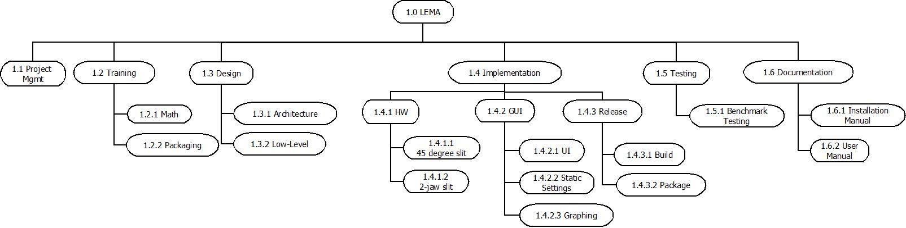

Figure Work Breakdown Structure

### WBS Dictionary

Table 1 describes the WBS elements from the previous section.

Table WBS Dictionary

|  |  |  |
| --- | --- | --- |
| **ID** | **Name** | **Description** |
| **1** | **LEMA** | **LINAC Emittance Measurement Application** |
| **1.1** | **Project Management** | **Includes all activities of PM.** |
| **1.2** | **Training** | **Training required for implementing the project** |
| 1.2.1 | Mathematical analysis | Understanding the mathematic methodologies being used |
| 1.2.2 | Packaging | Understand packaging methodologies on Windows, Mac, Linux |
| **1.3** | **Design** | **Analysis & Design activities** |
| 1.3.1 | Architecture | High-level design and documentation |
| 1.3.2 | Low-Level | Detailed design |
| **1.4** | **Implementation** | **This includes coding, refactoring, and unit test (CRUT)** |
| *1.4.1* | *Hardware communications* | *Implementation of hardware communications to obtain data files* |
| 1.4.1.1 | 45 degree slit | Creation of a raw profile data file and analyzed data file based upon communication with the 45 degree slit |
| 1.4.1.2 | 2-jaw slit | Communicate with the 2-jaw slit and use the analyzed data profile to calculate complete profile (X, X’, I) |
| *1.4.2* | *GUI* | *Implementation of the LEMA user interface* |
| 1.4.2.1 | UI skeleton | Creation of a skeleton layout for the user interface |
| 1.4.2.2 | Static settings | Implementation of static settings |
| 1.4.2.3 | Graphing | Implement 3-d graph of emittance along with overlays of analysis |
| 1.4.3 | Release | Activities related to software release |
| 1.4.3.1 | Build | Compiling, linking |
| 1.4.3.2 | Package | Packaging |
| **1.5** | **Testing** | **All testing related activities** |
| 1.5.1 | Benchmark Testing | Test cases |
| **1.6** | **Documentation** | **Writing manuals** |
| 1.6.1 | Installation manual |  |
| 1.6.2 | User manual |  |
| **1.7** | **Requirements** | **Requirements gathering, analysis, and documentation** |

# Project Strategy

## Technical Strategy

The overall strategy for this project is as follows:

* Develop the data collection and analysis part of the application, to be ready by the commissioning of the equipment (end of June 2010)
* Test the application by checking the results in the existing post-processor (written in MATLAB)
* Develop the post-processor in Qt

The challenges for this project are:

* Lack of knowledge of analysis methodology
* Lack of experience with Qt

## Critical Success Factors

* Availability of Subject Matter Expert (SME)
* Commissioning timeline
* Test data and methodology

## Project Life Cycle

The project will not be divided into subprojects. It will go through the activities as described on Quark [1].

## Product Life Cycle

* The solution will be developed in two phases:
  + data collection and analysis
  + post processing
* Multiple versions, with incremental functionality, will be developed
* Three versions of the product will be released

# Project Schedule

Schedule for this project is listed in **Error! Reference source not found.**. The details of the schedule are available in the LEMA Project Schedule [3]. Changes to the schedule are controlled by the Change Control process (Section 11.2).

## Project Milestones

The milestones listed in section 2.2 are marked on the LEMA Project Schedule [3] and also listed in **Error! Reference source not found.**.

# Project Budget

For each work package, each relevant expert will provide three effort estimates – optimistic, realistic, and pessimistic. Weighted average of these estimates will provide the estimate for a work package. Such estimates from several experts will be averaged to arrive at the final estimate for a work package. The effort estimates, in person hours, will be converted to cost using a normalized rate of USD 70 per hour. Contingency will be calculated using the methodology defined in Quark [1]. Variances from the budget will be monitored using the EVM methodology described in Quark. Changes to the budget will be controlled using the Change Control process (Section 11.2).

## Budget

The cost components for the project are given in Table 2. Budget for the project is shown in **Error! Reference source not found.**. LEMA Project Schedule [3] has the details.

Table Project Budget

|  |  |  |  |
| --- | --- | --- | --- |
| # | Item | Cost (USD) | Date |
| 1 | Labor (418 Hours) | 29260.00 | Project Duration |
| 2 | Contingency (10% of Effort) | 2660.00 |  |
|  |  |  |  |
|  | Total | 31920.00 |  |

# Human Resource Management

## Organization

* Sponsor: John Vincent
  + Project Leader: Robert Gaul III
    - Project Coordinator: Vasu Vuppala
    - Design Engineering Team: Robert Gaul III, Vasu Vuppala
    - Development Engineer: Robert Gaul III
    - Technical Writer: Robert Gaul III
    - Release Engineer: Robert Gaul III
  + Quality Manager: Vasu Vuppala
    - Test Engineering Team: APG, Vasu Vuppala, Robert Gaul III
  + Configuration/Change Control Board (CCB): John Vincent, Oliver Kester, Marc Doleans
* Customer: Oliver Kester, Marc Doleans
  + SME: Marc Doleans, Carla Benatti

## Roles and Responsibilities

Refer to Quark [1] for the standard roles and responsibilities. The additional roles are listed below.

|  |  |
| --- | --- |
| **Role** | **Responsibility** |
| Subject Matter Expert  (SME) | Provide consultation and training in mathematical analysis |
|  |  |
|  |  |

### Responsibility Assignment Matrix

The following table illustrates the responsibilities of various roles using RACI (R – Responsible, A – Accountable/Approver, C – Consulted, I – Informed) matrix.

Table RACI Matrix

|  |  |  |  |  |  |  |  |  |  |  |
| --- | --- | --- | --- | --- | --- | --- | --- | --- | --- | --- |
| **Work Package** | **Customer** | **Sponsor** | **PL** | **PC** | **DES** | **DEV** | **TE** | **TW** | **RE** | **SME** |
| **1.1** | I | I | I | R | I | I | I | I | - | I |
| **1.2.1** | I | I | I | I | C | C | - | - | - | R |
| **1.2.2** | I | I | I | I | C | C | - | - | - | - |
| **1.3.1** | I | I | A | I | R | I | I | I | - | C |
| **1.3.2** | I | I | A | I | R | I | I | I | - | C |
| **1.4.1.1** | I | I | A | I | I | R | I | I | - | - |
| **1.4.1.2** | I | I | A | I | I | R | I | I | - | - |
| **1.4.1.3** | I | I | A | I | I | R | I | I | - | - |
| **1.4.2.1** | I | I | A | I | I | R | I | I | - | - |
| **1.4.2.2** | I | I | A | I | I | R | I | I | - | - |
| **1.4.2.3** | I | I | A | I | I | R | I | I | - | - |
| **1.4.3.1** | I | I | A | I | I | I | I | I | R | - |
| **1.4.3.2** | I | I | A | I | I | I | I | I | R |  |
| **1.5.1** | I | I | A | I | I | I | R | - |  | - |
| **1.6.1** | I | I | A | I | C | C | I | R | C | - |
| **1.6.2** | I | I | A | I | C | C | I | R | C | - |
| **1.7** | A,C | I | R | I | C | C | I | I | I | I |

## Resource Loading and Release Plan

The resource loading and release schedule is given in the LEMA Project Schedule [3].

# Quality Management

The quality metrics defined below will be used for measuring the performance of the LEMA application. The following activities will be performed to manage quality:

1. Develop benchmarks, with Accelerator Physics Group, to test completeness, correctness, and performance of the application
2. Develop methodology to test with benchmarks
3. Determine quality audit schedule
4. Perform audits/reviews as per Quark [1] processes

## Quality Metrics

There are currently no Quality Metrics defined for this project.

# Risk Management

## Risk Breakdown Structure

### Risk Register

|  |  |  |  |  |  |
| --- | --- | --- | --- | --- | --- |
| **ID** | **Risk** | **Root Cause** | **Probability** | **Impact** | **Response** |
| 1 | Technical Know-how | Lack of knowledge (Qt and math) | Medium | High | Training |
| 2 | Beam Commissioning Delay | Operations | Medium | High | Wait for commissioning |
|  |  |  |  |  |  |

## Environment, Safety, and Health (ESH)

This project does not have any environmental, safety, or health related risks, and does not pose any risk to the environment, as per the NSCL’s ESH Management System [2].

# Communications Management

## Stakeholder Register

|  |  |  |
| --- | --- | --- |
| Name | Email | Phone |
| John Vincent | vincent@nscl.msu.edu | +1 (517) 908-7390 |
| Oliver Kester | kester@nscl.msu.edu | +1 (517) 908-7455 |
| Marc Doleans | doleans@nscl.msu.edu | +1 (517) 908-7181 |
| Carla Benatti | Benatti@nscl.msu.edu | +1 (517) 908-7170 |
| Robert Gaul | gaul@nscl.msu.edu | +1 (517) 908-7669 |
| Vasu Vuppala | vuppala@nscl.msu.edu | +1 (517) 908-7421 |

## Communications Plan

|  |  |  |  |
| --- | --- | --- | --- |
| Information | Recipients | Medium | Frequency |
| Performance Report (PR) | All Stakeholders | Email | Weekly |
| Project Status (contents of PR) | Customer | Meeting | Weekly |
| Project Management Documents | All Stakeholders | Email | As Available |

The project team will meet periodically to discuss project progress, as per the processes in Quark [1]. The frequency of such meetings may keep changing with project’s progress. Sometimes these meetings may be combined with the status meetings held with the Customer.

## Issue Escalation and Resolution

### Internal

All issues internal to the project team i.e. not related to the Customer must be escalated as follows (in the given order):

1. Project Leader
2. Line Manager
3. Department Head

### External

All issues concerning the Customer must be escalated as follows (in the given order):

1. Project Leader
2. Customer’s Line Manager
3. Customer’s Department Head

# Procurement Management

No procurement, in terms of material or human resources, is expected for this project.

## Procurement Items

Not applicable for this project.

|  |  |  |  |  |
| --- | --- | --- | --- | --- |
| # | Item | Description | Type | Quantity |
|  |  |  |  |  |
|  |  |  |  |  |

## Procurement Process

Not applicable for this project.

## Make or Buy Analysis

Not applicable for this project.

## Vendor Evaluation

Not applicable for this project.

# Configuration Management

## Configuration Items

The configuration items are:

* The deliverables
* Project documentation: RFW, Preliminary Project Plan, Project Charter, Project Plan, Change Requests, Project Closure Report
* Build Information: Compiler Version and configuration, required libraries, build procedure
* Test Information: Methodology, test plans, test cases, and test results

## Change Control

The change control process outlined in Quark [1] will be followed for this project.

## Change Classification (Major vs Minor)

* During development of Version 1.0 Alpha and Version 1.0 Beta: Any change requiring more than 1 person-weeks of effort will be considered as major.
* During development of Version 1.0: Any change requiring more than 0.5 person-weeks of effort will be considered as major.
* After a total of 1 person-month effort for changes, all changes will be considered as major
* Effort estimations must be approved by CCB

# References

1. Quark, The NSCL EE Process Infrastructure, <https://intra.nscl.msu.edu/departments/electronics/quark/quark.php>
2. NSCL ESH Management System, <https://intra.nscl.msu.edu/safety/>
3. LEMA Project Schedule Baseline, MS Project File, Bundle #227, Section LEMA

# Glossary

|  |  |
| --- | --- |
| Item | Description |
| APG | Accelerator Physics Group |
| DES | Design Engineer |
| DEV | Development Engineer |
| EE | NSCL’s Electronics Department |
| EPICS | Experimental Physics and Industrial Control System |
| ESH | Environment, Safety, and Health |
| EVM | Earned Value Management. A technique for measuring project performance. |
| LEMA | LINAC Emittance Measurement Application |
| LINAC | Linear Accelerator |
| NSCL | National Superconducting Cyclotron Laboratory |
| PL | Project Leader |
| PC | Project Coordinator |
| Quark | EE’s Process Infrastructure Web Portal <https://intra.nscl.msu.edu/departments/electronics/quark/quark.php> |
| RE | Release Engineer |
| ReA3 | The Re-Accelerator Project |
| SME | Subject Matter Expert |
| TE | Test Engineer |
| TW | Technical Writer |
| VE | Value Engineering |
| WBS | Work Breakdown Structure |
| Work Package | Leaf node of a WBS |

# Appendix A – Project Schedule

The complete and detailed schedule is available in LEMA Project Schedule [3].

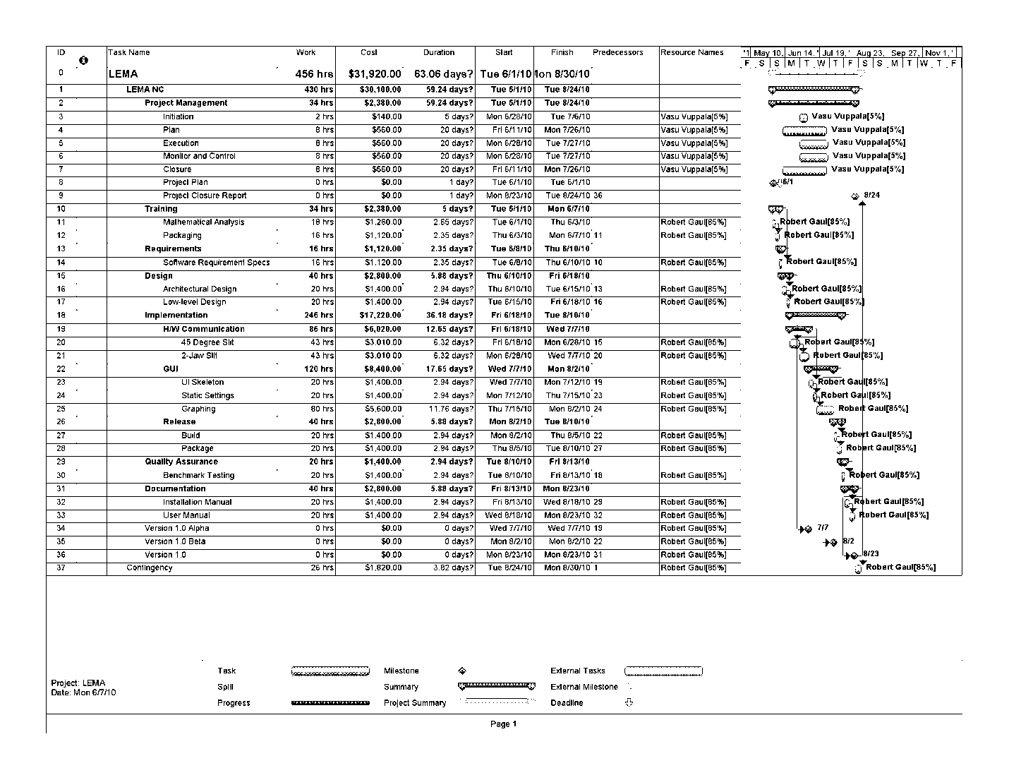

# Appendix B – Milestones

